**LAB 3 - PROGRAM RPGLE HIGHWAY TOLL**

FHWYTOLLDSPCF E WORKSTN

DAdjustHour S 2 0

F/FREE

//------------------------------------------------

EXFMT TOLLINFO;

DOW NOT(*IN03);

EXSR SetTollRate;

TOLLCHARGE = KILOMETERS * TOLLRATE;

If TRANSPNDR = 'N'; //Whereis Transpndr defined? DSP file QDDSRC

NOTRANSP = 4.07;

Else;

NOTRANSP = 0;

ENDIF;

TOTALDUE = TOLLCHARGE + NOTRANSP;

*IN99 = *ON;

WRITE TOLLINFO;

EXFMT SHOWTOLL;

*IN99 = *OFF;

IF *IN03 = *OFF;

EXSR CLEAR;

EXFMT TOLLINFO;

ENDIF;

ENDDO;

*INLR = *ON;

RETURN;

//------------------------------------------------

//------------------------------------------------

BEGSR SetTollRate;

EXSR AdjustTime;

Select;

When VEHICLE = 'L';

EXSR LightVehicle;

When VEHICLE = 'H';

EXSR HeavyVehicle;

When VEHICLE = 'M';

EXSR MultVehicle;

ENDSL;

ENDSR;

//-----------------------------------------------

//-----------------------------------------------

BEGSR AdjustTime;

SELECT;

When AMPM = 'PM' and HOUR <> 12;

AdjustHour = HOUR+12;

When AMPM = 'AM' and HOUR = 12;

AdjustHour = 0;

Other;

AdjustHour = Hour;

ENDSL;

ENDSR;

//-----------------------------------------------

//-----------------------------------------------

BEGSR LightVehicle;

Select;

When AdjustHour >= 6 or AdjustHour < 9;

TOLLRATE = 0.3707;

When AdjustHour >= 9 or AdjustHour < 10;

TOLLRATE = 0.3259;

When AdjustHour >= 10 or AdjustHour < 4;

TOLLRATE = 0.2833;

When AdjustHour >= 4 or AdjustHour < 7;

TOLLRATE = 0.3842;

When AdjustHour >= 7 or AdjustHour < 6;

TOLLRATE = 0.2162;

Other;

TOLLRATE = 0.3707;

ENDSL;

ENDSR;

//-----------------------------------------------

//-----------------------------------------------

BEGSR HeavyVehicle;

Select;

When AdjustHour >= 6 or AdjustHour < 9;

TOLLRATE = 0.7418;

When AdjustHour >= 9 or AdjustHour < 10;

TOLLRATE = 0.6518;

When AdjustHour >= 10 or AdjustHour < 4;

TOLLRATE = 0.5666;

When AdjustHour >= 4 or AdjustHour < 7;

TOLLRATE = 0.7683;

When AdjustHour >= 7 or AdjustHour < 6;

TOLLRATE = 0.4324;

Other;

TOLLRATE = 0.7418;

ENDSL;

ENDSR;

//-----------------------------------------------

//-----------------------------------------------

BEGSR MultVehicle;

Select;

When AdjustHour >= 6 or AdjustHour < 9;

TOLLRATE = 0.11122;

When AdjustHour >= 9 or AdjustHour < 10;

TOLLRATE = 0.9778;

When AdjustHour >= 10 or AdjustHour < 4;

TOLLRATE = 0.8499;

When AdjustHour >= 4 or AdjustHour < 7;

TOLLRATE = 0.11525;

When AdjustHour >= 7 or AdjustHour < 6;

TOLLRATE = 0.6486;

Other;

TOLLRATE = 0.11122;

ENDSL;

ENDSR;

//-----------------------------------------------

//-----------------------------------------------

BEGSR CLEAR;

TOLLRATE = 0;

TOLLCHARGE = 0;

NOTRANSP = 0;

TOTALDUE = 0;

KILOMETERS = 0;

VEHICLE = ' ';

AMPM = ' ';

HOUR = 0;

TRANSPNDR = ' ';

ENDSR;

//-----------------------------------------------

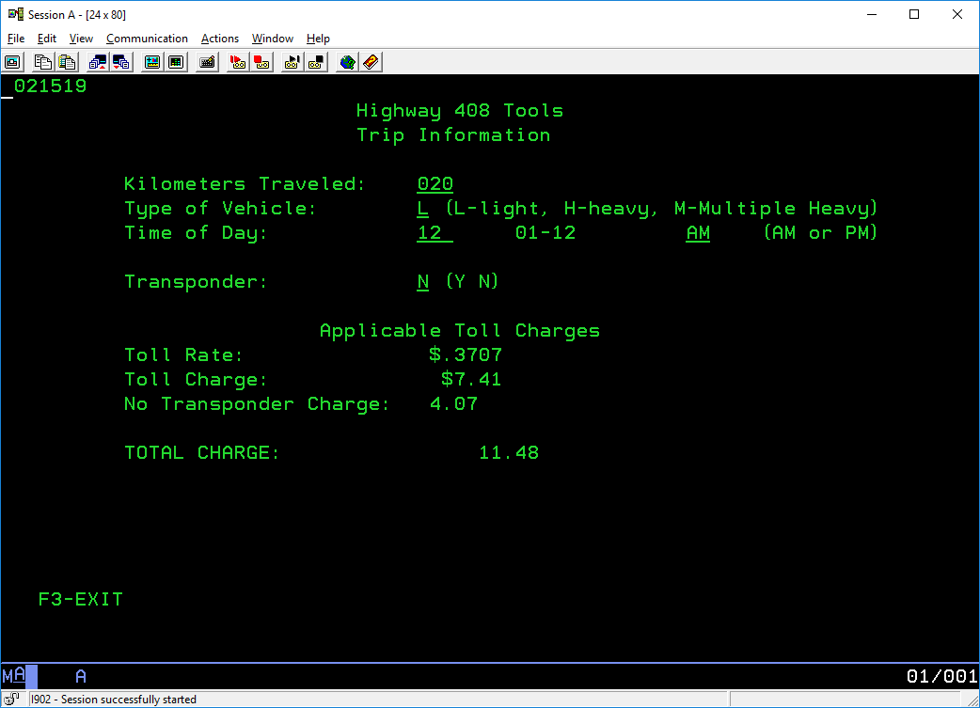

**LAB 3 - PROGRAM DSPF DISPLAY**

A R TOLLINFO

A 1 2DATE

A 2 30'Highway 408 Tools'

A 3 30'Trip Information'

A 5 11'Kilometers Traveled:'

A KILOMETERS 3Y 0B 5 35RANGE(0 999)

A 99 DSPATR(PR)

A 6 11'Type of Vehicle:'

A VEHICLE 1 B 6 35VALUES('L' 'H' 'M')

A 99 DSPATR(PR)

A 6 37'(L-light, H-heavy, M-Multiple Heav-)'

A y)'

A 7 11'Time of Day:'

A HOUR 2 0B 7 35RANGE(1 12)

A 99 DSPATR(PR)

A 7 43'01-12'

A AMPM 2 B 7 57VALUES('AM' 'PM')

99 DSPATR(PR)

7 63'(AM or PM)'

A 9 11'Transponder:'

A TRANSPNDR 1A B 9 35VALUES('Y' 'N')

A 99 DSPATR(PR)

A 9 37'(Y N)'

A R SHOWTOLL

A OVERLAY

A CA03(03 'Exit')

A 11 27'Applicable Toll Charges'

A 12 11'Toll Rate:'

A TOLLRATE 5Y 4O 12 35EDTCDE(1 $)

A 13 11'Toll Charge:'

A TOLLCHARGE 5Y 2O 13 35EDTCDE(1 $)

A 22 4'F3-EXIT'

A 14 11'No Transponder Charge:'

A NOTRANSP 4 2O 14 35EDTCDE(1)

A 16 11'TOTAL CHARGE:'

A TOTALDUE 9 2O 16 35EDTWRD(' . ')