INCEPTION V3 INSTALLATION IN RED HAT VM

Objective | A guide for installation and operation of InceptionV3 in Red Hat VM
Author | Andre Rosa
Date | 08 OCT 2018
Version | 1.0

Introduction

Inception V3 is a pretrained dataset freely available in the internet. This document teaches how to download, install and use Inception V3 with TensorFlow. Therefore before using this document go for the TensorFlow_install document.
Be aware that Inception V3 is a dataset for classification. It is not adequate for creation of detection boxes. If you are looking for an example for detection boxes try the code from: https://github.com/Cadesh/TensorFlow/tree/master/RetinaNetTest

1. Download Inception V3 Dataset

Download the file from:
https://github.com/fchollet/deep-learning-models/releases/download/v0.5/inception_v3_weights_tf_dim_ordering_tf_kernels.h5

2. Check the list of Inception V3 Categories

Inception V3 can detect 1000 categories. The complete list of categories can be found here: https://github.com/Cadesh/TensorFlow/blob/master/InceptionV3_Categories.py

3. Run the Example from GitHub

Download code and pictures from GitHub:
https://github.com/Cadesh/TensorFlow/tree/master/InceptionV3
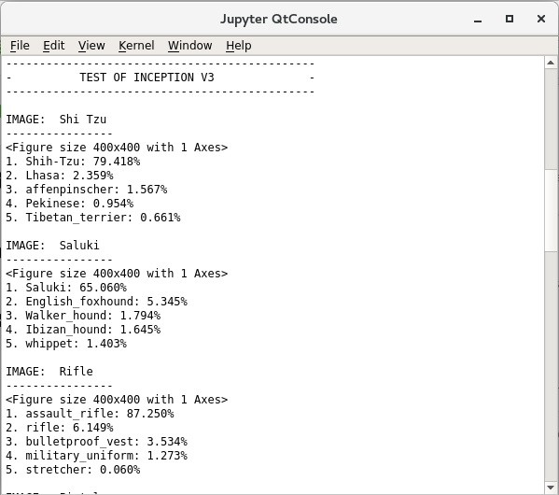Illustration 1: InceptionV3 categorization output.

