A FIRST USER GUIDE TO SOSCIP GPU PLATFORM

Objective | A guide for first users of SOSCIP GPU Platform
Author | Andre Rosa
Date | 04OCT18, 10OCT18, 13OCT2018, 18OCT18, 26OCT18, 01NOV18, 08NOV18, 15NOV18
Version | 1.8

Table of Contents
INTRODUCTION 1
LOGIN 2
MOVING TO THE GPU PLATFORM 2
LOAD MODULES 4
CREATE A CONDA ENVIRONMENT 4
INSTALL OPENCV 5
BACKUP THE CONDA ENVIRONMENT 5
RESTARTING 6
VERSIONS USED 6
SOURCES 7

1 - INTRODUCTION

The objective of this document is to offer a simple introduction for new developers to be able to run a TensorFlow program in SOSCIP GPU Platform.

- To access the system you must use the same login credential from SCINET site:
https://portal.scinet.utoronto.ca/authentication/login

The basic idea of this SOSCIP GPU Platform Tutorial is:
1) Login in SOSCIP (access node);
2) Move to the SOSCIP GPU Cluster (development node);
3) Load modules (TensorFlow, CUDA)
4) Create a Conda environment;
5) Install OpenCV3;
6) Save a backup of your environment;
7) Re-start the system after log off.

2 – LOGIN

Login with terminal
ssh username@bgqdev.scinet.utoronto.ca
or ssh -l username bgqdev.scinet.utoronto.ca -x
(-x for x graphics, not mandatory)

Example: ssh -l andrevr bgqdev.scinet.utoronto.ca
You will get a message as follows:

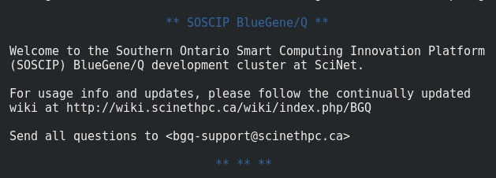Illustration 1: Blue Gene/Q welcome message

After login you will notice that each user has two directories on his file system
- /home/<first-letter-of-group>/<group>/<user>
- /scratch/<first-letter-of-group>/<group>/<user>
Use environment variables $HOME and $SCRATCH contain these names.

Example of user directory: /home/v/vida/andrevr

NOTES:
- Now you are logged in the “access node”.
- You can use WinSCP to transfer files in Windows. In Red Hat use Filezilla.

3 – MOVING TO THE GPU PLATFORM

To have access to the GPU platform you must move from the access node to the GPU development node, type from the BGQ terminal:
ssh -X sgc01-ib0

ATTENTION: at this date (15NOV18) sgc01-ib0 is the GPU development node as stated by https://docs.scinet.utoronto.ca/index.php/SOSCIP_GPU#TensorFlow

You will get an output message as follows:
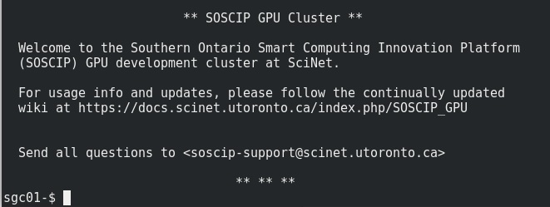Illustration 2: SOSCIP GPU Platform welcome message

In the picture bellow you can check the basic structure of the SCINET Cluster. When logging-in the user is directed to bgc01, then, with the command ssh -X sgc01-ib0 it is possible to move to the SOSCIP GPU (sgc01).
It is important to remember that all nodes share the same file systems, in the picture you can notice $HOME and $SCRATCH that can be accessed with the command cd as:
cd $HOME or cd $SCRATCH
More information on the use of SOSCIP file systems will be given in the document 5_SOSCIP_JOB_Submission.
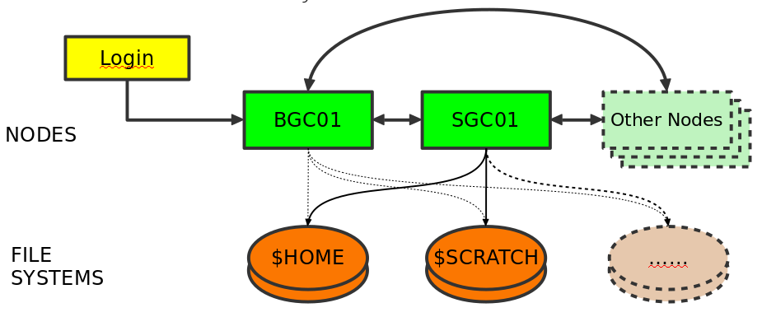Illustration 3: Nodes and File Systems

4 – LOAD MODULES

To run a code in SOSCIP you must load specific modules. There are several available modules that can be listed with the command: module avail
Check the modules already loaded you shall use: module list
Remove a module: module unload <name>
Install a module: module load <name>

For our first Python program we will issue the following commands:

1) To install Anaconda
module load anaconda3

2) For CUDA:
module load cuda/9.2
module load cudnn/cuda9.2/7.2.1

3) For TensorFlow:
module load nccl/2.2.13
module load powerAI-5.3/Tensorflow-1.10.0-py3

5 – CREATE A CONDA ENVIRONMENT

1) To create a Conda Environment (with the name ‘myPythonEnv’):
conda create -n myPythonEnv python=3.6

2) To activate the Conda Environment just created:
source activate myPythonEnv

If it is necessary to deactivate the environment type source deactivate and to destroy an environment use conda env remove --name myPythonEnv while to check a list of your environments use conda env list. For more information about managing conda environments check: https://conda.io/docs/user-guide/tasks/manage-environments.html

6 – INSTALL OPENCV

Now you are located inside a Conda Environment named ‘myPythonEnv’. The name ‘’myPythonEnv’ will be visible in the terminal command prompt as: (myPythonEnv) sgc01-$ . The next step is to install the necessary libraries to work with video categorization. Remember that these libraries will be only visible from inside the Conda Environment.

1) First install ‘pillow’, an image manipulation library, with the command:
pip install pillow

2) Install six, a library to manage conflicts between different versions of Python:
conda install six

3) Finally, to install OpenCV it is necessary to use the command:
conda install -c menpo opencv

4) Last dependencies to run the categorizer code for the project:

pip install --force protobuf (force to override the old protobuf from opencv)
conda install scipy (a math library, necessary for keras/tensorflow)
conda install matplotlib (a library to plot 2D graphics as histograms)

TESTING INSTALLATION

To test the OpenCV3 (version CV2 will not work!) installation run the code in:
https://github.com/Cadesh/TensorFlow/tree/master/FramesOpenCV3

Also you can test Tensorflow/Keras installation with the code here:
https://github.com/Cadesh/TensorFlow/tree/master/InceptionTest_SCINET_GPU

For the Tensorflow test above, it is necessary to get the InceptionV3 dataset from:
https://github.com/fchollet/deep-learning-models/releases/download/v0.5/inception_v3_weights_tf_dim_ordering_tf_kernels.h5

7 – BACKUP THE CONDA ENVIRONMENT

At this moment is a good idea to make a backup of your environment to continue. Use the sequence of commands:

conda deactivate
conda create --name myBackup --clone myPythonEnv (note double - - )
conda activate myPythonEnv or source activate myPythonEnv

The saved environment will keep a copy of the libraries you installed, therefore if you do something wrong you can always clone the backup and restart with a clean environment. The files you have in your folder are available from all environments so be careful because environments save the configuration of the system (programs installed, modules loaded) but if you delete a file it will disappear for all environments.

8 - RESTARTING

When you log off from SOSCIP, all your modules and environments will be unloaded, therefore, it is necessary to reload everything, when log again, to be able to run your Tensorflow code.

1) Load anaconda module:
module load anaconda3

2) Load the modules for CUDA and TensorFlow:
module load cuda/9.2 cudnn/cuda9.2/7.2.1 nccl/2.2.13 powerAI-5.3/Tensorflow-1.10.0-py3

3) Reactivate environment:
source activate <EnvironmentName>

Remember that to check the list of available environments type: conda env list
Now you are ready to run the Tensorflow code again.

9 - VERSIONS USED

This installation allowed the use of the following packages that were necessary to run the examples:

Python 3.6.6
FFMPEG 3.4
OpenCV 3.4.1
TensorFlow 1.10.0
Keras 2.2.4

SOURCES:

- Introduction to BGQ (presentation)
https://wiki.scinet.utoronto.ca/wiki/images/9/9a/Bgqintro.pdf

- SCINET Tutorial
https://wiki.scinet.utoronto.ca/wiki/images/5/54/SciNet_Tutorial.pdf

- SCINET Wiki on Compilers
https://wiki.scinet.utoronto.ca/wiki/index.php/BGQ#Compilers

- SCINET with TensorFlow
https://docs.scinet.utoronto.ca/index.php/SOSCIP_GPU#TensorFlow

- SCINET File Transfer
https://docs.scinet.utoronto.ca/index.php/BGQ#Filesystem

