5 - SOSCIP GPU JOB SUBMISSION

Objective | A guide for submitting jobs in SOSCIP GPU Platform
Author | Andre Rosa
Date | 08NOV2018, 22NOV2018, 06DEC2018
Version | 1.0

Introduction

The objective of this document is to teach new users how to submit jobs to SOSCIP GPU Platform.
For this we will be using Python as a programming language with TensorFlow and Keras, you must be familiar with Conda Environments and SOSCIP modules. For information on these topics refer to the document 4_SOSCIP_GPU_FirstSteps.

Table of Contents
NODES AND FILE SYSTEMS 2
FILE TRANSFER WITH SECURE COPY PROTOCOL (SCP) 3
ACCESSING DATA FROM DIFFERENT DATA SYSTEMS 3
THE TWO STYLES TO RUN A PROGRAM IN SOSCIP 4
JOB SCRIPT FOR MULTIPROCESSING PROGRAMS 5
JOB SCRIPT FOR 4x PROGRAMS RUNNING IN PARALLEL 6
HOW TO SUBMIT A JOB 7
SOURCES 8

1 – NODES AND FILE SYSTEMS

Currently SOSCIP GPU Platform is composed of 14 nodes. Each node has 4 Nvidia Tesla GPUs. Imagine each node as an independent computer equipped with four powerful video boards that can run in parallel.

SOSCIP GPU Platform shares the same file systems with others SCINET clusters as Blue Gene/Q. Imagine each file system as an independent disk. The two main file systems we will use are $HOME and $SCRACTH that can be accessed with the cd command as: cd $SCRACTH or cd $HOME
There are important differences between $SCRATCH and $HOME.
$HOME – disk space 50Gb only, backed-up.
$SCRATCH – disk space 20 Tb, no back-up.

The absolute path for each file system follow the rule:
/type/first_group_letter/group_name/user_id
Therefore the path to $SCRATCH, for a user named ‘andrevr’, from group ‘vida’, is: /scratch/v/vida/andrevr

As a good practice, because of disk space concerns, we will keep our Python code and other important files on $HOME while our video/experiment files on $SCRATCH.
As you can remember (from document 4), you must be located in scg01, the SOSCIP development node.

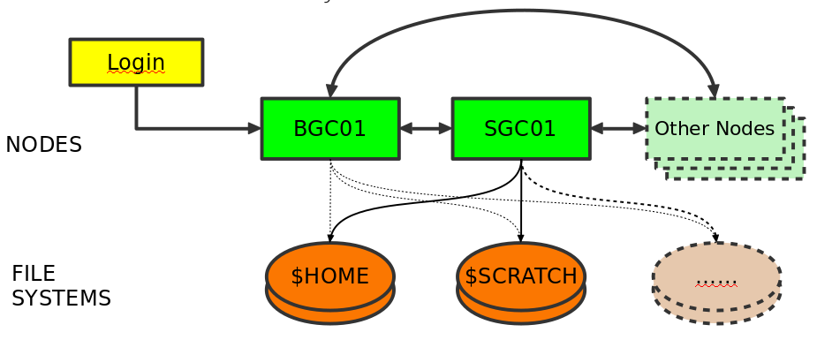Illustration 1: Nodes and File Systems

To verify how much available disk space you have use the command diskUsage -a in BGQ node just after login. The command will not work in SOSCIP GPU Platform.

2 – FILE TRANSFER WITH SECURE COPY PROTOCOL (SCP)

The first problem a new user will face is how to transfer huge amounts of data from your current computer to SOSCIP.
SOSCIP File System accept file transfer with the use of SCP (Secure Copy Protocol). Considering that the user name is andrevr from the group vida, you shall proceed as follows.

From your current computer open a new terminal window.

- Transfer a file (myDoc.pdf) from your current directory to SOSCIP:
scp myDoc.pdf andrevr@bgqdev.scinet.utoronto.ca:~/
Note that this file will be copied to the $HOME data system

- Transfer a file from your current directory to SOSCIP $SCRATCH
scp myDoc.pdf andrevr@bgqdev.scinet.utoronto.ca:/scratch/v/vida/andrevr
Now this file was moved to $SCRATCH under andrevr.

- Transfer a directory with all contents. From the directory above type:
scp -r myFolder andrevr@bgqdev.scinet.utoronto.ca:/scratch/v/vida/andrevr

Later if necessary, use the command mv oldName newName to rename the directory in SOSCIP. A more friendly way to transfer files can be done with FileZilla, an easy to use program found in: https://filezilla-project.org/

3 – ACCESSING DATA FROM DIFFERENT DATA SYSTEMS

As explained above there are the $HOME and the $SCRATCH data systems. The $HOME has backup but only offers 50Gb of space while the $SCRATCH has 20 Tera available but no backup.
While running code from $HOME direct the input/output to $SCRATCH with the use of absolute path names as: /scratch/v/vida/andrevr/videos/
Therefore a Python variable would look like:
videoFolder = '/scratch/v/vida/andrevr/videos/’

LINUX - Symbolic Links
An easier approach to deal with directories located in different data systems is with the use of symbolic links.
If you are in a folder located in $HOME and want your code to access files in $SCRATCH you can create a link with the command: ln –s <pathOrigin> <pathDestiny>
As example: ln -s /scratch/v/vida/andrevr/videos/ videos
This will create a link named ‘videos’ in your current directory, from your code you can now access files with the path ‘./videos/’
For more info on symbolic links check: https://kb.iu.edu/d/abbe

4 – THE TWO STYLES TO RUN A PROGRAM IN SOSCIP
From the sgc01 terminal prompt you will be able to run your programs for testing, however any task that is longer than ten minutes is killed. The only way to run longer tasks is with job submission.
To submit a job in SOSCIP you must use a script and join a queue (shown later). There are two ways to run a job in SOSCIP:
1 – A single process that access the four Tesla P100 GPU cards;
2 – Four parallel processes (programs) that access one Tesla P100 GPU each.

The picture bellow shows the two ways to run programs in SOSCIP.
On the left, we have four main.py programs running four times in parallel, note that to use this job style you need a script and an input file (grey boxes on the bottom).
On the right, there is one main.py program that can access all four GPU at the same time and distributes the workload. This style of job scheduling uses only a script file
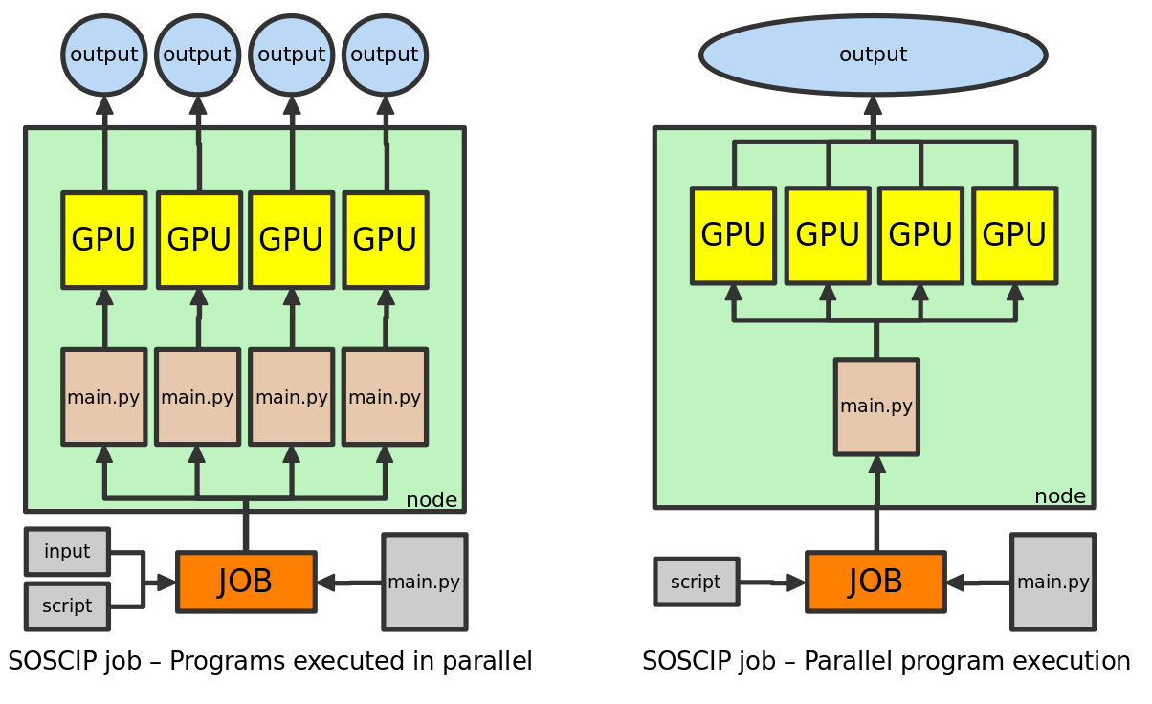Illustration 2: Two styles to run a program in SOSCIP
SOSCIP technicians receive reports of the GPUs usage for each user, therefore the best option is to always try to use fully all four GPUs you have. If you use a single threaded program that access one GPU only, be ready to receive an email from SOSCIP asking for explanations.

Now we will explain in deeper detail how to work with both job styles.

5 – JOB SCRIPT FOR MULTIPROCESSING PROGRAMS

To run a program that can access the four GPUs at the same time you need to use some kind of multithread technique. For our example we will use the Multiprocessing python library. A good explanation of how to use Python with Multiprocessing can be found here:
https://pymotw.com/2/multiprocessing/basics.html

The example of Multiprocessing program with GPU access (with Tensorflow and Keras) can be found here:
https://github.com/Cadesh/TensorFlow/tree/master/Parallel_GPU_Basic

To run a program like the one above in SOSCIP, you need to create a script file as the one bellow.

#!/bin/bash
#SBATCH --nodes=1
#SBATCH --ntasks-per-node=20
#SBATCH --time=00:40:00 #line 4 - time needed to finish job
#SBATCH --gres=gpu:4

. /etc/profile.d/modules.sh #enable module command
cd $SLURM_SUBMIT_DIR #moves to the directory where the batch is

#line 11 to 16 load modules
module purge
module load anaconda3
module load cuda/9.2
module load cudnn/cuda9.2/7.2.1
module load nccl/2.2.13
module load powerAI-5.3/Tensorflow-1.10.0-py3

source activate envFao #line 18 - conda environment

export OMP_NUM_THREADS=1

python main.py pics 0,1,2,3 #line 22 - program and parameters

hostname
nvidia-smi #use this to get the cuda report
Some comments:
Line 4 – This is where you will set the amount of time your program will use a node. You must estimate this correctly because if your program takes longer the process will be killed.
Lines 11 to 16 – Loads the modules that will be necessary for your program. (to learn more about modules check the document ‘4_SOSCIP_GPU_FirstSteps.odt’)
Line 18 – The conda environment that will be used for your program.
Line 22 – The command line to run your program with parameters if necessary.

6 – JOB SCRIPT FOR 4x PROGRAMS RUNNING IN PARALLEL

To run in a SOSCIP node a program that access a single GPU you will need a script file for the job and an input file. The input file has the command line to execute the program four times.
Bellow is an example of a script:
#!/bin/bash
#SBATCH --nodes=1
#SBATCH --ntasks-per-node=20
#SBATCH --time=00:45:00 # H:M:S
#SBATCH --gres=gpu:4 # Ask for 4 GPUs per node

. /etc/profile.d/modules.sh #enable module command
cd $SLURM_SUBMIT_DIR #moves to the directory where the batch is

# loads modules
module purge
module load gnu-parallel/20180422 #line 10 - to work with 4 programs in parallel
module load anaconda3
module load cuda/9.2
module load cudnn/cuda9.2/7.2.1
module load nccl/2.2.13
module load powerAI-5.3/Tensorflow-1.10.0-py3

source activate envFao #name of your previously created conda environment

export OMP_NUM_THREADS=1

parallel -a command.input --colsep ' ' -j 4 'CUDA_VISIBLE_DEVICES=$(( {%} - 1 )) numactl -N $(( ({%} -1) / 2 )) python {1} {2} {3} {4} {5} {6} &> jobname-{#}.out' #line 23 and 24

hostname
nvidia-smi
Some comments:
Line 10 – When launching an execution of different programs in parallel it is necessary to add this module in your script.
Line 23 and 24 – the file ‘command.input’ is the file that will be used as input of the command line. The number ‘4’ is the number of GPUs to be used. The numbers in curly brackets {..} are the parameters of the command line. If to run your code you need to issue the command ‘python main.py param1 param2’ this line will look like ‘python {1} {2} {3}’.

Example of command.input file:
The command.input file is where you issue a command line for each of the programs to be launched. Bellow there is an example for the script from above that requires six parameters input. This input file launches 4x times the same program (main.py) but with different parameters.
Example of .input file
main.py c11250 12k.csv 80 11001 11250
main.py c11500 12k.csv 80 11251 11500
main.py c11750 12k.csv 80 11501 11750
main.py c12000 12k.csv 80 11751 12000

7 – HOW TO SUBMIT A JOB

Now that you are ready to run a program with a script file, the next step is to submit a job command like: sbatch myJob.script

Your job is created and will join a queue to be executed. The command to check the job queue is: squeue
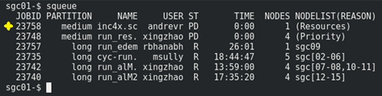Illustration 3: SOSCIP Job Queue
To check your jobs only type: squeue -u <username>
To cancel a job type: scancel <jobid>

When done, the terminal output code will be saved as an .out file. There you will find a report on the usage of GPUs as the one bellow:

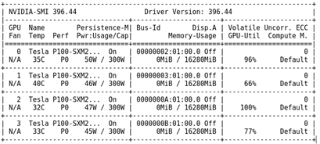Illustration 4: GPU report from SOSCIP

IMPORTANT NOTES:
- When your run a job you can’t be logged in the same conda environment that will be activated in the job script. If you are going to be logged in SOSCIP do not forget to use conda deactivate before launching your job.
- A job without the time parameter will have a default time limit of 10 minutes. If your job takes longer you will get an error as:
*** JOB 22875 ON sgc14 CANCELLED AT 2018-11-01T23:20:29 DUE TO TIME LIMIT ***
To avoid this problem you must set an appropriate time for the job with the line as

SOURCES:

- Introduction to BGQ (presentation)
https://wiki.scinet.utoronto.ca/wiki/images/9/9a/Bgqintro.pdf

- SCINET Tutorial
https://wiki.scinet.utoronto.ca/wiki/images/5/54/SciNet_Tutorial.pdf

- SCINET Wiki on Compilers
https://wiki.scinet.utoronto.ca/wiki/index.php/BGQ#Compilers

- SCINET with TensorFlow
https://docs.scinet.utoronto.ca/index.php/SOSCIP_GPU#TensorFlow

- SCINET File Transfer
https://docs.scinet.utoronto.ca/index.php/BGQ#Filesystem

