Batch-to-Field Traceability and Complaint Intelligence System
Project Proposal
V 1.0

By
1 | Asim Abid | NUM-BSCS-2023-38
2 | Qazi Muhammad Aoun Farooqi | NUM-BSCS-2024-64
3 | Saad Nawaz | NUM-BSCS-2024-67



Department of Computer Sciences
Namal University
Mianwali, Pakistan
Submission Date: 7th October, 2026
REVISION HISTORY
Date | Version | Description | Approved by
07-10-2026 | V 1.0 | Initial version of the project proposal | Dr. Shafiq Ur Rehman Khan

TABLE OF CONTENTS
1. INTRODUCTION: 4
2. PROBLEM STATEMENT: 4
3. PROJECT OBJECTIVES: 5
4. PROJECT SCOPE: 5
5. STAKEHOLDER IDENTIFICATION: 6
6. SOFTWARE DEVELOPMENT METHODOLOGY: 6
7. TOOLS AND TECHNOLOGIES: 7
8. PROPOSED ARCHITECTURE 8
9. AI-ASSISTED QUERIES 9
REFERENCES 10

REQUIREMENT PROVIDER AGREEMENT
This agreement is made between the Requirement Provider and the Project Team for the development of the proposed software project titled:
Project Title: | Batch-to-Field Traceability and Complaint Intelligence System
The Requirement Provider will provide the necessary project information, domain knowledge, user needs, and other relevant details required for understanding the proposed system and will review and validate the information documented by the Project Team. The Project Team will accurately document the agreed project scope and develop the system based on the requirements established and approved during the subsequent requirements engineering process. Any significant changes to the agreed project scope will be discussed with the Requirement Provider and Project Team before implementation. Both parties agree to maintain effective communication and cooperation throughout the project.

Requirement Provider  Name: Dr. Shafiq-Ur-Rehman Khan  Designation: Assistant Professor  Organization: NAMAL University Mianwali  Email: shafiq.rehman@namal.edu.pk  Signature with Date: | Project Team Representative  Name: Asim Abid  Roll No:NUM-BSCS-2023-38  Email: bscs23f38@namal.edu.pk  Signature with Date:

INTRODUCTION:
The agricultural and crop-input sector involves multiple stages from product production and quality control to dispatch, dealer distribution, and final application in the field. When a field-level complaint is received about a product, relevant information such as the product batch, production details, quality control results, dealer, application conditions, crop, dose, and timing may exist across different records. This makes it difficult to quickly understand the complete history of the product and determine the possible cause of the complaint.

The Batch-to-Field Traceability and Complaint Intelligence System is proposed as a mobile application to improve traceability and structured complaint management. The application will allow authorized users to access batch-related information through batch numbers or QR codes and record field complaints with relevant product and application details.

The proposed mobile application will connect important information related to a product batch, including production and quality control information, with its downstream distribution and field-level complaint information. It will also provide complaint analysis to identify patterns based on product, batch, location, crop, dealer, and season.

The system is intended to support VAN-VGreen by making field complaint information more structured and traceable. It can help relevant teams investigate complaints more efficiently, distinguish possible product-related issues from application-related issues, and provide organized field feedback to production, quality control, and R&D teams.

PROBLEM STATEMENT:
When a product complaint is received from the field, it can be difficult to quickly establish a connection between the complaint and the product's complete history. Information such as batch number, production date, quality control results, raw material source, dispatch information, dealer, crop, application dose, timing, and method of use may not be readily connected in one place.

As a result, investigating a complaint can require manual communication and searching through different records. It may also be difficult to determine whether a complaint is associated with a genuine product quality issue, incorrect application, unsuitable field conditions, or unrealistic expectations.

The proposed system addresses this problem through a mobile application that provides batch-based traceability and structured field complaint recording. By connecting batch information with complaint records and providing analytical views, the system aims to help relevant teams investigate complaints more efficiently and identify recurring patterns.

PROJECT OBJECTIVES:
- To develop a mobile application that enables authorized users to retrieve and trace product batch information using a batch number or QR code, including production, QC, dispatch, and dealer records.
- To provide a structured mobile complaint registration system for recording farmer details, crop, location, product and batch information, application dose, timing, method of use, and supporting photographs.
- To provide mobile-based analytical views for identifying complaint patterns based on product, batch, geographical area, crop, dealer, and season.
- To provide structured and traceable complaint information that supports production, QC, R&D, and field teams in investigating complaints, identifying potential patterns, and making informed decisions.
- PROJECT SCOPE:
A. Batch Traceability
- Batch Identification: Search by batch number or scan the associated QR code.
- Batch Information: View product and batch details.
- Production & QC Records: Link and view production and quality control information.
- Distribution Traceability: Track dispatch and associated dealer information.
B. Field Complaint Registration
The mobile application will allow authorized users to record:
- Customer & Product Information: Record farmer/customer, product name, and batch number.
- Field Information: Record crop, location, dealer/source, and application details.
- Application Details: Record dose applied, application timing, and method of application.
- Complaint Evidence: Record complaint description and upload supporting photographs/evidence.
C. Complaint Intelligence
The application will provide analytical information such as:
- Complaints by Product
- Complaints by Batch
- Complaints by Location
- Recurring Complaint Patterns

STAKEHOLDER IDENTIFICATION:

Table 1: Stakeholders and Their Roles in the Proposed System
Stakeholder | Role | Interaction with System
Requirement Provider | Provides domain requirements and validates proposed system | Reviews requirements and provides feedback
VAN-VGreen Management | Oversees business and operational needs | Views complaint trends and traceability information
Production Team | Maintains production/batch information | Provides/updates production-related batch information
QC Team | Maintains quality control information | Records and reviews QC information associated with batches
Field Team | Collects field-level information and complaints | Registers complaints and records application details
Sales/Dispatch Team | Handles product distribution | Maintains dispatch and dealer-related information
Dealers | Distribute products to customers/farmers | Associated with product distribution and complaints
Farmers/Customers | End users who may report product issues | Provide complaint and field-use information
System Administrator | Manages application users and records | Manages authorized access and system data
Project Team | Develops and maintains the application | Designs, implements, tests, and documents the system

SOFTWARE DEVELOPMENT METHODOLOGY:
Agile Methodology
The project will follow an Agile software development methodology. Agile is suitable for the proposed system because the requirements may evolve as the project team receives feedback from the Requirement Provider and understands the operational needs of production, QC, field, and other relevant users.
The development will be divided into iterative cycles in which requirements are analyzed, application features are designed and implemented, and the developed features are tested and reviewed. Feedback from the Requirement Provider will be incorporated into subsequent iterations.
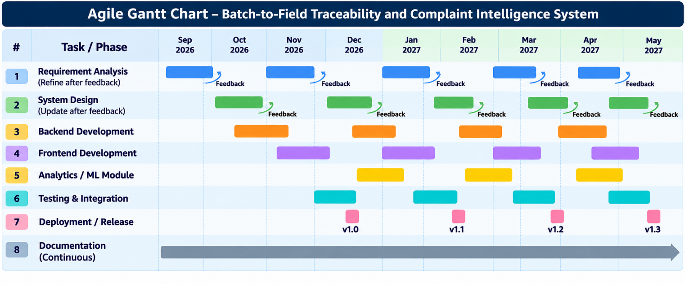
Figure 1:Gantt Chart for Batch to Field Traceability & Complaint Intelligence System

TOOLS AND TECHNOLOGIES:

Table 2: Proposed Tools and Technologies
# | Tool / Technology | Purpose / Details
1 | Flutter | Development of a cross-platform mobile application for batch traceability, complaint submission, QR scanning, and dashboards.
2 | Dart | Programming language used to develop the Flutter application, including its interface, application logic, and functionality.
3 | Firebase | Backend platform providing Firebase Authentication for user login and access control; Cloud Firestore for storing user, product batch, production, quality-control, dealer, and complaint records; Firebase Storage for complaint photographs and supporting evidence; and Cloud Functions for server-side processing, automated tasks, and backend logic where required.
4 | QR Code Scanner | Scanning product and batch QR codes to retrieve batch details and support product traceability.
5 | Figma | Designing mobile application interfaces, wireframes, interactive prototypes, and UI/UX layouts.
6 | Git | Version control for tracking code changes and managing development history.
7 | GitHub | Hosting source code, maintaining project documentation, tracking issues, and supporting team collaboration.
8 | Visual Studio Code (VS Code) | Primary development environment for writing, debugging, and managing Flutter and Dart code.
9 | Python | Data analysis, preprocessing, and experimentation with machine learning models for complaint classification and analytics, if required.

PROPOSED ARCHITECTURE
The proposed architecture of the VAN-VGreen Batch-to-Field Traceability and Complaint Intelligence System consists of a Flutter-based mobile application that connects farmers, field teams, dealers, production teams, QC teams, management, and the R&D team. It has two main modules: Batch Traceability, which supports QR-code scanning and access to product, production, and dispatch information, and Complaint Management, which allows users to record farmer details, crop information, product details, and complaint evidence.
The backend uses Firebase services, including Firestore for storing application data, Firebase Storage for complaint photographs and evidence, and Cloud Functions for backend processing. These services support communication between the mobile application and its data. Finally, the Analytics and Reports module presents complaint trends, geographical patterns, and summary reports to help management and relevant teams investigate recurring issues and make informed decisions.
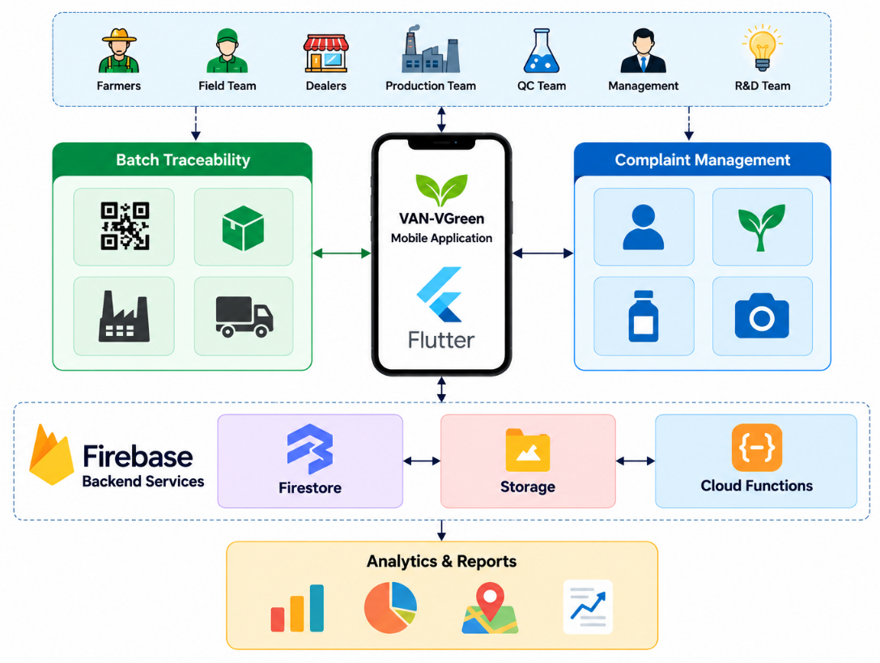
Figure 2: Architecture Diagram For the System

AI-ASSISTED QUERIES
- "Explain how an online courier tracking system works and identify the main traceability concepts relevant to a batch-to-field product traceability system."
- "Explain the FBR Track and Trace System in Pakistan and identify relevant features such as unique identification, product tracking, supply-chain monitoring, and fertilizer traceability."
- "Suggest suitable concepts and features for a mobile-based batch-to-field traceability and complaint management application for an agricultural product company."
- Create a simple, color-coded Gantt chart for the Batch-to-Field Traceability System (Sep 2026–May 2027), showing repeated development, feedback, testing, deployment, and continuous documentation.
- Create a clean architecture diagram: Users → Flutter/Dart App → Firebase Services → Python Analytics/ML → Dashboard, including QR batch tracking and complaint management.

REFERENCES

[1] Pakistan Post, “Express Mail Track & Trace System (EMTTS),” Pakistan Post, 2026. Pakistan Post Track & Trace System
[2] Federal Board of Revenue, Government of Pakistan, “Track and Trace System,” FBR, Islamabad, Pakistan, 2026. FBR Track and Trace System
[3] GS1, “GS1 Global Traceability Standard,” GS1, 2024. GS1 Global Traceability Standard
[4] git_repo_link

