**Alamat Aplikasi**

<https://spms2021.000webhostapp.com/>

**Screen Shot**

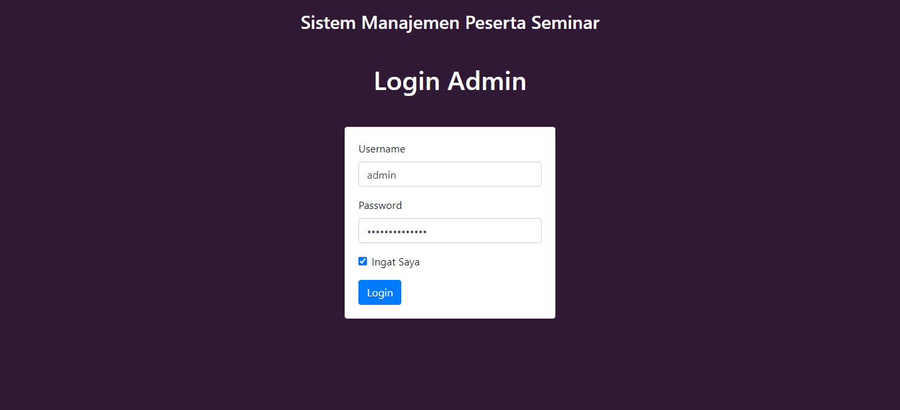

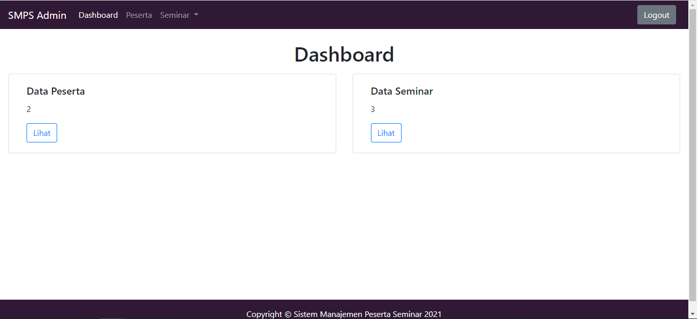

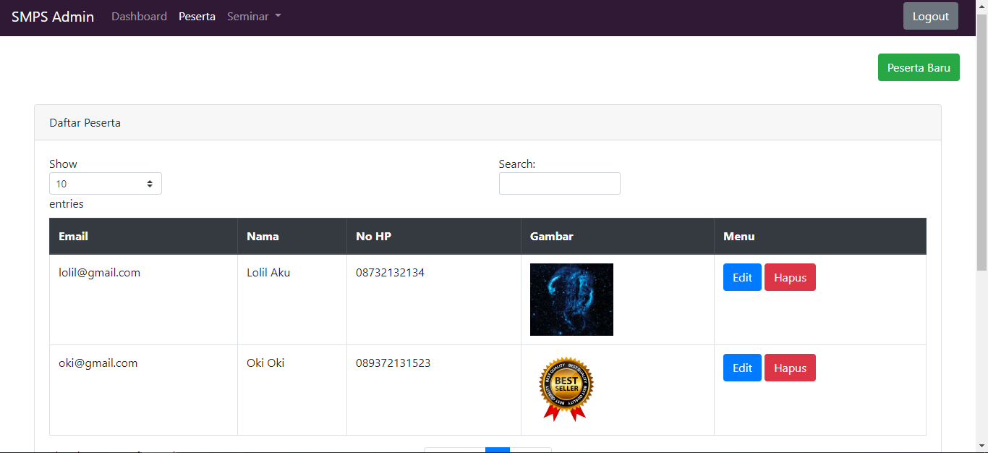

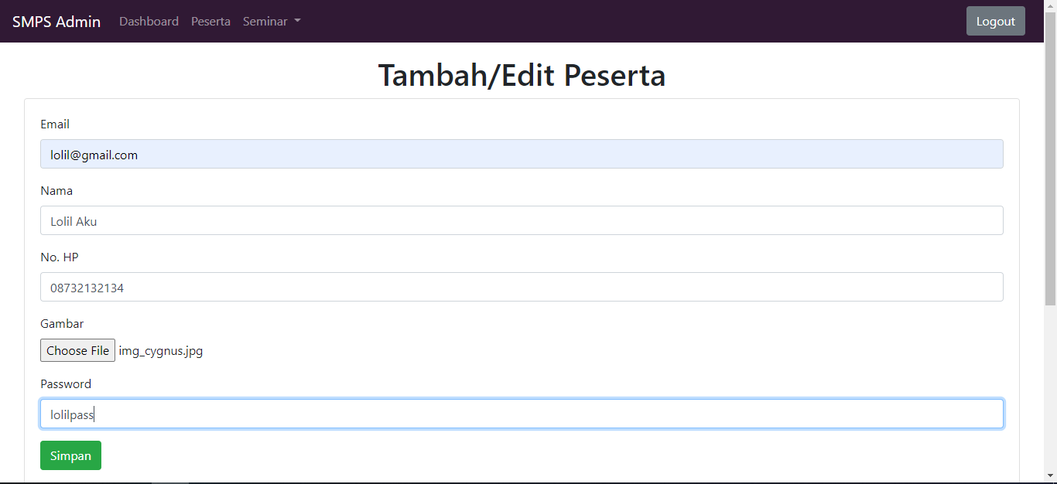

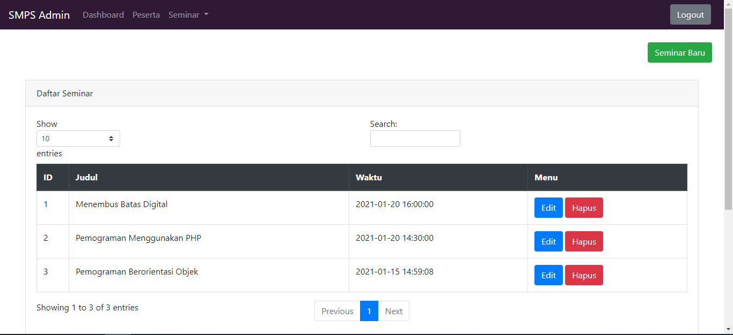

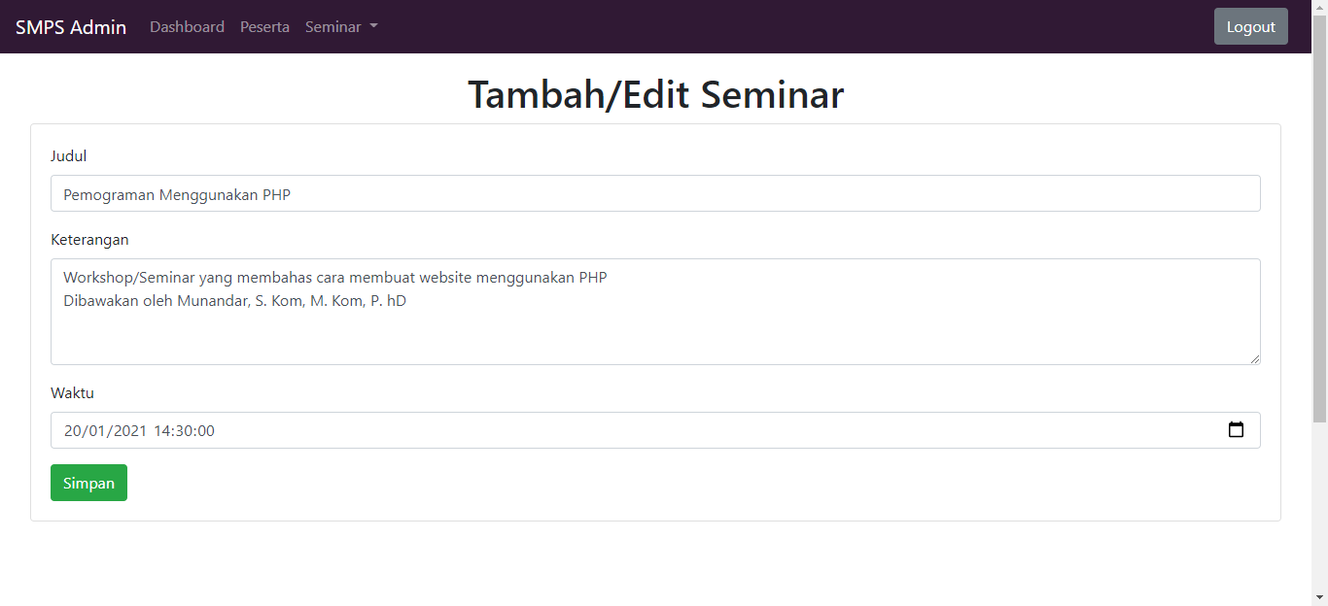

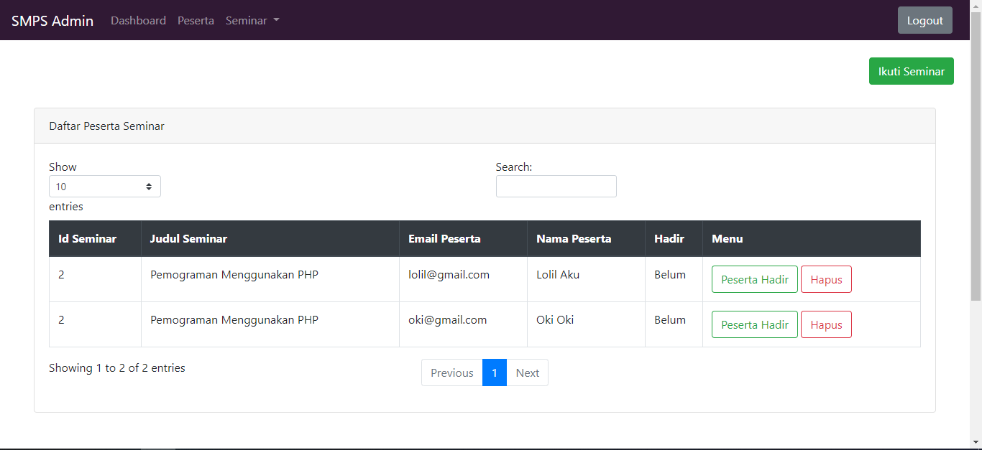

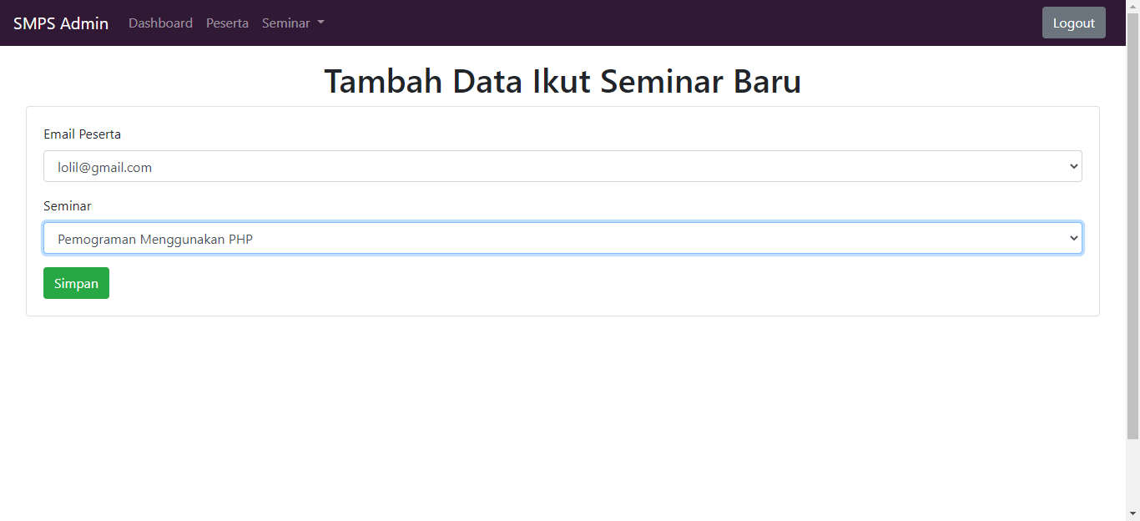

**Source Code**

**Sql**

DROP DATABASE IF EXISTS `smps`;

CREATE DATABASE IF NOT EXISTS `smps` DEFAULT CHARSET=utf8mb4 COLLATE=utf8mb4_unicode_ci;

USE `smps`;

CREATE TABLE `admin` (

`username` VARCHAR(20) COLLATE utf8mb4_unicode_ci NOT NULL,

`password` CHAR(128) COLLATE utf8mb4_unicode_ci NOT NULL,

PRIMARY KEY (`username`)

) ENGINE=INNODB DEFAULT CHARSET=utf8mb4 COLLATE=utf8mb4_unicode_ci;

INSERT INTO `admin`(`username`,`password`) VALUES

('admin','31a556961f3438f9f632ca27812d22228e98e5083eea2bf9b78d0bb374d44deb0dc4d1bc16ab64127eb74e8452ea6902d97937c28310a7ab62a9ae1c15d96d69');

CREATE TABLE `peserta` (

`email` VARCHAR(70) COLLATE utf8mb4_unicode_ci NOT NULL,

`nama` VARCHAR(50) COLLATE utf8mb4_unicode_ci DEFAULT NULL,

`nohp` VARCHAR(20) COLLATE utf8mb4_unicode_ci DEFAULT NULL,

`password` CHAR(128) COLLATE utf8mb4_unicode_ci NOT NULL,

`gambar` VARCHAR(100) COLLATE utf8mb4_unicode_ci DEFAULT NULL,

PRIMARY KEY (`email`)

) ENGINE=INNODB DEFAULT CHARSET=utf8mb4 COLLATE=utf8mb4_unicode_ci;

CREATE TABLE `seminar` (

`judul` VARCHAR(100) COLLATE utf8mb4_unicode_ci DEFAULT NULL,

`keterangan` TEXT COLLATE utf8mb4_unicode_ci,

`id` INT(10) UNSIGNED NOT NULL AUTO_INCREMENT,

`waktu` DATETIME DEFAULT NULL,

PRIMARY KEY (`id`)

) ENGINE=INNODB DEFAULT CHARSET=utf8mb4 COLLATE=utf8mb4_unicode_ci;

CREATE TABLE `peserta_seminar` (

`id_seminar` INT(10) UNSIGNED NOT NULL,

`email` VARCHAR(70) COLLATE utf8mb4_unicode_ci NOT NULL,

`waktu_daftar` DATETIME DEFAULT CURRENT_TIMESTAMP,

`id` INT(10) UNSIGNED NOT NULL AUTO_INCREMENT,

`hadir` TINYINT(1) DEFAULT '0',

PRIMARY KEY (`id`),

KEY `ps_seminar` (`id_seminar`),

KEY `ps_peserta` (`email`),

CONSTRAINT `ps_peserta` FOREIGN KEY (`email`) REFERENCES `peserta` (`email`) ON DELETE CASCADE ON UPDATE CASCADE,

CONSTRAINT `ps_seminar` FOREIGN KEY (`id_seminar`) REFERENCES `seminar` (`id`) ON DELETE CASCADE ON UPDATE CASCADE

) ENGINE=INNODB DEFAULT CHARSET=utf8mb4 COLLATE=utf8mb4_unicode_ci;

DELIMITER $$

CREATE PROCEDURE `add_peserta`(

IN `email1` VARCHAR(70),

IN `password1` CHAR(128),

IN `nama1` VARCHAR(50),

IN `nohp1` VARCHAR(20),

IN `emailnow` VARCHAR(70),

IN `gambar1` VARCHAR(100),

IN `mode` TINYINT(1)

)

BEGIN

IF `mode` = 1 THEN

INSERT INTO `peserta` SET

`email` = `email1`,

`password` = `password1`,

`nama` = `nama1`,

`gambar` = `gambar1`,

`nohp` = `nohp1`;

ELSE

IF CHAR_LENGTH(`password1`) > 0 AND CHAR_LENGTH(`gambar1`) > 0 THEN

UPDATE `peserta` SET

`email` = `email1`,

`password` = `password1`,

`nama` = `nama1`,

`gambar` = `gambar1`,

`nohp` = `nohp1`

WHERE `email` = `emailnow`;

ELSEIF CHAR_LENGTH(`password1`) = 0 AND CHAR_LENGTH(`gambar1`) > 0 THEN

UPDATE `peserta` SET

`email` = `email1`,

`nama` = `nama1`,

`gambar` = `gambar1`,

`nohp` = `nohp1`

WHERE `email` = `emailnow`;

ELSEIF CHAR_LENGTH(`password1`) > 0 AND CHAR_LENGTH(`gambar1`) = 0 THEN

UPDATE `peserta` SET

`email` = `email1`,

`nama` = `nama1`,

`password` = `password1`,

`nohp` = `nohp1`

WHERE `email` = `emailnow`;

ELSE

UPDATE `peserta` SET

`email` = `email1`,

`nama` = `nama1`,

`nohp` = `nohp1`

WHERE `email` = `emailnow`;

END IF;

END IF;

END $$

DELIMITER ;

DELIMITER $$

CREATE PROCEDURE `add_peserta_seminar`(

IN `id_seminar1` INT UNSIGNED,

IN `email1` VARCHAR(70),

IN `hadir1` TINYINT(1)

)

BEGIN

IF `hadir1` = 0 THEN

INSERT INTO `peserta_seminar` SET

`id_seminar` = `id_seminar1`,

`email` = `email1`;

ELSE

UPDATE `peserta_seminar` SET `hadir` = 1

WHERE `id_seminar` = `id_seminar1` AND `email` = `email1`;

END IF;

END $$

DELIMITER ;

DELIMITER $$

CREATE PROCEDURE `add_seminar`(

IN `judul1` VARCHAR(100),

IN `keterangan1` TEXT,

IN `waktu1` DATETIME,

IN `idnow` INT UNSIGNED

)

BEGIN

IF `idnow` = 0

THEN

INSERT INTO `seminar` SET

`judul` = `judul1`,

`keterangan` = `keterangan1`,

`waktu` = `waktu1`;

ELSE

UPDATE `seminar` SET

`judul` = `judul1`,

`keterangan` = `keterangan1`,

`waktu` = `waktu1`

WHERE `id` = `idnow`;

END IF;

END $$

DELIMITER ;

DELIMITER $$

CREATE PROCEDURE `delete_peserta`(

IN `email1` VARCHAR(70)

)

BEGIN

DELETE FROM `peserta` WHERE `email` = `email1`;

END $$

DELIMITER ;

DELIMITER $$

CREATE PROCEDURE `delete_peserta_seminar`(

IN `idnow` INT UNSIGNED,

IN `hadir1` TINYINT(1)

)

BEGIN

IF `hadir1` = 0 THEN

DELETE FROM `peserta_seminar` WHERE `id` = `idnow`;

ELSE

DELETE FROM `peserta_seminar` WHERE `hadir` = `hadir1`;

END IF;

END $$

DELIMITER ;

DELIMITER $$

CREATE PROCEDURE `delete_seminar`(

IN `idnow` INT UNSIGNED,

IN `mode` TINYINT(1)

)

BEGIN

IF `mode` <> 0 THEN

DELETE FROM `seminar` WHERE `waktu` < (SELECT NOW());

ELSE

DELETE FROM `seminar` WHERE `id` = `idnow`;

END IF;

END $$

DELIMITER ;

DELIMITER $$

CREATE PROCEDURE `get_admin`(

IN `uname` VARCHAR(20),

IN `pass` CHAR(128)

)

BEGIN

SELECT * FROM `admin` WHERE `username`=`uname` AND `password`=`pass`;

END $$

DELIMITER ;

DELIMITER $$

CREATE PROCEDURE `get_count_peserta_seminar`()

BEGIN

SELECT (SELECT COUNT(`email`) `peserta` FROM `peserta`) `peserta`,

(SELECT COUNT(`id`) `seminar` FROM `seminar`) `seminar`;

END $$

DELIMITER ;

DELIMITER $$

CREATE PROCEDURE `get_peserta`(

IN `email` VARCHAR(70),

IN `password` CHAR(128)

)

BEGIN

IF CHAR_LENGTH(`password`) = 0 AND CHAR_LENGTH(`email`) = 0

THEN

SELECT * FROM `peserta`;

ELSEIF CHAR_LENGTH(`password`) = 0 AND CHAR_LENGTH(`email`) > 0

THEN

SELECT * FROM `peserta` `p` WHERE `p`.`email` = `email`;

ELSE

SELECT * FROM `peserta` `p` WHERE `p`.`email` = `email` AND `p`.`password` = `password`;

END IF;

END $$

DELIMITER ;

DELIMITER $$

CREATE PROCEDURE `get_peserta_seminar`(

IN `id_seminar1` INT UNSIGNED,

IN `email1` VARCHAR(70)

)

BEGIN

IF `id_seminar1` = 0 AND CHAR_LENGTH(`email1`) = 0

THEN

SELECT `ps`.*, `s`.`judul`, `s`.`keterangan`, `s`.`waktu`, `p`.*

FROM `peserta_seminar` `ps` JOIN `seminar` `s`

ON `ps`.`id_seminar` = `s`.`id` JOIN `peserta` `p`

ON `ps`.`email` = `p`.`email`;

ELSEIF `id_seminar1` <> 0 AND CHAR_LENGTH(`email1`) = 0

THEN

SELECT `ps`.*, `s`.`judul`, `s`.`keterangan`, `s`.`waktu`, `p`.*

FROM `peserta_seminar` `ps` JOIN `seminar` `s`

ON `ps`.`id_seminar` = `s`.`id` JOIN `peserta` `p`

ON `ps`.`email` = `p`.`email`

WHERE `ps`.`id_seminar` = `id_seminar1`;

ELSEIF CHAR_LENGTH(`email1`) <> 0 AND `id_seminar1` = 0

THEN

SELECT `ps`.*, `s`.`judul`, `s`.`keterangan`, `s`.`waktu`, `p`.*

FROM `peserta_seminar` `ps` JOIN `seminar` `s`

ON `ps`.`id_seminar` = `s`.`id` JOIN `peserta` `p`

ON `ps`.`email` = `p`.`email`

WHERE `ps`.`email` = `email1`;

ELSE

SELECT `ps`.*, `s`.`judul`, `s`.`keterangan`, `s`.`waktu`, `p`.*

FROM `peserta_seminar` `ps` JOIN `seminar` `s`

ON `ps`.`id_seminar` = `s`.`id` JOIN `peserta` `p`

ON `ps`.`email` = `p`.`email`

WHERE `ps`.`email` = `email1` AND `ps`.`id_seminar` = `id_seminar1`;

END IF;

END $$

DELIMITER ;

DELIMITER $$

CREATE PROCEDURE `get_seminar`(

IN `id` INT

)

BEGIN

IF `id` = 0 THEN

SELECT * FROM `seminar`;

ELSE

SELECT * FROM `seminar` `s` WHERE `s`.`id`=`id`;

END IF;

END $$

DELIMITER ;

**header.php**

<?php

session_start();

if (!isset($_SESSION['uname'])){

header("Location: login.php");

exit;

}

?>

<!doctype html>

<html lang="en">

<head>

<!-- Required meta tags -->

<meta charset="utf-8">

<meta name="viewport" content="width=device-width, initial-scale=1, shrink-to-fit=no">

<!-- Bootstrap CSS -->

<link rel="stylesheet" href="lib/css/bootstrap.min.css">

<script src="lib/js/jquery.min.js"></script>

<title>Sistem Manajemen Peserta Seminar</title>

</head>

<body>

<nav class="navbar navbar-expand-lg navbar-dark" style="background-color: #301934;">

<a class="navbar-brand pull-left" href="#">SMPS Admin</a>

<button class="navbar-toggler" type="button" data-toggle="collapse" data-target="#navbarSupportedContent" aria-controls="navbarSupportedContent" aria-expanded="false" aria-label="Toggle navigation">

<span class="navbar-toggler-icon"></span>

</button>

<div class="collapse navbar-collapse" id="navbarSupportedContent">

<ul class="navbar-nav mr-auto">

<li class="nav-item">

<a class="nav-link" href="index.php" id="dashboard">Dashboard</a>

</li>

<li class="nav-item">

<a class="nav-link" href="peserta.php" id="peserta">Peserta</a>

</li>

<li class="nav-item dropdown">

<a class="nav-link dropdown-toggle" href="#" id="data" role="button" data-toggle="dropdown" aria-haspopup="true" aria-expanded="false">

Seminar

</a>

<div class="dropdown-menu" aria-labelledby="data">

<a class="dropdown-item" id="seminar" href="seminar.php">Data Seminar</a>

<a class="dropdown-item" id="peserta_seminar" href="peserta_seminar.php">Peserta Seminar</a>

</div>

</li>

</ul>

<a href="logout.php" class="btn btn-secondary mr-2 my-2 my-sm-0" type="submit">Logout</a>

</div>

</nav>

<div class="container-fluid">

**footer.php**

</div>

<!-- Footer -->

<footer class="sticky-footer" style="background-color: #301934; color: white; padding: 1rem; margin-top:18rem;">

<div class="container my-auto">

<div class="copyright text-center my-auto">

<span>Copyright &copy; Sistem Manajemen Peserta Seminar <script>document.write(new Date().getFullYear());</script></span><br>

</div>

</div>

</footer>

<script src="lib/js/popper.min.js"></script>

<script src="lib/js/bootstrap.min.js"></script>

</body>

</html>

koneksi.php

<?php

$servername = "localhost";

$dbname = "smps";

$username = "root";

$password = "";

$conn = new mysqli($servername, $username, $password, $dbname);

?>

**delete_peserta_seminar.php**

<?php

session_start();

if (!isset($_SESSION['uname']) || !isset($_SESSION['pass'])){

header("Location: login.php");

exit;

}

if(isset($_GET['id'])){

$id = $_GET['id'];

include_once "lib/koneksi.php";

$sql = "CALL `delete_peserta_seminar`($id, 0);";

if(mysqli_query($conn, $sql)){}

$conn->close();

}

header("Location: peserta_seminar.php");

exit;

?>

**delete_peserta.php**

<?php

session_start();

if (!isset($_SESSION['uname']) || !isset($_SESSION['pass'])){

header("Location: login.php");

exit;

}

if(isset($_GET['id'])){

$id = $_GET['id'];

include "lib/koneksi.php";

$sql = "CALL `get_peserta`('$id', '');";

$data = mysqli_query($conn, $sql);

while($row = mysqli_fetch_assoc($data)){

$path_gambar = $row['gambar'];

if(strlen($path_gambar) > 0){

unlink($path_gambar);

}

}

$conn->close();

include "lib/koneksi.php";

$sql = "CALL `delete_peserta`('$id');";

if(mysqli_query($conn, $sql)){}

$conn->close();

}

header("Location: peserta.php");

exit;

?>

**delete_seminar.php**

<?php

session_start();

if (!isset($_SESSION['uname']) || !isset($_SESSION['pass'])){

header("Location: login.php");

exit;

}

if(isset($_GET['id'])){

$id = $_GET['id'];

include_once "lib/koneksi.php";

$sql = "CALL `delete_seminar`($id, 0);";

if(mysqli_query($conn, $sql)){}

$conn->close();

}

header("Location: seminar.php");

exit;

?>

**detail_peserta.php**

<?php include_once 'lib/header.php';

$cur_email = "";

$nama = "";

$nohp = "";

$first_time = true;

if($first_time){

$first_time = false;

if(isset($_GET['id'])){

include 'lib/koneksi.php';

$cur_email = $_GET['id'];

$sql = "CALL `get_peserta`('$cur_email', '');";

$data = mysqli_query($conn, $sql);

if(mysqli_num_rows($data) > 0){

while ($row = mysqli_fetch_assoc($data)):

$cur_email = $row['email'];

$nama = $row['nama'];

$nohp = $row['nohp'];

endwhile;

}else{

$cur_email = "";

}

$conn->close();

}

}

if(isset($_POST['simpan'])){

$email = $_POST['email'];

$nama = $_POST['nama'];

$nohp = $_POST['nohp'];

$password = $_POST['password'];

$hashed_password = '';

$newFilePath = '';

if(strlen($password) > 0){

$hashed_password = hash("sha512", $password);

}

if(isset($_FILES['foto']['name'])){

$cur_file = $_FILES['foto']['name'];

$tmpFilePath = $_FILES['foto']['tmp_name'];

$ext = strtolower(pathinfo($cur_file, PATHINFO_EXTENSION));

if($ext == 'jpg' || $ext == 'png' || $ext == 'jpeg'){

if ($tmpFilePath != ""){

$t_nama_file = md5(uniqid()).".".$ext;

$newFilePath = "gambar_peserta/" . $t_nama_file;

if(move_uploaded_file($tmpFilePath, $newFilePath)) {}

}

}

}

if(strlen($cur_email) > 0){

$sql = "

CALL `add_peserta`('$email', '$hashed_password', '$nama', '$nohp', '$cur_email', '$newFilePath', 0);

";

}else{

$sql = "

CALL `add_peserta`('$email', '$hashed_password', '$nama', '$nohp', NULL, '$newFilePath', 1);

";

}

include 'lib/koneksi.php';

if(mysqli_query($conn, $sql)){

echo "<script language=\"javascript\">window.location.href = 'peserta.php';</script>";

}else{

echo "<script language=\"javascript\">alert(\"Gagal simpan data peserta!\");</script>";

}

$conn->close();

}

?>

<h1 class="text-center mt-3">Tambah/Edit Peserta</h1>

<div class="card ml-3 mr-3">

<div class="card-body">

<form method="post" enctype="multipart/form-data">

<div class="form-group">

<label for="email">Email</label>

<input type="text" class="form-control" id="email" name="email" required value="<?=$cur_email?>">

</div>

<div class="form-group">

<label for="nama">Nama</label>

<input type="text" class="form-control" id="nama" name="nama" required value="<?=$nama?>">

</div>

<div class="form-group">

<label for="nohp">No. HP</label>

<input type="text" class="form-control" id="nohp" name="nohp" required value="<?=$nohp?>">

</div>

<div class="form-group">

<label for="foto">Gambar</label>

<input class="form-control-file" type="file" id="foto" name="foto">

</div>

<div class="form-group">

<label for="password" id="password_label">Password (Kosong = Tidak diubah)</label>

<input type="text" class="form-control" id="password" name="password">

</div>

<button type="submit" class="btn btn-success" id="simpan" name="simpan" value="simpan">Simpan</button>

</form>

</div>

</div>

<script>

var cur_email = "<?=$cur_email?>";

if(cur_email.length == 0){

var elem1 = document.getElementById("password");

elem1.required = true;

var elem2 = document.getElementById("password_label");

elem2.innerHTML = "Password";

var elem3 = document.getElementById("foto");

elem3.required = true;

}

</script>

<?php

include_once 'lib/footer.php';

?>

**detail_seminar.php**

<?php include_once 'lib/header.php';

$cur_id = 0;

$judul = "";

$keterangan = "";

$waktu = "";

$first_time = true;

if($first_time){

$first_time = false;

if(isset($_GET['id'])){

include 'lib/koneksi.php';

$cur_id = $_GET['id'];

$sql = "CALL `get_seminar`($cur_id);";

$data = mysqli_query($conn, $sql);

if(mysqli_num_rows($data) > 0){

while ($row = mysqli_fetch_assoc($data)):

$cur_id = $row['id'];

$judul = $row['judul'];

$keterangan = $row['keterangan'];

$waktu = date('Y-m-d\TH:i:s', strtotime($row['waktu']));

endwhile;

}else{

$cur_id = 0;

}

$conn->close();

}

}

if(isset($_POST['simpan'])){

$judul = $_POST['judul'];

$keterangan = $_POST['keterangan'];

$waktu = $_POST['waktu'];

$sql = "CALL `add_seminar`('$judul', '$keterangan', '$waktu', $cur_id);";

include 'lib/koneksi.php';

if(mysqli_query($conn, $sql)){

echo "<script language=\"javascript\">window.location.href = 'seminar.php';</script>";

}else{

echo "<script language=\"javascript\">alert(\"Gagal simpan data seminar!\");</script>";

}

$conn->close();

}

?>

<h1 class="text-center mt-3">Tambah/Edit Seminar</h1>

<div class="card ml-3 mr-3">

<div class="card-body">

<form method="post" enctype="multipart/form-data">

<div class="form-group">

<label for="judul">Judul</label>

<input type="text" class="form-control" id="judul" name="judul" required value="<?=$judul?>">

</div>

<div class="form-group">

<label for="keterangan">Keterangan</label>

<textarea type="text" rows="4" class="form-control" id="keterangan" name="keterangan" required><?=$keterangan?></textarea>

</div>

<div class="form-group">

<label for="waktu">Waktu</label>

<input type="datetime-local" step="1" class="form-control" id="waktu" name="waktu" required value="<?=$waktu?>">

</div>

<button type="submit" class="btn btn-success" id="simpan" name="simpan" value="simpan">Simpan</button>

</form>

</div>

</div>

<?php

include_once 'lib/footer.php';

?>

**ikut_seminar.php**

<?php include_once 'lib/header.php';

if(isset($_POST['simpan'])){

$id_seminar = $_POST['judul'];

$email = $_POST['email'];

include 'lib/koneksi.php';

$sql = "CALL `get_peserta_seminar`($id_seminar, '$email');";

$data = mysqli_query($conn, $sql);

$t_row = mysqli_num_rows($data);

$conn->close();

if($t_row == 0):

include 'lib/koneksi.php';

$sql = "CALL `add_peserta_seminar`($id_seminar, '$email', 0);";

if(mysqli_query($conn, $sql)){

echo "<script language=\"javascript\">window.location.href = 'peserta_seminar.php';</script>";

}else{

echo "<script language=\"javascript\">alert(\"Peserta gagal mengikuti seminar!\");</script>";

}

$conn->close();

else:

echo "<script language=\"javascript\">alert(\"Peserta dengan email $email sudah mengikuti seminar ini\");</script>";

endif;

}

?>

<h1 class="text-center mt-3">Tambah Data Ikut Seminar Baru</h1>

<div class="card ml-3 mr-3">

<div class="card-body">

<form method="post" enctype="multipart/form-data">

<div class="form-group">

<label for="email">Email Peserta</label>

<select class="form-control" id="email" name="email" required>

<option disabled selected value="">Pilih Email Peserta</option>

<?php

include 'lib/koneksi.php';

$sql = "CALL `get_peserta`('', '');";

$data = mysqli_query($conn, $sql);

while ($row = mysqli_fetch_assoc($data)):

?>

<option value="<?=$row['email']?>"><?=$row['email']?></option>

<?php

endwhile;

$conn->close();

?>

</select>

</div>

<div class="form-group">

<label for="judul">Seminar</label>

<select class="form-control" id="judul" name="judul" required>

<option disabled selected value="">Pilih Seminar</option>

<?php

include 'lib/koneksi.php';

$sql = "CALL `get_seminar`(0);";

$data = mysqli_query($conn, $sql);

while ($row = mysqli_fetch_assoc($data)):

?>

<option value=<?=$row['id']?>><?=$row['judul']?></option>

<?php

endwhile;

$conn->close();

?>

</select>

</div>

<button type="submit" class="btn btn-success" id="simpan" name="simpan" value="simpan">Simpan</button>

</form>

</div>

</div>

<?php

include_once 'lib/footer.php';

?>

**index.php**

<?php include_once 'lib/header.php';

$uname = $_SESSION['uname'];

include_once 'lib/koneksi.php';

$t_pes = 0; $t_sem = 0;

$sql = "CALL `get_count_peserta_seminar`();";

$data = mysqli_query($conn, $sql);

while($row = mysqli_fetch_assoc($data)){

$t_pes = $row['peserta'];

$t_sem = $row['seminar'];

}

$conn->close();

?>

<h1 class="mb-2 mt-4 text-center">Dashboard</h1>

<div class="row mt-3 mb-3">

<div class="col card ml-3 mr-3">

<div class="card-body justify-content-center">

<h5 class="card-title">Data Peserta</h5>

<p class="card-text" id="training_count"><?=$t_pes?></p>

<a href="peserta.php" class="btn btn-outline-primary">Lihat</a>

</div>

</div>

<div class="col card ml-3 mr-3">

<div class="card-body justify-content-center">

<h5 class="card-title">Data Seminar</h5>

<p class="card-text" id="testing_count"><?=$t_sem?></p>

<a href="seminar.php" class="btn btn-outline-primary">Lihat</a>

</div>

</div>

</div>

<script>

var elem = document.getElementById("dashboard");

elem.className += " active";

</script>

<?php

include_once 'lib/footer.php';

?>

**login.php**

<?php

session_start();

if (isset($_SESSION['uname'])){

header("Location: index.php");

exit;

}

?>

<!doctype html>

<html lang="en">

<head>

<!-- Required meta tags -->

<meta charset="utf-8">

<meta name="viewport" content="width=device-width, initial-scale=1, shrink-to-fit=no">

<!-- Bootstrap CSS -->

<link rel="stylesheet" href="lib/css/bootstrap.min.css">

<title>Sistem Manajemen Peserta Seminar</title>

</head>

<body style="background-color: #301934;">

<div class="container-fluid">

<?php

include_once "lib/koneksi.php";

if(isset($_POST['login'])){

$uname = $_POST['uname'];

$pass = $_POST['pass'];

$hashed_pass = hash("sha512", $pass);

$sql = "CALL `get_admin`('$uname', '$hashed_pass');";

$data = mysqli_query($conn, $sql);

$total_row = mysqli_num_rows($data);

$akun_ada = false;

if($total_row > 0){

$akun_ada = true;

}

if($akun_ada){

$_SESSION['uname'] = $uname;

$_SESSION['pass'] = $hashed_pass;

if(isset($_POST['remember'])){

setcookie('save_uname', $uname, time() + (86400 * 30), "/");

setcookie('save_pass', $pass, time() + (86400 * 30), "/");

}else{

clear_cookie('save_uname');

clear_cookie('save_pass');

}

echo "<script language=\"javascript\">window.location.href = 'index.php';</script>";

}else{

clear_cookie('save_uname');

clear_cookie('save_pass');

echo "<script language=\"javascript\">alert(\"Username atau password salah atau tidak terdaftar!\");</script>";

}

}

function clear_cookie($cookie_name){

if(isset($_COOKIE[$cookie_name])){

unset($_COOKIE[$cookie_name]);

setcookie($cookie_name, null, -1, '/');

}

}

$conn->close();

?>

<div class="col">

<h3 class="text-center mt-3" style="color:white;">Sistem Manajemen Peserta Seminar</h3>

<h1 class="text-center mt-5" style="color:white;">Login Admin</h1>

<div class="row justify-content-center" style="margin-top: 3rem;">

<div class="card" style="width: 20rem;">

<div class="card-body">

<form method="post" enctype="multipart/form-data">

<div class="form-group">

<label for="exampleInputEmail1">Username</label>

<input type="text" class="form-control" id="uname" name="uname" required>

</div>

<div class="form-group">

<label for="pass">Password</label>

<input type="password" class="form-control" id="pass" name="pass" required>

</div>

<div class="form-group form-check">

<input type="checkbox" class="form-check-input" id="remember" name="remember" value="checked">

<label class="form-check-label" for="remember">Ingat Saya</label>

</div>

<button type="submit" class="btn btn-primary" id="login" name="login" value="login">Login</button>

</form>

</div>

</div>

</div>

</div>

<script>

var cond = <?php if(isset($_COOKIE['save_uname']) && isset($_COOKIE['save_pass'])){echo 1;}else{echo 0;}?>;

if(cond == 1){

document.getElementById("remember").checked = true;

document.getElementById("uname").value = '<?php if(isset($_COOKIE['save_uname'])) echo $_COOKIE['save_uname'];?>';

document.getElementById("pass").value = '<?php if(isset($_COOKIE['save_pass'])) echo $_COOKIE['save_pass'];?>';

}

</script>

</div>

<script src="lib/js/jquery.min.js"></script>

<script src="lib/js/popper.min.js"></script>

<script src="lib/js/bootstrap.min.js"></script>

</body>

</html>

**logout.php**

<?php

session_start();

session_destroy();

header("Location: login.php");

exit;

?>

**peserta_seminar.php**

<?php include_once 'lib/header.php';?>

<div class="mb-2 mt-4 ml-2 mr-2 col row">

<a href="ikut_seminar.php" class="btn btn-success ml-auto">Ikuti Seminar</a>

</div>

<div class="card" style="margin: 2rem;">

<div class="card-header">

Daftar Peserta Seminar

</div>

<div class="card-body">

<table class="table table-bordered table-responsive-md" id="tabel">

<thead class="thead-dark">

<th scope="col">Id Seminar</th>

<th scope="col">Judul Seminar</th>

<th scope="col">Email Peserta</th>

<th scope="col">Nama Peserta</th>

<th scope="col">Hadir</th>

<th scope="col">Menu</th>

</thead>

<tbody>

<?php

include_once 'lib/koneksi.php';

$sql = "CALL `get_peserta_seminar`(0, '');";

$data = mysqli_query($conn, $sql);

while ($row = mysqli_fetch_assoc($data)):

?>

<tr>

<td><?=$row['id_seminar']?></td>

<td><?=$row['judul']?></td>

<td><?=$row['email']?></td>

<td><?=$row['nama']?></td>

<td><?php

if(intval($row['hadir']) == "1"){

echo 'Ya';

}else{

echo 'Belum';

}

?></td>

<td>

<a href="ubah_hadir.php?id_seminar=<?=$row['id_seminar']?>&email=<?=$row['email']?>" class="btn btn-outline-success">Peserta Hadir</a>

<a href="delete_peserta_seminar.php?id=<?=$row['id']?>" class="btn btn-outline-danger">Hapus</a>

</td>

</tr>

<?php endwhile;?>

</tbody>

</table>

</div>

</div>

<script>

$(document).ready(function(){

var table = $('#tabel').DataTable({});

});

var element = document.getElementById("peserta_seminar");

element.classList.add("active");

</script>

<script src="lib/js/jquery.dataTables.min.js"></script>

<script src="lib/js/dataTables.bootstrap4.min.js"></script>

<?php include_once 'lib/footer.php';

$conn->close();

?>

**peserta.php**

<?php include_once 'lib/header.php';?>

<div class="mb-2 mt-4 ml-2 mr-2 col row">

<a href="detail_peserta.php" class="btn btn-success ml-auto">Peserta Baru</a>

</div>

<div class="card" style="margin: 2rem;">

<div class="card-header">

Daftar Peserta

</div>

<div class="card-body">

<table class="table table-bordered table-responsive-md" id="tabel">

<thead class="thead-dark">

<th scope="col">Email</th>

<th scope="col">Nama</th>

<th scope="col">No HP</th>

<th scope="col">Gambar</th>

<th scope="col">Menu</th>

</thead>

<tbody>

<?php

include_once 'lib/koneksi.php';

$sql = "CALL `get_peserta`('', '');";

$data = mysqli_query($conn, $sql);

while ($row = mysqli_fetch_assoc($data)):

?>

<tr>

<td><?=$row['email']?></td>

<td><?=$row['nama']?></td>

<td><?=$row['nohp']?></td>

<td><img src="<?=$row['gambar']?>" style="max-height: 100px; max-width: 300px;"></td>

<td>

<a href="detail_peserta.php?id=<?=$row['email']?>" class="btn btn-primary">Edit</a>

<a href="delete_peserta.php?id=<?=$row['email']?>" class="btn btn-danger">Hapus</a>

</td>

</tr>

<?php endwhile;?>

</tbody>

</table>

</div>

</div>

<script>

$(document).ready(function(){

var table = $('#tabel').DataTable({});

});

var element = document.getElementById("peserta");

element.classList.add("active");

</script>

<script src="lib/js/jquery.dataTables.min.js"></script>

<script src="lib/js/dataTables.bootstrap4.min.js"></script>

<?php include_once 'lib/footer.php';

$conn->close();

?>

**seminar.php**

<?php include_once 'lib/header.php';?>

<div class="mb-2 mt-4 ml-2 mr-2 col row">

<a href="detail_seminar.php" class="btn btn-success ml-auto">Seminar Baru</a>

</div>

<div class="card" style="margin: 2rem;">

<div class="card-header">

Daftar Seminar

</div>

<div class="card-body">

<table class="table table-bordered table-responsive-md" id="tabel">

<thead class="thead-dark">

<th scope="col">ID</th>

<th scope="col">Judul</th>

<th scope="col">Waktu</th>

<th scope="col">Menu</th>

</thead>

<tbody>

<?php

include_once 'lib/koneksi.php';

$sql = "CALL `get_seminar`(0);";

$data = mysqli_query($conn, $sql);

while ($row = mysqli_fetch_assoc($data)):

?>

<tr>

<td><?=$row['id']?></td>

<td><?=$row['judul']?></td>

<td><?=$row['waktu']?></td>

<td>

<a href="detail_seminar.php?id=<?=$row['id']?>" class="btn btn-primary">Edit</a>

<a href="delete_seminar.php?id=<?=$row['id']?>" class="btn btn-danger">Hapus</a>

</td>

</tr>

<?php endwhile;?>

</tbody>

</table>

</div>

</div>

<script>

$(document).ready(function(){

var table = $('#tabel').DataTable({});

});

var element = document.getElementById("seminar");

element.classList.add("active");

</script>

<script src="lib/js/jquery.dataTables.min.js"></script>

<script src="lib/js/dataTables.bootstrap4.min.js"></script>

<?php include_once 'lib/footer.php';

$conn->close();

?>

**ubah_hadir.php**

<?php

session_start();

if (!isset($_SESSION['uname']) || !isset($_SESSION['pass'])){

header("Location: login.php");

exit;

}

if(isset($_GET['id_seminar']) && isset($_GET['email'])){

$id_seminar = $_GET['id_seminar'];

$email = $_GET['email'];

include "lib/koneksi.php";

$sql = "CALL `get_peserta_seminar`($id_seminar, '$email');";

$data = mysqli_query($conn, $sql);

$hadir = null;

while($row = mysqli_fetch_assoc($data)){

$hadir = $row['hadir'];

if($hadir == 0){

$hadir = 1;

}

}

$conn->close();

if($hadir != null):

include "lib/koneksi.php";

$sql = "CALL `add_peserta_seminar`($id_seminar, '$email', $hadir);";

if(mysqli_query($conn, $sql)){}

$conn->close();

endif;

}

header("Location: peserta_seminar.php");

exit;

?>