ICT SECURITY
Today attacks are easier then past because you can do an attack using a tool an you have to know only how to use it.
Security managmenet

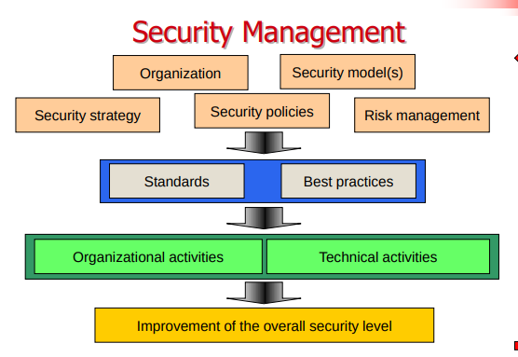

strategies and policies change scenario by scenario.
We could manage risks that our infrastructure could have.
The organization activities can’t be underestimate (rules how use infrastructures, how create users, how organized activities and access, ...).
The improvement of the security must be reviewed periodically based on vulnerabilities, attacks, events.

Physical security and organization is important as technical security.

Security components
- Reliable system architectures
- Data and information backup
- Firewalls
- Intrusion detection and prevention
- Virus and malware protection
- Encryption
- Authentication and authorization
- System’s hardening: setup system properly, make system resilient
- Sandboxing
- VPN
- Auditing and assessment
- Monitoring and system control

Security strategy
A security strategy must be applied to entire company (all departments).
Describe and classify all needs of the company in terms of security.
Create the basis of a risk analysis.
Study and document a BCP, business continuity plan, it is a plan that allows the company to continue the operative.
Consider certifications whenever applicable.
Adequate contracts and SLAs (service level agreements), make contracts with other companies that provide external services.
Security policies
A security policy is a policy that define the security in the company.
They indicate how use the systems and infrastructures.
Security policy must be understandable to everyone, no complicated language.
If there is a company regulation, policy must follow it..
Policy must be applied not only written.

Training is very important in fact it needs an intensive training at the beginning and it will refresh periodically to update staff.
There are different ways to do training (video, meeting, internal test, promotional trinkets, posters…).

Physical security means define perimeter and manage accesses to rooms, server rooms …
Risks to against:
- Physical penetration by malicious or unauthorized people.
- Damage from environmental contaminants
- Electronic penetration through active or passive electronic emissions(Hacking)

Organizations need to demonstrate that they have Information Security controls in place through dedicated staff.
Provide the framework to initiate, implement, maintain, and manage Information Security
Single Point of Contact for:
- Training and Awareness
- Policies and Procedures
- Physical Security Controls
- Technical Security Controls
- Administrative Security Controls

Risk management
organizational activities reduce risks
Identification, valuation and classification of all resources
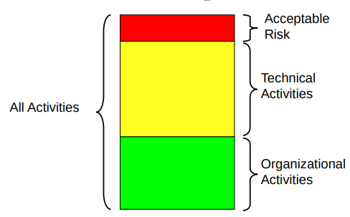

Standards
There are a lot of standard, ISO, BS7799, ITIL, NIST, Canadian Handbook, BSI
they can be :
- generic
- sectorial
Reliable system architectures
all systems have errors, keep always informed.
USE redundant hardware components (HHD, Fans, Power Supply)→all these components have mechanical components in addition to electronic components.
UPS are hardware that allowed power continuity in case of blackout, can manage server power-off.
UPS use lead(piombo) batteries, they are heavy and they have determinate life time (3 years maximum), the battery life is inversely proportional to temperature.

Disks

put disks in mirror, using RAID0, 2 disks put together 2 disks and see as once, no backup, not safe!!.
RAID=Redundant Array Of Inexpensive Disks

RAID1 2 disks first as operative the second as backup , RAID 5 use n-1 disks for storage and the remain as backup, redundant is only 1 disk, if more than 1 disk breaks RAIDs stop working to avoid Spare Disk 1 disk as backup of RAID.
RAID 1 and 5 are used for the safety.

Clustering
it’s used for load balancing and fail over configuration.
Is very useful have hot-plug components.

Backup
know which data have to backup, how often, how long I keep backup(retention).
Do recovery test; backup can’t save always from cryptolocker malware if properly set.

Recovery point Objective(RPO) represents the point in time where data is lost.
Recovery Time Objective (RTO) is very important estimate the downtime of the systems due to a data recovery.

Firewalls
there are 2 firewalls
- Network
- Personal

it separate LAN from public internet,
Firewall governs flow of data into and out of a LAN.
Firewall can manage DMZ networks.
DMZ is a zone where outside can access, we put here webserver for example. It is a network and it is managed by firewall.
Port forwarding is managed by firewall, it can route requests based on socket from outside inside firewall networks.
Firewall are based on rules.
A firewall protects a network if:
- is updated
- is well configured
- rules are correctly programmed
- all the traffic go through firewall
A firewall is just rule driven application.
It simply applies the programmed rules.

State full inspection firewall can put rules on all layers of OSI/IP stack, is useful to manage users

Note:
Mail server must be in the LAN, for law. Webserver with web mail will do proxy.

Mail client use mail proxy, it is like a webmail server but use smtp and imap protocol to communicate with client.

Intrusion detection system
It listens network traffic and check If there are suspect actions, and alert if finds it.
Port scanning is easy to detect because an user try connection to different services in a short time. (SNORT)
Intrusion prevention system
It needs a firewall and edit rules to face attacks. It is not more used because it risks to lock services easily.

Cryptography
Symmetric key:
this type of encryption is faster, less complex, than public key.
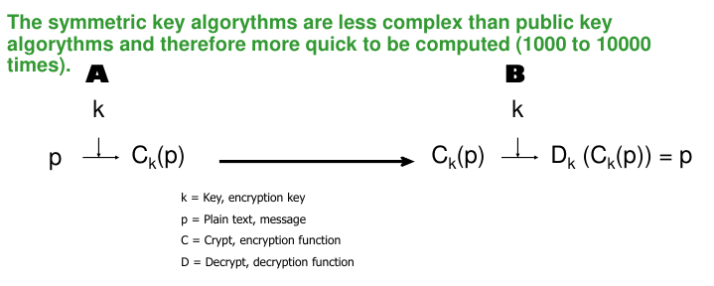
Public key:
There are 2 keys a public key visible by everyone and a private key known only by user.
Sender send to User: Public key encrypt →User decrypt with his private key.
With symmetric key there is a problem of authenticity of origin.

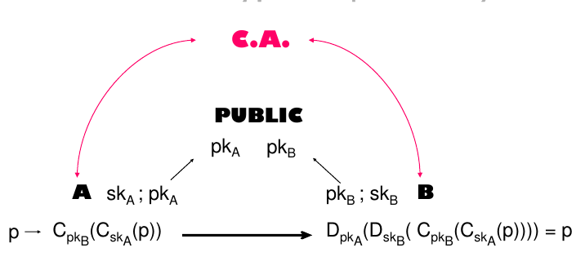
Throw certification authority (C.A.) it certificates our identity and our activities in the communications.

Computer recognizes C.A. of certificates and if it knows the entity it considers it secure else it alert us that the certificate is not valid.

Key length
if the length of a key is long it is securer but it is longer to calculate.
Symmetric keys has short keys, asymmetric(public key) has long keys.
Symmetric is not adequate to manage multiple users.
Public key are slow.
Https mix symmetric and public keys, uses public to create communication channel then it use symmetric keys.

Hash functions
An hash function is a function that given an input it return a string that not permit go back, only one direction.
MD5 (vulnerable), SHA-1 and SHA-256 more secure.
To hack an hash we could create collision, giving random strings since we found the match.
Hash are used also for file integrity.
Digital signature
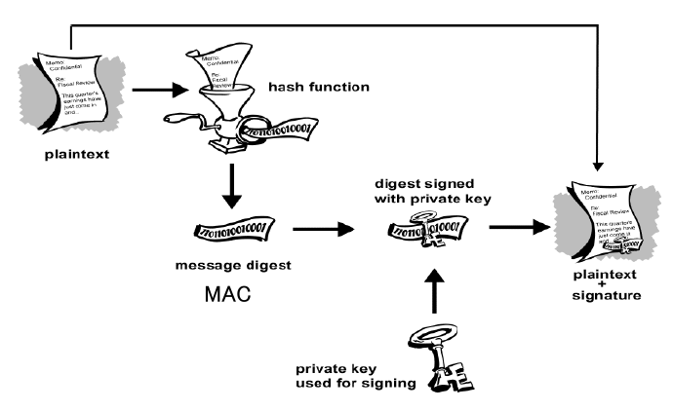
digital signature doesn’t give confidentiality but certificates the origin and the integrity.
Receiver check the hash message with received message+signature.

Authentication and Authorization
There are 3 forms of credentials:
- something to have: Smartcard, token
- something to know: password, PIN
- something you are: fingerprint, retina scan, biometric information
Use 2 factors authentication is more secure.
Password should be:
- at least 8 mixed characters and numbers
- change periodically
- have timeout of attempts.
Authorization is the process when someone is authenticated.

Token are based on series number, server start from series number and an algorithm calculates the code generated by token. If token has a button there is a list of code that server expect that token generates.

Token are:
- highly accurate
- secret data/code
- some are hard to forge
- some are expensive
- simple but costly
- portable
- some are transferable
- all are revocable
- management systems may be expensive and complex

Biometric sensors are less accurate because of they are analogical measures, less accurate.

Typing characteristic it associates how you write something

