Transport layer

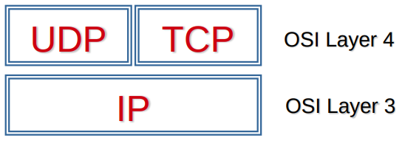
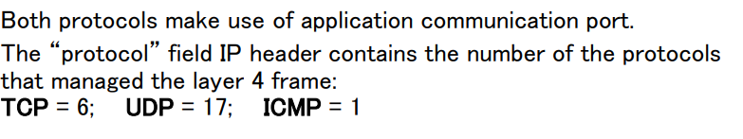
the protocol has 8 bit in the package.
- UDP User Datagram Protocol
- TCP Transmission Control Protocol
UDP is not reliable protocol, useful if we can allow packages missed. The protocol leaves the tasks to the applications if data is arrival order is correct, if data actually arrived a the destination, if data are not duplicated
TCP
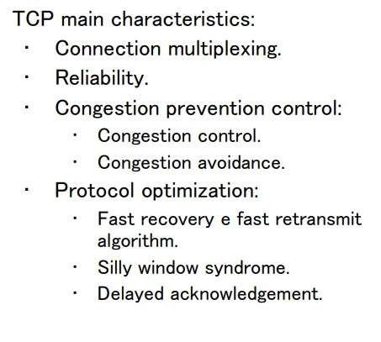

sequence number needs to build the message in the right sequence
acknodwloedgment number it represents the next package expected.
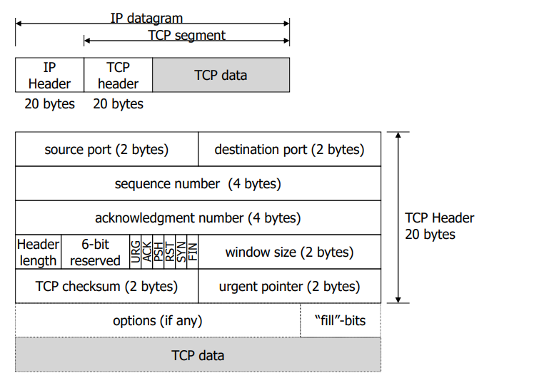
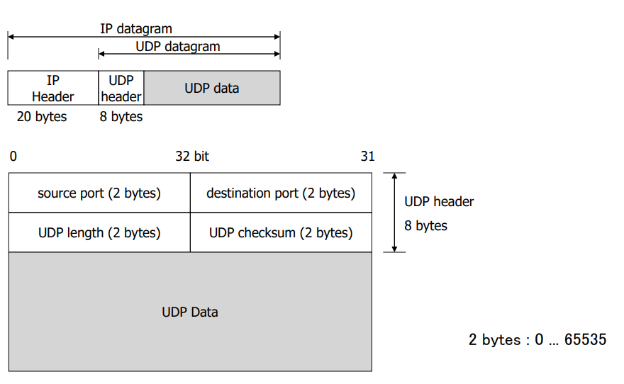
-
Tcp if data are not receive properly, they will be resend.
It use ACK to confirm right data.

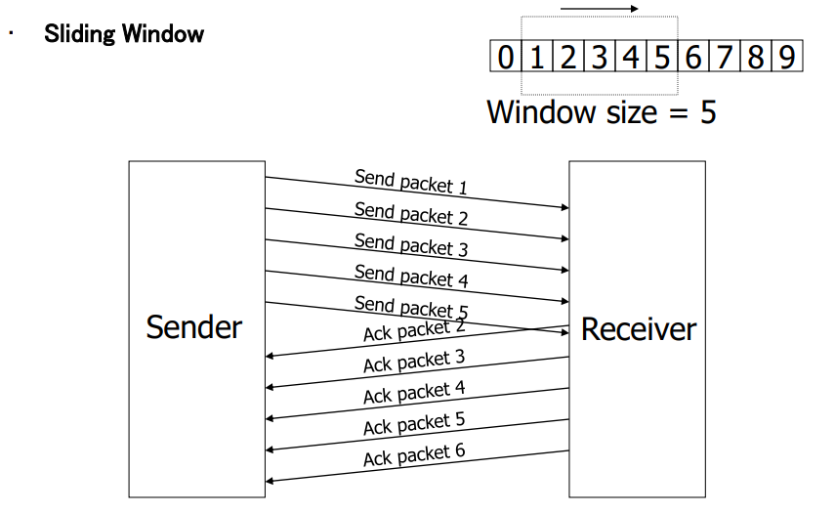
Open connection

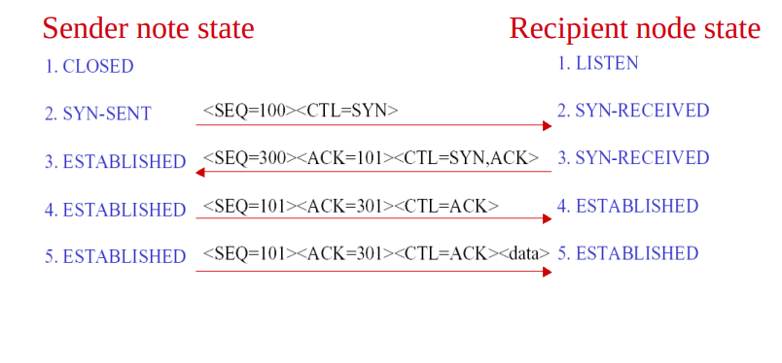
Through SYN request we create a session and when we open a connection, the connection is called socket.
A socket is formed by: ipHost:port ipLocal:port
Close connection
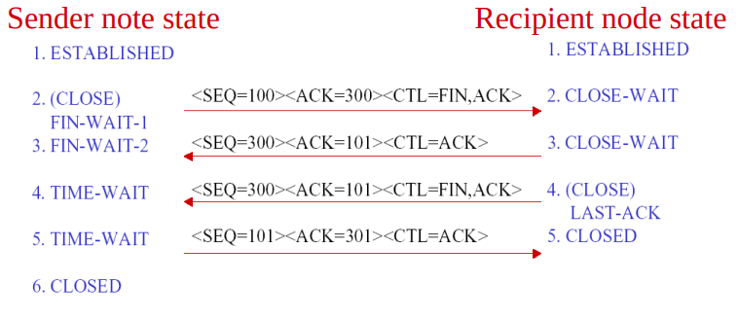

The first 1024 ports are reserved for standard server services, but there are also server port over 1024.

Networking address translation (NAT)
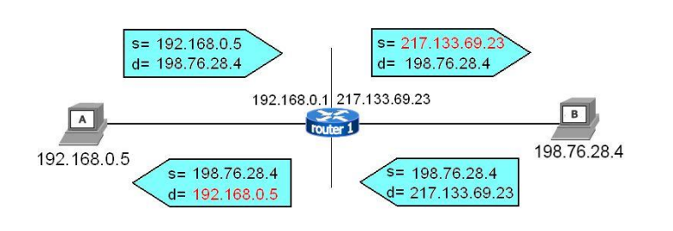
it is a technique used to send data through internet, it uses a public ip to communicate outside of the network.
If I communicate with outside the other side doesn’t see my private ip, but it read that request come from my router, the response will arrive to my router and it will route it to my device.
Port forwarding allow the exposition of a service to the internet, it says: if someone request something on public ip on a determinate port, route the request to the machine that provide that service.
A good practice is isolate servers from LAN (DMZ)
There are different types of NAT. if There are communication problems it is used NAT trasveral, STUN, ICE, TURN.

