Cloud database
Cloud computing features:
- Self-service on demand : web interfaces, API
- Broad access network : you can control resources remotely
- Measured service : to measure bill there are systems that measure usage of resources according with contracts
- Rapid elasticity
- Resource Sharing

There are 4 type of cloud:
- Private Cloud
- Community Cloud
- Public Cloud
- Hybrid Cloud

Cloud is elastic, hence it can spent money efficiently.
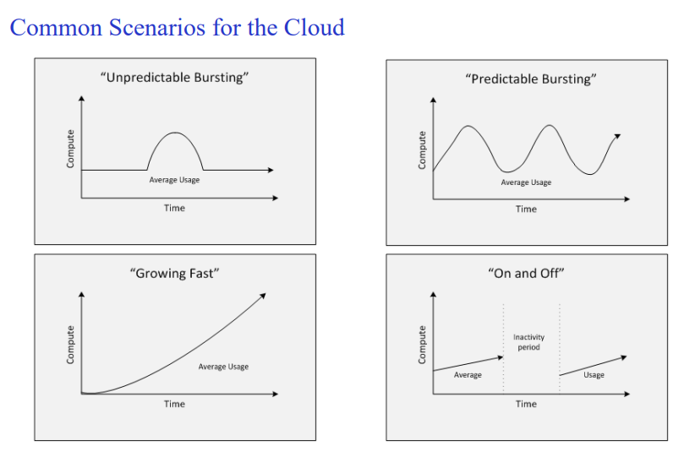
Cloud database
there are 3 modalities:
- Virtual machine where you install dbms and others
- DaaS : database as a service
- Use Database managed by the provider, Hosting e.g.

