Database security

there are 3 aspects of database security :
- Availability: ensure the availability of data
- Confidentially: protect data for unauthorized accesses
- Integrity: protect data from improper modifications
Specific aspects of DBMS
- Each user can be granted the permission to read a part of the data and write a part of the data
- The authorization may apply to an entire table or to a part of it (rows or columns)
The DBA responsibility include
- classifying users and data according to the company policy
- creating users and granting/revoking privileges to users
- monitoring the access and usage of the system / data (audit)
Data security classifies into various stages i.e.
- Authentication,
- Authorization,
- Access control
- Auditing

With authorization commands we gives permissions to users to access
the database, modify the data or display the information
Authorizations can be defined at different levels
- Typically
- Type of action user
- Type of resource (or specific resource)
the operation can do using command grant,
grant operation on tableName to user
there also connection authorization clause CONNECT dbms manager can allow the connection to specific tables.
RESOURCE a user with this authorization can modify the scheme
DBA a user with this can administrate the dbms include startup and shutdown of it.

Grant command
GRANT <privilege list> ON <relation or view name> TO <user list>
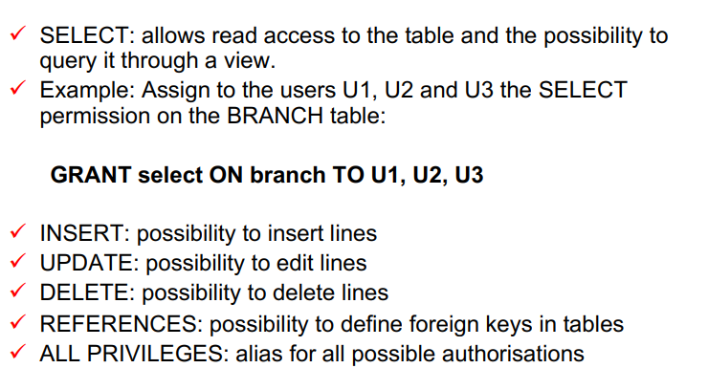

Every user can customized for different authorization.
It’s possibile to give authorization only on a table.
Grant option allows the user to give grant option to other user

REVOKE needs to remove privileges to user
REVOKE <privilege list> ON <relation or view name> FROM <user list>
cascade at the end remove permissions to all users that the selected user gave permissions.
It’s possible create role it is a group of permissions.

View combined with dbms security help to define the rules and the data that user need to access to the information.
Audit
some systems provide this feature. It needs to monitor activity on the dbms.

SQL Injection
it is an attack that allow to attacker the execution of sql code through query parameters.
An application or website is vulnerable to an injection attack if the
programmer hasn’t added code to check for special characters in the
input:
- ' represents the beginning or end of a string
- ; represents the end of a command
- /*...*/ represent comments
- -- represents a comment for the rest of a line
There are many ways to protect information from this type of attack
In essence, don't trust that all users will do what you expect them to do
- Restrict DBMS access privileges to the minimum
- Validate input
- Encrypt sensitive data
Data encryption

encryption must used to protect sensitive data.
Never store not encrypted passwords.
DBMS provide encryption tools.

Data redaction
data redaction reports containg sensitive data.
Data redaction applies also to reports containing sensitive data
Text based example
- Before: John plans to buy a new car next year.
- After: [Redacted] plans to buy a new car next year.
How it works
- page region
- pattern matching
- manual
Data masking
also knows as data obfuscation is a process enterprise use to hide data when exporting entire datasets.
Data are obfuscated by random characters or other fake data
it used for exporting data to an external system.

Data firewalls
it needs to filter dbms traffic, it blocks unauthorized activities like sql injection, use drop, alter …

