Object Oriented Model
It used to represent the reality using objects, like OOP.
To represent entities we use classes diagrams.
The diagram used for this model is different from ER.
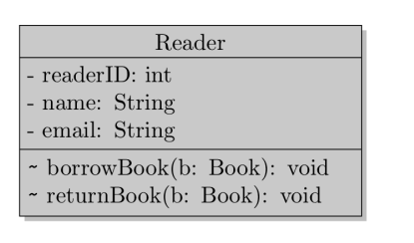

The behavior is optional, but the declaration of field is mandatory.
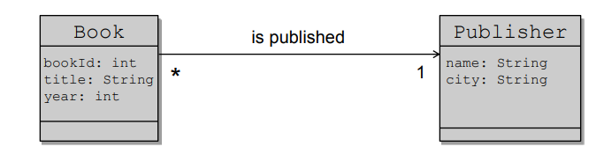

The association types are the same of ER (1:1;1:N;N:1;N:N)

To do aggregation we use the following notation
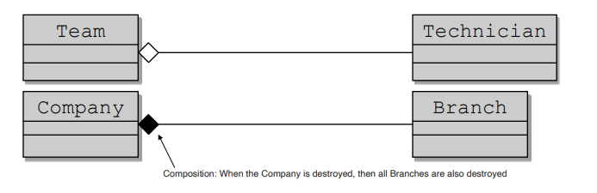
The first is independent from team, if we delete team, technician will exist anymore.
In the second if we delete a company branch will be deleted to.

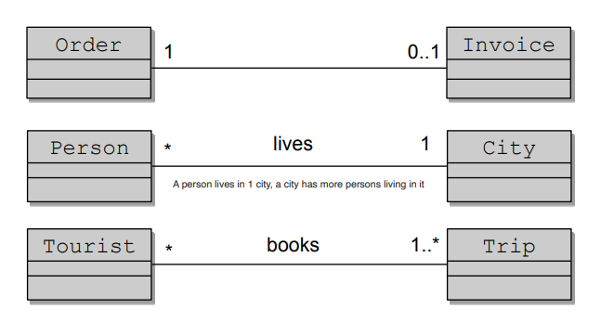
Generalization can be made using inheritance.
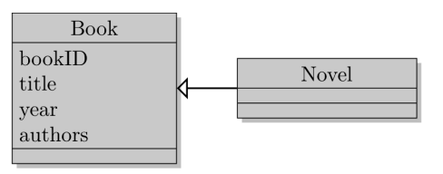

There also here the normalization process.
Object
An object is an entity in the real world, which is distinguishable one from another.
The notion of object, in the object oriented data model, corresponds to that of entity, in the ER data model.
Class
A class represent a group of object that:
- share the same variables
- respond to the same messages
- use the same methods
The notion of class, in the object oriented data model, corresponds to that of entity set, in the entity-relationship data model.

Objects can be identified in different ways:
- value based: the data value identifies an entity
- name base: a name provided by the user identifies an entity
- built-in: the identification of the entities is inherent in the programming language and/or in the data model
An object can contains references to other objects.
We could delegate the object identifier by system, the disadvantages are:
- object identifiers are usually system specific and will need to be translated if you migrate data to a different system.
- Could be redundant, if the entity being modelled already has a natural unique attribute

The peculiarities of an object-oriented model are not well implemented in conventional databases (relational ones).
The incompatibility between the object oriented model and the relational model is called impedance mismatch.

