NOSQL
NOSQL databases save data in different ways then relational, indeed they saves data without table division, in these type of database redundancy is a good thing.
These db was born near 2009/2010, they are often opensource, and schema free, you don’t have to define schema before inserting of data.
Some names: mongoDB, redis, cassandra, dynamo db.
Some times application can use more database technologies based on what have you to save.
Key-value data model
this type save data associating data values to a key.
Column-family data model
this type associate data to key that reference a column family that has a key with associated data.
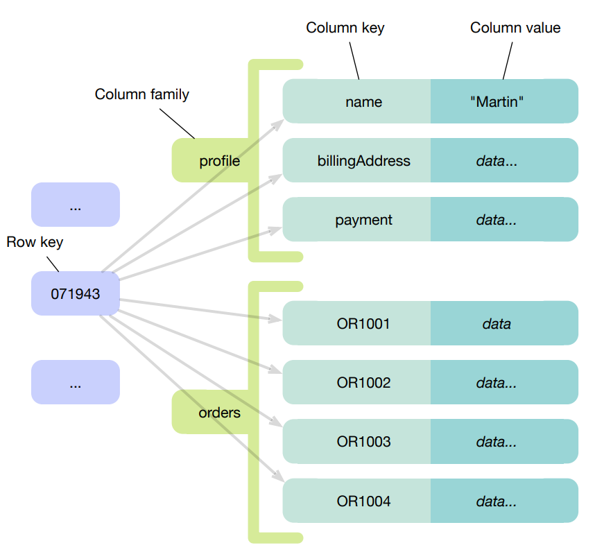

Document data model
It use JSON file with structured objects, you can query the JSON file.
It can also use XML file.
Graph data model
data are saved in nodes and they have relationships, that can be mono or bi directional.
The query’s language isn’t SQL.
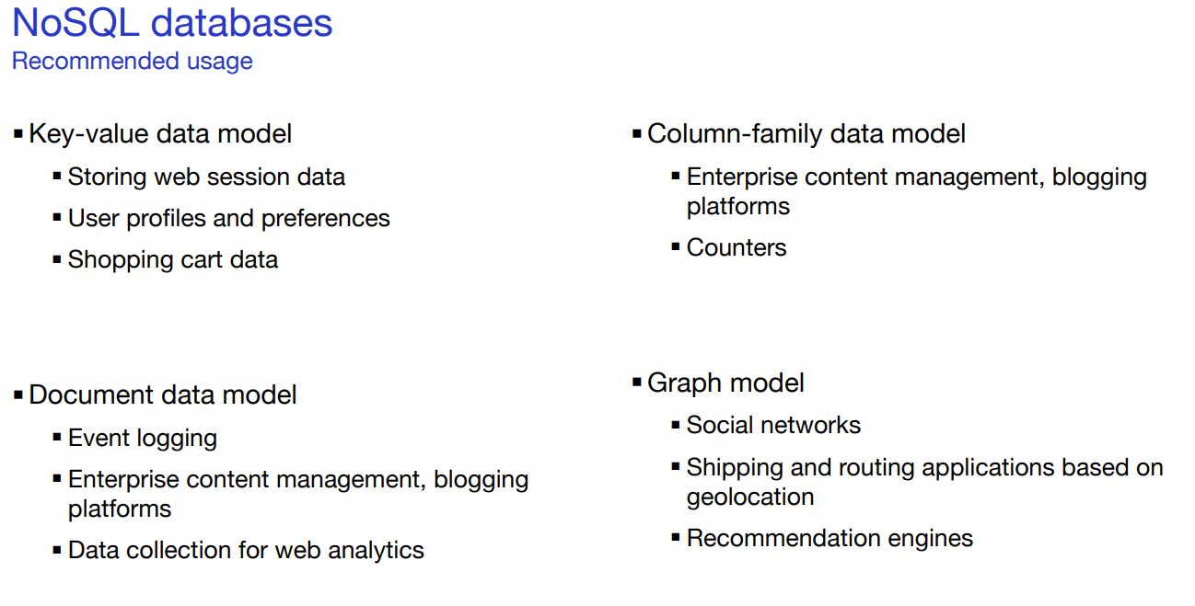
The biggest problem of this databases is that are designed for clustering, hence distributed databases.
Dimensions in which a database may need to scale:
Storage capacity
- Number of objects stored
  - Search engine: metadata of 2B pages of the world-wide-web
  - Social networks: user profiles of 1B users
  - Behavior tracking
  - Internet of Things
Read request throughput capacity
- Number of read requests per second
  - E-commerce
  - Online games: up to 100k reads per second
Write request throughput capacity
- Number of write requests per second
  - Online games: up to 100k writes per second
  - Internet of Things: up to 1M writes per second
Distribution principles
- Sharding: The storage space is subdivided into several zones. Each zone is assigned to a machine
- Replication: for each object a copy is created, each copy is stored on a different machine
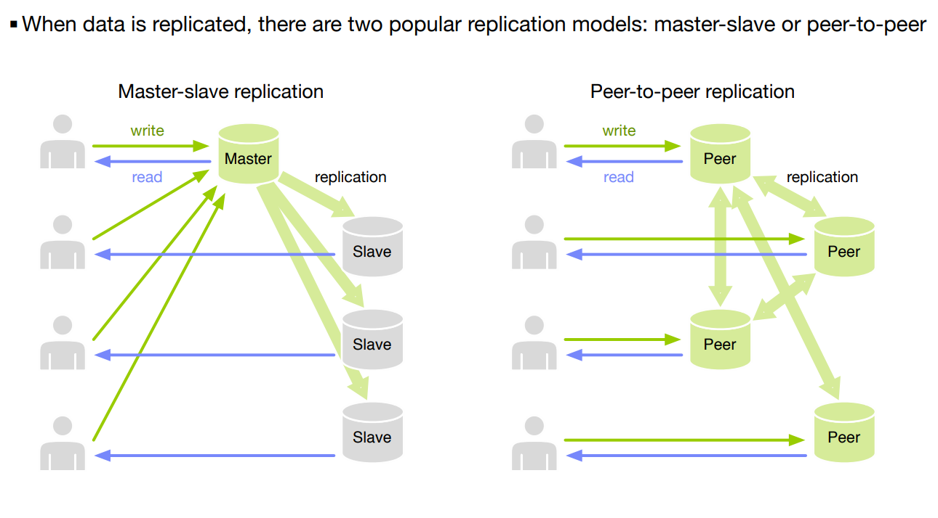
Shardering manage the storage using rules and load-balancing.
Shardering can be combined with replication:
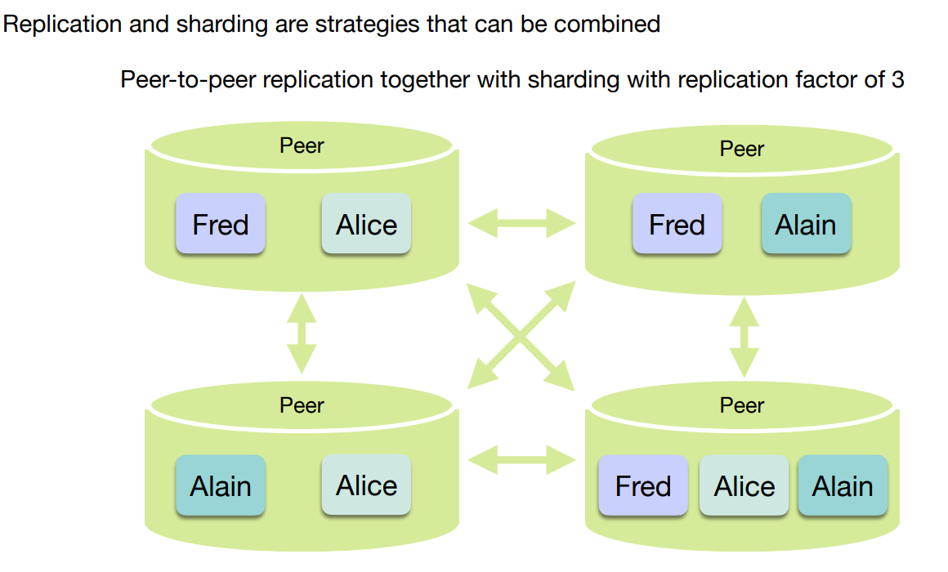

The Cap Theorem
In a distributed system, managing consistency (C), availability (A) and partition toleration (P) is
important.
The CAP theorem states that between the goals of Consistency (C), Availability (A) and tolerance
to network Partitions (P), only two can be achieved.
- Consistency: Strong consistency in the sense of ACID guarantees typically provided by
relational databases. To all observers it appears as if there was a single database and
updates appear to happen in the same sequence.
- Availability: The database remains available to applications for reading and writing at all
times.
- Partition tolerance: In a distributed system, “partitions” occur when the network connection
between nodes is interrupted, when a node crashes, but also when a node is taken down for
maintenance.

The replication of data creates new consistency problems.
As long as the replicas are connected, all is well.
When they become disconnected (network partition) problems can occur.
Several approaches are possible.
- Refuse the writing of data to guarantee
consistency of the replica: this is what relational
databases do
- Allow the writing of data and accept inconsistent
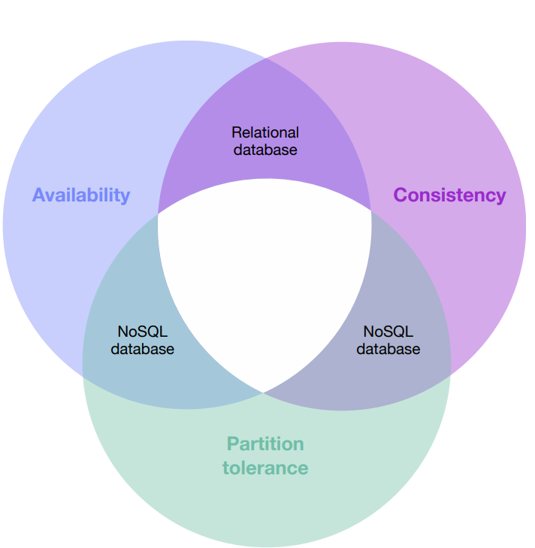
replicas: this is what NoSQL databases do

