Object Relation Mapping and JPA

ORM is a programming technique used to facilitate the integration of OOP with RDBMS systems.

There are 2 approaches:
- RDBMS→ OO Language
- OO Language→RDBMS (Code first)
advantages:
- overcoming the incompatibility between the object project and relational model
- Reduce the amount of code
- change DBMS is easy and not require rewrite code in the persistence layer

Implementations:
- JAVA : JPA
- .NET: Entity Framework
- PHP: CakePHP
JPA
JPA is a standard (JPA 2.0)
the query’s language is JPQL and we can get Metadata for object/relational mapping

Mapping is made by annotations.

@Table(name=”tableName”) we map the class with @Entity

@Column(name=”columnName”) is used to indicate a column, we use it on class fields

in the table generate by ORM the field’s names,table’s names .., are the names declared in the annotation not the field name!

To indicate the primary key we put @Id annotation.

Relationship
Many to One

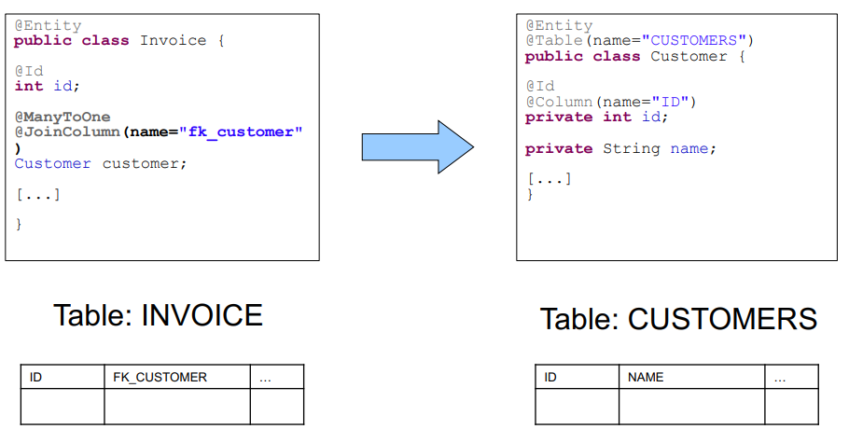
One to Many

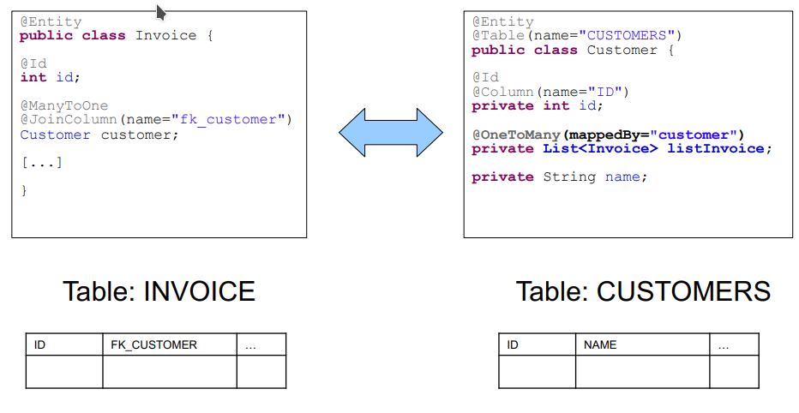

One to One

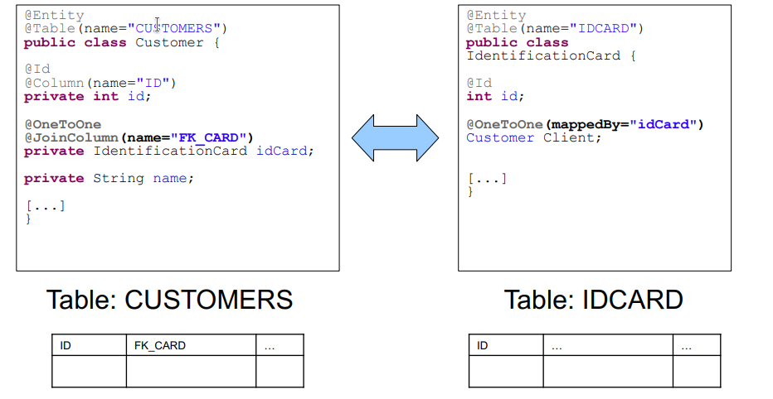
Many to Many

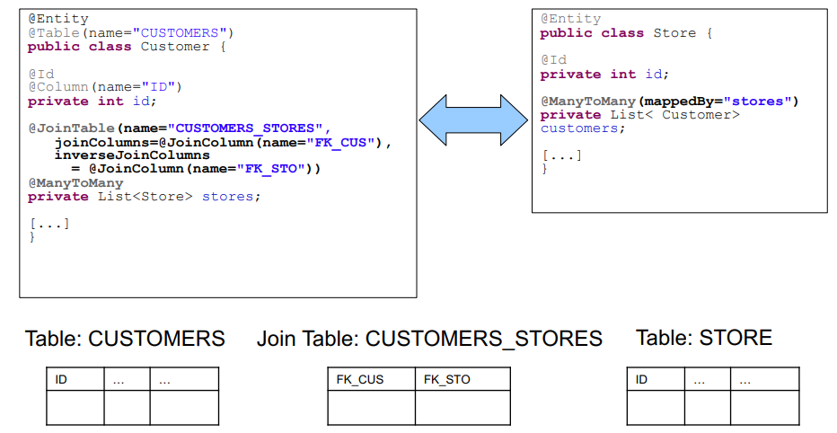

Inheritance
in JPA there are 3 solutions
- Single table + discriminator: collapse all classes into parent class and use single table
- Joined table: it mimics the class hierarchy for each a table created and by join create the complete entity
- Table per class: parent class is collapsed into children (no nulls but same data distributed in a lot tables)
annotation to put outside father class
@Inheritance(strategy=InheritanceType.SINGLE_TABLE)

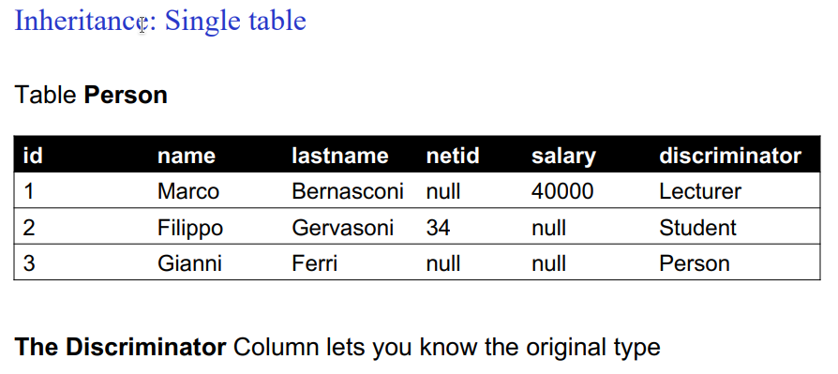
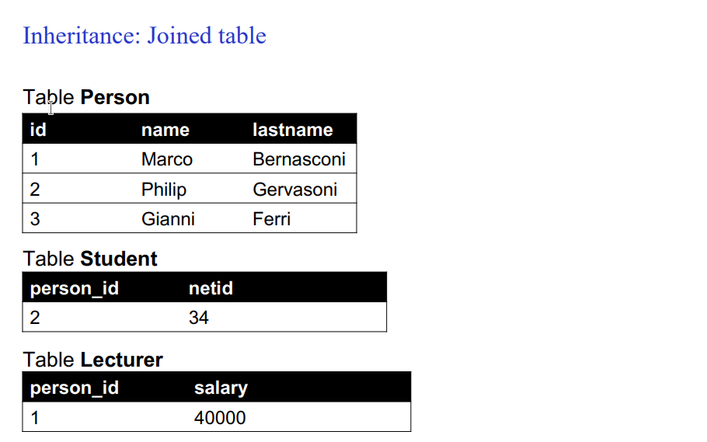

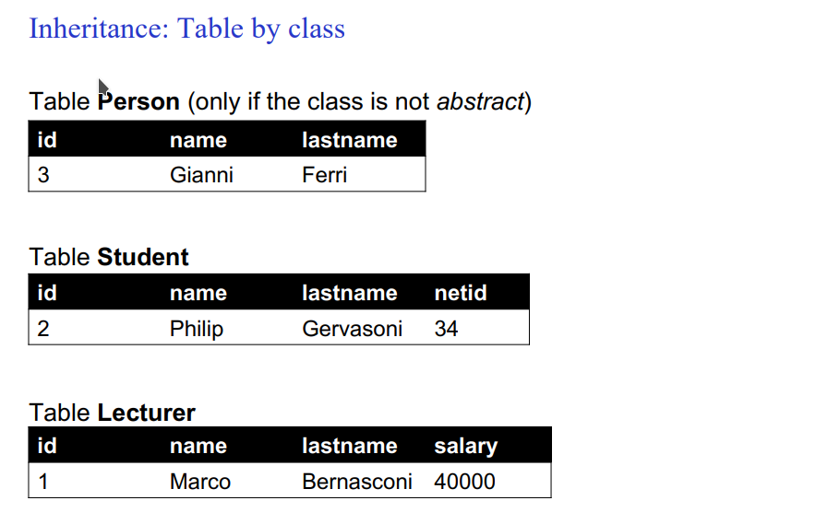
the table class hasn’t got good performance in queries.

Cascade property
@OneToMany(
cascade = {
CascadeType.PERSIST,
CascadeType.REMOVE,
CascadeType.MERGE,
CascadeType.REFRESH
}
)

we can execute operations in cascade when some data are removed, update in the binded table.
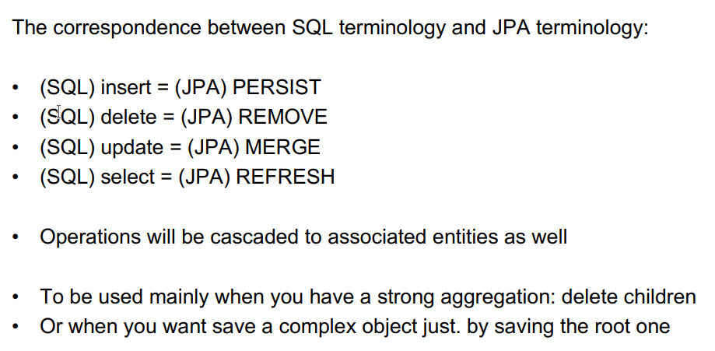

JPQL

SELECT c FROM Client c WHERE c.idCard.idNumber = '424242'

there also update and delete, and we can perform this operation using methods contains in javax.persistence.

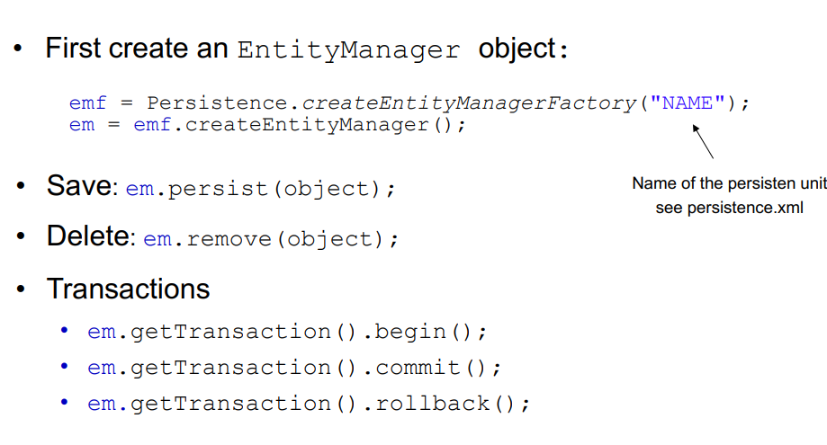

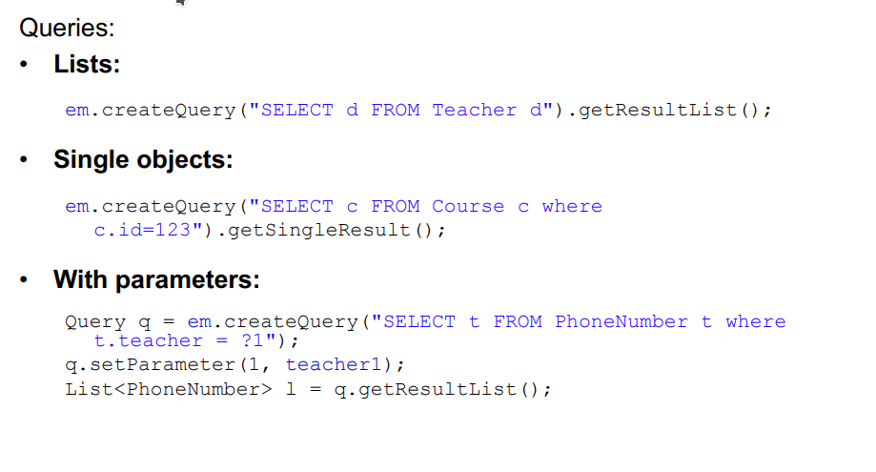
An alternative to 1:1 is @Embedded.

