Query Processing

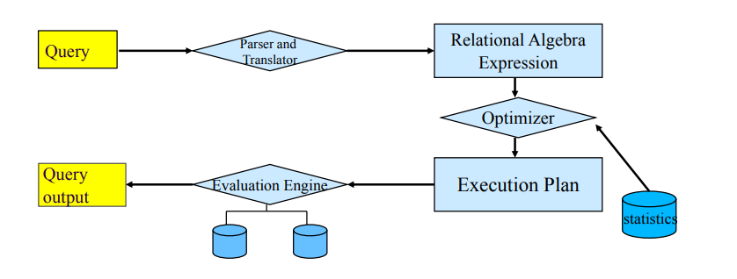
Query processing is composed by 3 phases:
- Parsing Translation
- Optimization
- Evaluation
Parsing translation consists to translate query to internal form. It is translated in relational algebra. The parser check if query syntax is correct, and it find data in the data dictionary. Before optimization DBMS rewrite query, it follows these phases:
- View resolution: merge the input query with the queries that define the
referenced views
- Unnesting: if the query includes sub-queries it tries to transform it into a form without them
- Use of Constraints: the constraints defined on the schema are used to simplify the query
Rewrite process change for every DBMS

On slide example of View resolution and Unnesting

Optimization
it allows to execute query in the fastest way.
There are 2 types of optimizations:
- cost based optimization, DBMS estimate cost of the operation analyzing rows number, blocks number in a table, if is table indexed ecc..
- rules base optimization, it follow specific rules defined on the dbms

the optimizer is able to determinate the access plan at minimum cost.
Evaluation trackers track of execution time and it show the result.
There are several ways to estimate query cost (disk access, cpu time …)

