Stored procedures and triggers
SQL allows to create procedure, a group of instructions to execute, to reach an objective.
PL/SQL: procedural language sql
it is a language that allows to write sql as procedural language.
Structure:
DECLARE (optional)
Define PL/SQL objects to be used within this block
BEGIN (mandatory)
Executable statements
EXCEPTION (optional)
What to do if the executable action causes an error
condition
END; (mandatory)

Stored procedures are procedures stored in the dbms.
Sql procedures are compiled and executed in the dbms.
Benefits:
- Improved maintenance
- Improved data security and integrity
- Improved performance
procedures allows to hide database from outside, client will call only procedure.
It is more secure to interact with db.
It improve performance because it needs only input and output, not full query.
Create procedure
CREATE [OR REPLACE] PROCEDURE procedure_name
(argument1 [mode1] datatype1,
argument2 [mode2] datatype2,
. . .
IS [AS]
PL/SQL Block;
example:
CREATE OR REPLACE PROCEDURE
fire_emp (v_id IN emp.empno%TYPE)
IS
BEGIN log_execution;
DELETE FROM emp
WHERE empno = v_id;
END fire_emp;

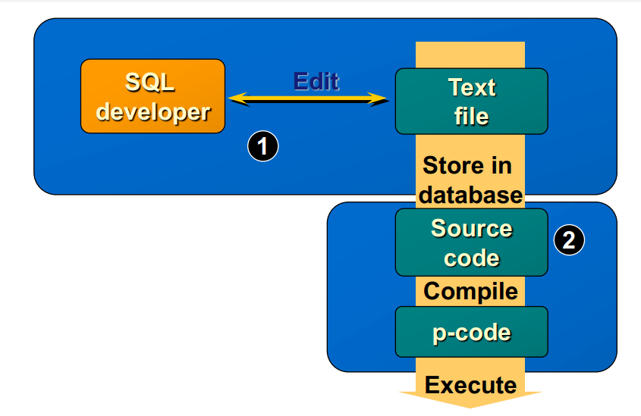
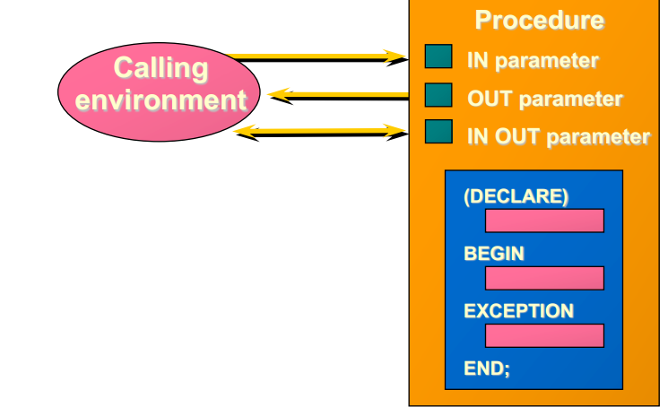

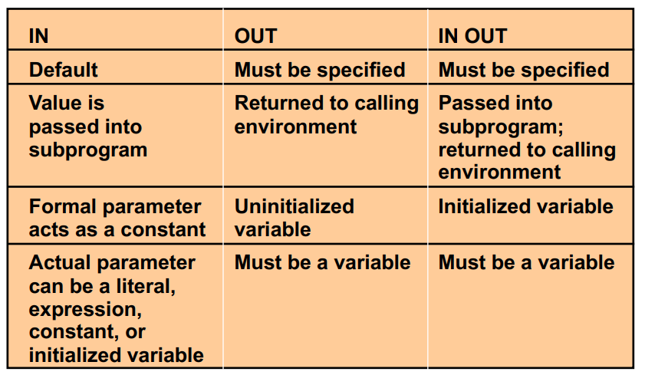
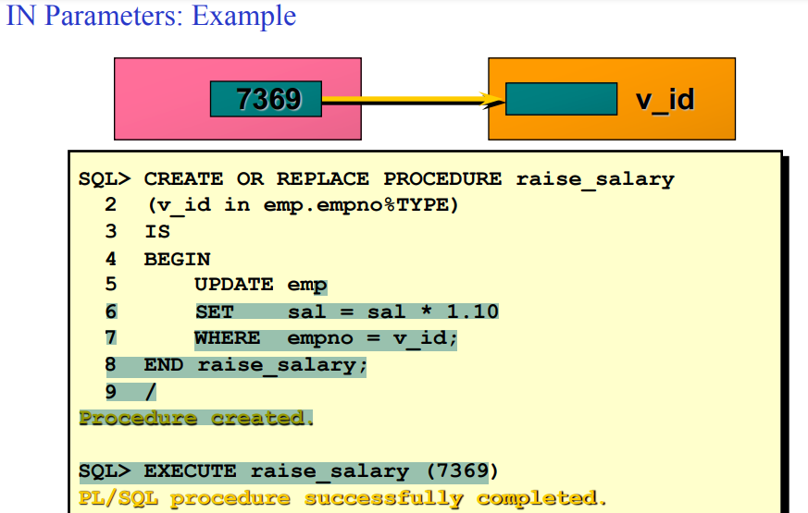

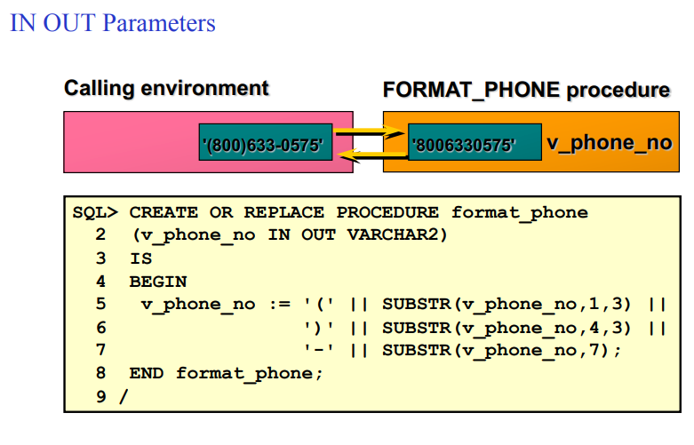
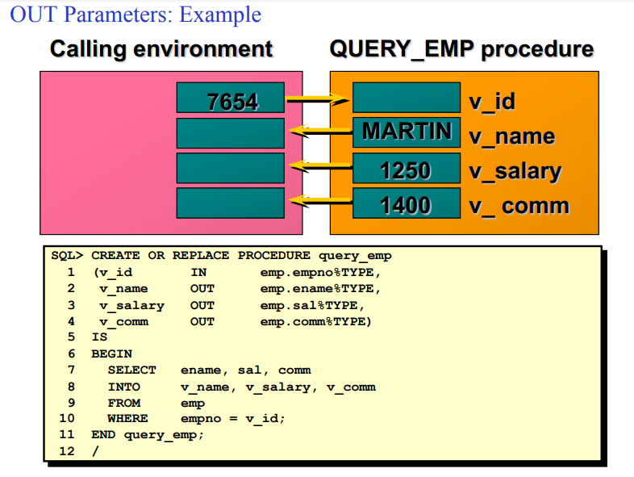

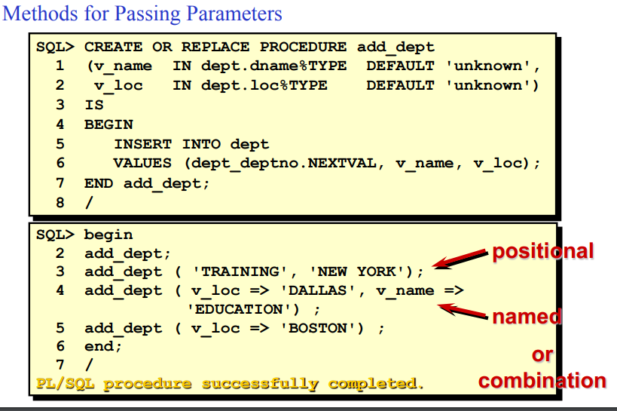

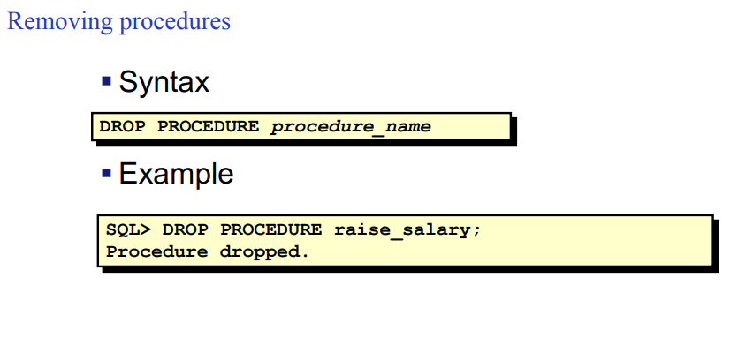
-
Use procedures in Java
System.out.println(”Emplyee ID:");
id = input.nextInt();
System.out.print(”New salary: ");
salary = input.nextDouble();
CallableStatement cs = conn.prepareCall("begin SET_SALARY(?,?); end;");
cs.setInt(1, id);
cs.setDouble(2, salary);
cs.execute();
Triggers
A trigger is a PL/SQL block that executes implicitly whenever a particular event takes place.
They can be fired before or after the event.
they can be fired once per event or once for each row affected by the event.
Triggering Event: What DML operation will
cause the trigger to execute?
- INSERT
- UPDATE
- DELETE
- Any combination of the above
Trigger body

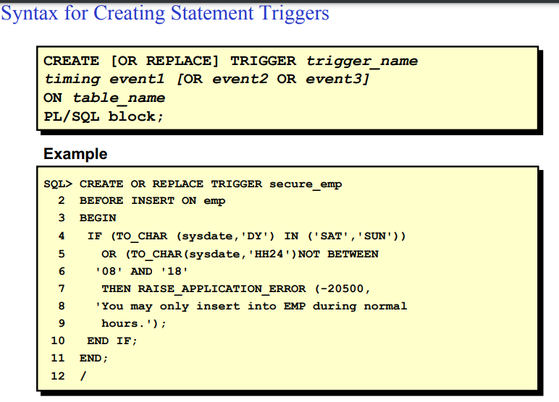
a row trigger needs to check rows when you edit a row for instance.

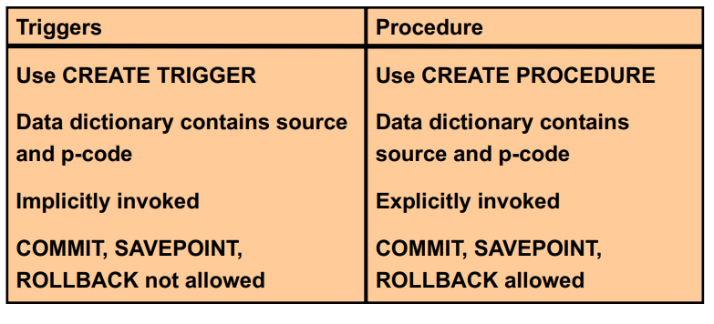

Triggers are used for many scopes:security, auditing, data integrity, event logging...

