Routing
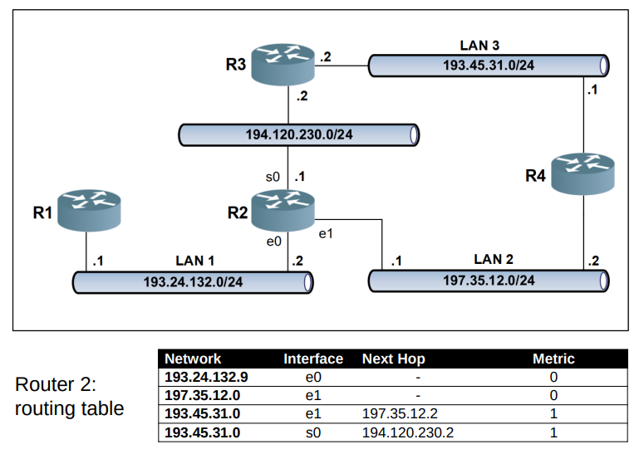
Routing can be grouped in a bigger network (geographical routing)
0.0.0.0/0 all networks.
Routing table must contains only optimized paths, I put paths that have the same metric.
For RIP protocol 16 is infinite, network is offline.
In the table we could put a backup paths.
Routing algorithm get data and optimize routing tables.
RIP learns routes sending messages in the network and adds new routers that missed in the routing table.
It starts from known networks.
Routing topology
every router interface must be on at least 1 network.
An interface can have multiple ips.
In static routing you must maintain all routers in the network, if you edit something you must change every router that reflect that change.
Static routing must be used only for special cases.

Use dynamic routing!
It uses routing tables.
An Ethernet packet size is maximum 1500 byte.
Routing algorithm must be simple.
Routing tables are based on network status.
Non adaptive routing:
Router propagated incoming routing information to all neighbor.
Adaptive routing
it search the shortest path using Dijkstra algorithm , measuring the cost called metrics expressed in hops.
IGRP
Interior Gateaway routing protocol: it base on distance vector with additional metrics on network status. IGRP is used for bigger network. Maximum number of hops 255, RIP was 15.
it uses and equation based on bandwidth, load and delay to calculate metric.

OSPF
Open shortest path first
this algorithm works on areas. And the management in the areas is specific for the areas.x
This is the way how internet works.
It is open source.

The protocols based on the link state have a complete vision of the network topology and its status (unlike distance vector that is limited to hop count).

The protocol acquires information on the near link states and forwards it information to the other nodes using the algorithm link state broadcast

EIRGP
Enhanced Interior Gateway Routing Protocol: protocol based on
combination of distance vector and link state information.

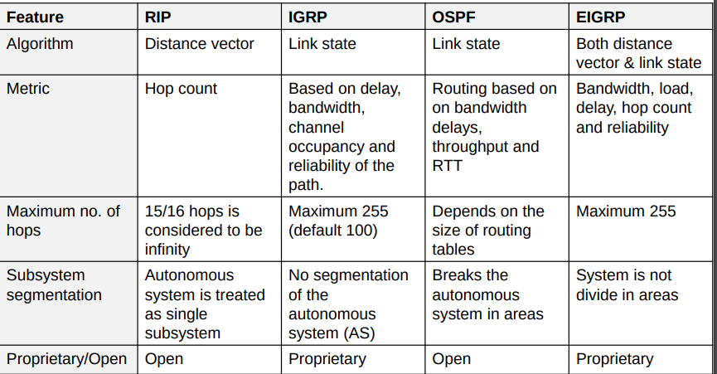
An autonomous system is a system that internally managed the networks independently and use internal router they can use different routing algorithm from border routers. The communication with outside is managed by border routers.
Exterior router
it is a router that communicate with outside for the opposite network, thus for internal router the router that communicate with external is border router for the other networks outside from the system the border router is called external router.

Intradomain routing
- Distance vector:RIP
- Link state:OSPF
- Hybrid: IRGP, EIRGP

Interdomain routing
- EGP
- BGP (eBGP, iBGP)
inside an autonomous system could be exist internal border routers.

