VOIP and phone
Radio communications was invented by Marconi in 1901.
the signal transmission technology is a no memory process.
The goal of a transmission is transport the information to destination with less number of resources with the best quality.

Transmission technology
Transport of signals via transmitting media.
Exchange technology
Supply of a transmission path between terminals by variable coupling of transmission mechanisms.
Terminal technology
Technical mechanisms with the telecommunications participant: Input, data and signal preparation for the purpose of the transmission and switching, plus genuine rendition of the entered data if possible.

Public network structure works with commutation of circuit system, ask before communication the construction of the path to follow.
If there isn’t information transport the channel remain reserved, in fact the service is paid for time of use, not for data transfer.
In the past if an actor don’t close the call the channel remained reserved and the user that didn’t close communication continued to paid, and the other user had the line occupied.

The signal can be express with Fourier analysis. Digital signal has infinite components, but it is a lot, so we cut the signal in frequency, and so we have an approximation.
The 90% energy in a vocal signal is contained in the range of 300-3400 Hz during a communication, the other frequencies are cut.
In the ADSL splitter, it divided the frequency of voice and the adsl traffic.
On frequency 3,4 Khz today we use for different types of services.
The phone band is always guarantee.
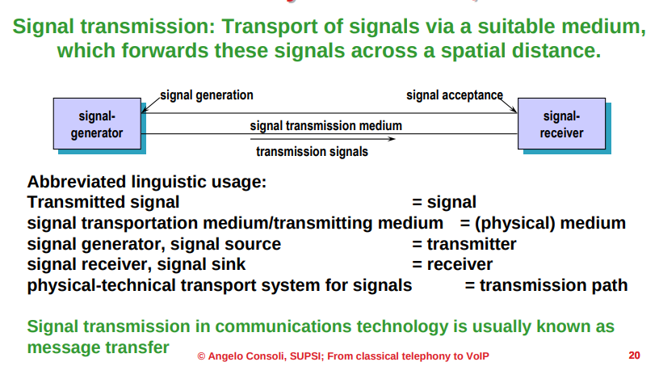
To sample 3400Hz we have to sample with at least double of the frequency, example of frequency of sampling 8k.
Number of layers to divide the signal for quantization is 256 quantization layer, in Europe.
The transmission require minimum 64kbits.
Bit rate: sampling rate * code word length= 8000/s*8bits=64kbits
ISDN (integrated services digital network)
it introduce smarter communication devices and the multimedia transmission through network.
It has 4 wire bus (3,4,5,6).
Basic rate interface has 2 audio channel and a signalization channel
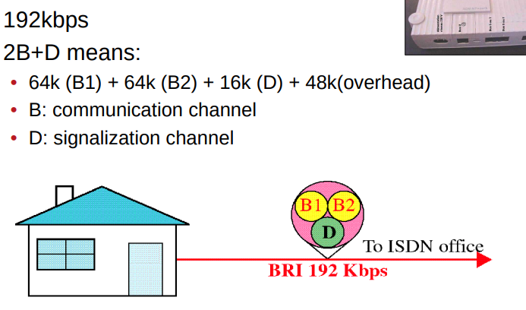
Digital brought the possibility to use phone and internet.

Companies has internal phone central that can manage multiple communications toward outside.
USA has 24 lines, EU has 30 users.
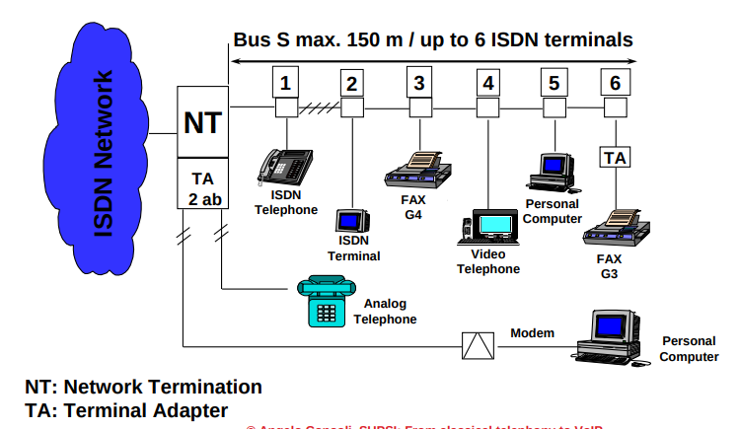

Codec
it allows the conversion to A/D, in fact codec means : coder-decoder, it codify and de-codify the signal.

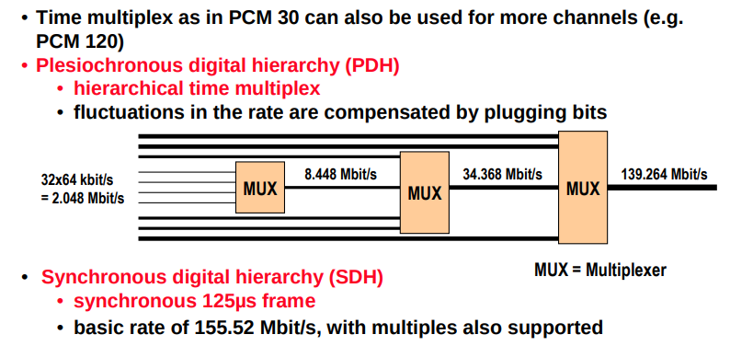
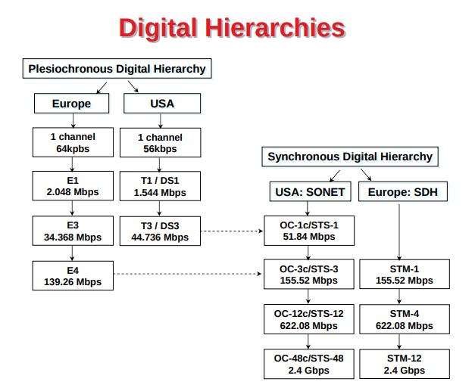
The mordern telephone network is composed by: users, STP(Service transfer point) SCP(Service control point), SSP (Service Switching point)
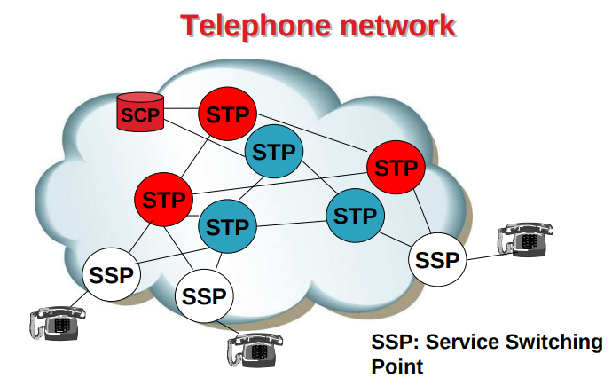
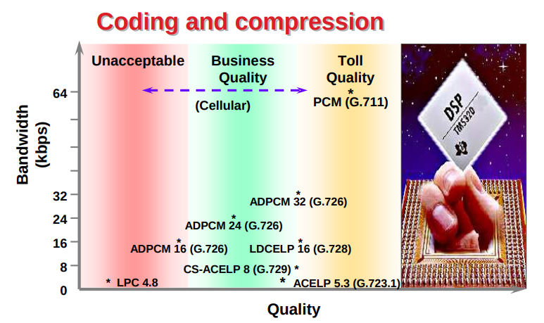
G.729 with 8 kbps we have the best quality,, needs 20 MIPS.
The compression is made using vocoders, that create the model of the voice.
Waveform coders works based on maths principles.
Hybrid coders works with both previous techniques and they have best quality.

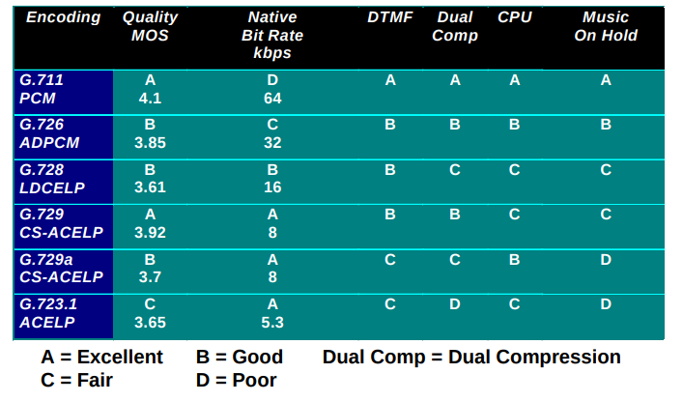
DTMF: dual tone multiple frequencies, it is the result of the phone pressure sound.

Loss of packets
the quality of a call is determinate by the number of packets received.
The latency is acceptable only if the delay is in the range 0-150ms and 400 for intercontinental communication.
Frames has delay.
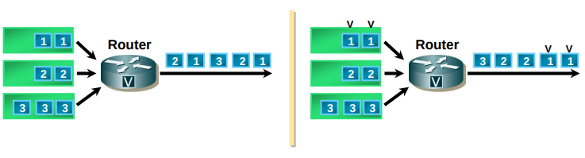
Are present when the input data flow is higher than the output data flow capacity.
Possible solution: queuing with priority.

De-jitter: allows to have a constant delay between packets.
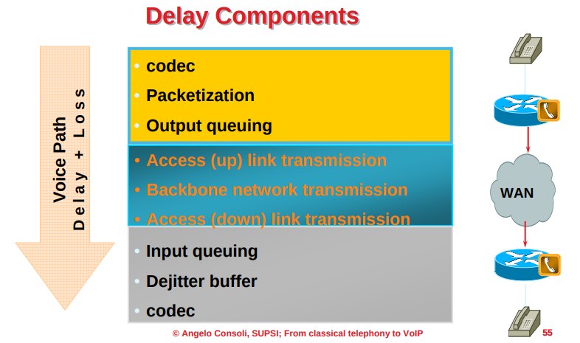
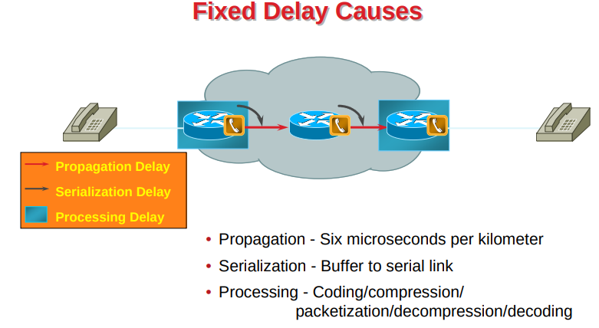
Propagation, serialization and processing always influence delay.
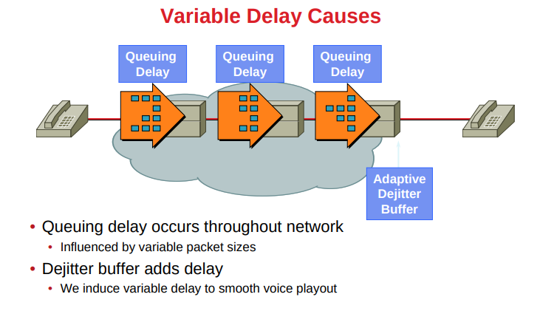

The sum of delay budget is given by the sum of: fixed delay + variable delay
VOIP technology

SIP
it is an application layer signaling control protocol. It is the core protocol for initiating managing and terminating sessions in the internet.

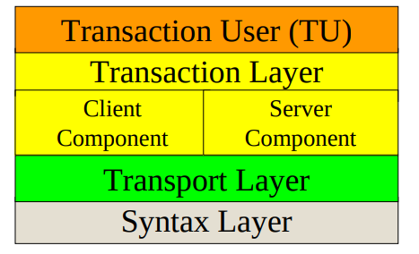

To call someone we have to know internet address.
Example something@domain2.domain1
we have 2 agents:
- User Agent Client: UAC
  - initiates SIP requests
  - Acts as the user’s calling agent
- User Agent Server: UAS
  - receive requests and return responses
  - Acts as the user-called agent
SIP port: 5060
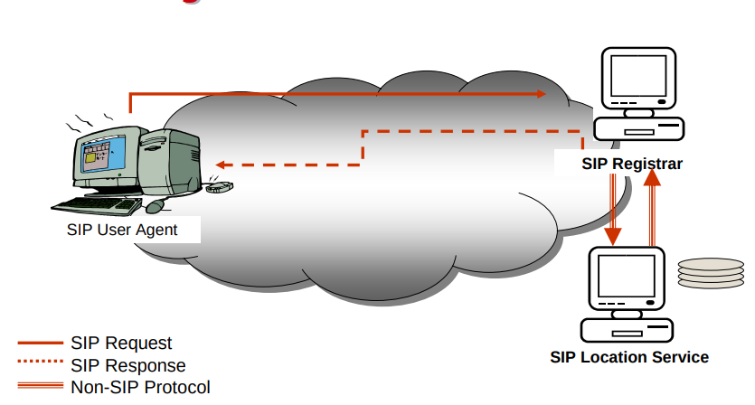

How VOIP works (IMPORTANT)
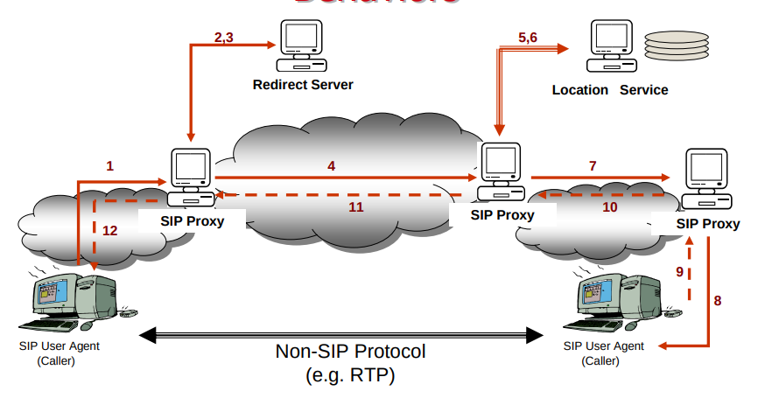
THE CALL ISN’T SIP, SIP needs only for initialization.
The call works on RTP, secure version SRTP.
Red part are SIP requests/respones.
if we use few portion of band we doesn’t have interference problems.
Softphone allows to simulate a voip phone through software, that use the same protocols.

SIP codes:
- 1## Informational Responses
  - 100 Trying
  - 180 Ringing
  - 181 Call is being forwarded
- 2## Success
  - 200 OK
- 3## Redirection
  - 300 Multiple Choices
  - 301 Moved Permanently
  - 302 Moved Temporarily
- 4## Client Error
  - 400 Bad Request
  - 401 Unauthorized
  - 482 Loop Detected
  - 486 Busy Here
- 5## Server Failure
  - 500 Server Internal Error
- 6## Global Failure
  - 600 Busy Everywhere
