Network partitioning
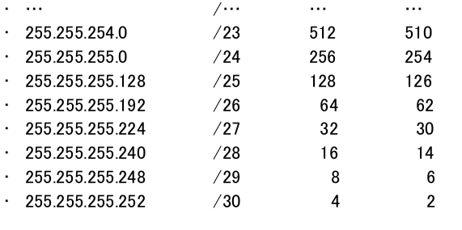
Network ip is always even and broadcast ip is odd, broadcast ip is the last ip and network is the first; gateway for convention is the first available ip.

Loopback ips are local-host ips, 127.0.0.0, 127.0.0.1,…
IP is a number, the representation using byte blocks is only a representation, but it can be write as an unique integer value.
Private IP addresses
there are some classes of ips used for private, thus they can’t be used to connect networks cross internet.
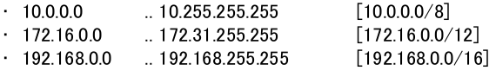
A device can act on LAN through 2 parameters: IP address, subnet mask.
To communicate outside the LAN it must have default gateway(Router) address in the IP configuration.
Routing
a router is a network infrastructure able to carry out routing decisions on frames.
Router operate on level 3(network) of OSI.
Routing decision are done for each single packet.
To route packet routers use routing tables.
A routing table contains:
- Distance vector
- (Sub)networks of contiguous ip addresses
- Bandwith
- delay
- Default route (if any)

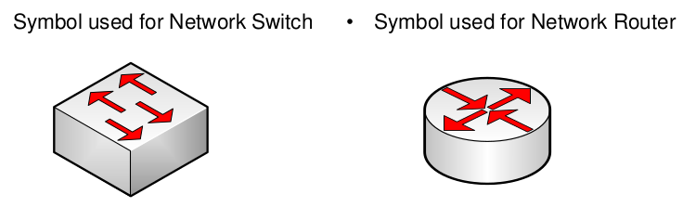
some network can’t be routed: e.g. netbeui
router communicate using protocols to exchange routing information and transport data on the network.
Routers use protocols to communicate with end-nodes to learn information from the connected networks, obtain the MAC address from net address and gain information about possible network issues.
There are 2 types of routing:
- Static routing: each route is manually added, programmed and maintained on each routers
- Dynamic routing:
it use routing table and update that continuously.
The optimization of routing path is based on 2 principles:
  - Distance vector: metric system to calculate the path,
number of hop, or number of networks between 2 end nodes
  - link state:it operates taking into account the current
state of the path: bandwidth, link state such as delay and
network congestion
Routers’ hardware have Von Nemann architecture.
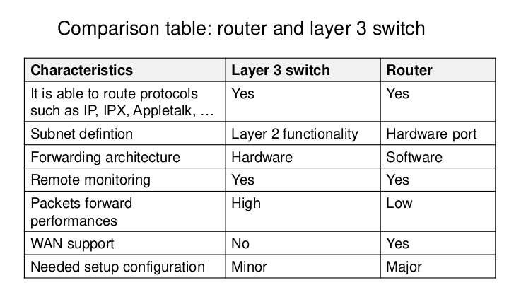
Some switchs can work at level 3 but they are not able to connect wan like routers.
Routers are “slow” machines. Its possible setup a PC as router.
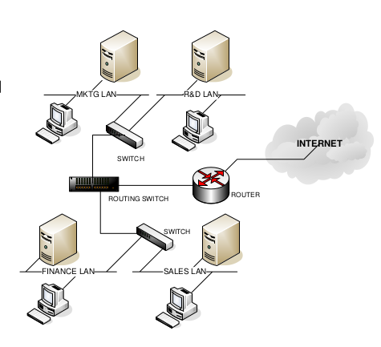

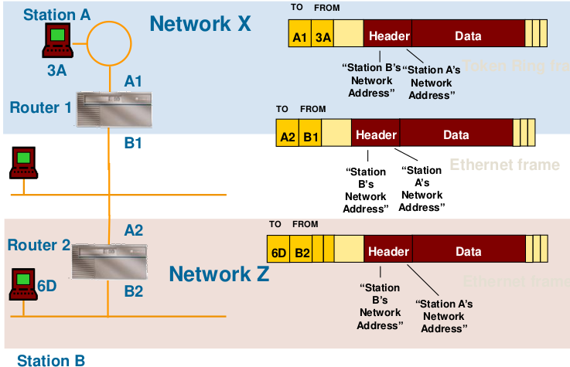
- Network protocols (not IP)
- Routing protocols, e.g. OSPF, RIP, …
- Network protocols, IP protocol:

- IPv4
- Address Resolution Protocol (ARP)
- Internet Control Message Protocol (ICMP)
- IPv6
Routing:
- Static
- Dynamic
there are different protocols of level 3 like (IP, appletalk, decnet, lat …)
some protocols can’t be routed.
There are different routing topology:
- Unicast: send message to a single node (lan)
- Broadcast: transmit to evrey nodes on the network
- Multicast:(IGMP protocol, it can manage nodes enrollment to receive a message) mainly used for streaming
- Anycast: similar to multicast but it select only one host, e.g 1st respondent. Peer to peer networks
- Geocast: similar to multicast but receiver are a group of ip located in the same geographical location.

