Liveness
There are 3 types of problem
- DeadLock
- Starvation
- LiveLock
These problems don’t permit to program to go forward.

Thread safety has 2 big categories:
- Safety: nothing bad ever happens
- Liveness: at least something good happens
Liveness problems can’t be predicted, and they are difficult to reproduce.

Deadlock
Deadlock occurs when a thread locks a lock forever.
The other threads try to lock but they can’t acquire because one thread keep it forever.

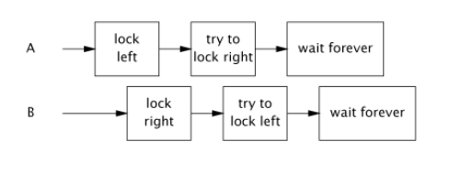
It’s not said that clean solution exists.
The most frequent type are lock-ordering deadlocks.
The solution is maintain lock in the same order..
if we work with one lock deadlock will not appear, performance problems in this case.
Lock-ordering are always fixable.
Lock in another lock is a bad practice.

Starvation
Starvation occurs when a thread execution is hindered(ostacolato).
It could be generated by a bad use of thread priorities.

Livelock
it is different from deadlock, livelock occurs when a thread is alive but is not able to progress, because it failed always the same operation.
It is similar to starvation.
Synchronization problem
Some of these problems are famous:
- Dining Philosophers Problem
- Sleeping Barber's Problem
- Producer-Consumer Problem
- Reader-Writer Problem

Dining Philosophers Problem
the solution to deadlock here is change the acquisition order.
The robust solution consists in:
A possible improvement is to release the lock before eating, but with both forks already taken.
This solution seems efficient, but only shifts the problem: the other philosophers end up fighting for the remaining forks, with the risk of running again into a liveness problem.
This doesn’t solve starvation.
Solution:
- if the philosopher is able to take both forks, then he'll eat.
- Otherwise, he have to signal that he's hungry and wait.
- He will be awakened by his neighbor when releasing the forks.

Producer and Consumer
we have some threads that produce something and the final product will be consumed by other threads.
The product will be put in a buffer.
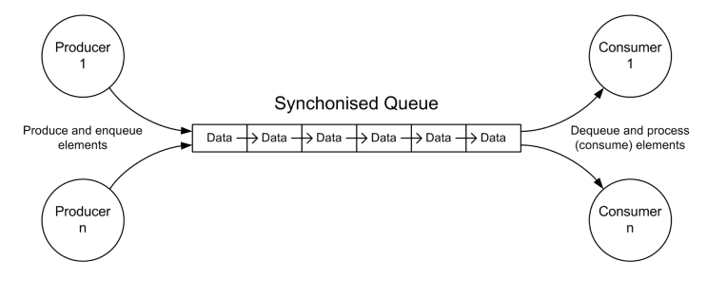
Solution in Java, BlockingQueue, non robust solutions could cause deadlock.

The Barber problem
it is a problem that needs lock and conditions.
It possible that someone enter while barber is cutting hairs and the new one enter in the waiting room, but when he is going in the waiting room barber finishes to cut and start sleep, new customer will be locked in the waiting room, because no new customer awake barber.

