Inheritance
to inherit a class we use the following synthax

class Lecturer : public Employee {

Lecturer extends Employee class.
If employee is private the inheritance will not correct, we can’t see outside employee data, inheritance concept falls. Private is default for classes in struct is public, use always public for inheritance in explicit way.

We can inherit only public and protected fields.
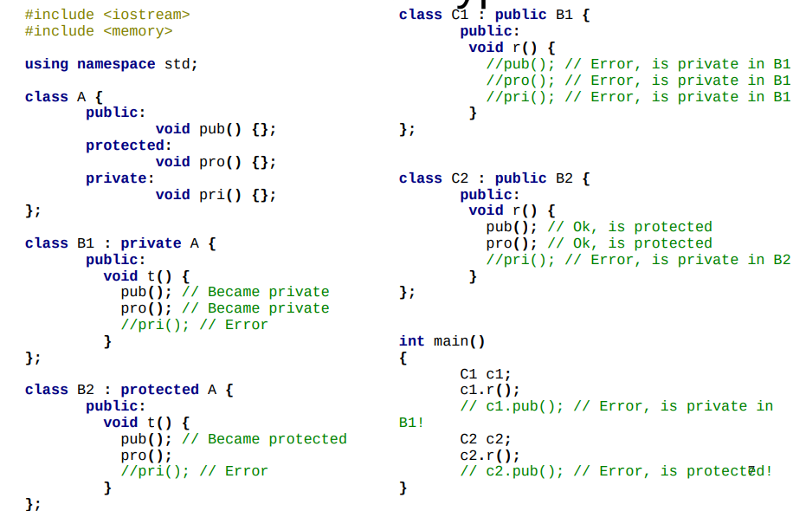
Classname() methods return object class name.
If we call the base class throw value passage on a derived object, it get only base class sector and the copied object will lose the specialized information.
If we pass the reference it will be different and so the polymorphism will works properly.

To have polymorphic method we must add virtual keyword to the method.

Virtual functions, you must declare a function virtual (anywhere in the hierarchy is fine), this tells the compiler to create a virtual function table, and to look up the address of the function in this table depending on what type you are when running.

Through BaseClass::Method we can access to the base class method implementation; it’s like super in Java or base in C#
in the derived class the overridden class must have override keyword at the of the declaration.
If we removed virtual, the overridden method will notify an error.
Binding

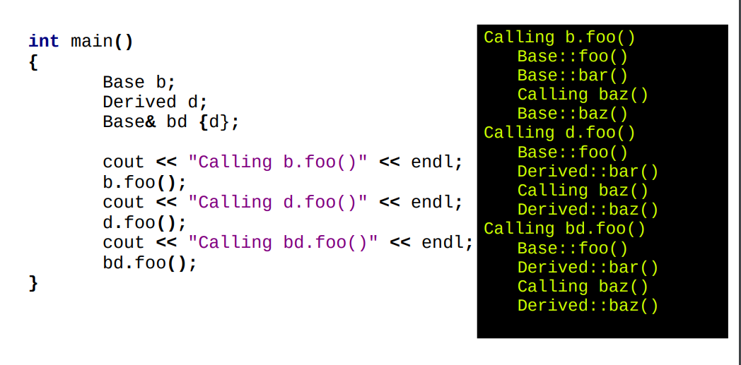
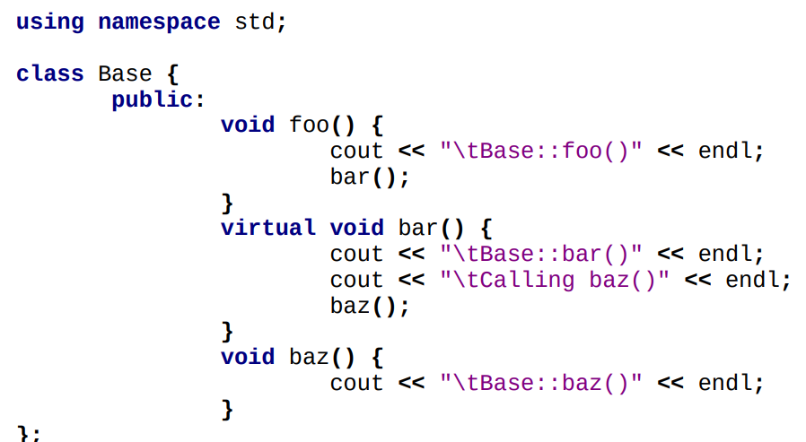
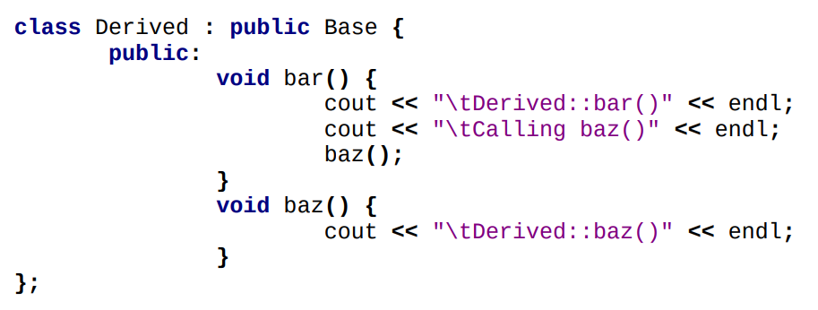

Abstract classes
we can declare an abstract class putting all methods virtual. This classes don’t require implementation, because that will be added by concrete classes.
In C++ there is no abstract keyword, and if we leave a method without implementation we will receive an error. The solution is: put the method equal 0, the method will be pure virtual.

virtual string name() const = 0;

this declaration of the object not allowed the creation of an object, because it is abstract.
We have created a similar Java interface in this way.

Difference between Overloading Overriding and Hiding

Overloading:
Two or more versions of the same method/function exist within the same scope, but with different signature (parameter types/count)

Overriding:
Re-implementing a virtual method in a derived class

Hiding:
Implementing a method with the same name but different parameters in the derived class: all methods with the same name in the base class are hidden

in C++ there is no possibility to auto recognize the type of method if you change parameters in the derived class, for example, you will hide the base class method; different compared to Java. We can reuse the method calling Base class and the method.
Otherwise, re-implement the method making override and calling base method. We can also import a method using , using keyword.
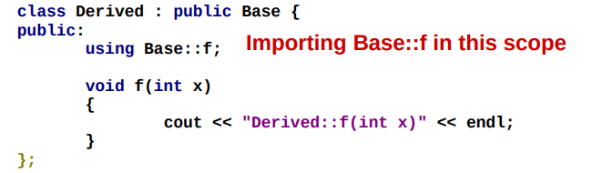
Some methods can’t be inherit like copy constructor, copy assignment operator and destructors.

We can put virtual to the destructor, then if we override the destructor it will use the overridden method.
We can set default constructor using default keyword: ClassNameConstructor()=default; after declaration.
If we use delete instead of default we make the method inaccessible.
Final keyword prevents inheritance for classes and override for methods.

Multiple inheritance

