Standard Library (watch lessons test for code test and more details)
it contains base functionality such as memory allocation, strings, streams, containers …

Strings
it allows easy manipulation of characters strings, easier than C.
In C++ in Strings are mutable.
Sstream library allows to concatenate different type of streams.
Create a stream stream object, use << operator like cout to allocate the string
to print on stdoutput use cout<<ssObject.str();
A string stream is similar StringBuilder in Java.

Vector
vector is the arraylist in java,
it use “generics” same notation like java.
Example:
vector<int>list;
we can init the list from declaration using {} example: vector<int> v{1,2,3,4}.
push_back() add an element to the list, pop_back() remove last element inserted.
To get elements we use array notation v[index]
initializer_list is a special type that allows to pass in the constructor a list of values, it use a vector. We can use it for every object that needs a list of multiple values of the same type.
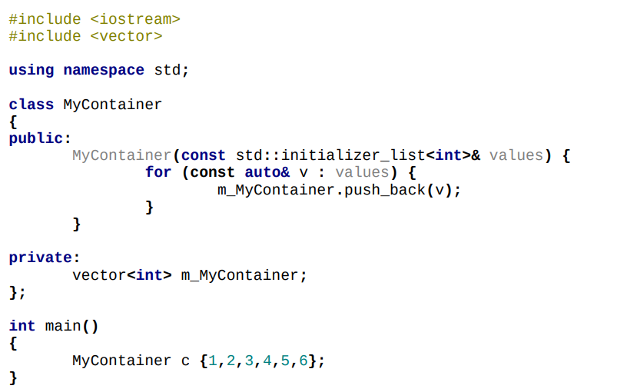
ATTENTION: the constructor that use initializer list is always chosen when you create an and init an object using {}.

if we want use other constructor use (). to use {} we must use initializer_list if we put normal vector it will not work.

Map
A map is like tree map in java, it is sorted list. It is a generic type. It sort elements for key. To add data we use map[keyValue]=value to access to key we use element.first instead for value element.second.
We can add element using initializer:
map<typeKey,typeValue> map{{key1,v1},{key2,v2}…};
count method check if there is the key passed as argument.
Erase delete element with passed key.

Note on the operator: we can edit [] operator for a specific type.
At function return element at passed key, if doesn’t exist it return null, e can override it.

Smart pointers
they help to manage ownership and preventing memory leaks.
2 types of pointers:
- unique_ptr: a smart pointer which cannot be shared and implants unique ownership
- shared_ptr a smart pointer which allows for shared ownership

they need memory library.
Is not possible create copy unique pointer, obvious
so is not possible pass data using normal types/normal pointers.

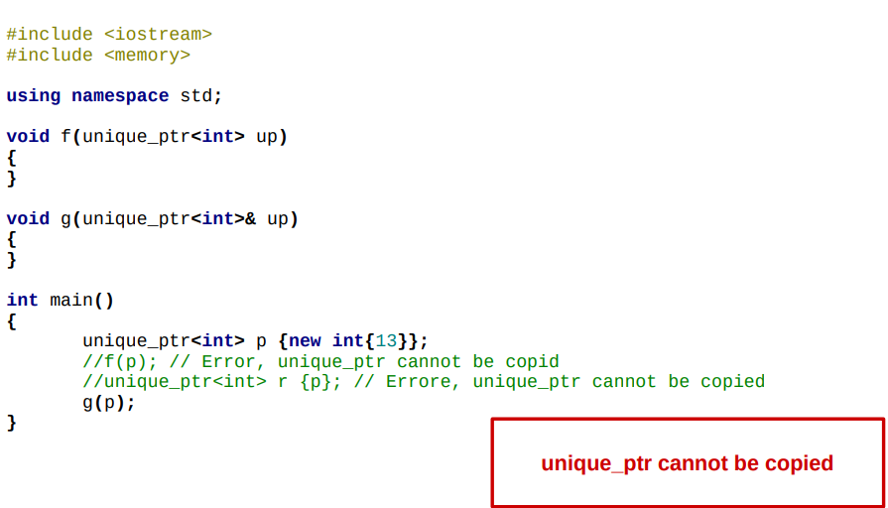
Using move function we can change the ownership of the data.
After moved data isn’t accessible anymore.

Shared_ptr can share access to a pointer, when the last copy is destroyed the associated memory is released.
Is a good way use smart pointers instead of raw pointers.
If we don't intend to take ownership use a "normal pointer"

