Concurrent Building Blocks
there are synchronized collections, because normal version of collections are not thread safe.
We can find these type of collections with:
List synchList = Collections.synchronizedList(new ArrayList());
they have poor performance, poor concurrency.
Client side locking
synchronized (myList) {
Interator<Integer> it=myList.iterator();
while(it.hasNext())
doSomething(it.next)
}

it needs to access to synchronized collection in the client.
Synchronized list can give a lot of problems an alternative could be Immutable collections
Immutable collections
they are unmodificable collections are similar to immutable objects (but are not completely immutable).
It provide read-only views of collection objects.
This collections don’t guarantee correct memory visibility. If modified the read-only views should be safely republished or outdated values have to be tolerated.
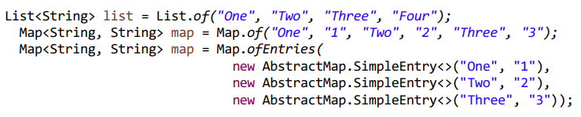
Immutable collections don’t accept null values
Immutable collection are not the solution of all problems.
Concurrent building blocks
Concurrent collections
these collections are designed to support concurrent access by multiple thread
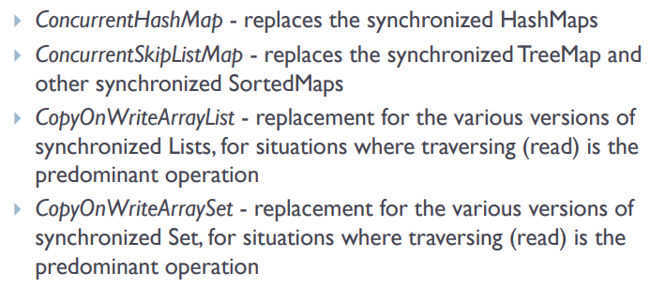
you can iterate and edit the list at the same time using these collections.

CopyOnWriteArrayList and CopyOnWriteArraySet are List and Set implementations that allow efficient concurrent access, when frequently iterated (read) and rarely modified.
Concurrent collections can’t be locked.

Non-blocking algorithms
free lock are immune to deadlocks.
These algo are used in the concurrent collections.

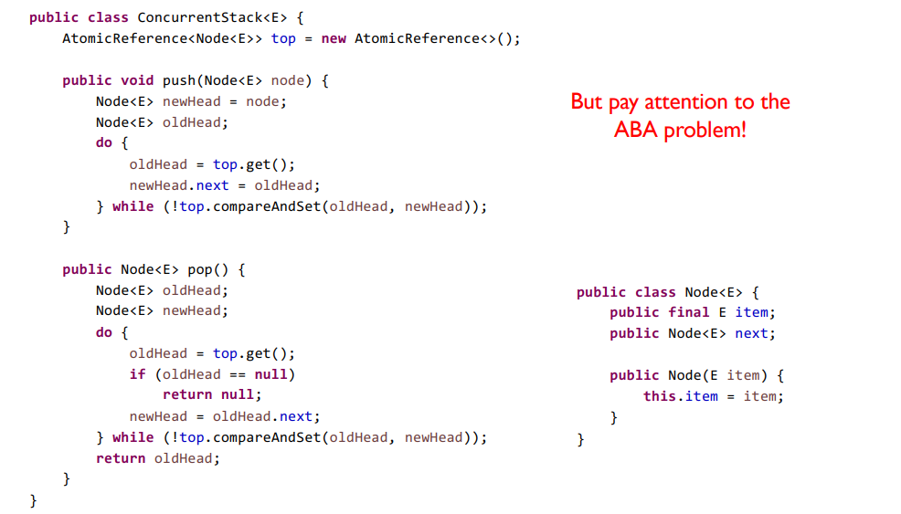
ABA problem
it is a problem of these algorithms caused by optimistic locks.

If the value of a variable V is A before V is modified, the algorithm might fall into confusion, if at the same time, the value is modified from A to B and then back to A. In this situation, the initial modification is successful, but the result might not be the desired one.

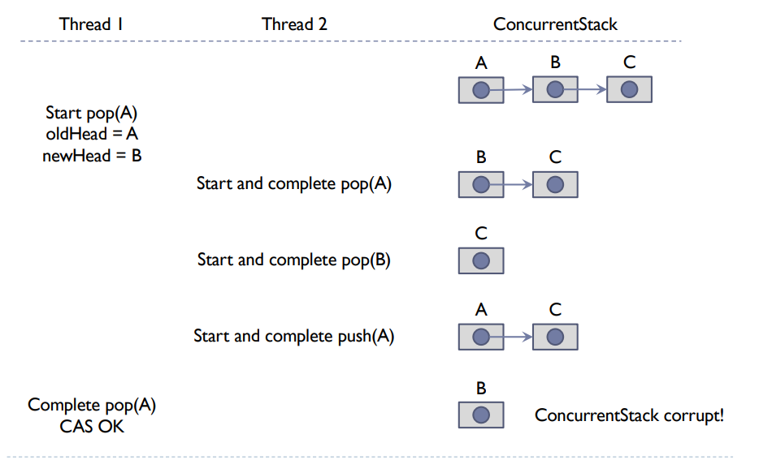
Thread 1 is stopped on the 3th instruction, thread 2 can perform 3 tasks but when the thread 1 restart it broke stack because it has the old data, it has B as new head, but now the head is the new A added by the thread 2.
The solution is pass the value of the node and create new node.
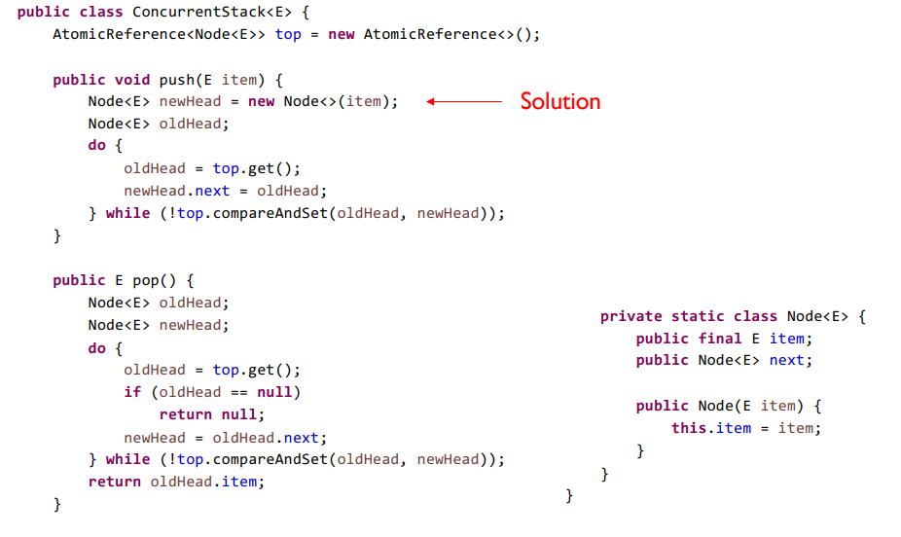
Thread safety delegation
in some situations the composition of thread-safe objects is automatically thread-safe.
Thread-safe delegation performed bu a class to the contained object might require additional protection.

To extend in thread-safe we haven’t robust code, a solution could be client-side locking(doesn’t work for concurrent collections because they don’t use intrinsic lock(synchronized)). An other solution could be composition and delegation, much robust, always.

It is possible to delegate the thread-safety to the objects contained in the class, if these objects are independent from one another (there are no invariants that simultaneously involves the objects).
e.g:(ConcurrentHashMap + Immutable Point + Returns Unmodifiable Map)

Instead, if a class implements compound actions, delegation to the contained objects is not sufficient to grant thread-safety .

Composition and delegation works like inheritance technique with compound action and synchronization techniques for methods.
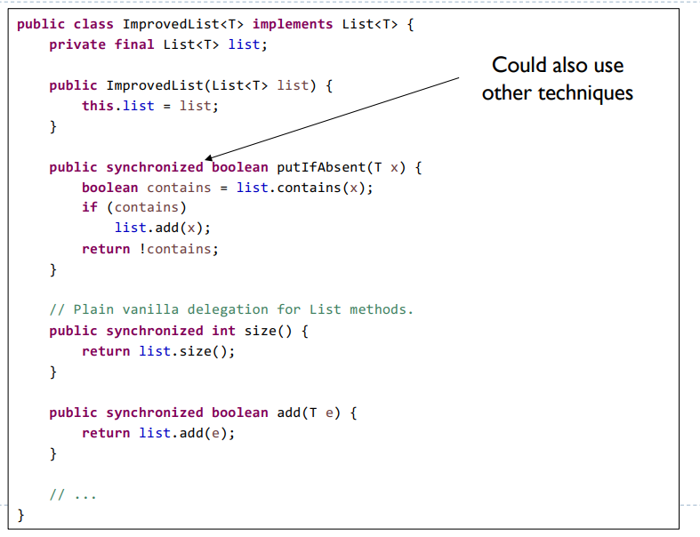
We use the same methods that we have to used in the original class, we

