Parallel processing
The fork/join framework and other thread-pools, significantly simplify the implementation of parallel processing in Java. However, it is still required to perform the decomposition of the program in lightweight tasks in an explicit way.

Internal iterations can be easily decomposed into independent tasks. These tasks can be executed in parallel.

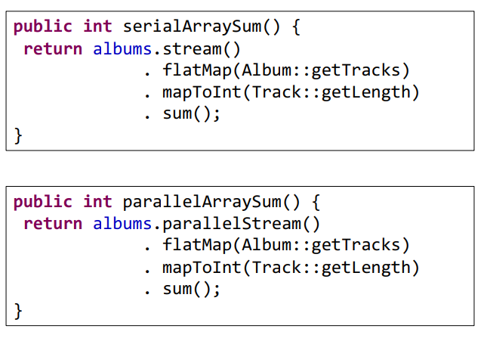
ParallelStream execute the stream in parallel.
We can use parallel-stream also for not-thread-safe collections, with the constraint of don’t modify data in the collection, use immutable objects.
Strongly recommended to avoid the acquisition locks in the lambda functions.

Concurrent executions and completable futures

Futures are limited because If there’s the need to perform additional operations on the result provided by a future, it is required to retrieve the result with get(), then submit additional tasks for the second part of the work.

Completable Futures
they implement Future interface as well as the CompletionStage interface.
Completable futures use listener, the are based on event-based callbacks.

It is possible to instantiate a completable future to represent a result, share it with some code that needs to wait for the result, then complete it with the complete method. The part of the program that needs to obtain the result will just use the get method to wait until the result is available.

1 CompletableFuture<String> future = new CompletableFuture<>();
2 // ...
3 try {
4 future.get();
5 } catch (InterruptedException e) {
6 e.printStackTrace();
7 } catch (ExecutionException e) {
8 e.printStackTrace();
9 }
10 // ...
11 future.complete("42");

The get method throws checked exceptions:
- ExecutionException - encapsulates an exception that occurred
during the execution
- InterruptedException - is thrown if the thread responsible for
the execution is interrupted
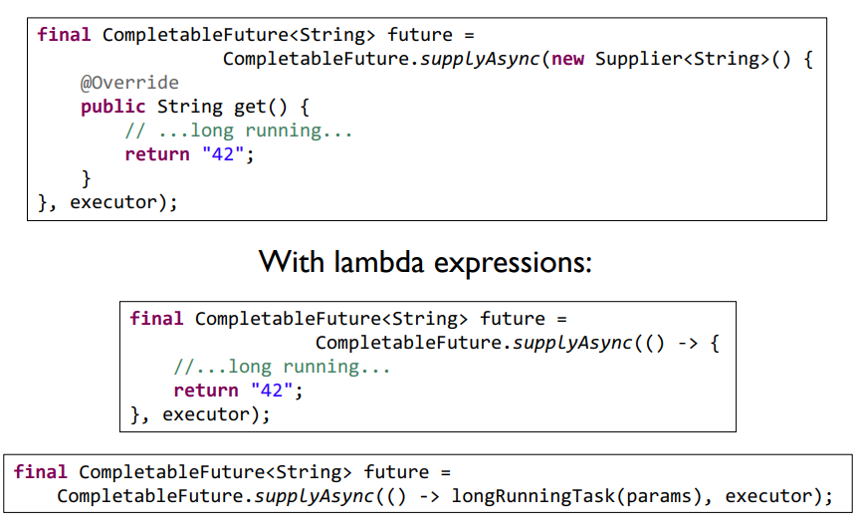
As previously introduced, completable futures are more flexible than futures because CompletableFuture is both a functor (object representing a function) and a monad (can be concatenated with other functions).

Therefore, is is possible to register callback functions, that execute automatically when the result is available.
The main approach used for additional processing is to provide an additional function. It is possible to do it with the thenApply method.
1 CompletableFuture<String> cf = CompletableFuture.supplyAsync(() -> "Hello");
2 CompletableFuture<String> future = cf.thenApply(s -> s + " World");
3 assertEquals("Hello World", future.get());

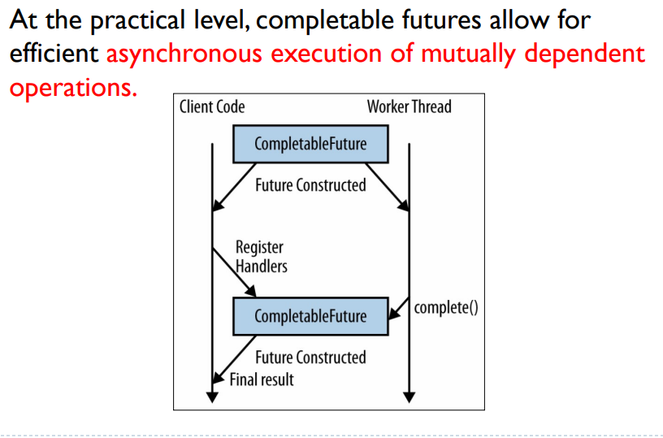
ThenAccept()
If a return value is not needed, there's a variant supporting the Consumer interface (that receives a parameter and returns void). The get() method of the resulting completable future won’t return a value, but still allow for waiting until the operation is complete.
Monadic Pattern
it allows to combine multiple completable future and perform something at the end of these.
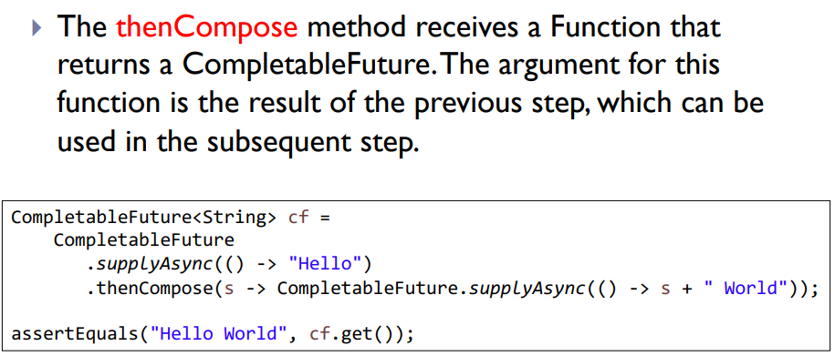
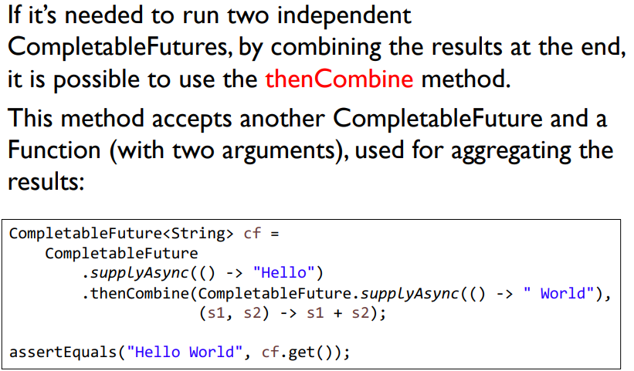
The thenAcceptBoth method is similar, but doesn’t return a result.

