Task Executor Framework
there’s a difference between a generic concurrent execution and a parallel execution.
Parallel execution improve execution performances.
Parallel execution is a subset of concurrent executions.

Parallel execution ideally has no thread pauses, instead of concurrent execution.
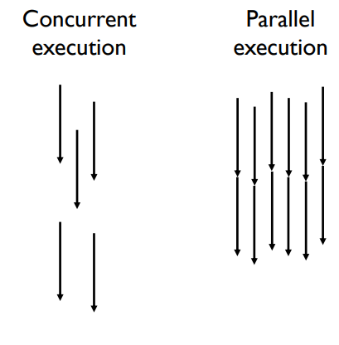
To do parallel execution we have to decompose program in independent parts, and assign these to every core.
An other approach could be replicate the operation performed by the application.

Context-switch use about 100 clock cycles, thread start needs more.

For parallel execution, threads aren’t optimal.
If I use a big number of threads on a reduce quantity of physical core we will have a lot of context-switch and OS have to schedule other threads of external application.
Not efficient, we could use n-1 thread for core to have parallel executions.

Thread problems of multi-thread approach:
- consuming of resources
- a lot of context-switch
- code must be thread-safe
- stability
- handling of failures can be difficult
- under-threading, over-threading, load-balancy and scalbility

Alternative to multi-threading: lightweight-tasks
Lightweight-tasks are work units (operations + data) that execute in a "deterministic way"
The running time of lightweight-tasks is limited and usually short
The occupation of resources (such as memory), is also normally subject to constraints.

Executions behind are done by thread, but we work with a thread-pool
that execute lightweight-tasks. With lightweight-tasks overheads are few.

To implement a lightweight we have to implement Runnable or Callable.

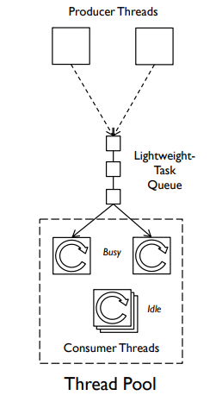
- Lightweight-tasks are small units of work
(data + algorithms).
- Threads activate lightweight-tasks in an opaque way: threads are not aware of the operations performed by the tasks.

A Callable is similar to a Runnable, but runnable has some defects that callable resolved.
Callable accept generics that call method return. Runnable has run void, not useful.
1 class Multiplication implements Callable<double[][]> {
2 final double[][] first;
3 final double[][] second;
4 public Multiplication(final double[][] first, final double[][] second) {
5 this.first = first;
6 this.second = second;
7 }
8 @Override
9 public double[][] call() {
10 final double[][] result = new double[first.length][first.length];
11 for (int i = 0; i < first.length; i++)
12 for (int j = 0; j < first.length; j++)
13 for (int k = 0; k < first.length; k++)
14 result[i][j] += first[i][k] * second[k][j];
15 return result;
16 }
17 }

Create a thread pool
1 public class MultiplicationTest {
2 // ...
3 public static void main(final String[] args) {
4 final ExecutorService executorService = Executors.newFixedThreadPool(10);
5 final List<Future<double[][]>> futures = new ArrayList<>();
6 for (int i = 0; i < NUM_TASKS; i++) {
7 final double[][] first = createMatrix();
8 final double[][] second = createMatrix();
9 futures.add(executorService.submit(new Multiplication(first, second)));
10 }
11 executorService.shutdown();
12 for (final Future<double[][]> future : futures) {
13 try {
14 final double[][] result = future.get();
15 // ...
16 } catch (InterruptedException | ExecutionException e) {
17 e.printStackTrace();
18 }
19 }
20 }
21 }

the number of thread-pool initialized int the constructor is the number of task.

Task boundaries
Task have to be independent of each other, no link between states and task operations.
The best way is task work in stack-confinement, avoid shared and mutable states of the application.

Important: if it is strictly required to access a shared and mutable state of the program from the lightweight-tasks, synchronization tools have to be used!

The executor framework guarantees safe publication only when sending lightweight-tasks and when retrieving results, NOT for all operations internally performed by the tasks

Executor framework
The executor framework is a tool provided by Java for the asynchronous execution of lightweight-tasks.

Executor
it is an interface that implements execute() method.

Pre-configured thread-pools

they are contain in ExecutorService class that provide factory methods.

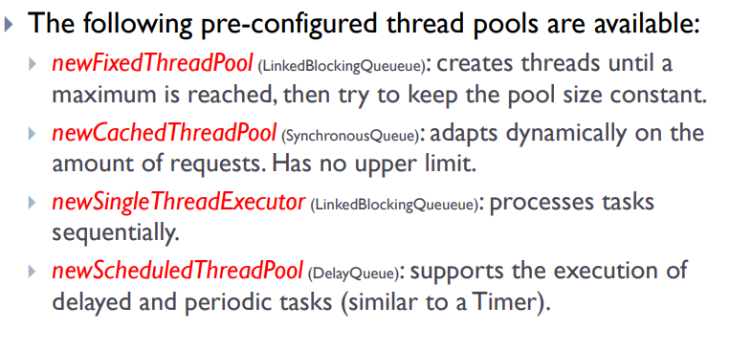
Thread-pools has its own execution policy:
how many tasks can be processed concurrently, in which order the tasks are processed how many tasks can wait in the queue…

Future<T>
it is returned from submit method, it represent the result in the future. It allows to “anchor” the result for the future retrieving.
Future is an interface, the concrete class is FutureTask, with get I can try to retrieve result, if it is not ready put in wait status.
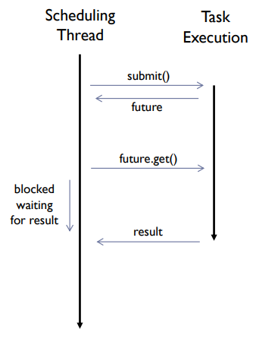

Future has cancel method to cancel the execution of that task.

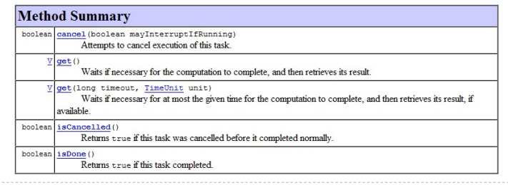
Without ExecutorService submit method doesn’t exist, all Java executors implements ExecutorService.

The submission of a Runnable or Callable to an executor is a safe-publication, also the return of a result from a Future is a safe-publication.

CompletionService with poll retrieves and removes the future the next completed task, it isn't blocking, null if there aren’t present.
With take method use loop to get the right number of task.

Thread poll on task can delete using cancel method, we can call from future through cancel().

We can develop custom thread-pool extending ThreadPoolExecutor or ScheduledThreadPoolExecutor.

Fork join
it is a framework that use and executor, behind, it is design for problems that can be decomposed recursively.
It implements a work-stealing approach in order to have good performance: Threads in the pool that have completed the assigned tasks are allowed to steal the tasks of other busy threads.

Fork-join model is widely used in parallel programming.
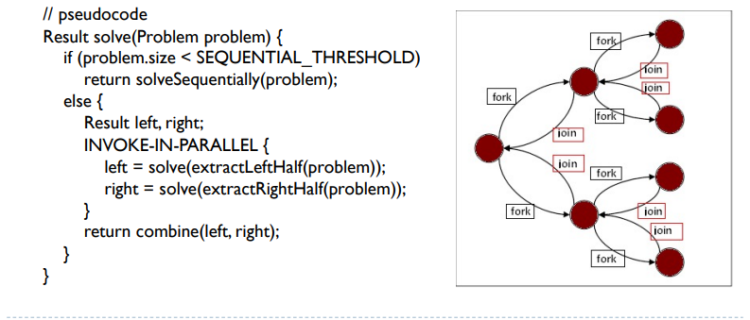
The ForkJoinPool executes ForkJoinTask, a light-weight version of a Future.
ForkJoinTask has two specializations: RecursiveTask (is allowed to return a result) and RecursiveAction.

A ForkJoinTask starts its execution when it is sent to a ForkJoinPool.

The task must extends RecursiveTask<...>

