Deep Learning Food Intake Detection Method from the AIM-2 Wearable Sensor

Caelan Dunlea
Department of Electrical and Computer Engineering
The University of Alabama
Tuscaloosa, AL, United States
cadunlea@crimson.ua.edu

Abstract—Self-report of food intake events is unreliable and susceptible to underreporting and recall errors. Additionally, human annotation of video eating events is time-intensive and does not scale to free-living conditions. The Automatic Ingestion Monitor Version 2 (AIM-2) is an eyeglass-mounted device that combines a jaw-muscle optical sensor with an accelerometer for passive eating monitoring. Food intake detection is the gateway algorithm on which other models and metrics depend. However, previous food intake detection methods for AIM-2 relied on hand-crafted features, and its performance has not been compared with the agreement between independent human annotators. This study presents a supervised deep learning approach, combining a convolutional neural network with attention and an auxiliary chew-count output. The model is evaluated with leave-one-subject-out cross-validation on data spanning 61 meals and 43 participants. The time-domain input outperformed a frequency-domain input, with an F1 of 0.854 against 0.791 and half the false alarms. Overall, the model achieved an F1 of 0.86 approaching the 0.91 agreement between two human annotators, with an accuracy of 0.89, and detected 91.9% of all eating episodes. All 60 sessions containing eating were detected, as was every eating episode lasting a minute or longer. The model detects eating reliably enough to be utilized in parallel future models, such as those that identify meal timing, meal count, chew counts, and chewing rates.
Keywords—food intake detection, convolutional neural network, wearable sensors, channel attention, chewing, leave-one-subject-out, deep learning, ablation study
Funding source and grant number for the ETS study.

Introduction
Measuring eating habits and behavior is important for health, nutrition, and obesity-related research. Self-report of food intake is not reliable due to underreporting and errors in recalling eating episodes. Wearable sensors are used to overcome these limitations, detecting eating passively from image data, sensor signals, or a combination of both [1].
The Automatic Ingestion Monitor Version 2 (AIM-2) , the successor to the Automatic Ingestion Monitor [2], combines an optical sensor and a 3-axis accelerometer, both sampling at 128 Hz on an eyeglass-mounted sensor [3]. Food intake detection is determined from the sensor signals when a person is eating. The AIM-2 original food intact detector used hand-crafted features with a support vector machine, reaching an F1 score of 81.8% ± 10.1% under leave-one-subject-out validation across 30 participants with an accuracy of 82.7% on detected eating episodes [3]. Ghosh and Sazonov compared five deep learning architectures on AIM-2 time-series data obtained from free-living conditions and found that a residual network performed best [4]. Networks learning directly from raw signals have outperformed hand-crafted features from in-ear audio for chewing detection [5] and bite detection from smartwatch motion [6].
Earlier AIM-2 detectors reported window or epoch-level scores against one annotator [3], [4] but did not report how this compares with agreement between two independent human annotators. Without a baseline for human agreement on the same labels, it is difficult to judge a score. Chew count and chewing rate have been measured from a piezoelectric jaw sensor [7], but not from the AIM-2 optical sensor with a detector.
This paper introduces a compact convolutional neural network for food intake detection with channel attention and attention pooling in a supervised learning scheme, learning from raw 8 second windows of AIM-2 human annotated study data. The model was tested using leave-one-subject-out cross-validation on 61 eating sessions from 43 participants. The paper contributes (i) an evaluation at window and episode level against inter-annotator agreement, (ii) an ablation study showing the input representation rather than architectural components determines performance, (iii) an analysis of where errors occur by bout position and meal type, (iv) chewing rate measured from the optical signal sensor data.

Methods

Data and Annotation
ETS study and IRB approval; 43 participants, 61 sessions by meal type; video annotation at 10 Hz (bouts, bites, chews); eating = bout or bite; one session without eating; second annotator on one session. Compendium Table 1.
- Dataset Summary
Item | Value
Participants | 43
Sessions | 61 (breakfast 8, lunch 18, dinner 12, snack 23)
Annotated recording | 24.2 h, of which 9.6 h eating
Signals | Accelerometer (X, Y, Z) and optical, 128 Hz
Annotation | Video, 10 Hz; eating = chewing bout or bite
Windows (8 s) | 18,227 for training (38.5% eating); 9,133 scored

Windowing and Preprocessing
8 s windows at 128 Hz; label rule (over half eating); exclusions; 4 s hop for training, non-overlapping for scoring; per-window z-score, no filtering. Compendium Sections 1 and 2.

Model Architecture
Three convolutional blocks [7], channel attention [8], attention pooling [9], auxiliary chew-count output [10]; 47,282 parameters. Compendium Table 2.
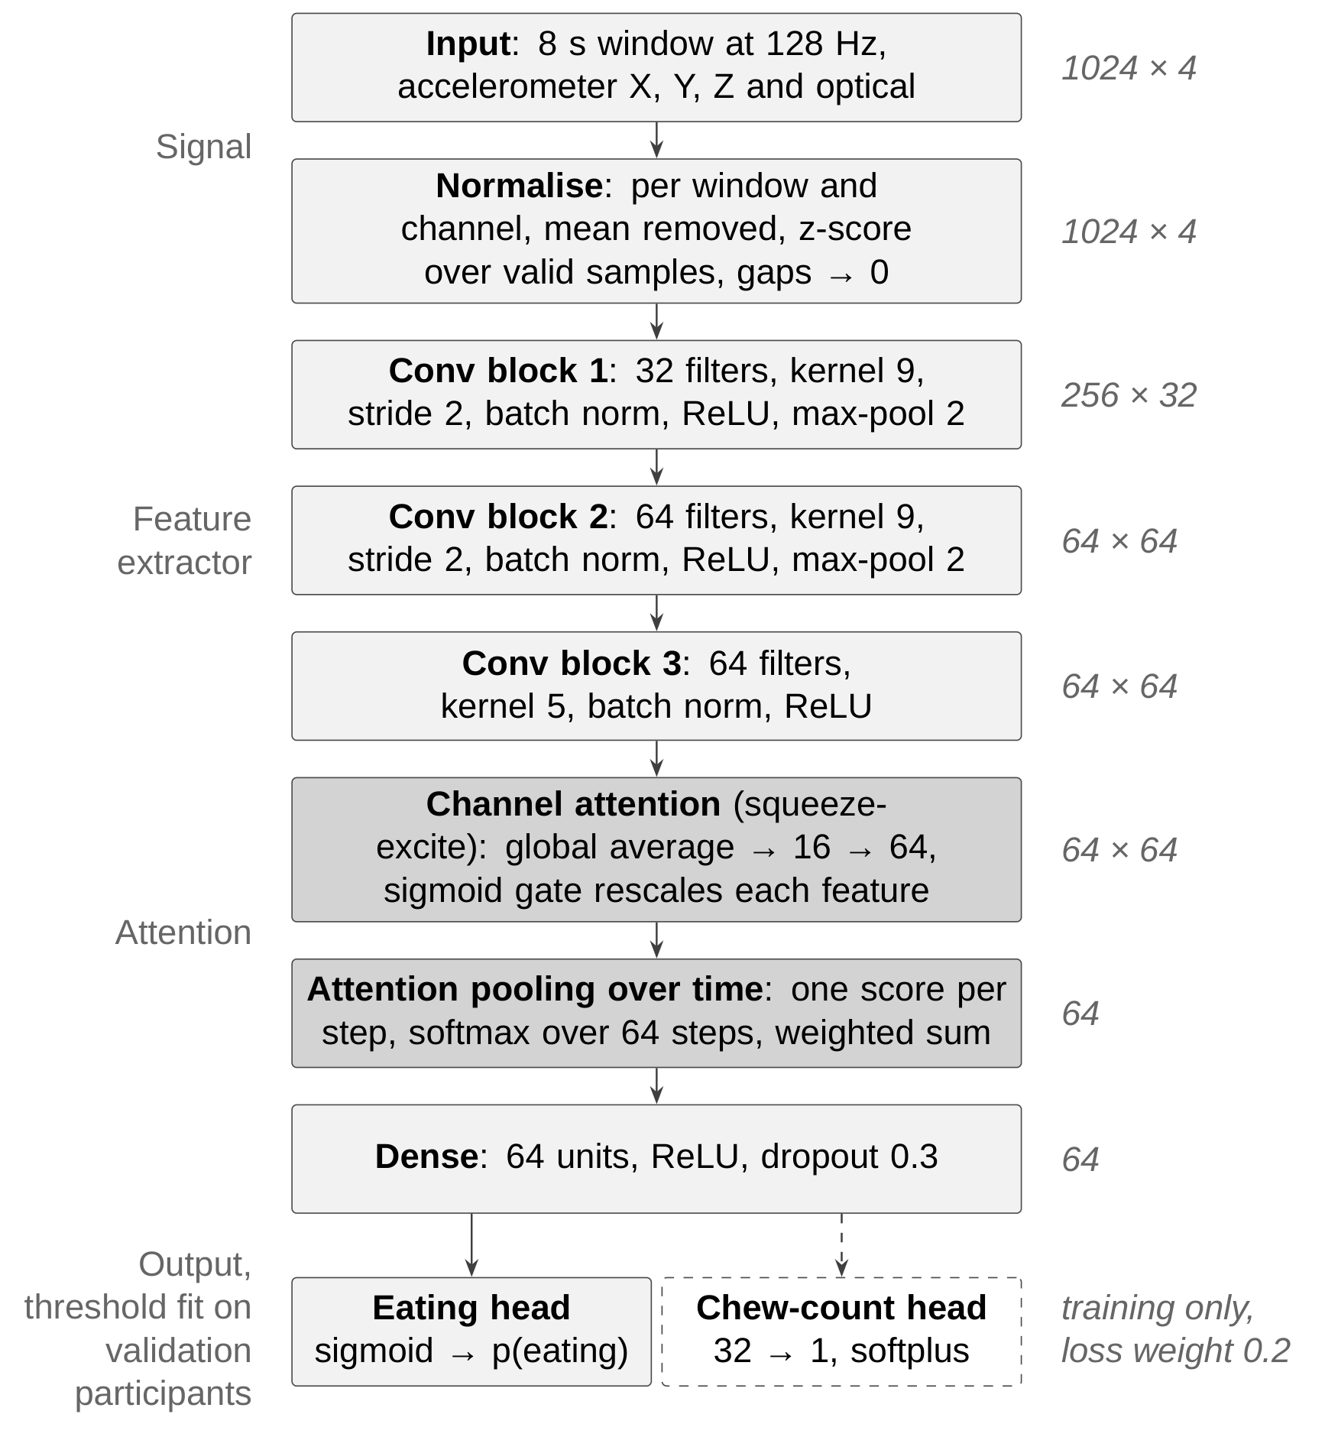
- Model architecture.

Training and Evaluation
Adam, early stopping, class weights; leave-one-subject-out [11]; 5 validation participants choose the threshold; 3 seeds; pooled metrics; episode definition; statistical tests. Compendium Table 3.

Chewing Rate
Optical signal band-passed to the chewing band [12], peaks counted, no training.

Results

Detection Performance
Window-level results and human agreement; why the weakest participants fail. Compendium Tables 4 and 5.
- Window-Level Detection Results
Measure | Value
Window level
F1 (3 seeds) | 0.86 (0.859 to 0.861)
Precision / recall | 0.849 / 0.870
Specificity / balanced accuracy | 0.902 / 0.886
Participant F1, median | 0.862
Participant F1, mean ± SD | run participant_summary.py
False alarms per hour of non-eating | 43.8
Episode level
Episodes detected | 91.9%
Episodes of 64 s or longer detected | 100%
Median delay to first detection | 0 s
False episodes per hour | 9.9
Episode precision | 87.8%
Human agreement (one session) | F1 0.912

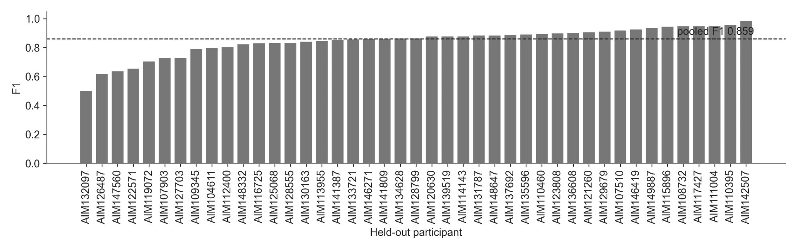
- F1 per held-out participant.
Replace Fig. 2 with figures\participants_anon.png from participant_summary.py (P1 to P43, mean over seeds).

Episode Detection
91.9% of episodes, 100% of those 64 s or longer, 0 s median delay, 9.9 false episodes per hour. Compendium Table 6.
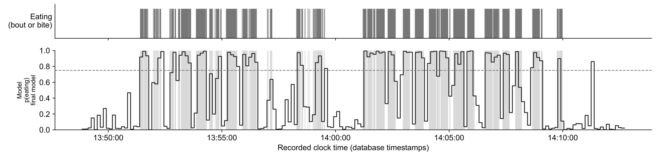
- Example held-out session.

Input Representation
Time domain against FFT input: F1 0.854 against 0.791, half the false alarms. Compendium Table 8; operating curve (compendium Figure 4) only if there is room.
- Design Comparisons
Change from the final model | Effect on F1
Frequency-domain (FFT) input | 0.854 → 0.791; false alarms 41 → 84 per hour
Two validation participants instead of five | −0.008 [−0.016, −0.001]
Eight validation participants instead of five | +0.001
32 Hz / 16 Hz instead of 128 Hz | −0.013 / −0.020
16 s windows instead of 8 s | −0.014 [−0.030, +0.002]
No channel attention; average pooling; chew weight 0 or 1; transformer layer; ensemble; augmentation; recurrent model; soft labels | Within seed variation (±0.007)

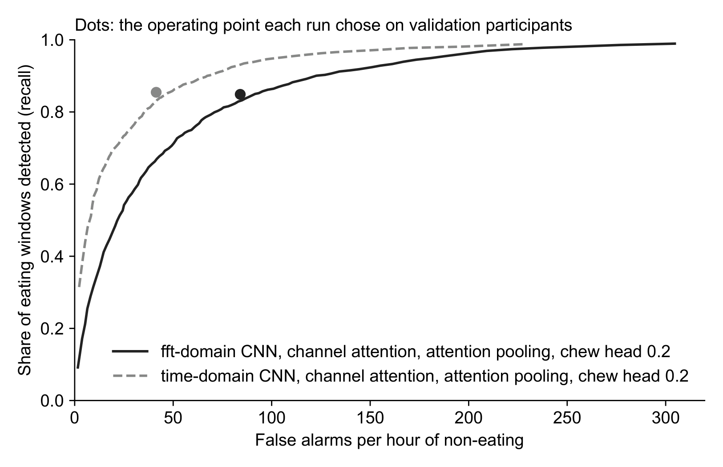
- Recall against false alarms per hour of non-eating for time-domain and frequency-domain input to the same network.

Error Analysis
Errors at bout edges (recompute on the final configuration first); lunch against other meals. Compendium Sections 5 and 7.

Chewing Rate
Peak count r = 0.72, median error 7% against 10% for a constant rate; 7% on the model's detected windows. Compendium Table 12.

Discussion
P1: close to human agreement; remaining errors at bout edges, where labels are uncertain.
P2: comparison with prior AIM-2 work, and why it is not like for like [3], [4]. Compendium Table 13.
P3: the lunch result (meal type, not group eating); chew output against optical rate.
P4: limitations: one annotator per session, agreement on one session, 8 s resolution, recorded meals rather than free living.

Conclusion
Three to four sentences on what was shown; one line of future work.

Acknowledgment
The author thanks Kenzy Nguyen for data annotation and Siavash Esfandiari Fard for data collection. Claude (Anthropic) was used to assist in software development and to provide editorial feedback on the manuscript. The author wrote the manuscript and takes full responsibility for its content.

References
- B. M. Bell et al., “Automatic, wearable-based, in-field eating detection approaches for public health research: a scoping review,” npj Digital Medicine, vol. 3, Art. no. 38, 2020, doi: 10.1038/s41746-020-0246-2.
- J. M. Fontana, M. Farooq, and E. Sazonov, “Automatic Ingestion Monitor: A novel wearable device for monitoring of ingestive behavior,” IEEE Trans. Biomed. Eng., vol. 61, no. 6, pp. 1772–1779, 2014, doi: 10.1109/TBME.2014.2306773.
- A. Doulah, T. Ghosh, D. Hossain, M. H. Imtiaz, and E. Sazonov, “‘Automatic Ingestion Monitor Version 2’ – A novel wearable device for automatic food intake detection and passive capture of food images,” IEEE J. Biomed. Health Inform., vol. 25, no. 2, pp. 568–576, 2021, doi: 10.1109/JBHI.2020.2995473.
- T. Ghosh and E. Sazonov, “A comparative study of deep learning algorithms for detecting food intake,” in Proc. 44th Annu. Int. Conf. IEEE Eng. Med. Biol. Soc. (EMBC), 2022, pp. 2993–2996, doi: 10.1109/EMBC48229.2022.9871278.
- V. Papapanagiotou, C. Diou, and A. Delopoulos, “Chewing detection from an in-ear microphone using convolutional neural networks,” in Proc. 39th Annu. Int. Conf. IEEE Eng. Med. Biol. Soc. (EMBC), 2017, pp. 1258–1261, doi: 10.1109/EMBC.2017.8037060.
- K. Kyritsis, C. Diou, and A. Delopoulos, “A data driven end-to-end approach for in-the-wild monitoring of eating behavior using smartwatches,” IEEE J. Biomed. Health Inform., vol. 25, no. 1, pp. 22–34, 2021, doi: 10.1109/JBHI.2020.2984907.
- M. Farooq and E. Sazonov, "Automatic measurement of chew count and chewing rate during food intake," Electronics, vol. 5, no. 4, Art. no. 62, 2016, doi: 10.3390/electronics5040062.
- Z. Wang, W. Yan, and T. Oates, “Time series classification from scratch with deep neural networks: A strong baseline,” in Proc. Int. Joint Conf. Neural Netw. (IJCNN), 2017, pp. 1578–1585, doi: 10.1109/IJCNN.2017.7966039.
- J. Hu, L. Shen, and G. Sun, “Squeeze-and-excitation networks,” in Proc. IEEE Conf. Comput. Vis. Pattern Recognit. (CVPR), 2018, pp. 7132–7141, doi: 10.1109/CVPR.2018.00745.
- M. Ilse, J. M. Tomczak, and M. Welling, “Attention-based deep multiple instance learning,” in Proc. 35th Int. Conf. Mach. Learn. (ICML), vol. 80, 2018, pp. 2127–2136.
- R. Caruana, “Multitask learning,” Machine Learning, vol. 28, pp. 41–75, 1997, doi: 10.1023/A:1007379606734.
- S. Saeb, L. Lonini, A. Jayaraman, D. C. Mohr, and K. P. Kording, “The need to approximate the use-case in clinical machine learning,” GigaScience, vol. 6, no. 5, 2017, doi: 10.1093/gigascience/gix019.
- J. M. C. Po, J. A. Kieser, L. M. Gallo, A. J. Tésenyi, P. Herbison, and M. Farella, “Time-frequency analysis of chewing activity in the natural environment,” J. Dental Res., vol. 90, no. 10, pp. 1206–1210, 2011, doi: 10.1177/0022034511416669.

