Deep Learning Food Intake Detection Method from the AIM-2 Wearable Sensor

Caelan Dunlea
Department of Electrical and Computer Engineering
The University of Alabama
Tuscaloosa, AL, United States
cadunlea@crimson.ua.edu

Abstract—Self-report of food intake events is unreliable and susceptible to underreporting and recall errors. Additionally, human annotation of video eating events is time-intensive and does not scale to free-living conditions. The Automatic Ingestion Monitor Version 2 (AIM-2) is an eyeglass-mounted device that combines a jaw-muscle optical sensor with an accelerometer for passive eating monitoring. Food intake detection is the gateway algorithm on which other models and metrics depend. However, previous food intake detection methods for AIM-2 relied on hand-crafted features, and its performance has not been compared with the agreement between independent human annotators. This study presents a supervised deep learning approach, combining a convolutional neural network with attention and an auxiliary chew-count output. The model is evaluated with leave-one-subject-out cross-validation on data spanning 61 meals and 43 participants. The time-domain input outperformed a frequency-domain input, with an F1 of 0.854 against 0.791 and half the false alarms. Overall, the model achieved an F1 of 0.86 approaching the 0.91 agreement between two human annotators, with an accuracy of 0.89, and detected 91.9% of all eating episodes. All 60 sessions containing eating were detected, as was every eating episode lasting a minute or longer. The model detects eating reliably enough to be utilized in parallel future models, such as those that identify meal timing, meal count, chew counts, and chewing rates.
Keywords—food intake detection, convolutional neural network, wearable sensors, channel attention, chewing, leave-one-subject-out, deep learning, ablation study
Funding source and grant number for the ETS study.

Introduction
Measuring eating habits and behavior is important for health, nutrition, and obesity-related research. Self-report of food intake is not reliable due to underreporting and errors in recalling eating episodes. Wearable sensors are used to overcome these limitations, detecting eating passively from image data, sensor signals, or a combination of both [1].
The Automatic Ingestion Monitor Version 2 (AIM-2) , the successor to the Automatic Ingestion Monitor [2], combines an optical sensor and a 3-axis accelerometer, both sampling at 128 Hz on an eyeglass-mounted sensor [3]. Food intake detection is determined from the sensor signals when a person is eating. The AIM-2 original food intact detector used hand-crafted features with a support vector machine, reaching an F1 score of 81.8% ± 10.1% under leave-one-subject-out validation across 30 participants with an accuracy of 82.7% on detected eating episodes [3]. Ghosh and Sazonov compared five deep learning architectures on AIM-2 time-series data obtained from free-living conditions and found that a residual network performed best [4]. Networks learning directly from raw signals have outperformed hand-crafted features from in-ear audio for chewing detection [5] and bite detection from smartwatch motion [6].
Earlier AIM-2 detectors reported window or epoch-level scores against one annotator [3], [4] but did not report how this compares with agreement between two independent human annotators. Without a baseline for human agreement on the same labels, it is difficult to judge a score. Chew count and chewing rate have been measured from a piezoelectric jaw sensor [7], but not from the AIM-2 optical sensor with a detector.
This paper introduces a compact convolutional neural network for food intake detection with channel attention and attention pooling in a supervised learning scheme, learning from raw 8 second windows of AIM-2 human annotated study data. The model was tested using leave-one-subject-out cross-validation on 61 eating sessions from 43 participants. The paper contributes (i) an evaluation at window and episode level against inter-annotator agreement, (ii) an ablation study showing the input representation rather than architectural components determines performance, (iii) an analysis of where errors occur by bout position and meal type, (iv) chewing rate measured from the optical signal sensor data.

Methods

Data and Annotation
Data were collected in the Eating Trajectory Study (ETS), approved by the Institutional Review Board of The University of Alabama [protocol number]. Forty-three participants each ate one meal per session under supervision in a laboratory at The University of Alabama, across one or more sessions, for 61 sessions in total. Meals were chosen from a predefined menu spanning breakfasts, lunches, dinners and snacks, and varying in texture, size and style of cuisine. Participants wore the AIM-2, which recorded a 3-axis accelerometer and an optical sensor at 128 Hz, and each meal was video recorded. The videos were manually annotated at 10 Hz in custom annotation software, played at one-third speed, following a written protocol that defined each label and how to handle edge cases. Three labels were annotated: individual chews, chewing bouts and bites; a sample was labeled as eating if it fell within a chewing bout or a bite. One session contained no annotated eating, and a second annotator independently labeled three sessions to estimate annotation reliability. The dataset is summarized in Table I.
- Dataset Summary
Item | Value
Participants | 43
Sessions | 61 (breakfast 8, lunch 18, dinner 12, snack 23)
Annotated recording | 24.2 h, of which 9.6 h eating
Signals | Accelerometer (X, Y, Z) and optical, 128 Hz
Annotation | Video, 10 Hz; eating = chewing bout or bite
Windows (8 s) | 18,227 for training (38.5% eating); 9,133 scored

Windowing and Preprocessing
The signals were segmented into 8 s windows, each containing 1024 samples (8 s × 128 Hz) for each of the four channels. Windows were excluded when more than half of their sensor samples were missing or when they lay more than halfway outside the annotated portion of the video. A window was labeled as eating if more than half of its annotated samples were eating. The number of annotated chews in each window was also recorded as the target for an auxiliary output (Section II-C). For training, a new window started every 4 s, so consecutive windows overlapped by half; for scoring, windows did not overlap, so each moment was scored only once. Each channel of each window was z-scored over its valid samples, with missing samples set to zero, which removed differences in signal level between participants and sensor placements; no other filtering was applied to the model input. The resulting window counts are given in Table I.

Model Architecture
The model is a compact one-dimensional convolutional neural network (CNN) that takes a normalized 8 s window and outputs the probability of eating (Fig. 1). The model has 47,282 parameters in total and was implemented in TensorFlow/Keras. The feature extractor consists of three convolutional blocks, each with batch normalization and ReLU activation, a structure similar to the fully convolutional network of Wang et al. [8]. Strides and max-pooling in the first two convolutional blocks shorten the 1024 samples to 64 time steps of 125 ms each. Squeeze-and-excitation channel attention [9] reweights the 64 feature channels in each window, intended to let features carrying chewing count more than their motion-artifact counterparts. Attention pooling [10] learns one weight for every time step, so that a short bite is not averaged away over the entire 8 s window. A dense layer of 64 units with dropout of 0.3 feeds into a sigmoid classifier, which outputs the probability of eating between zero and one. Lastly, an auxiliary chew head [11] predicts the number of chews in each window during training, weighted 0.2 relative to the eating loss, to encourage the network to learn the chewing rhythm. This auxiliary chew head is not used at inference.
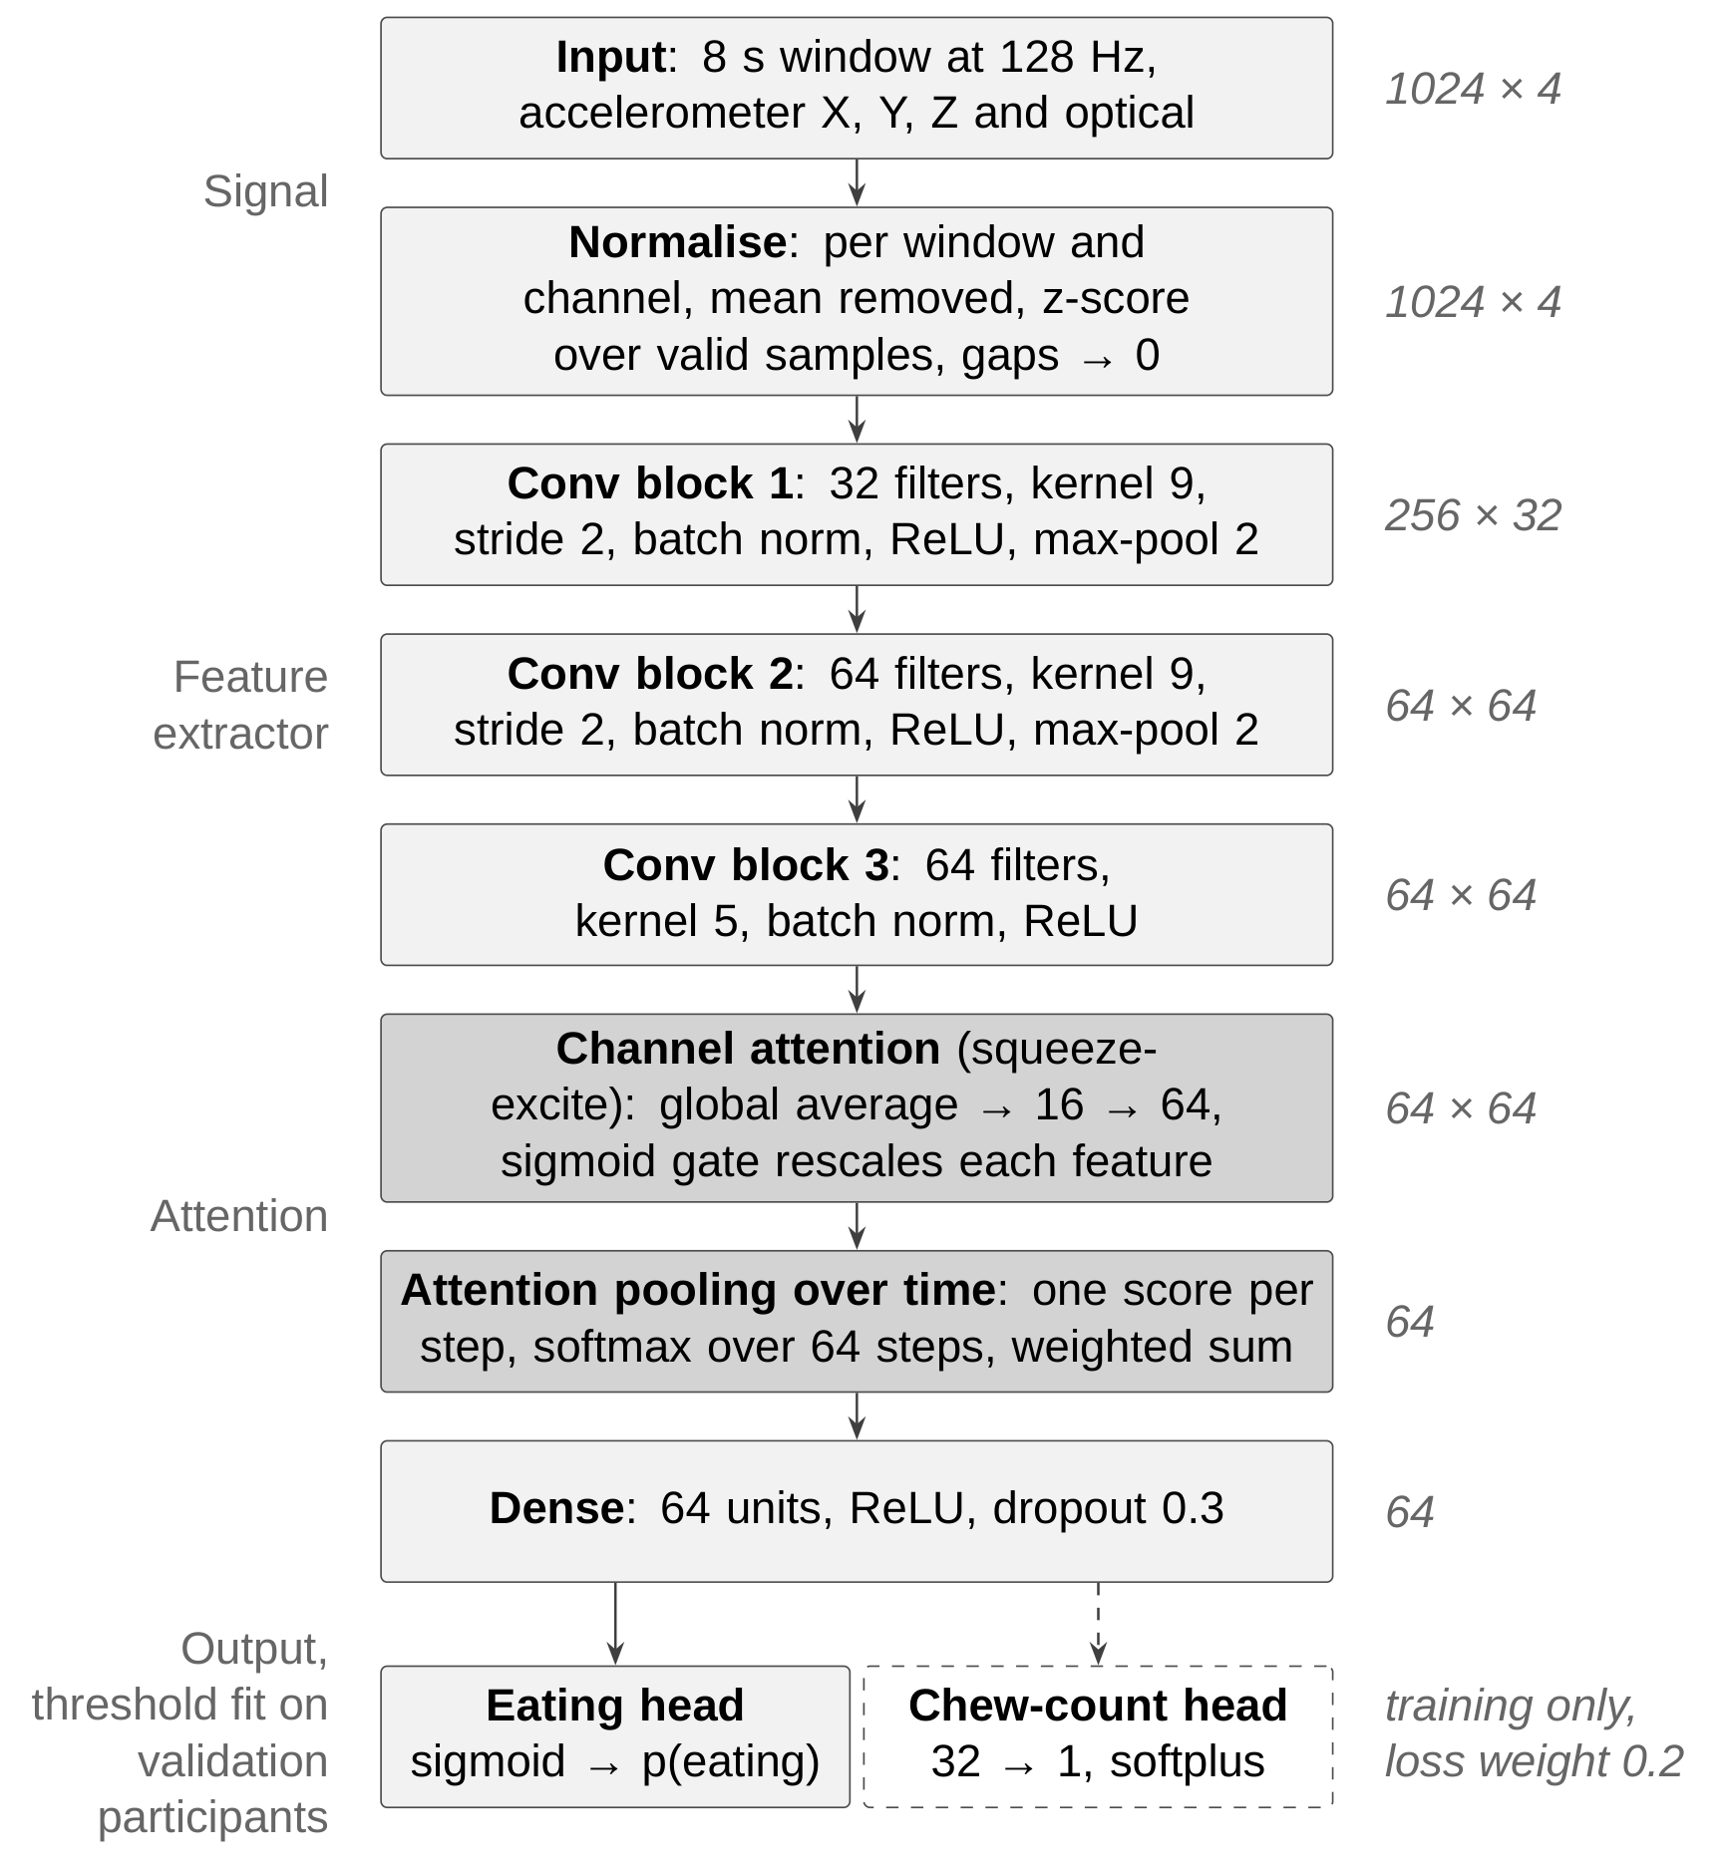
- Model architecture.

Training and Evaluation
The network was trained to minimize binary cross-entropy on the eating output plus 0.2 times the mean squared error of the auxiliary chew head's output. Training used the Adam optimizer [12] with a learning rate of 0.0003, a batch size of 64 and at most 80 epochs. To address class imbalance, eating and non-eating windows were weighted inversely to their share of the training data, with the weights recomputed in each fold and applied to the eating loss only. Training was stopped early when the area under the receiver operating characteristic curve (AUROC) on the validation participants had not improved for 12 consecutive epochs, and the weights from the epoch with the highest validation AUROC were restored. The learning rate was halved after 4 epochs without improvement, to a minimum of 10⁻⁵.
The model was evaluated with leave-one-subject-out cross-validation [13]. There were 43 folds, one per participant: in each, all of that participant's sessions were held out for testing and excluded from both training and validation. Within each fold, 5 of the remaining 42 participants, a different 5 in each fold, were held out as a validation set for early stopping and threshold selection, and the model was trained on the other 37. On the validation participants, F1 was computed at thresholds from 0.05 to 0.95 in steps of 0.01, and the threshold at the centre of the range within 0.01 of the maximum F1 was selected. The entire procedure was repeated with three random seeds. Precision, recall and F1 were computed on the non-overlapping windows of each held-out participant and pooled across all participants; per-participant F1 is also reported as mean ± standard deviation, the form reported by Doulah et al. [3]. An eating episode was defined as one or more consecutive eating windows, with no merging across pauses. A true (annotated) episode was counted as detected if at least one of its windows was predicted as eating. Episode precision is the fraction of predicted episodes that overlap true eating, and false episodes are predicted episodes that do not touch any true eating, expressed per hour of non-eating time. Results are also reported with pauses of up to 32 s merged into a single episode. Each design variant in Table III was compared with the final model on the same participants, using a 95% bootstrap confidence interval for the change in pooled F1 (2,000 resamples of participants) and a Wilcoxon signed-rank test on the per-participant differences in F1.

Chewing Rate
Chewing rate was estimated separately from the classifier, directly from the optical signal, with no training. The optical signal of each eating window was band-pass filtered to the natural chewing band of 0.94–2.17 Hz reported by Po et al. [14], using a second-order Butterworth filter applied forward and backward. Peaks were counted if they were at least 0.46 s apart, corresponding to the band's upper limit, and had a prominence of at least 0.5 standard deviations of the filtered window. The chewing rate was the number of peaks multiplied by 60 and divided by the 8 s window length, in chews per minute, averaged over each meal's eating windows. Each meal's estimated rate was compared with its annotated rate, defined as the number of annotated chews in its eating windows per minute of those windows, and with a baseline that assigned every meal the same rate, the mean annotated rate.

Results

Detection Performance
Window-level results and human agreement; why the weakest participants fail. Compendium Tables 4 and 5.
- Window-Level Detection Results
Measure | Value
Window level
F1 (3 seeds) | 0.86 (0.859 to 0.861)
Precision / recall | 0.849 / 0.870
Specificity / balanced accuracy | 0.902 / 0.886
Participant F1, median | 0.863
Participant F1, mean ± SD | 0.844 ± 0.101
False alarms per hour of non-eating | 43.8
Episode level
Episodes detected | 91.9%
Episodes of 64 s or longer detected | 100%
Median delay to first detection | 0 s
False episodes per hour | 9.9
Episode precision | 87.8%
Human agreement (3 sessions) | F1 0.81–0.93

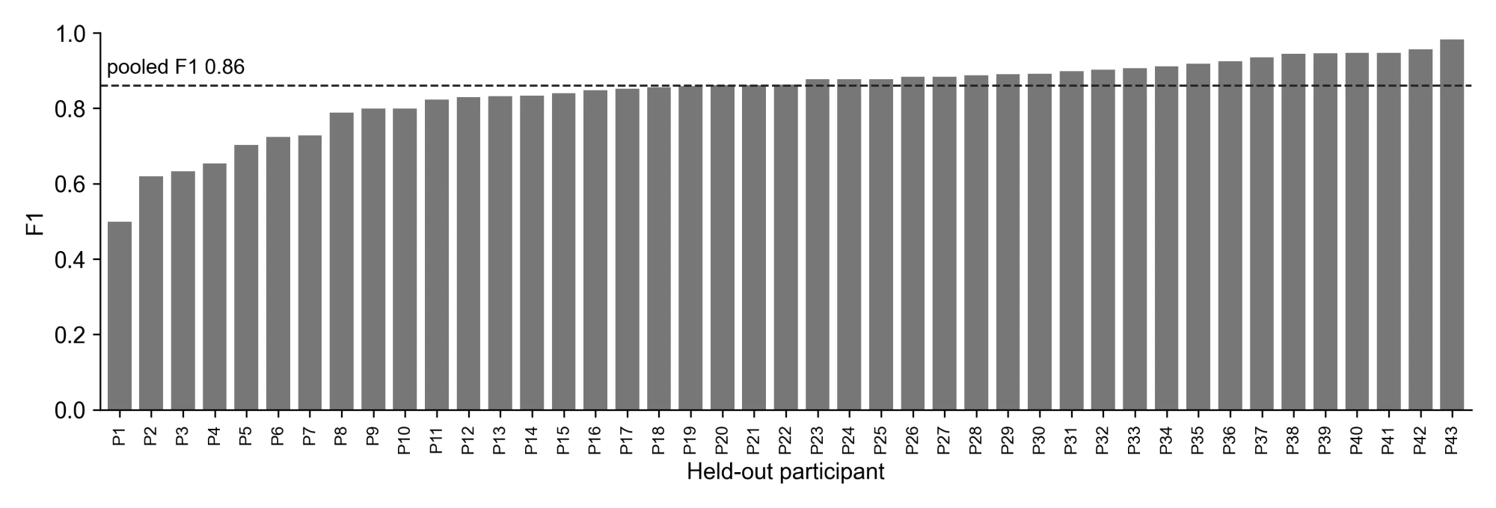
- F1 per held-out participant.

Episode Detection
91.9% of episodes, 100% of those 64 s or longer, 0 s median delay, 9.9 false episodes per hour. Compendium Table 6.
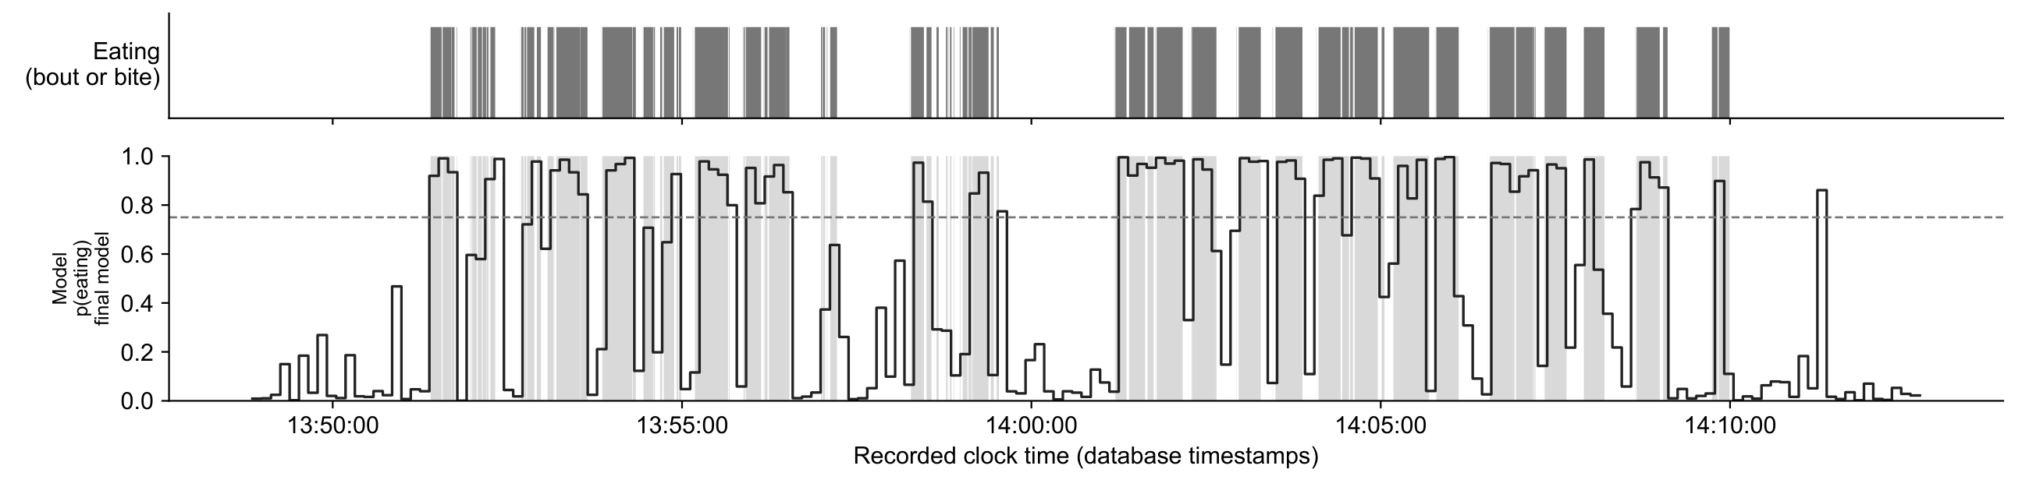
- Example held-out session.

Input Representation
Time domain against FFT input: F1 0.854 against 0.791, half the false alarms. Compendium Table 8; operating curve (compendium Figure 4) only if there is room.
- Design Comparisons
Change from the final model | Effect on F1
Frequency-domain (FFT) input | 0.854 → 0.791; false alarms 41 → 84 per hour
Two validation participants instead of five | −0.008 [−0.016, −0.001]
Eight validation participants instead of five | +0.001
32 Hz / 16 Hz instead of 128 Hz | −0.013 / −0.020
16 s windows instead of 8 s | −0.014 [−0.030, +0.002]
No channel attention; average pooling; chew weight 0 or 1; transformer layer; ensemble; augmentation; recurrent model; soft labels | Within seed variation (±0.007)

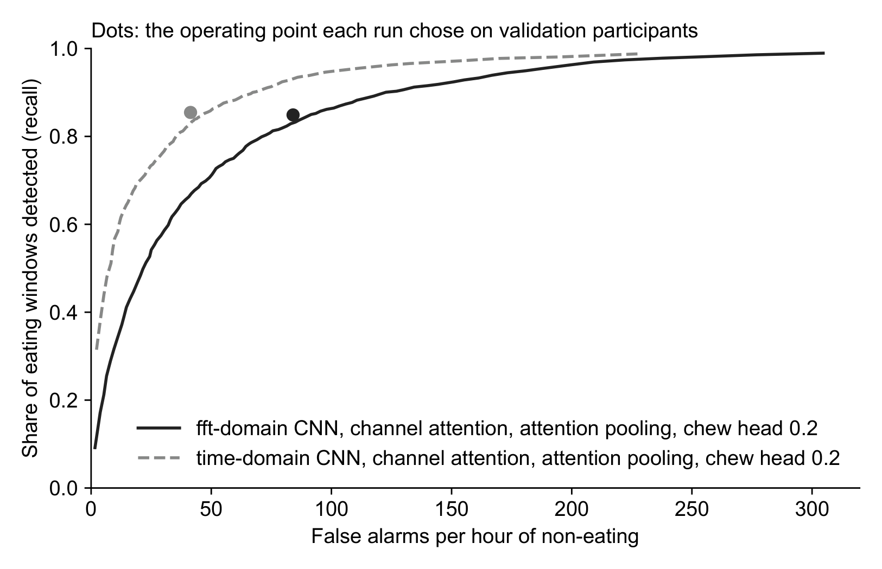
- Recall against false alarms per hour of non-eating for time-domain and frequency-domain input to the same network.

Error Analysis
Errors at bout edges (recompute on the final configuration first); lunch against other meals. Compendium Sections 5 and 7.

Chewing Rate
Peak count r = 0.72, median error 7% against 10% for a constant rate; 7% on the model's detected windows. Compendium Table 12.

Discussion
P1: close to human agreement; remaining errors at bout edges, where labels are uncertain.
P2: comparison with prior AIM-2 work, and why it is not like for like [3], [4]. Compendium Table 13.
P3: the lunch result (meal type, not group eating); chew output against optical rate.
P4: limitations: one annotator per session, agreement on one session, 8 s resolution, recorded meals rather than free living.

Conclusion
Three to four sentences on what was shown; one line of future work.

Acknowledgment
The author thanks Kenzy Nguyen for data annotation and Siavash Esfandiari Fard for data collection. Claude (Anthropic) was used to assist in software development and to provide editorial feedback on the manuscript. The author wrote the manuscript and takes full responsibility for its content.

References
- B. M. Bell et al., “Automatic, wearable-based, in-field eating detection approaches for public health research: A scoping review,” npj Digit. Med., vol. 3, Art. no. 38, 2020, doi: 10.1038/s41746-020-0246-2.
- J. M. Fontana, M. Farooq, and E. Sazonov, “Automatic Ingestion Monitor: A novel wearable device for monitoring of ingestive behavior,” IEEE Trans. Biomed. Eng., vol. 61, no. 6, pp. 1772–1779, 2014, doi: 10.1109/TBME.2014.2306773.
- A. Doulah, T. Ghosh, D. Hossain, M. H. Imtiaz, and E. Sazonov, “‘Automatic Ingestion Monitor Version 2’ – A novel wearable device for automatic food intake detection and passive capture of food images,” IEEE J. Biomed. Health Inform., vol. 25, no. 2, pp. 568–576, 2021, doi: 10.1109/JBHI.2020.2995473.
- T. Ghosh and E. Sazonov, “A comparative study of deep learning algorithms for detecting food intake,” in Proc. 44th Annu. Int. Conf. IEEE Eng. Med. Biol. Soc. (EMBC), 2022, pp. 2993–2996, doi: 10.1109/EMBC48229.2022.9871278.
- V. Papapanagiotou, C. Diou, and A. Delopoulos, “Chewing detection from an in-ear microphone using convolutional neural networks,” in Proc. 39th Annu. Int. Conf. IEEE Eng. Med. Biol. Soc. (EMBC), 2017, pp. 1258–1261, doi: 10.1109/EMBC.2017.8037060.
- K. Kyritsis, C. Diou, and A. Delopoulos, “A data driven end-to-end approach for in-the-wild monitoring of eating behavior using smartwatches,” IEEE J. Biomed. Health Inform., vol. 25, no. 1, pp. 22–34, 2021, doi: 10.1109/JBHI.2020.2984907.
- M. Farooq and E. Sazonov, “Automatic measurement of chew count and chewing rate during food intake,” Electronics, vol. 5, no. 4, Art. no. 62, 2016, doi: 10.3390/electronics5040062.
- Z. Wang, W. Yan, and T. Oates, “Time series classification from scratch with deep neural networks: A strong baseline,” in Proc. Int. Joint Conf. Neural Netw. (IJCNN), 2017, pp. 1578–1585, doi: 10.1109/IJCNN.2017.7966039.
- J. Hu, L. Shen, and G. Sun, “Squeeze-and-excitation networks,” in Proc. IEEE Conf. Comput. Vis. Pattern Recognit. (CVPR), 2018, pp. 7132–7141, doi: 10.1109/CVPR.2018.00745.
- M. Ilse, J. M. Tomczak, and M. Welling, “Attention-based deep multiple instance learning,” in Proc. 35th Int. Conf. Mach. Learn. (ICML), vol. 80, 2018, pp. 2127–2136.
- R. Caruana, “Multitask learning,” Mach. Learn., vol. 28, no. 1, pp. 41–75, 1997, doi: 10.1023/A:1007379606734.
- D. P. Kingma and J. Ba, “Adam: A method for stochastic optimization,” in Proc. 3rd Int. Conf. Learn. Represent. (ICLR), San Diego, CA, USA, 2015.
- S. Saeb, L. Lonini, A. Jayaraman, D. C. Mohr, and K. P. Kording, “The need to approximate the use-case in clinical machine learning,” GigaScience, vol. 6, no. 5, Art. no. gix019, 2017, doi: 10.1093/gigascience/gix019.
- J. M. C. Po, J. A. Kieser, L. M. Gallo, A. J. Tésenyi, P. Herbison, and M. Farella, “Time-frequency analysis of chewing activity in the natural environment,” J. Dent. Res., vol. 90, no. 10, pp. 1206–1210, 2011, doi: 10.1177/0022034511416669.

