Results Compendium
AIM-2 food intake detection, ETS dataset. Caelan Dunlea, 4 November 2026.
Every result for the paper in one place, with the run it comes from and its caveats. Reference material for writing, not paper text. Section 10 lists what must be recomputed or confirmed before submission.
Conventions used throughout
- Leave-one-subject-out (LOSO): 43 folds, each holding out one participant with all of their sessions; 5 of the remaining participants choose early stopping and the threshold.
- Pooled metrics are computed over all held-out windows together; participant metrics are computed per participant, then summarized.
- Windows are 8 s. Training uses a 4 s hop; every score uses non-overlapping windows set up per session.
- “Final configuration” is the frozen setup with 5 validation participants, run with 3 seeds. “Reference configuration” is the earlier 2-validation-participant setup; numbers from it are marked.

1. Dataset
Table 1. Dataset summary.
Item | Value
Participants | 43
Sessions | 61: breakfast 8, lunch 18, dinner 12, snack 23
Sessions with eating | 60 (AIM125068 snack has no window labeled eating)
Annotated recording | 24.2 h, of which 9.6 h eating
Annotated span per session | 2 to 55 min
Eating share per session | 0% to 86%
Full recordings (sensor data) | 0.09 to 12.5 h per session
Training windows (8 s, 4 s hop) | 18,227 (7,014 eating, 38.5%)
Scored windows (8 s, non-overlapping) | 9,133
Annotation | Video, 10 Hz: chewing bouts, bites, individual chews
Label | Eating = bout or bite; window eating if more than half of its annotated samples are eating
Excluded windows | Under half annotated, or over half of sensor samples missing
Inter-annotator agreement | F1 0.912 on 8 s windows, one snack session (C. Dunlea and K. Nguyen)
Source: ets_cache\ets_windows_w8_h4.npz; process_database.py --list; literature review model description.

2. Model and training
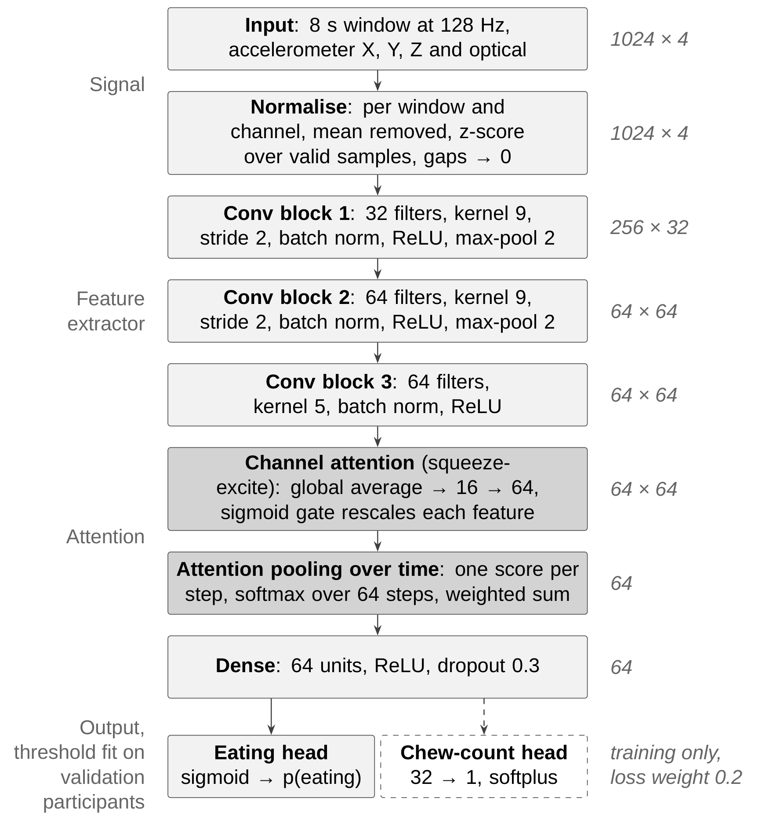
Figure 1. Model architecture (from the literature review). The chew-count head is trained jointly; its rate output is not used (Section 8).
Table 2. Layers and parameters.
Layer | Configuration | Output | Parameters
Input | Acc X, Y, Z, optical | 1024 × 4 | –
Conv block 1 | 32 filters, kernel 9, stride 2, BN, max-pool 2 | 256 × 32 | 1,312
Conv block 2 | 64 filters, kernel 9, stride 2, BN, max-pool 2 | 64 × 64 | 18,752
Conv block 3 | 64 filters, kernel 5, BN | 64 × 64 | 20,800
Channel attention | Squeeze-excite, 64 → 16 → 64 | 64 × 64 | 2,128
Attention pooling | 1 × 1 conv, softmax over time | 64 | 65
Dense | 64, ReLU, dropout 0.3 | 64 | 4,160
Eating head | 1, sigmoid | 1 | 65
Total at inference |  |  | 47,282
Chew-count head | 32 → 1, softplus (trained jointly) | 1 | 2,113
Table 3. Training settings.
Setting | Value
Preprocessing | Per window and channel: mean removed, z-score over valid samples, gaps set to 0. No band-pass filter.
Optimizer | Adam, learning rate 0.0003, batch 64, class-balanced sample weights
Stopping | Up to 80 epochs; early stopping on validation ROC AUC, patience 12, best weights restored; learning rate halved on plateau
Chew target | Annotated chews per window divided by its 99th percentile; loss weight 0.2
Threshold | Chosen per fold on the 5 validation participants to maximize F1
Seeds | 3 (9, 10, 11)

3. Window-level results (LOSO)
Table 4. Final configuration, 43 participants, 3 seeds.
Metric | Value
F1 | 0.86 (0.859 to 0.861 across seeds)
Accuracy | 0.890
Balanced accuracy | 0.886
Precision | 0.849
Recall (sensitivity) | 0.870
Specificity | 0.902 (from balanced accuracy and recall)
Participant F1, median | 0.863 (mean over seeds per participant)
Participant F1, mean ± SD | 0.844 ± 0.101 (range 0.499 to 0.983; 4 below 0.70)
False alarms per hour of non-eating | 43.8 windows
Seed-to-seed variation | about ±0.007 F1
Human agreement (one session) | 0.912
Source: results_fixed\time_se_attnpool_chew0.2_w8_128hz_loso_seed9_x3_stopauc_lr0.0003_inner5; docs/presentation/final_metrics_table.pptx.
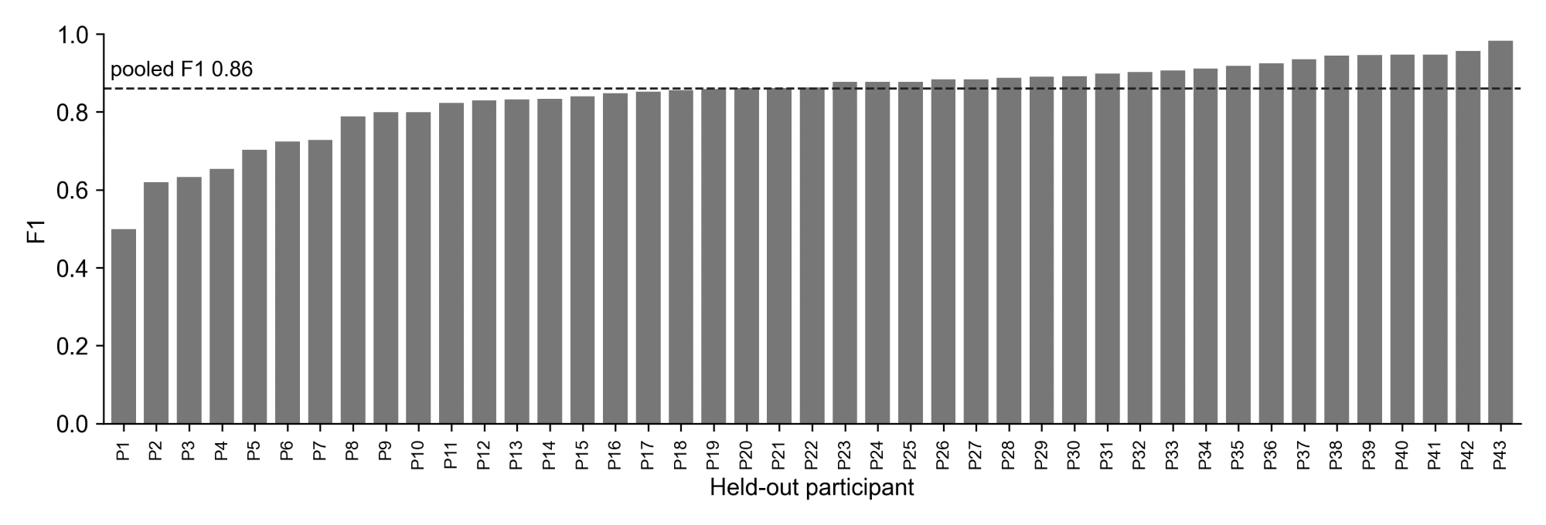
Figure 2. F1 per held-out participant (mean over 3 seeds), final configuration, labeled P1 to P43, with the pooled F1 dashed. The key from codes to IDs is results_fixed\participant_codes.csv (private).
Table 5. Lowest participants and causes (F1 read from the earlier chart with IDs).
Participant | F1 | Cause
AIM132097 | ~0.50 | Chews about 4 s, pauses about 3 s to talk, repeats: bouts shorter than a window; errors at edges
AIM126487 | ~0.62 | Not investigated; the lunch is the weak session (re-annotation planned)
AIM147560 | ~0.63 | Soft food (oatmeal) barely moves the jaw sensor; 6 min session, 46 windows
AIM122571 | ~0.65 | Short eating bouts
AIM119072 | ~0.70 | Not investigated
AIM107903 | ~0.73 | Weak at both meals
AIM127703 | ~0.73 | Long high-probability stretches between annotated bouts; possible unannotated eating (check video at 1.8–3, 11.3–12.3, 15.5–16.3 min)
AIM112400 was 0.48 with 2 validation participants (threshold too strict) and is about 0.80 in the final configuration.

4. Episode-level results
Table 6. Final configuration. An episode is a run of consecutive eating windows.
Measure | Value
Eating episodes detected | 91.9%
Episodes of 64 s or longer detected | 100%
Episodes of 8 s detected | 82%
Median delay to first detection | 0 s
False episodes per hour (away from meals) | 9.9
Episode precision | 87.8%
Sessions with eating that had a detection | 60 of 60
Source: episode_metrics.py on the final run; docs/presentation/episode_table_final.pptx. Confirm the merge gap used (0 or 32 s) before reporting.
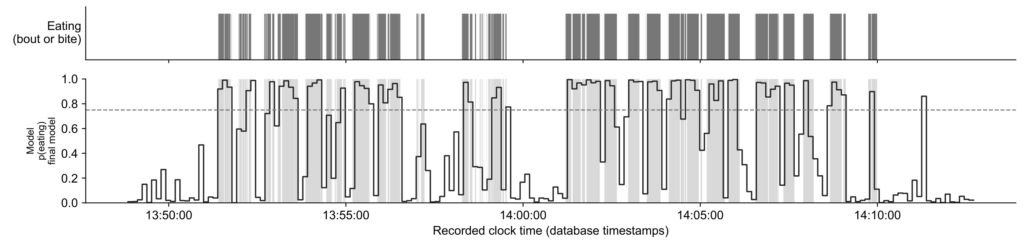
Figure 3. Held-out example, AIM146271 lunch (final model): annotated eating above, model probability below with the 0.75 threshold dashed. F1 0.886, precision 0.925, recall 0.849.

5. Where errors occur
Table 7. Error location (reference configuration, one seed; recompute on the final configuration).
Measure | Value
Errors at bout edges | 62% of all errors
False-alarm windows at edges | 75%
Missed windows at edges | 49%
F1 with edge windows forgiven | 0.944
Isolated false alarms | 19% of false alarms
False episodes per hour | 8.9
Fold thresholds | 0.06 to 0.89 in the final configuration (0.06 to 0.93 with 2 validation participants)
Source: results_fixed\time_se_attnpool_chew0.2_w8_128hz_loso_seed9_stopauc_lr0.0003 (2 validation participants); error_breakdown.py.

6. Design comparisons
Table 8. Same LOSO folds; differences in F1 from the reference unless stated.
Change | Result
Frequency (FFT) input instead of time domain | F1 0.854 → 0.791; false alarms 41 → 84 per hour; 5 of 43 participants better
5 validation participants instead of 2 | +0.008 [0.001, 0.016], 30 better / 12 worse, p = 0.004
8 validation participants instead of 5 | +0.001 (no difference)
Recurrent model over 2 min of windows | −0.003 (no difference)
Soft labels | +0.001 (no difference)
32 Hz / 16 Hz instead of 128 Hz | −0.013 / −0.020
16 s windows instead of 8 s | −0.014 [−0.030, +0.002]
Within seed variation | Average pooling, no channel attention, chew weight 0 or 1, transformer layer, 3-model ensemble, augmentation, 4 s windows, 64 Hz
Excluding the 3 participants below 0.55 | 0.854 → 0.864, inside the 95% CI
Source: compare_runs.py on results_fixed\ (paired bootstrap over participants, Wilcoxon).
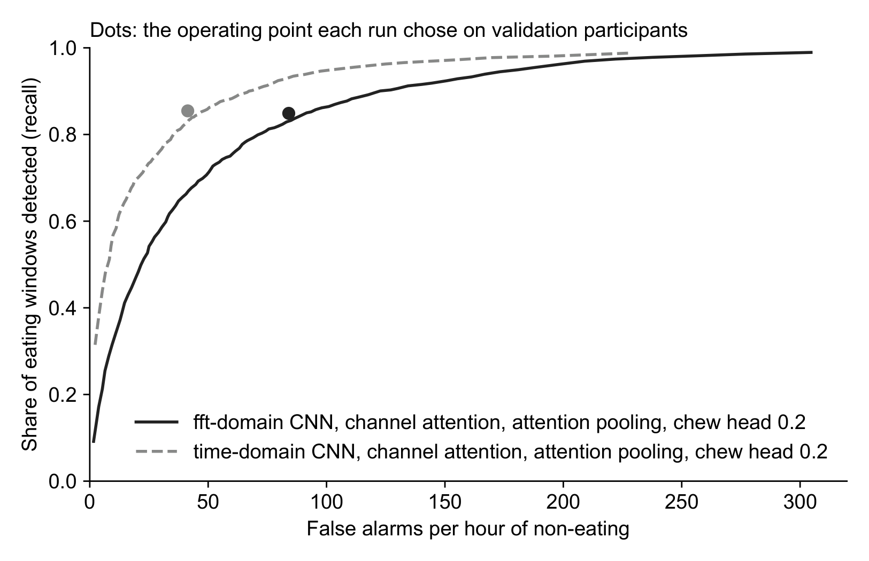
Figure 4. Recall against false alarms per hour, time-domain vs FFT input, same network. Dots: operating points chosen on validation participants.

7. Meal type
Table 9. Final configuration, LOSO.
Meal | Sessions | F1 (pooled) | Recall | Median bout
Breakfast | 8 | 0.882 | 0.909 | 16 s
Dinner | 12 | 0.884 | 0.931 | 24 s
Lunch | 18 | 0.829 (precision 0.841) | 0.819 | 16 s
Snack | 23 (22 with eating) | 0.877 | 0.891 | 20 s
- Per-session median F1: lunch 0.815 vs 0.890 for other meals, Mann-Whitney p = 0.009.
- Participants with a lunch and another session (9): 7 lower at lunch, median difference −0.081, Wilcoxon p = 0.098.
- Some lunches were eaten alone: this is a meal-type result, not a group-eating result.
Source: session_type_analysis.py and plot_meal_types.py on results_fixed\time_se_attnpool_chew0.2_w8_128hz_loso_seed9_x3_stopauc_lr0.0003_inner5.
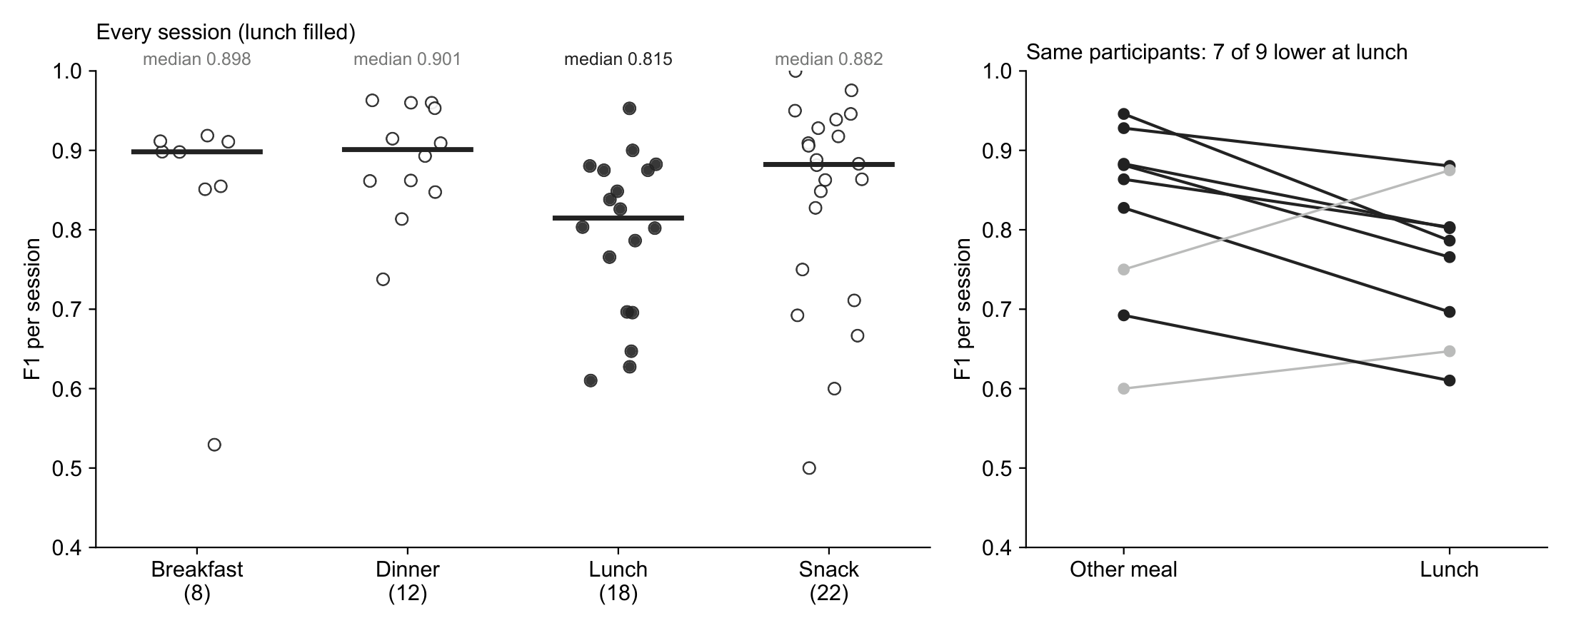
Figure 5. Left: every session's F1 by meal type, medians marked. Right: the 9 participants with a lunch and another session.

8. Final model, inference and chewing
Table 10. The shipped model.
Item | Value
Training participants | 38
Validation participants | AIM146271, AIM128555, AIM109345, AIM147560, AIM116725 (early stopping and threshold only)
Threshold | 0.750
Best epoch | 3 of 15
Whole database | 61 recordings, 370 eating episodes; about 1 s per recording (4 s for 12.5 h)
Database write-back | process_database.py --database dry-run or write: insert-only, new record type, refuses if it exists; format awaiting approval
Median F1, 8 held-out sessions | 0.854 (LOSO median participant F1: 0.862)
Median F1, 53 trained-on sessions | 0.889 (optimistic: the model trained on them)
Table 11. Held-out sessions (final model).
Participant | Meal | F1
AIM109345 | Lunch | 0.792
AIM109345 | Snack | 0.864
AIM116725 | Lunch | 0.823
AIM116725 | Snack | 0.865
AIM128555 | Breakfast | 0.844
AIM128555 | Snack | 0.915
AIM146271 | Lunch | 0.886
AIM147560 | Breakfast | 0.667
Median |  | 0.854
Source: train_final_model.py; process_database.py --overwrite, 4 November 2026.
Table 12. Chews and chewing rate per meal against the annotations.
Estimate | Windows | Meals | r | Median error
Chew count, model output | Detected | 8 held out / 53 trained | 0.92 / 0.97 | 14% / 10%
Chewing rate, model output | Detected | 8 / 52 | −0.23 / 0.42 | 20% / 12%
Chewing rate, optical peak count | Annotated | 59 | 0.72 | 7%
Chewing rate, optical spectral peak | Annotated | 59 | 0.67 | 15% (16% high)
Chewing rate, optical peak count | Detected | 8 / 52 | 0.39 / 0.75 | 7% / 7%
Same rate for every meal (baseline) | – | 60 | – | 10%
- The chew-count output is right mainly because eating time is right: it predicts about the same chews per window for everyone, so its rate is nearly constant.
- Optical peak count: optical signal band-passed to 0.94–2.17 Hz (Po et al. 2011), peaks at least 0.46 s apart counted. No training; settings fixed from the literature and not tuned on these meals. It needs no held-out split; the r of 0.39 is on 8 meals only.
- Annotated rate: chews in annotated eating windows per minute of those windows (61 to 112 chews/min, mean 85).
Source: plot_meals.py and chew_rate_check.py, 4 November 2026.
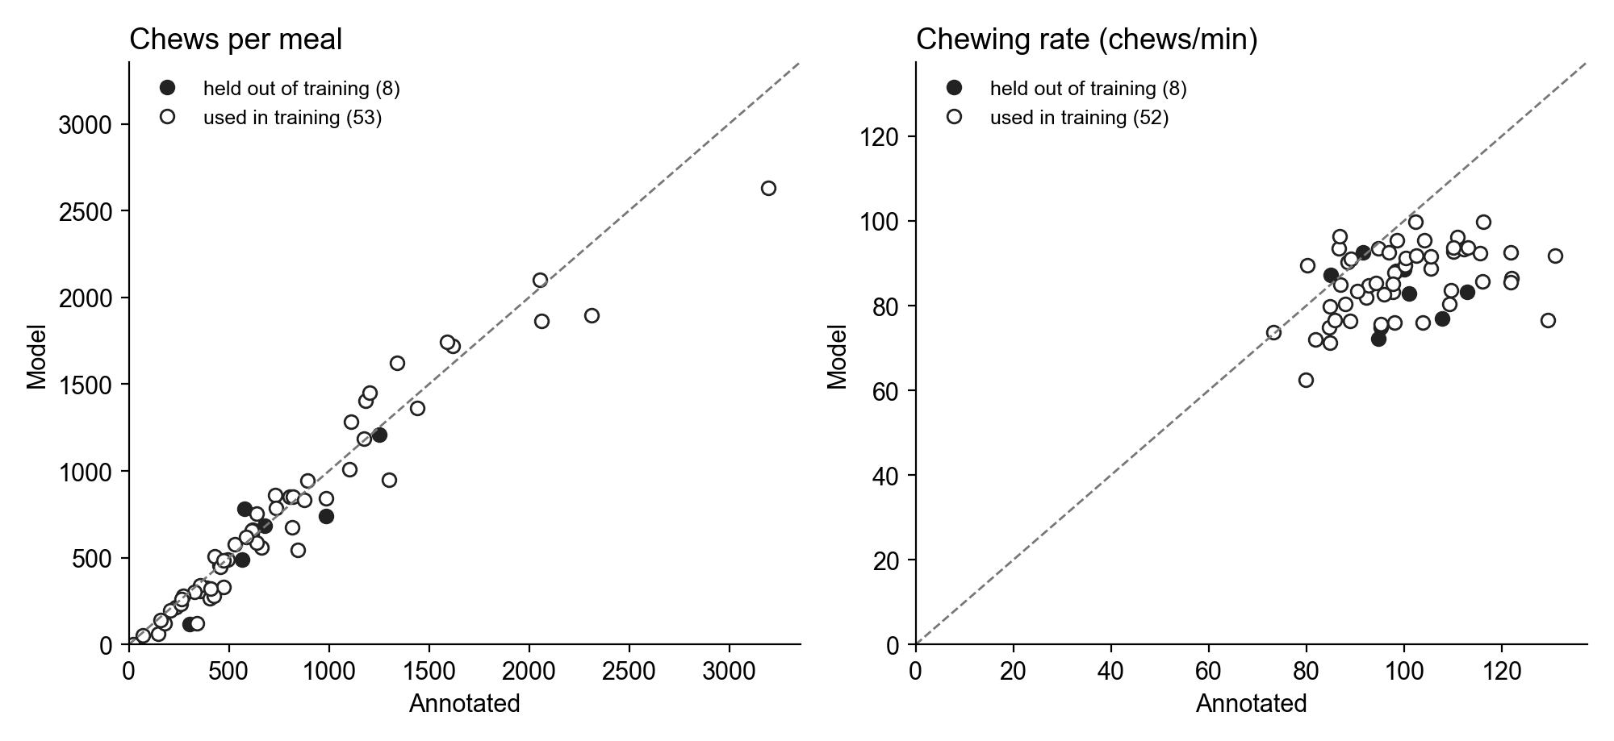
Figure 6. Chews per meal and chewing rate from the model's chew output (earlier two-panel version). Replace with figures\chew_check.png from the lab machine, which adds the optical rate, and add figures\chew_rate_check.png.

9. Prior work for comparison
Table 13. Not directly comparable: data, epochs and protocols differ.
Study | Data and method | Result
Doulah et al. 2021 (AIM-2) | 30 participants, 10 s epochs, hand-crafted features, SVM, LOSO | F1 81.8 ± 10.1% (mean over participants); episode detection accuracy 82.7%
Ghosh and Sazonov 2022 | AIM-2 time series, five deep architectures | Best (ResNet) balanced accuracy 93.47%
Ghosh et al. 2024 | AIM-2 images plus accelerometer, free living | F1 80.77% combined (sensitivity 94.59%, precision 70.47%)
Kyritsis et al. 2021 | Smartwatch inertial data, CNN plus LSTM, LOSO | Bite F1 0.923; meal start/end Jaccard 0.820
This work | 43 participants, 8 s windows, compact CNN, LOSO | F1 0.86 pooled; per participant 84.4 ± 10.1% (median 0.863); 91.9% of episodes
Like for like with Doulah et al. (mean ± SD over participants): 84.4% ± 10.1% here against 81.8% ± 10.1%, on different data and epochs.

10. To recompute or confirm before submission
- Error location (Section 5) on the final configuration (error_breakdown.py).
- Episode metrics: which merge gap the reported table used.
- AIM125068 snack: why no window is labeled eating (near-empty snack or missing annotation).
- Sensor type: the ETS database calls the channel optical; Doulah 2021 describes a flex sensor. Confirm which AIM-2 version ETS used.
- Whether Doulah 2021 or Ghosh 2022 compared against inter-annotator agreement (Farooq and Sazonov 2016 reported agreement for chew counting only: intra-class correlation 0.988).
- Database write-back: table and format to agree (process_database.py --database dry-run is ready; a separate table is the proposed option).
- Inter-annotator agreement on more than one session (re-annotation of the weakest participants planned).
- With Dr. Sazonov: author list and order, funding and grant number, whether ETS data can be published, SoutheastCon deadline, AI-use disclosure wording.

