Food-Intake Detection from AIM-2 Sensor Signals: Literature Review and Model Description
Caelan Dunlea · University of Alabama · 9 October 2026

1 Literature Review
Self-reported food intake is inaccurate and cannot capture how people eat within a meal, such as eating rate or pauses (Diou et al., 2022). Wearable sensors that detect chewing or bites address this. The Automatic Ingestion Monitor version 2 (AIM-2) places a temporalis-muscle sensor and a 3-axis accelerometer on eyeglasses; its original detector extracted 38 hand-crafted features per signal and classified 10 s epochs with a support vector machine, reaching F1 0.818 under leave-one-subject-out validation on 30 participants (Doulah et al., 2021). Feature-engineered detectors of this kind are limited by the features chosen by hand and are sensitive to variation between people. Table 1 summarises the studies reviewed.
Table 1. Reviewed studies
Reference | Technique | Findings
Doulah et al., 2021 | AIM-2; hand-crafted features and SVM, 10 s windows | F1 0.818 (leave-one-out, 30 participants)
Ghosh and Sazonov, 2022 | Five deep networks on AIM-2 optical and accelerometer signals | ResNet best, balanced accuracy 93.5%
Ghosh et al., 2024 | Wavelet image of accelerometer, fused with food images | Fused F1 0.808; fusion reduces false positives
Kyritsis et al., 2021 | CNN + LSTM trained end to end on wrist IMU | Bite F1 0.923 (leave-one-out)
Diou et al., 2022 | Review: CNN on in-ear audio for chewing, smartwatch for bites | CNN F1 0.908 vs. 0.748 for an SVM
Stankoski et al., 2021 | Hard negative examples selected for training | F1 0.82 on unseen people; fewer false positives
Wang et al., 2024 | Temporal CNN + multi-head self-attention, wrist IMU | 61 participants; eating-speed error 11%
Vedovelli et al., 2026 | Transformer on smartwatch sensors | Sensitivity 0.69, specificity 0.50 (leave-one-out)
Hannun et al., 2019 | 34-layer CNN on raw ECG | F1 0.837, above cardiologists (0.780)
Ikram et al., 2025 | Transformer on ECG | Accuracy 97.1%; split by beats, not patients

1.1 Learned features
Networks trained on the signal itself have outperformed hand-crafted features. On wrist inertial data, an end-to-end CNN and LSTM reached a bite-detection F1 of 0.923 and outperformed hand-engineered methods (Kyritsis et al., 2021). For chewing, a CNN on in-ear audio reached F1 0.908 against 0.748 for an SVM, although such models “require significantly larger volumes of labeled data” (Diou et al., 2022, p. 8). On AIM-2 itself, five deep architectures were compared on the optical and accelerometer time series, with a residual network best at 93.5% balanced accuracy (Ghosh and Sazonov, 2022). Outside eating, a CNN applied to raw ECG exceeded the average cardiologist (Hannun et al., 2019). In this literature, a raw input means one without hand-engineered features; light preprocessing such as normalisation is still applied. Ghosh et al. (2024) instead converted the accelerometer signal to a wavelet image. None of the reviewed studies compares time-series and spectral input on the same network; that comparison is made in this work.

1.2 Attention and Transformers
Attention lets a network weight the parts of its input that carry evidence. A temporal CNN with multi-head self-attention measured eating speed on 61 participants (Wang et al., 2024). A Transformer encoder on smartwatch data, however, reached a sensitivity of 0.69 but a specificity of only 0.50 under leave-one-subject-out validation (Vedovelli et al., 2026), and the 97.1% accuracy reported for a Transformer on ECG comes from a split of beats rather than patients (Ikram et al., 2025). This work therefore uses light attention on a CNN by default and evaluates a Transformer layer as a separate option.

1.3 False positives and evaluation
False positives are the main weakness of eating detectors. Walking has a rhythm similar to chewing, 1 to 3 Hz, and causes chewing classifiers “to yield high false-positive detections”, which accelerometer data can be used to remove (Diou et al., 2022, p. 8). Selecting hard negative examples for training (Stankoski et al., 2021) and fusing sensor and image classifiers (Ghosh et al., 2024) both reduced false positives, and a detector can be tuned “towards higher recall or precision, or a balanced mode, based on the needs of each use-case” (Diou et al., 2022, p. 8). The intake studies reviewed evaluate on held-out people (Doulah et al., 2021; Kyritsis et al., 2021; Vedovelli et al., 2026), which is the protocol adopted here.

1.4 Contribution of this work
- A compact convolutional model with channel attention, temporal attention pooling and an auxiliary chew-count head, trained on normalised AIM-2 optical and accelerometer signals from 61 annotated sessions (43 participants) and evaluated leave-one-subject-out.
- A direct comparison of time-series and spectral input on the same network: the time series reaches F1 0.858 against 0.796 and reduces false alarms from 81 to 32 per hour of non-eating.
- Controlled experiments that change one design choice at a time on identical participant-level folds, including negative results reported with their mechanism.

2 Model Description
The model is a one-dimensional convolutional network that reads 8 s windows of the normalised AIM-2 signals and outputs the probability that the window contains eating (Figure 1). Three convolution blocks learn their own filters from the time series; a squeeze-and-excitation gate reweights the feature channels in each window; an attention pooling layer weights the time steps that carry the evidence; and a chew-count head, used only during training, adds supervision from the chew annotations. The network has 47,282 parameters at inference.
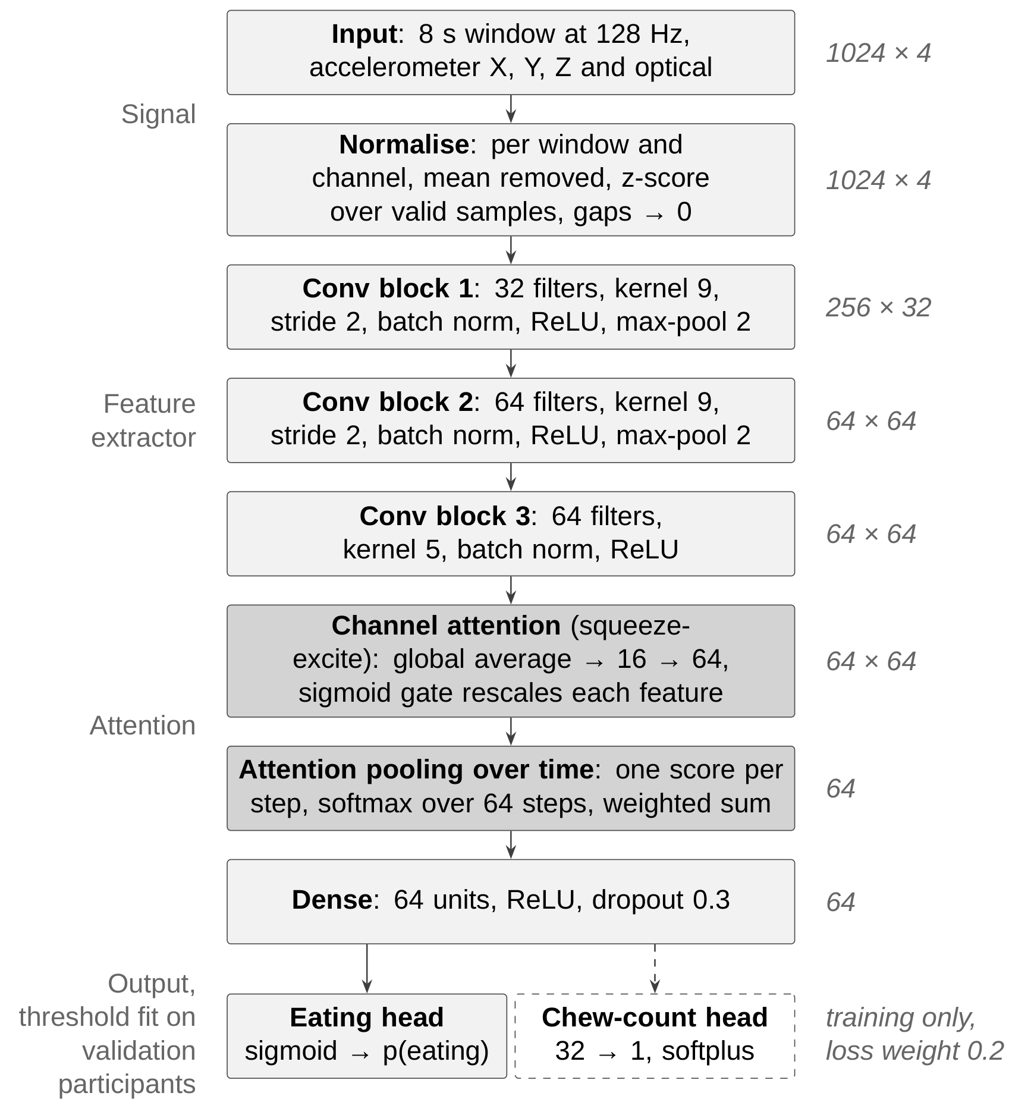
Figure 1. Model architecture. Shaded blocks are the two attention mechanisms; the dashed chew-count head is used only during training. Output shapes are time steps × features.
Table 2. Layer dimensions
Layer | Configuration | Output | Parameters
Input | Acc X, Y, Z, optical | 1024 × 4 | –
Conv block 1 | 32 filters, kernel 9, stride 2, max-pool 2 | 256 × 32 | 1,312
Conv block 2 | 64 filters, kernel 9, stride 2, max-pool 2 | 64 × 64 | 18,752
Conv block 3 | 64 filters, kernel 5 | 64 × 64 | 20,800
Channel attention | 64 → 16 → 64, sigmoid | 64 × 64 | 2,128
Attention pooling | Score per step, softmax over time | 64 | 65
Dense | 64 units, ReLU, dropout 0.3 | 64 | 4,160
Eating head | 1 unit, sigmoid | 1 | 65
Total at inference |  |  | 47,282
Chew-count head | 32 → 1, softplus (training only) | 1 | 2,113

Table 3. Design decisions
Component | Design | Rationale
Window | 8 s at 128 Hz, accelerometer X, Y, Z and optical | Chewing lies at 1–3 Hz, so 8 s holds at least eight chews (Diou et al., 2022); best of 2–16 s tested here
Labels | Eating = bout or bite; window is eating if over half its annotated samples are; unrecorded time dropped | Treating unannotated time as non-eating would bury the real labels
Alignment | No time shift | Measured lag of 0.1 s between sensor and annotations (this work)
Input | Normalised time series; no spectrum, no hand-crafted features | Learned features outperformed hand-crafted ones (Ghosh and Sazonov, 2022; Kyritsis et al., 2021); time series vs. FFT tested here
Normalisation | Per window and channel: mean removed, z-scored; gaps set to 0 | Removes each participant’s sensor baseline
Convolution | Three 1D conv blocks with batch norm and ReLU | CNNs on the raw signal (Ghosh and Sazonov, 2022; Hannun et al., 2019); each output step covers about one chew cycle
Channel attention | Squeeze-and-excitation gate | Walking resembles chewing; the accelerometer separates the two (Diou et al., 2022)
Temporal pooling | Attention pooling over 64 time steps | Averaging would dilute a 1–2 s bite across 8 s
Chew-count head | Regression of chews per window, loss weight 0.2, training only | Deep models need large amounts of labelled data (Diou et al., 2022); design specific to this work
Training | 50% overlapping windows; Adam, learning rate 0.0003; early stopping on validation AUC; class-balanced weights | At 0.001 the validation optimum fell at the first epoch; eating share ranges 0–86% by session
Validation | Leave-one-subject-out, 43 folds | Standard in intake detection (Doulah et al., 2021; Kyritsis et al., 2021); sample-level splits overstate accuracy (Ikram et al., 2025)
Threshold | Chosen on validation participants; best F1 or a false-alarm budget | Detectors can be tuned towards recall or precision by use case (Diou et al., 2022)
Post-processing | None | Median smoothing lowered F1: meals are punctuated by pauses

2.1 Dataset and Performance
The dataset is 61 annotated eating sessions (breakfast, lunch, dinner and snack) from 43 participants, 2 to 55 minutes each: 24.2 hours of annotated recording, of which 9.6 hours is eating. Each leave-one-subject-out fold holds out one participant with all of their sessions.
Table 4. Performance (pooled over 10,891 held-out windows)
Metric | Leave-one-subject-out | 5-fold
F1 | 0.856 | 0.864
Accuracy | 0.887 | 0.893
Precision | 0.860 | 0.867
Recall | 0.853 | 0.861
False alarms per hour of non-eating | 41.1 | 38.8
Per-participant F1, median | 0.867 | 0.881

The estimate is not sensitive to the validation scheme. Training settings change F1 by no more than 0.006, while replacing the time series with a magnitude spectrum lowers F1 from 0.858 to 0.796 and raises false alarms from 32 to 81 per hour (5-fold). The variation between participants is larger than any difference between training configurations.

References
Diou, C., Kyritsis, K., Papapanagiotou, V., & Sarafis, I. (2022). Intake monitoring in free-living conditions: Overview and lessons we have learned. Appetite, 176, 106096. https://doi.org/10.1016/j.appet.2022.106096
Doulah, A., Ghosh, T., Hossain, D., Imtiaz, M. H., & Sazonov, E. (2021). “Automatic Ingestion Monitor Version 2” – A novel wearable device for automatic food intake detection and passive capture of food images. IEEE Journal of Biomedical and Health Informatics, 25(2), 568–576. https://doi.org/10.1109/JBHI.2020.2995473
Ghosh, T., & Sazonov, E. (2022). A comparative study of deep learning algorithms for detecting food intake. 44th Annual International Conference of the IEEE Engineering in Medicine and Biology Society (EMBC), 2993–2996. https://doi.org/10.1109/EMBC48229.2022.9871278
Ghosh, T., Han, Y., Raju, V., Hossain, D., McCrory, M. A., Higgins, J., Boushey, C., Delp, E. J., & Sazonov, E. (2024). Integrated image and sensor-based food intake detection in free-living. Scientific Reports, 14, 1665. https://doi.org/10.1038/s41598-024-51687-3
Hannun, A. Y., Rajpurkar, P., Haghpanahi, M., Tison, G. H., Bourn, C., Turakhia, M. P., & Ng, A. Y. (2019). Cardiologist-level arrhythmia detection and classification in ambulatory electrocardiograms using a deep neural network. Nature Medicine, 25(1), 65–69. https://doi.org/10.1038/s41591-018-0268-3
Ikram, S., Ikram, A., Singh, H., Ali Awan, M. D., Naveed, S., De la Torre Díez, I., Gongora, H. F., & Candelaria Chio Montero, T. (2025). Transformer-based ECG classification for early detection of cardiac arrhythmias. Frontiers in Medicine, 12, 1600855. https://doi.org/10.3389/fmed.2025.1600855
Kyritsis, K., Diou, C., & Delopoulos, A. (2021). A data driven end-to-end approach for in-the-wild monitoring of eating behavior using smartwatches. IEEE Journal of Biomedical and Health Informatics, 25(1), 22–34.
Stankoski, S., Jordan, M., Gjoreski, H., & Luštrek, M. (2021). Smartwatch-based eating detection: Data selection for machine learning from imbalanced data with imperfect labels. Sensors, 21(5), 1902. https://doi.org/10.3390/s21051902
Vedovelli, L., Bhuyan, M. J., Lanera, C., Baldi, I., & Gregori, D. (2026). Recognition of eating episodes via commercial smartwatch sensors. PLOS Digital Health. https://doi.org/10.1371/journal.pdig.0001539
Wang, C., Kumar, T. S., De Raedt, W., Camps, G., Hallez, H., & Vanrumste, B. (2024). Eating speed measurement using wrist-worn IMU sensors towards free-living environments. IEEE Journal of Biomedical and Health Informatics, 28(10), 5816–5828.

