Working draft v0.1, 4 November 2026. Gray bracketed notes mark items to verify or decide before submission. Target venue: IEEE SoutheastCon [confirm deadline and page limit]; the submission version will use the IEEE conference template.

Food Intake Detection from Eyeglass-Mounted Jaw and Head-Motion Sensors with a Compact Convolutional Neural Network
Caelan Dunlea, [co-authors and order to be confirmed], Edward Sazonov
Department of Electrical and Computer Engineering, The University of Alabama, Tuscaloosa, AL, USA [confirm affiliations]

Abstract
Automatic detection of food intake from wearable sensors enables objective monitoring of eating behavior without self-report. This paper presents a compact one-dimensional convolutional neural network that detects eating from the temporalis-muscle optical sensor and three-axis accelerometer of the Automatic Ingestion Monitor Version 2 (AIM-2), worn on eyeglasses. The network reads raw 8 s windows at 128 Hz and combines channel attention, attention pooling over time and an auxiliary chew-count output, with 47,282 parameters. Under leave-one-subject-out cross-validation on 61 annotated eating sessions from 43 participants, the model reached a window-level F1 score of 0.86 (precision 0.849, recall 0.870) and detected 91.9% of eating episodes, including every episode of 64 s or longer, with a median detection delay of 0 s. A matched comparison showed that the raw time-domain input outperformed a frequency-domain input (F1 0.854 against 0.791, with 41 against 84 false alarms per hour). Errors concentrated at the boundaries of chewing bouts, and detection was lower in lunch sessions than in other meals (median session F1 0.815 against 0.890, p = 0.009). The trained model processes a recording in about one second and reports eating episodes and per-meal chew counts.
Keywords: food intake detection, wearable sensors, AIM-2, convolutional neural network, chewing, leave-one-subject-out

I. Introduction
Measuring when and how people eat is central to research on obesity and eating behavior, yet self-report is burdensome and unreliable. Wearable sensors that detect chewing, bites and hand-to-mouth gestures offer an objective alternative, and approaches range from classical machine learning on hand-crafted features to end-to-end deep learning [1]. The Automatic Ingestion Monitor (AIM) combined jaw-motion, hand-gesture and accelerometer sensors [2]; its successor, AIM-2, moved the sensors onto eyeglasses, with a temporalis-muscle optical sensor and a three-axis accelerometer sampled at 128 Hz [3]. With hand-crafted features and a support vector machine on 10 s epochs, AIM-2 reached F1 0.818 under leave-one-subject-out validation on 30 participants [3], and a comparison of five deep architectures on AIM-2 time series found a residual network best [4].
Deep networks that learn their own filters from raw signals have outperformed hand-crafted features in chewing and bite detection [5, 6] and form strong baselines for time-series classification [7]. Their evaluation, however, is often limited to a single window-level score. For a monitoring system the relevant questions are also whether each eating episode is found, how quickly, how many false episodes occur, and where the remaining errors fall.
This paper makes four contributions. First, it presents a compact convolutional network with two attention mechanisms and an auxiliary chew-count output for AIM-2 eating detection. Second, it evaluates the network with leave-one-subject-out cross-validation on 43 participants at the window, episode and meal level, against an inter-annotator benchmark. Third, it isolates the effect of the input representation and of the validation design in matched comparisons. Fourth, it analyzes where errors occur, by position within a chewing bout and by meal type, and reports the trained model as a tool that processes complete recordings.

II. Methods

A. Data and annotation
The data come from the Eating Trajectory Study (ETS), in which participants wore AIM-2 during breakfast, lunch, dinner and snack sessions [add setting, recruitment, IRB approval and demographics]. AIM-2 records the optical temporalis-muscle signal and three-axis acceleration at 128 Hz in 8 s packets. Sessions were annotated from video at 10 Hz with three tracks: chewing bouts, bites and individual chews. A sample was labeled eating when it fell within a chewing bout or a bite. Table I summarizes the dataset.
TABLE I. Dataset summary.
Item | Value
Participants | 43
Sessions | 61 (breakfast 8, lunch 18, dinner 12, snack 23)
Annotated recording | 24.2 h, of which 9.6 h eating
Annotated span per session | 2 to 55 min
Eating share per session | 0% to 86%
Training windows (8 s, 4 s hop) | 18,227 (38.5% eating)
Evaluation windows (8 s, non-overlapping) | 9,133

B. Windowing and preprocessing
Signals were cut into 8 s windows of 1024 samples by four channels. A window was labeled eating when more than half of its annotated samples were eating. Windows with less than half of their samples annotated, or with more than half of their sensor samples missing, were excluded. Training windows overlapped by half; evaluation used a non-overlapping grid set up separately for each session, so that no second of recording was scored twice. Each window and channel was normalized to zero mean and unit variance over its valid samples, and missing samples were set to zero. No band-pass filtering was applied.

C. Model
The network (Fig. 1) has three convolutional blocks (32, 64 and 64 filters; kernels 9, 9 and 5; batch normalization and ReLU; the first two with stride 2 and max pooling), which reduce each window to 64 time steps of 64 features. A squeeze-and-excitation gate [8] reweights the feature channels, and attention pooling [9] forms a weighted sum over time steps. A dense layer of 64 units with dropout 0.3 feeds two heads: a sigmoid eating output and a softplus chew-count output trained jointly as an auxiliary task [10] on the number of annotated chews per window. The network has 47,282 parameters excluding the chew head.
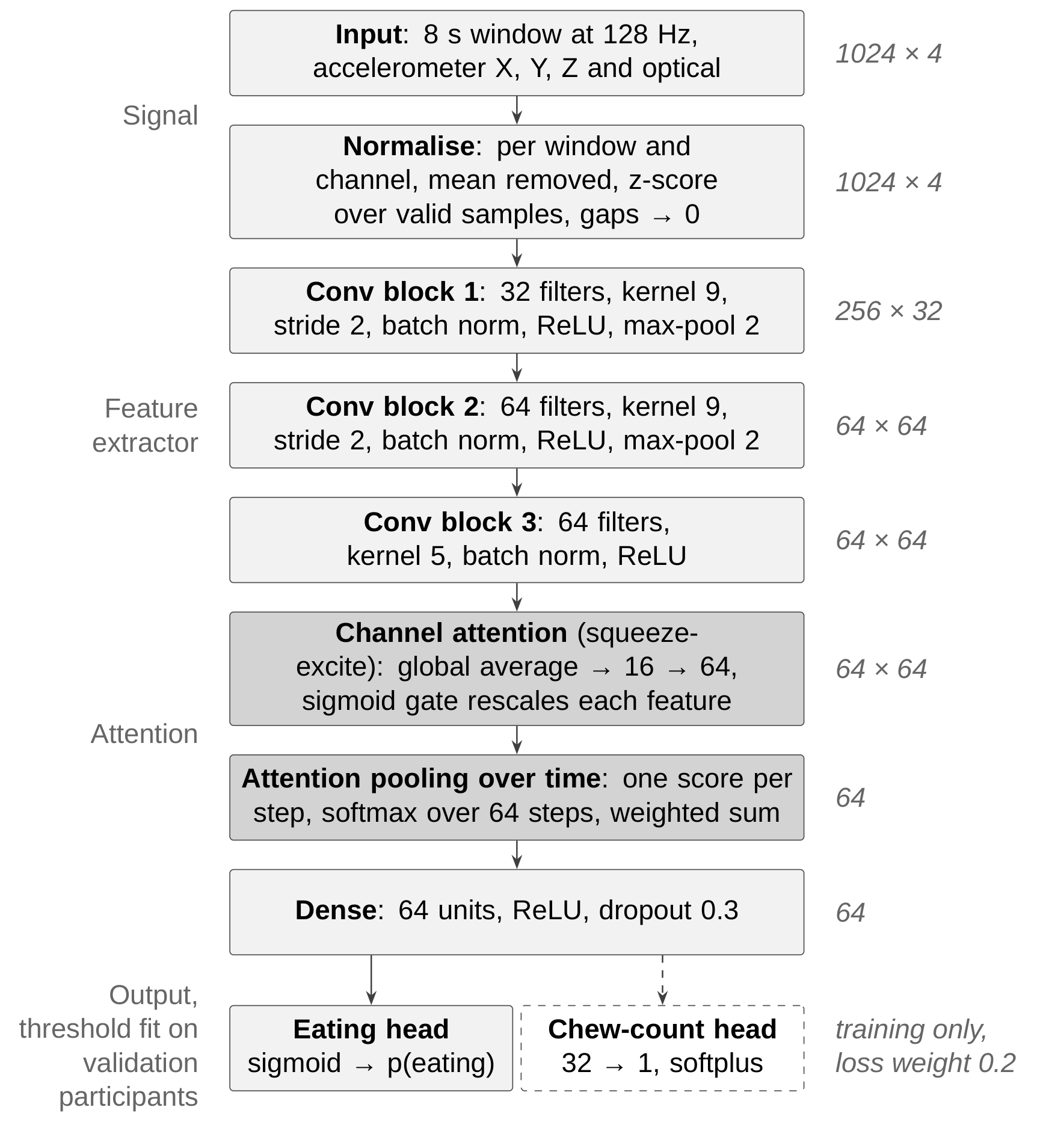
Fig. 1. Model architecture. Shaded blocks are the two attention mechanisms; the dashed chew-count head is trained jointly with the eating output.

D. Training and evaluation
Models were trained with Adam at a learning rate of 3 × 10⁻⁴, batch size 64 and class-balanced sample weights, for up to 80 epochs. Early stopping monitored validation ROC AUC with a patience of 12 epochs and restored the best weights; the learning rate was halved on plateaus. The chew target was divided by its 99th percentile and weighted 0.2 in the loss.
Performance was estimated with leave-one-subject-out cross-validation [11]: 43 folds, each holding out one participant with all of their sessions. Within each fold, five of the remaining participants formed a validation set, used for early stopping and for choosing the decision threshold that maximized F1; the model was trained on the other 37. Each configuration was run with three random seeds. Metrics were pooled over all held-out windows. An eating episode was defined as a run of consecutive eating windows, and an annotated episode counted as detected when at least one of its windows was predicted as eating [confirm the definitions in episode_metrics.py, and the merge gap used for Table III]. Configurations were compared on the same folds with a paired bootstrap over participants and the Wilcoxon signed-rank test; meal types were compared with the Mann-Whitney U test on per-session F1.
Inter-annotator agreement was measured by having a second annotator label one snack session independently and scoring the two annotations against each other on the same 8 s windows [extend to more sessions; see Section IV].

III. Results

A. Window-level detection
Table II gives the leave-one-subject-out results. The model reached F1 0.86 with precision 0.849 and recall 0.870; the three seeds ranged from 0.859 to 0.861. The two annotators agreed at F1 0.912 on the same window definition, which bounds the score that can be expected against a single annotator.
TABLE II. Window-level leave-one-subject-out results (43 participants, 3 seeds).
Metric | Value
F1 | 0.86 (0.859 to 0.861 across seeds)
Accuracy / balanced accuracy | 0.890 / 0.886
Precision / recall | 0.849 / 0.870
Median participant F1 | 0.862
False alarms per hour of non-eating | 43.8 windows
Inter-annotator agreement (one session) | F1 0.912

Performance varied more between participants than between any two configurations (Fig. 2). Four participants scored below 0.70. Review of their video identified chewing in short bursts between speech, soft food (oatmeal) that produced little temporalis-muscle activity, and very short sessions in which a few missed windows dominated the score. Their errors were predominantly missed eating rather than false alarms [recompute the false-alarm count for these participants on the final configuration].
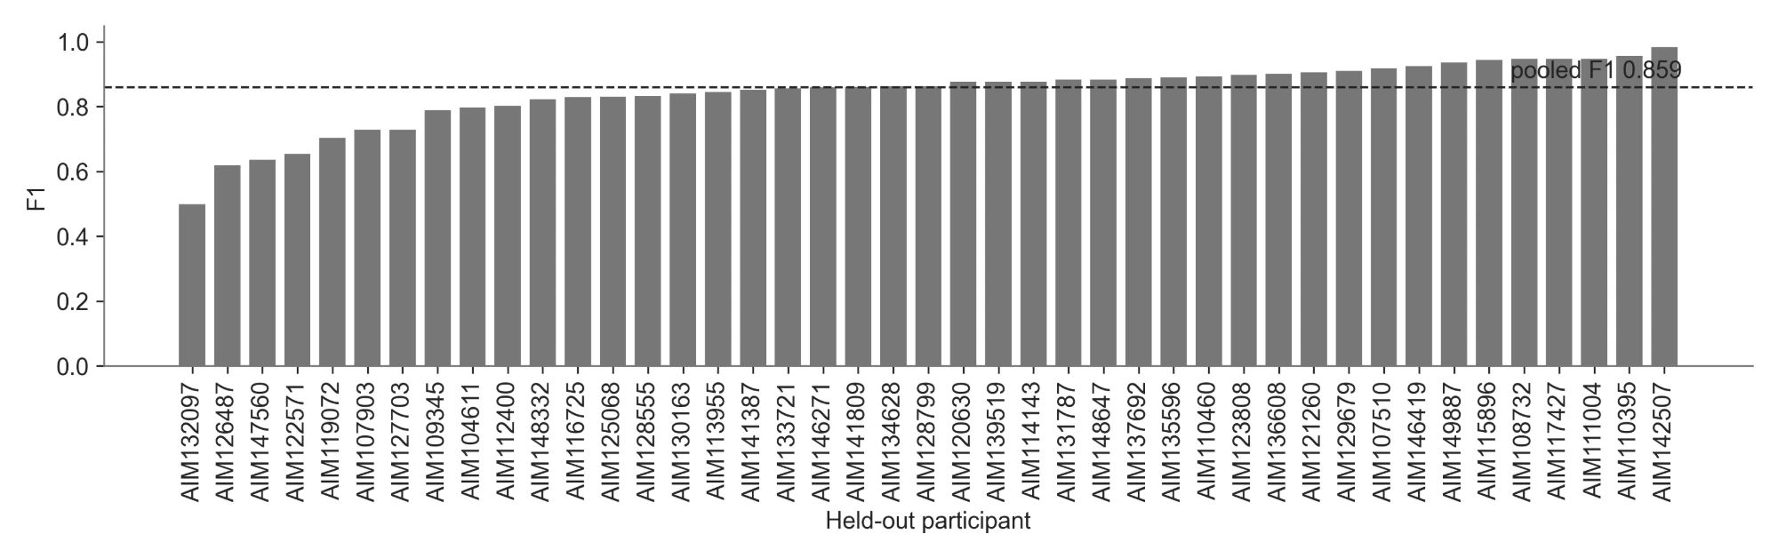
Fig. 2. Window-level F1 per held-out participant, with the pooled F1 as a dashed line. [Replace participant IDs with P1 to P43 before submission.]
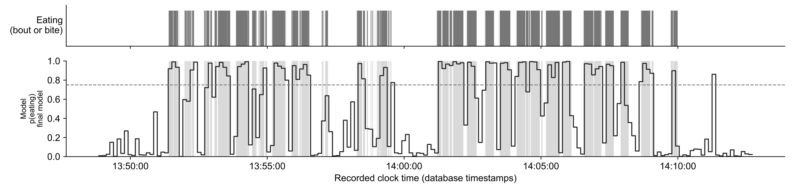
Fig. 3. Example held-out lunch session. Top: annotated eating (chewing bout or bite). Bottom: model probability per 8 s window, with annotated eating shaded and the decision threshold dashed. On this session F1 was 0.886, precision 0.925 and recall 0.849.

B. Episode-level detection
At the episode level (Table III) the model detected 91.9% of annotated eating episodes and every episode of 64 s or longer; the misses fell among short episodes, and 82% of single-window (8 s) episodes were detected. The median delay from the start of an episode to its first detected window was 0 s, and every one of the 60 meals with annotated eating had at least one detection. False episodes away from meals occurred 9.9 times per hour.
TABLE III. Episode-level results.
Measure | Value
Eating episodes detected | 91.9%
Episodes of 64 s or longer detected | 100%
Episodes of 8 s detected | 82%
Median delay to first detection | 0 s
False episodes per hour (away from meals) | 9.9
Episode precision | 87.8%
Meals with any detection | 60 of 60

C. Where errors occur
Most errors lay at the boundaries of chewing bouts: 62% of all errors, including 75% of false-alarm windows and 49% of missed windows, were adjacent to a change in the annotation. Scoring with boundary windows excluded raised F1 to 0.944, and only 19% of false alarms were isolated from any eating [these figures are from one seed of the reference configuration; recompute with the final configuration]. Because an 8 s window that straddles the start or end of a bout is partly eating and partly not, a share of these errors reflects the label resolution rather than the detector.

D. Design comparisons
Table IV compares design choices on the same folds. Replacing the time series with its magnitude spectrum lowered F1 from 0.854 to 0.791 and doubled false alarms, and the time-domain input detected more eating at every false-alarm rate (Fig. 3). Choosing the threshold on five validation participants rather than two raised F1 by 0.008 (95% CI 0.001 to 0.016; 30 participants better, 12 worse; p = 0.004), mainly by stabilizing the threshold for the weakest participants. Other changes, including a recurrent model over two minutes of context, soft labels, a transformer layer, a three-model ensemble and data augmentation, stayed within the seed-to-seed variation of about ±0.007.
TABLE IV. Design comparisons on the same leave-one-subject-out folds.
Change from the reference | Effect on F1
Frequency-domain (FFT) input instead of time domain | 0.854 → 0.791; false alarms 41 → 84 per hour
Five validation participants instead of two | +0.008 [0.001, 0.016], p = 0.004
Eight validation participants instead of five | +0.001 (no difference)
Recurrent model over 2 min of windows | −0.003 (no difference)
Soft labels (eating fraction) | +0.001 (no difference)
Sampling rate 32 Hz / 16 Hz instead of 128 Hz | −0.013 / −0.020
16 s windows instead of 8 s | −0.014 [−0.030, +0.002]

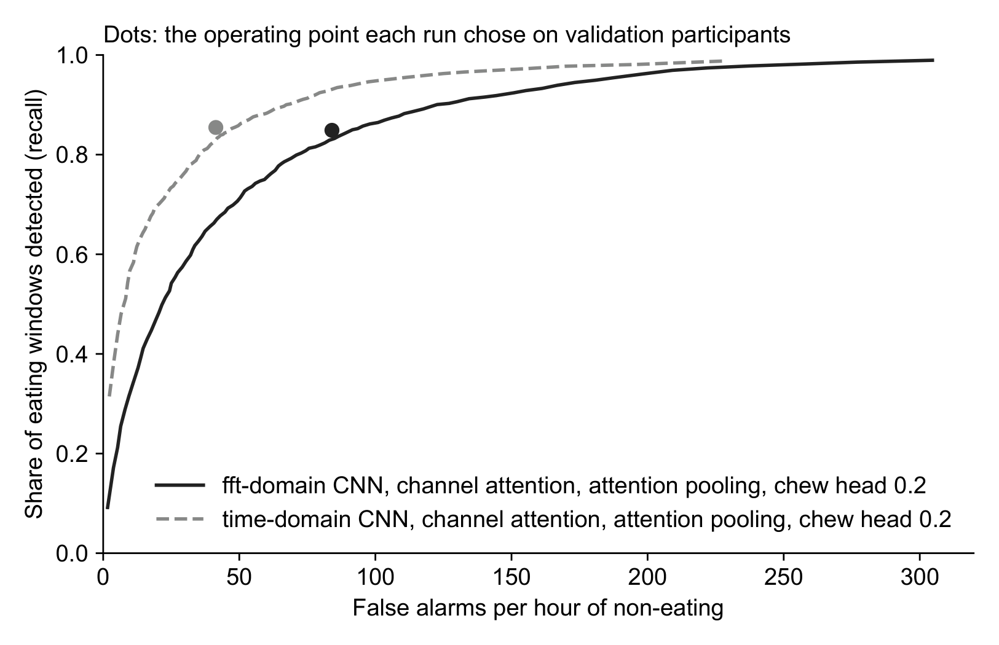
Fig. 4. Share of eating windows detected against false alarms per hour of non-eating, for the same network with time-domain and frequency-domain input. Dots mark the operating points chosen on the validation participants.

E. Meal type
Detection was lower in lunch sessions than in other meals (Fig. 4): median session F1 0.815 against 0.890 (Mann-Whitney p = 0.009), driven by recall (0.819 at lunch against 0.891 to 0.931 for the other meals). Among the nine participants with both a lunch and another session, seven scored lower at lunch (median difference −0.081, Wilcoxon p = 0.10). Median bout length did not differ between lunch and breakfast (16 s), so bout length alone does not explain the difference. Some lunches were eaten alone, so this result concerns meal type, not group eating [test group against solo sessions once the session setting is available].
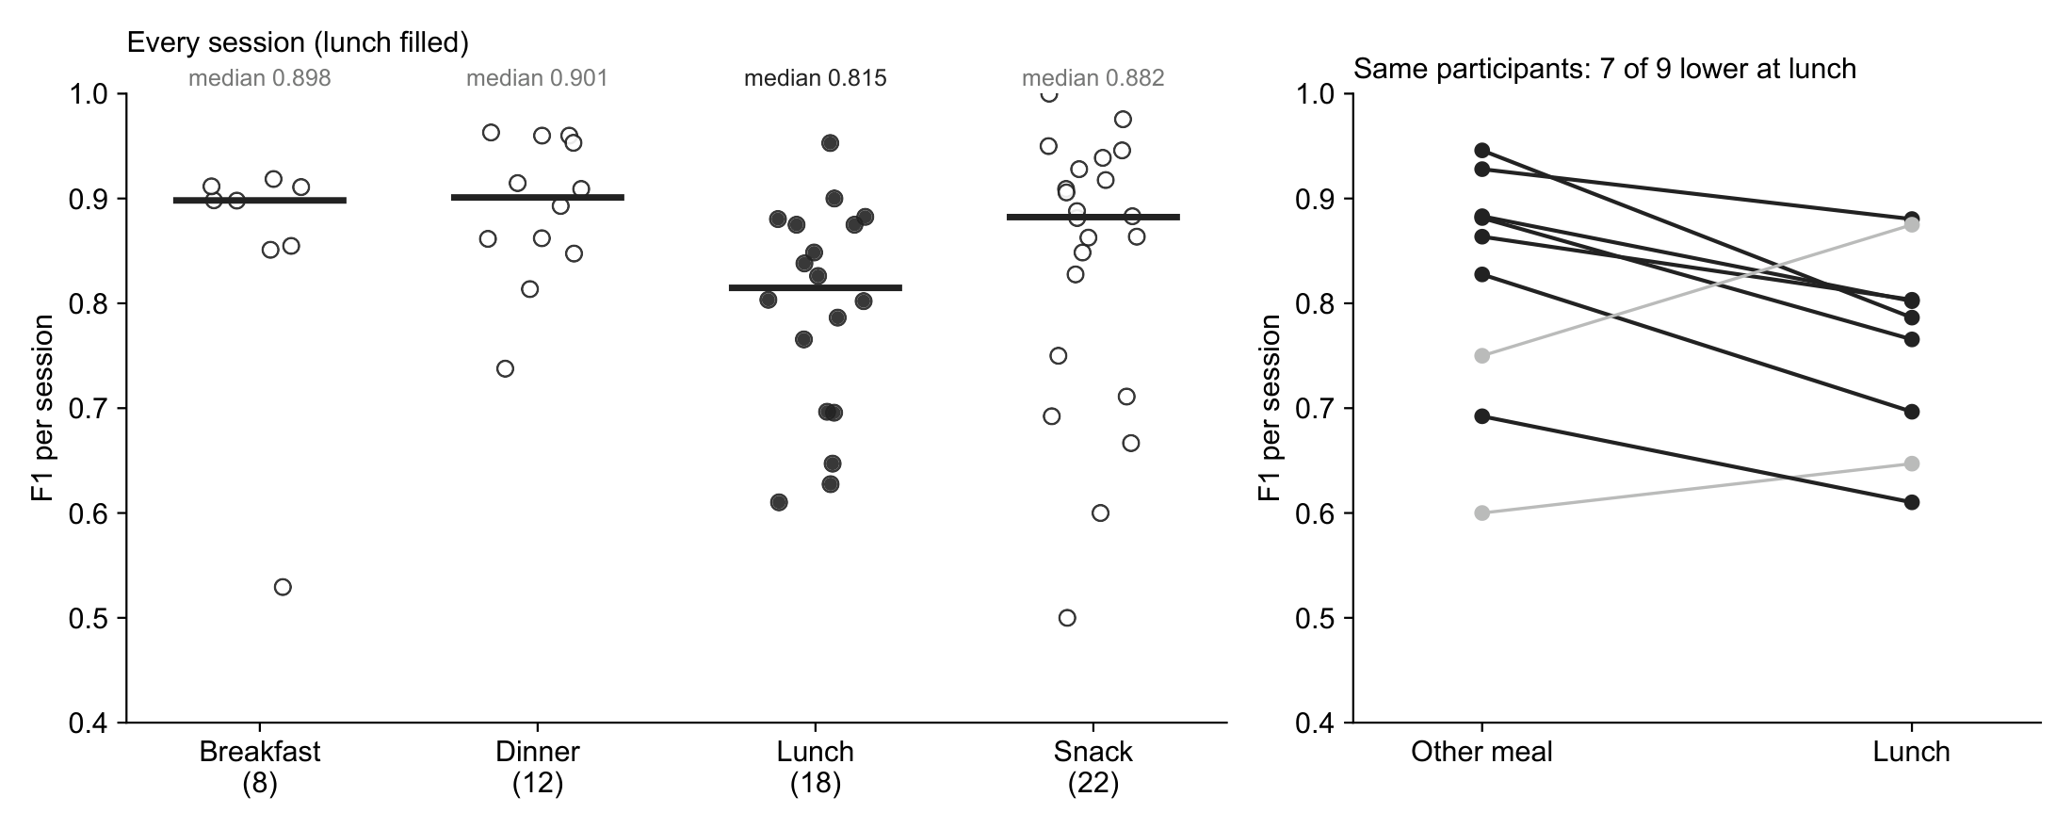
Fig. 5. Left: F1 of every session by meal type, with medians. Right: participants with a lunch and another session; dark lines are lower at lunch.

F. Chew counts and the trained model
The final model was trained once on all annotated participants, with five held out for early stopping and threshold selection (threshold 0.75). On the eight sessions of those five participants, which the model never trained on, median F1 was 0.854, close to the leave-one-subject-out median of 0.862. Applied to all 61 recordings, it processed each in about one second and produced a list of eating episodes with start, end, duration and chew count.
Chews per meal from the auxiliary output agreed with the annotated counts on the eight held-out meals (r = 0.92, median error 14%, 8% undercount), but chewing rate did not (r = −0.23): the model assigned 70 to 100 chews per minute to every meal, while annotated rates ranged from 75 to 130 (Fig. 5). Because the number of chews is the product of eating time and rate, and eating time varies far more between meals than rate, the count is accurate mainly because eating time is.
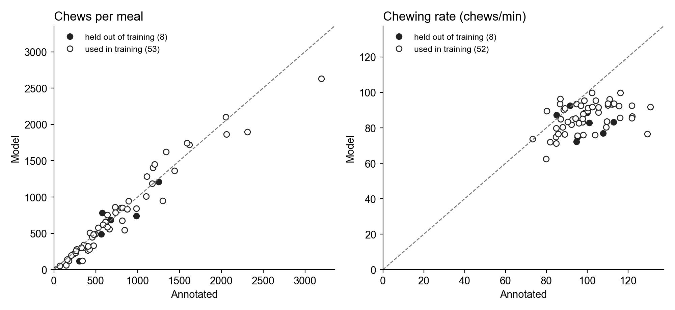
Fig. 6. Model against annotated chews per meal (left) and chewing rate (right). Filled: participants the model never trained on; open: participants it trained on.

IV. Discussion
The model approaches the agreement between two human annotators on the same windows, and its residual errors are concentrated where the labels themselves are least certain: at the edges of chewing bouts and in short, fragmented eating. At the episode level, which is what a monitoring application acts on, every eating episode of a minute or more was found without delay. The 0.86 F1 is not directly comparable with the 0.818 reported for AIM-2 with hand-crafted features [3] or the balanced accuracy of the deep models in [4], since datasets, epoch lengths and protocols differ [re-run a baseline on this dataset if a direct comparison is wanted].
The comparison of input representations indicates that the learned time-domain filters, rather than any training refinement, carry the performance: no other change exceeded the seed-to-seed variation, while the spectral input cost 0.06 F1. The variation between participants was larger than any configuration difference, which supports participant-level validation as the basis for these estimates [11].
The lower detection at lunch is consistent with eating broken up by conversation, which was observed on video for the weakest participants, but the present data cannot separate meal type from group setting, food or session length. The chew results suggest a direct route to chewing rate: the optical signal shows a clear spectral peak near 1.7 Hz during eating, inside the chewing band reported for natural chewing [12], and the peak frequency of each eating window could estimate rate without relying on the auxiliary output.
Limitations. Most sessions were annotated by one person, and agreement was measured on a single session. Windows of 8 s limit the timing resolution at bout boundaries. Decision thresholds chosen per fold varied widely, reflecting differences in the probability scale between fold models [report the range for the final configuration; it was 0.06 to 0.93 with two validation participants]. [Add: study setting relative to free living; number of participants; sessions without eating.]

V. Conclusion
A compact convolutional network operating on raw AIM-2 signals detected eating with F1 0.86 under leave-one-subject-out validation on 43 participants, found every eating episode of a minute or longer with no median delay, and outperformed the same network on spectral input. Errors concentrated at bout boundaries and in lunch sessions. Future work will extend the inter-annotator comparison, estimate chewing rate from the optical spectrum, and test whether eating in groups explains the lower detection at lunch.

Acknowledgment
[Funding source and grant number for the ETS study: ask Dr. Sazonov.] The authors thank Kenzy Nguyen for annotation [confirm].

References
[1] B. M. Bell et al., “Automatic, wearable-based, in-field eating detection approaches for public health research: a scoping review,” npj Digital Medicine, vol. 3, pp. 38, 2020. doi: 10.1038/s41746-020-0246-2.
[2] J. M. Fontana, M. Farooq, and E. Sazonov, “Automatic Ingestion Monitor: A Novel Wearable Device for Monitoring of Ingestive Behavior,” IEEE Transactions on Biomedical Engineering, vol. 61, no. 6, pp. 1772–1779, 2014. doi: 10.1109/TBME.2014.2306773.
[3] A. Doulah, T. Ghosh, D. Hossain, M. H. Imtiaz, and E. Sazonov, “Automatic Ingestion Monitor Version 2 – A Novel Wearable Device for Automatic Food Intake Detection and Passive Capture of Food Images,” IEEE Journal of Biomedical and Health Informatics, vol. 25, no. 2, pp. 568–576, 2021. doi: 10.1109/JBHI.2020.2995473.
[4] T. Ghosh, and E. Sazonov, “A Comparative Study of Deep Learning Algorithms for Detecting Food Intake,” in 44th Annual International Conference of the IEEE Engineering in Medicine and Biology Society (EMBC), pp. 2993–2996, 2022. doi: 10.1109/EMBC48229.2022.9871278.
[5] V. Papapanagiotou, C. Diou, and A. Delopoulos, “Chewing detection from an in-ear microphone using convolutional neural networks,” in 39th Annual International Conference of the IEEE Engineering in Medicine and Biology Society (EMBC), pp. 1258–1261, 2017. doi: 10.1109/EMBC.2017.8037060.
[6] K. Kyritsis, C. Diou, and A. Delopoulos, “A Data Driven End-to-End Approach for In-the-Wild Monitoring of Eating Behavior Using Smartwatches,” IEEE Journal of Biomedical and Health Informatics, vol. 25, no. 1, pp. 22–34, 2021.
[7] Z. Wang, W. Yan, and T. Oates, “Time series classification from scratch with deep neural networks: A strong baseline,” in International Joint Conference on Neural Networks (IJCNN), pp. 1578–1585, 2017. doi: 10.1109/IJCNN.2017.7966039.
[8] J. Hu, L. Shen, and G. Sun, “Squeeze-and-Excitation Networks,” in Proceedings of the IEEE Conference on Computer Vision and Pattern Recognition (CVPR), pp. 7132–7141, 2018. doi: 10.1109/CVPR.2018.00745.
[9] M. Ilse, J. M. Tomczak, and M. Welling, “Attention-based Deep Multiple Instance Learning,” in Proceedings of the 35th International Conference on Machine Learning (ICML), vol. 80, pp. 2127–2136, 2018.
[10] R. Caruana, “Multitask Learning,” Machine Learning, vol. 28, pp. 41–75, 1997. doi: 10.1023/A:1007379606734.
[11] S. Saeb, L. Lonini, A. Jayaraman, D. C. Mohr, and K. P. Kording, “The need to approximate the use-case in clinical machine learning,” GigaScience, vol. 6, no. 5, 2017. doi: 10.1093/gigascience/gix019.
[12] J. M. C. Po, J. A. Kieser, L. M. Gallo, A. J. Tésenyi, P. Herbison, and M. Farella, “Time-frequency analysis of chewing activity in the natural environment,” Journal of Dental Research, vol. 90, no. 10, 2011. doi: 10.1177/0022034511416669.

