This is a rough translation (from Portuguese) by Maria Goncalves, a user of the software.
ECGLAB
A scientific project of Joao Liuz de Caravalho (Electrical Engineer), oriented by the following professors Adson Ferreira da Rocha (Electric Engineer) and Luis Fernando Junqueira Jr (Medical Doctor). University of Brasilia, 2000-2001

- About the ECGLAB
The ECGLAB is software specially developed to analyze the variations of cardiac frequency signals. The program should be used as a toolbox to the MATLAB 5.3, from MathWorks; it requires that the following toolboxes installed: Signal Processing, Image Processing, Splines, System Identification and Statistics. Your video needs to be configured to the following resolution: 1024x768. ECGLAB has the following modules:

  - ECGfilt
    - Opens the ECG signals recorded in the board of ECGCapt (Appendix A)
    - It allows visual imagery and noise filtering of 60Hz of muscular noise and the oscillation of the base line.
  - ECGLabRR
    - It automatically shows/reads R waves, allowing manual correction.
    - It shows/reads the previous ectopic movements. The user needs to verify the readings and correct errors
    - It measures R-R intervals
  - RR outliers
    - Shows graphically a series of intervals obtained from the readings in the previous module;
    - It also allows to import previous series of intervals in the archives (Chapter 5) and saves them in the memory of the ECGLAB to allow for use with other modules
    - Automatically detects the static outliers
    - Allows observation, reading and saving of the ectopic movements in the previous module
    - Allows to select only desired parts of the reading and intervals
  - Temporal RR
    - Presents the interval graph in function of time in function of the movement indexes
    - Presents statistic and temporal indexes, including r-MSSD, pNN50, and the coefficient of variation
    - Determines if the signal is stationary
    - Allows to write message containing patient information in question
  - Spectral RR
    - Does a spectral analyses of the R-R signal through various methods
    - Allows for the division of spectral potency in 3 bands, returning the energy in each band and the reason for high and low frequencies.
    - Calculates the spectral potency through the Tansformada de Fourier, in the auto-regressive model or the Lomb method. For the first 2 methods, you can work with a series of corrected normal intervals or with a signal obtained through the splines interpolation;
    - You can work with an instant cardiac period (HP) or with the instant cardiac frequency
    - It’s possible to choose between 5 types of frequency windows, which act as filters for the spectral potency.
  - Sequential RR
    - Does an analysis of the tendencies of sequential variations of the R-R intervals;
    - Calculates the percentages of differences in each quadrant and also the null differences
  - Poincare RR
    - Presents the plot of the Poincare interval series
    - Calculates vertical and longitudinal deviations in relation to the regressive line or the identifying line;
    - Calculates the reason/time between the deviations, the elliptical area formed by the former, and the coefficients of regression and correlation;
    - Calculates the interval series in the following percentiles 10, 25, 50, 75 & 90
  - ECGLabQT
    - Allows Q and T wave capture in the ECG
    - It’s necessary that the previous RR wave capture in the module ECGLab RR
    - Calculates QTo and QTc intervals
    - A series of the QTc intervals can be analyzed in the same manner in which the R-R wave intervals were analyzed, using the modules Outliers QT, Temporal QT, Spectral QT, Sequential QT, and Poincare QT

The modules of relative analysis are in the HTML format. It is recommended that the use of MS Internet Explorer to print the results. The archives of the relative analysis, as graphs, will be recorded in the directory where the analyzed signal is stored.

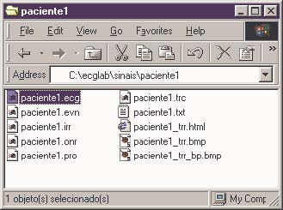

- Installing the ECGLAB
To install ECGLAB, create a directory called: ‘c:\ecg_lab’ and copy the files/archives inside this directory. Next, copy your files containing ECG signals, the R-R interval series and the Q-T interval series in the directory c:\ecglab\sinais(signals)’
To start the program, open MATLAB 5.3 and write/search for cd c:\ecglab

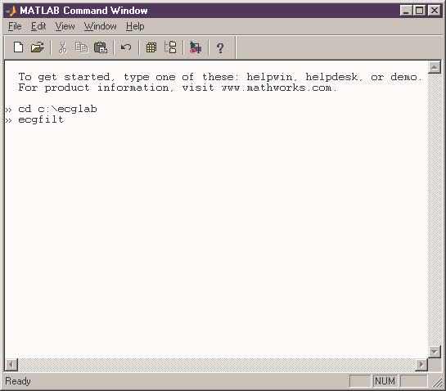

If when you are seeing a graph, and you wish to remove a traced grade helping the visualization of a scale, you can do so in this command screen. All you need to do is type ‘grid off’.

- ECG Filt Module
To start this module, open the MATLAB and type:
cd c:\ecglab
ecgfilt

To open an ECG signal type in the area indicated, the location and name of the ECG file that one desires to open. Click the ‘abrir’ button. If there is an error message, please verify your directory, the name of the file/document, and the extension you are in, are the correct ones. Try once more.

Note: When the ECG document/file is opened, the ECGLAB-RR records/creates a document with the extension ‘.evn’. The document contains a position/picture of the events the ECG found in that time recorded. It uses a fluctuating 32 bits format.

Graph figure No 100:ECGLAB –Filtragem do ECG (ECG filtering)

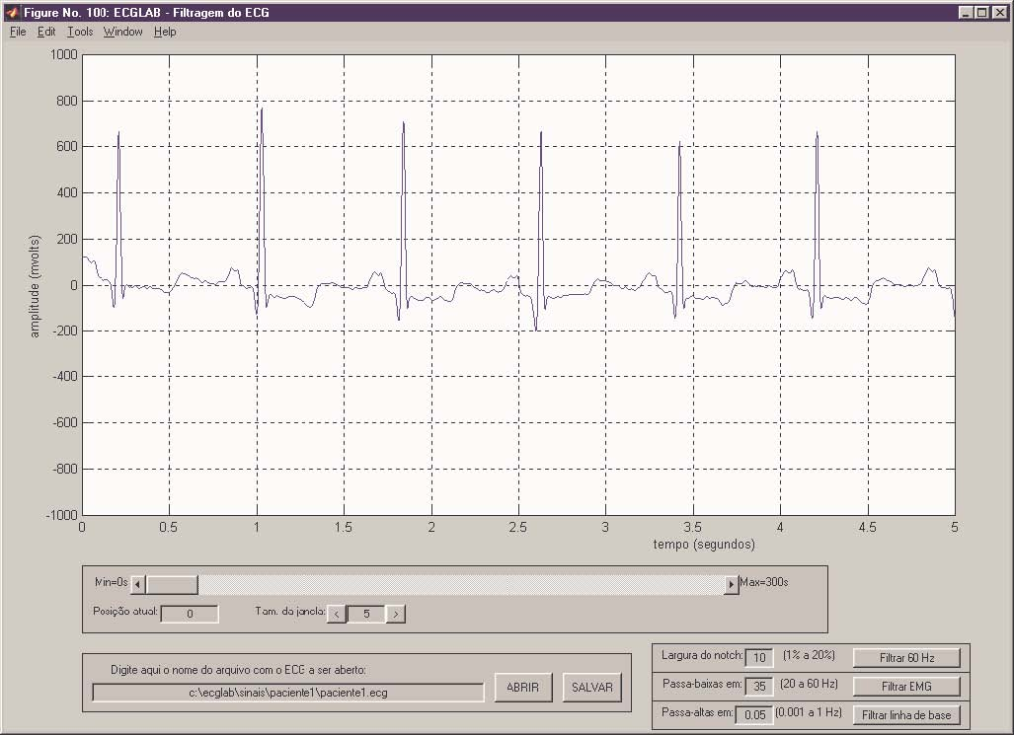

The objective of this module is to first remove the 60 Hz noise the electric grid or muscular noise (EMG) and second, the oscillation of the baseline. To accomplish this, one can use 3 different filters.

The first step is to remove the EMG which is almost always present in the ECG. To accomplish the latter, use the notch filter. The notch filter allows the passage of all frequencies minus the 60 Hz and its harmonics (120 Hz, 180 Hz, 240 Hz, etc.). In the area of the length of the notch, the user can determine the relaxation gird in the 60 Hz zone. With values as little as 1%, the components of 60 Hz are affected. Even though it is the ideal solution, it may not be enough to remove all the EMG interference. If that is the case, attempt to open the ECG again (‘abrir’ button), and increase the length of the notch and filter once more. If you use a length that is too long, the filter will reject it, which will distort the signal. If the latter is what happens, try once more to open the ECG, diminish the length of the notch and filter once more. When you reach a good result, save the signal, clicking in the ‘salvar’ button.

Largura do Notch – Length of the notch chart here
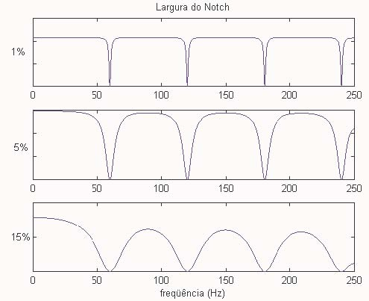

The next step is the echo of the EMG, which has competition from the 20 Hz frequencies. To eliminate this noise, one much apply a filter that passes low frequencies around 35 Hz. Using the closest values to 20 Hz, and starting the filter at the same time as the ECG signal, one can get distorted tracing. Filtering at higher frequencies, one has to be careful because the results may not be truthful. If that is what happens, try to open again the ECG, change the filtering lower frequencies and filter once more (‘filtrar EMG’ button). When reaching a good result, save the signal, clicking the ‘salvar’ button.

Once the noise has been removed, the remaining step is to attenuate the baseline. Since the baseline is of low frequency, this process is completed with a high frequencies filter with a cut point around the 0.1 Hz. Again, with big values (around 1 Hz) distortion starts to happen once more and the results may not be truthful/distorted. If the latter is what happens, try to open again the ECG, change the frequency and filter again. When a good result is obtained, save it.

Note: The high and low frequency filters are 2nd edition Butterworth. The notch filter is constructed technically by placing the zero poles. A zero phase in the 3 filters can be achieved through he forward/reverse filtering.
- ECGLAB RR module
To start the ECGLAB RR, in the command section of the MATLAB type the following:

cd c:\ecglab
ecglabRR

To open the ECG signal, type in the corresponding area the name of the ECG program one desires to open. Click the ‘abrir’ button. If an error message appears, please verify the directory, the name of the program and the extension and try once more.

Figure No 100: ECGLAB – Marcacao das ondas R (scoring the R waves)

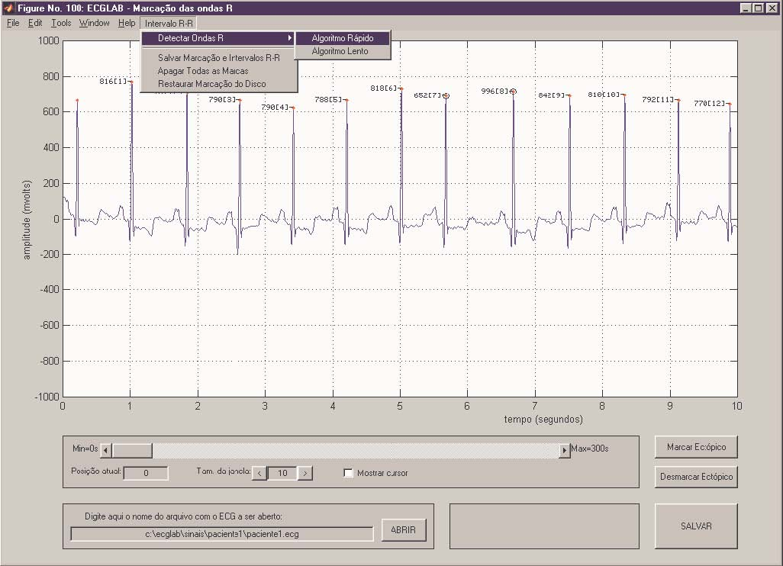

Once the ECG is open, click on the menu ‘Intervalo R-R’ and then the option ‘Detectar Ondas R’ (detecting R waves). At this point one of the 2 algorithms needs to be selected to detect the waves. The rapid algorithm is more efficient in terms of speed, however the slow algorithm makes a considerable better detection of the waves with a lot of noise. It is suggested that you test with the fast algorithm first. If the scoring is not efficient enough for the ECG in question, then try the slow algorithm.

Once the algorithm has been chosen, the ECGLAB will start automatically detecting the QRS complex, and finally, the R waves. This process takes time, and it is not possible to use the MATLAB while the process is taking place. Whichever operation you are realizing in the MATLAB while the wave detection is taking place can cause an erroneous detection. It is possible to use other software programs, but not MATLAB, to run concurrent programs. To interrupt the process, press the CTRL-C and restart the ECGlabRR.

When the detection is complete, a message will appear stating that the detection was successfully completed and small red points will appear over the R waves of the ECG. Save this score with the option ‘Salvar marcacao e intervalos R-R’ in the menu ‘Intervalo R-R’.

To see the value of each interval, change the area value ‘Tam. Da janela’ to 10 seconds or less. The number of points corresponding to the interval index, and the number to the left of each spike corresponds to the duration of the R-R interval in milliseconds.

In conjunction with the R waves' detection, the algorithm does a statistic analysis of the interval series, and scores the outliers as supposed ectopic movements. The outliers appear circled in black around a red dot. The user needs to observe the ECG and very that no errors occurred in the scoring.

To confer/compare the scoring of the R waves and the ectopic movements, change the size of the ECG window in the area ‘tam. Da janela’. With big values the verification is faster, as well as having a bigger section of the signal available in the window. Putting verification in the correction is minor.

When clicking an already existing r wave scoring the ectopic movements, the application is closed. Clicking a region of the ECG now scored, the software scores the point as an R wave. One still has the option to use the cursor (click ‘mostrar cursor’) but this is very slow, so use your computer for faster results. Each scored modification and intervals are re-calculated once more.

With the ‘marcar ectopico’ and ‘desmarcar ectopico’ buttons is possible to correct previous scoring of the static outliers. Verifying that a scored outlier does not belong to an ectopic movement, it should be un-scored/un-marked. On the other hand, when a verified ectopic movement hasn’t been scored, it should be scored. This is a simple process: click in the ‘markar’ or ‘desmarcar’ button and take the cursor to the R wave that one desires to score or un-score as an ectopic movement. Clicking in the R wave (that should already be scored with a red dot), the black corresponding black circle should appear or disappear (as it may be the case) around the scoring of the R wave.

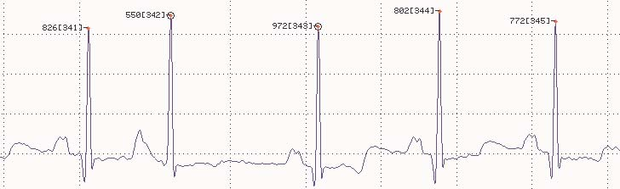

With the ‘<’ and ‘>” buttons, the signal is dissolved window by window. With the bar of rolagem, one can go directly to a more distant place in the signal. With the same end, a value can be entered in seconds, compressed between the ‘Min’ and ‘Max’ indicated on the sides of the rolagem bar, in the area ‘posicao atual’.

The recommended process to correct the R wave scoring is the following:

- Configure the size of the window with a big value, say around 60 seconds
- Start unlocking the signal with the ‘>” button and conferring the scoring
- When finding a scoring error, look at the time in which the erred position is, enter an approximate value in this area in the ‘posicao actual’
- Do a zoom in the signal, entering a small value in the ‘tam. Da janela’, say around 1 or 2 seconds
- Start unlocking the signal with the ‘<’, and ‘>’ buttons until you find the exact point of the scoring error
- With the mouse, stop the erroneous scoring and correctly score where appropriate
- Configure the window size again to return to the big value and repeat the process until the final signal
- Finding ectopic movements that are not scored or circled in black, correct the scoring of the ectopic movements with the buttons ‘marcar ectopico’ or desmarcar ectopico’.
- Save again the new scoring, clicking the ‘salvar’ button.

In the ‘intervalo R-R’ (R-R interval) menu there still exist other options to score the R waves:
  - ‘Apagar todas as marcas’: removes all the R waves signal scoring
  - ‘Restaurar marcacao R-R do disco’: opens the R wave program in the program.
When the R wave scoring is saved, 3 files are generated:
- arquivo.onr: corresponds to the scoring itself. The scoring is saved in complete signals of 32 bits, corresponding to the indexes of the R wave signals of the ECG in question.
- Arquivo.irr: has the R-R intervals done in the time of the interval table, viewed as indexes of the ectopic movements and of the ‘true’ movements that should be considered in future analysis. The first 4 words of 16 bits without signal in the program correspond to the number of intervals, showing in time true and ectopic movements respectively. Following, the R-R intervals are recorded as ‘uint16’, or done in time as ‘float32’. The indexes of true movements are ‘uint16’ as well as the ectopic movements.
- Arquivo.txt: it is a list of the R-R intervals in ASCII. Each interval comes in a line in milliseconds.

Once the R wave scoring is complete, the scoring should be saved. Close the ECGlabRR and go to the next module: Outliers RR. To do so, type the command outliersRR in the Matlab command window. For more information about this, please read the following module.

- R-R Outliers Module
To start this module, in the command window, type:
cd c:\ecglab
outliersRR

To open the saved R-R signal that has been scored in the ECG with this module type in the indicated area the name and location of the file: ‘.irr’ that you desire to open. Click on the button ‘abrir irr’. If an error message appears, verify the directory name, the name of the file and the extension and try once more.

To import a series of R-R intervals in the ASCII, the procedure is the same but one must click on the ‘abrir ASCII’ button. The file must be typed in a way that shows each interval in an individual line and without skipping lines. Examples of the R-R signal in the ASCII text done by the ECG lab show as follows:

814 | 1340, | Q: Qualified QRS | A: Atrial Ectopic
788 | 1360, | V: Ventricular Ectopic | Z: Artifact
790 | 1290, | Start time:11:05
788 | 1330, ESV | First beat time:11:20:00.304
762 | 1400, | End header
 | 1330, | Q818
 | 1290, | Q897
 |  | Z901
 |  | Z886

The objectives of the ASCII file are:
- To view the series of intervals made in the previous module
- To import series of intervals in the files and saving them in the memory of the ECGLAB to use the series in other modules.
- To observe and score abnormal movements that were not captured in the previous scoring.
- To select only a section of the interval series, if one desires.

When opening a series of intervals, the interval graph appears in the window. The black points correspond to the movements classified as normal in the previous module. The red points correspond to the ectopic movements. If one observes an error in the scoring (ectopic or normal movements misclassified as the other), the scoring can be corrected by clicking the button ‘marcar/desmarcar intervalo com mouse’. It will then be sufficient to take the cursor to the desired interval. To un-score all the ectopic intervals (classify them all as normal), click on the ‘limpar marcacao’ button. To save the scoring, click on the ‘salvar marcacaoes do intervalograma’. When doing the latter, the ectopic movements should appear as red dots outside the normalR-R signal in blue.

The system still has an automatic detection: ‘deteccao automatica’. This algorithm first undoes all the previous scoring. Next, it scores the static outlier values as ectopic movements in the series in question.

Attention: When scoring in the graph interval table an interval as an ectopic movement, either manually, with your mouse or automatically, one needs to verify in the ECG tracing that the scoring is indeed an ectopic movement. To do this, save the scoring and note the indexes of each interval. Next, close the outliersRR and return to the module ECGlabRR. Verify, in the scoring of the ECG that the movements scored with a red or black dot are indeed ectopic movements. If this is not the case, un-score the movements (‘desmarcar ectopico’ button) and save once again the R-R wave scoring. To more easily locate the scored intervals, look for the indexes that were scored, as suggested before.

Figure No 100: ECGLAB – Marcacao does Outliers GRAPH HERE
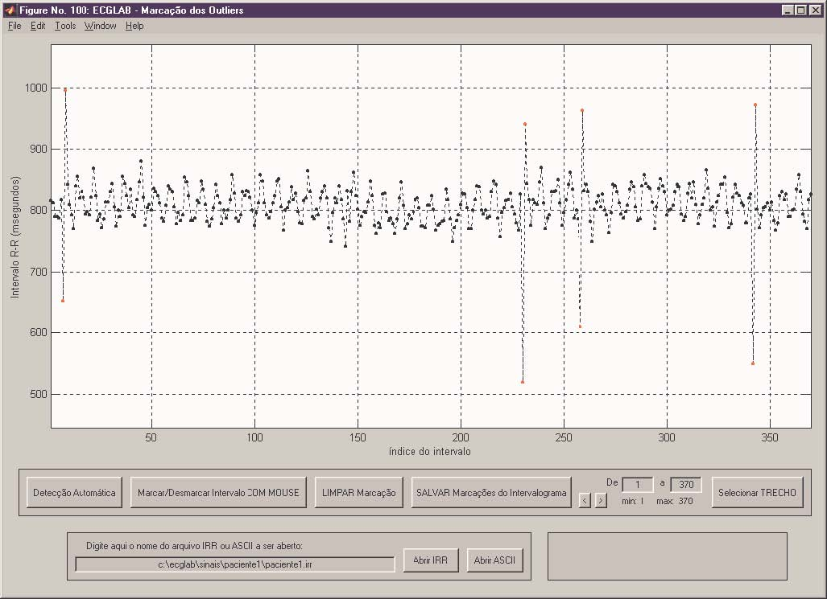

To facilitate a visual image of the big intervals, use the area of ‘de_a_’. If a window was defined, with say 100 intervals, when one presses the keys of ‘deslocamento’ a window will open with the 100 intervals in it.

In case one desires to use only a small stretch of the analysis of the cardiac frequency variability, proceed in the following manner: indicate and visualize the stretch using the ‘de_a_’ command. Next, click the ‘selecionar TRECHO’ button. If the result left is what you want, save it. If you desire to obtain the original series, click the ‘abrir IRR’ or the ‘abrir ASCII’ button. Once you save a stretch, the original series will only be accessible again when re-doing the R wave scoring in the ECGlabRR module.

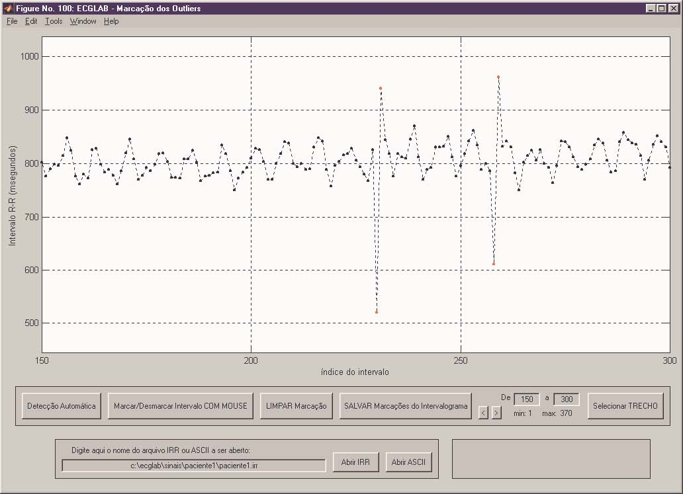

Attention: the scoring and selections in this section are saved in the IRR format, the same as with the original document text saved. Therefore, this module should be used to validate a series of intervals in the archives/files. Starting here, start working with the series in the IRR format in the other modules. By doing this, one saves time as well as guarantying that the series analyzed do not contain ectopic movements.

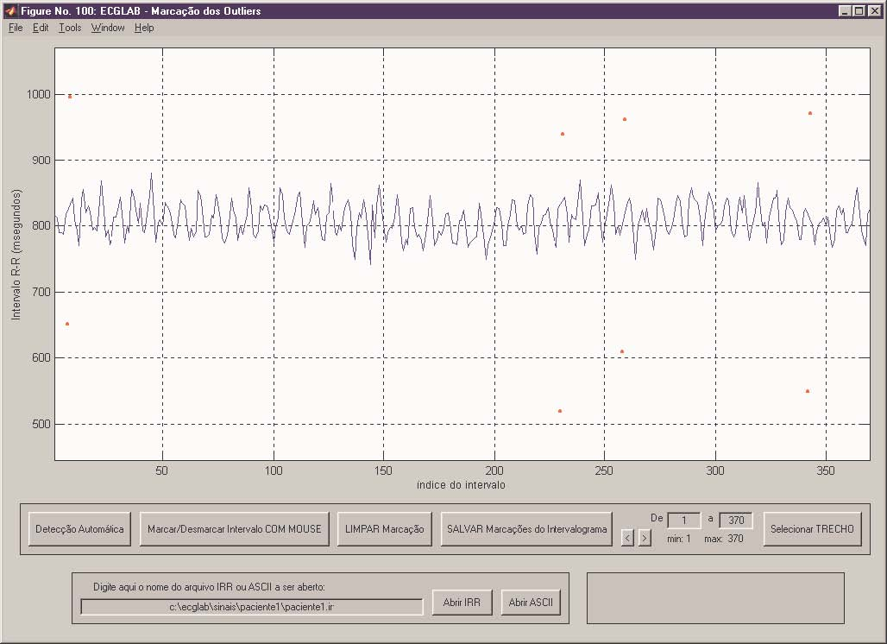

- Temporal RR Module
To start the temporal RR module, type in the command window of MATLAB the following:
cd c:\ecglab
temporalRR

To open a signal in the IRR format type in the indicated place the name of the ‘irr’ file that you desire to open. Click the ‘abrir RR’ button. If an error message appears, please verify that the directory, name of the file and extension are correct and try once more.

Here you can also import a series of R-R intervals in the ASCII text format. The procedure is the same as in chapter/module 5. Once again, we reinforce the message that you should not import files from the analysis module. Instead of the latter, try to make the import in the RR Outliers module. Once a series of intervals has been analyzed and validated, save it in the module in which you did this, and in this module, you can utilize the option ‘abrir RR’. In this manner you save time and also guarantee that the analyzed series doesn’t contain ectopic movements.

When opening a signal, a graph automatically of the R-R series opens. The events scored during the acquisition of the ECG (with the ECGCapt program) show as a vertical green line indicating the instant in which the event occurred. The program presents a schematic design of the statistics of the interval series, in which the ‘x’ indicates statistical outliers, the red line indicates the median and the blue lines indicate 1o and 3o quartile of the series. Disabling the ‘outliers; option in the controls, the outliers will not show as x’s, instead they will show as normal intervals in the series.

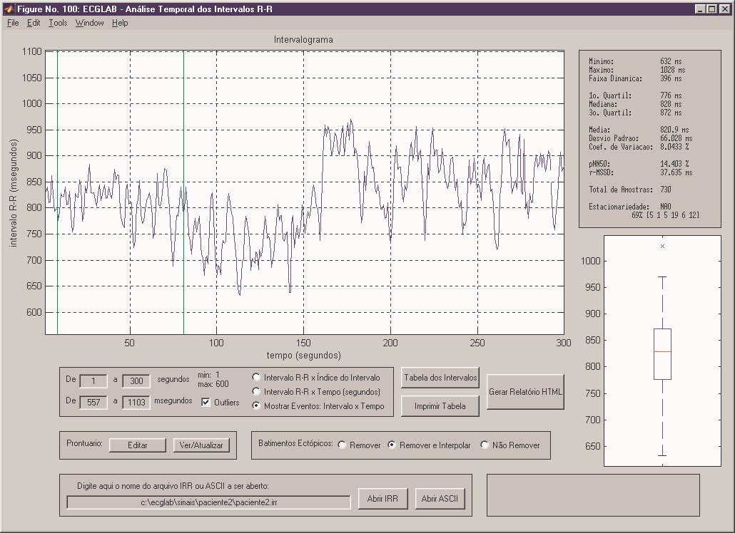

In the controls, the user has the option to adjust the graphics’ scale in the ‘de_a_’ area. Note that the minimum and maximum values for x are represented in the graph. It is possible to choose in between 3 presentation formats for the graph: intervals in function of the index of movement, intervals in function of time, and intervals in function of time plus showing the scored events in the acquisition lines with green vertical lines.

The user can choose between 3 different versions of the interval series: the original series, including the original movements that were scored as ectopic; original series without the ectopic movements; a corrected series, substituting the ectopic movements with values calculated by interpolation. The latter can be done in the area ‘batimentos ectopicos’, choosing one of the 3 options: ‘nao remover’ (don’t remove), ‘remover’ (remove) or ‘remover interpolar’ (remove interpolarization).

Besides the graphs, the following temporary indexes are calculated:
- Total intervals, smallest interval, biggest interval, and the excursion
- 1o quartile, median, 3o quartile, average, deviation and coefficient of variation
- pNN50 and r-MSSD
- Validation of the stationary

The pNN50 is an index that presents the differential percentages between consecutive normal intervals that exceed 50 ms. The r-MSSD, if the root square mean of the standard deviation, and it is a measure of the variation of duration of the consecutive R-R intervals. It is the following equation.

rMSSD = ^{i} 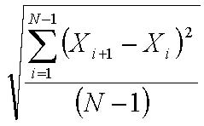
The validation of the stationary, besides stating that it is the stationary signal, presents its numbers in the following formula –X% [a b c d e f]. To calculate, the series is divided in 3 segments of equal sizes; in this form one compares the measure/size of each of these segments. The formula is as follows:
- a = 100. (median of the 1st segment – median of the 2nd segment)/median of the 2 medians
- b = 100 (median of the 2nd segment –median of the 3rd segment)/median of the 2 medians
- c = 100 (median of the 1st segment – median of the 3rd segment)/median of the 2 medians
- d = 100 (deviation of 1st segment – deviation of 3rd segment)/median of the 2 deviations
- e = 100 (deviation of the 1st segment – deviation of the 3rd segment)/median of the 2 deviations
- f = 100 (deviation of the 1st segment – deviation of the 3rd segment)/median of the 2 deviations
- X is a validation of the stationary grade of the series, and is obtained with the basis on the previous 6 indexes. The bigger the percentage, the higher the stationary level of the series.

In this module it is possible to edit or visualize the patient’s readings. To edit, click the ‘editar’ button. A window in the WordPad will open, showing a format in the memory. Fill out the format and you finish, save it to the file text. Next, click the ‘ver/atualizar’ button and check that the data you entered is correct. The data will stay in the formulary related in HTML that will generate an analysis of the data. The same formulary will also be used in the rest of the modules in the following analysis.

To generate the formulary, you can press the button ‘gerar relatorio HTML’. The document will appear with the data you entered, and all the graphs and indexes obtained in this module. The formulary needs to be opened automatically once the temporal RR generates it (the process takes some time). It is recommended that you use the internet as your link. In the operational system (windows 98) the program was tested, the ECGLab can automatically open the formulary. If this doesn’t happen, you still can open a formulary manually. The file attachment in the HTLM will have a directory where you can locate the RR intervals that were opened. The figures with the graphs will also be in the same directory, either in a file ending .BAT or internet explorer. The name of the HTLM file with the formulary will be ‘xxxxx_trr.htlm’, and the name of the file with the intervals.

This module has 2 more options. With the button ‘tabela dos intervalos’ (interval table), the user can see a table with the RR intervals within the graph. In this table, the intervals show in lines. With the button ‘imprimir tabela’ (print the table), the ECGlabRR opens the table in the WordPad thus allowing printing. Please note that the HMTL already open already contains the R-R intervals as well as the instances of movements. In the HMLT the movements were obtained due to the removal of the ectopic movements, the movements will show with ‘0’.

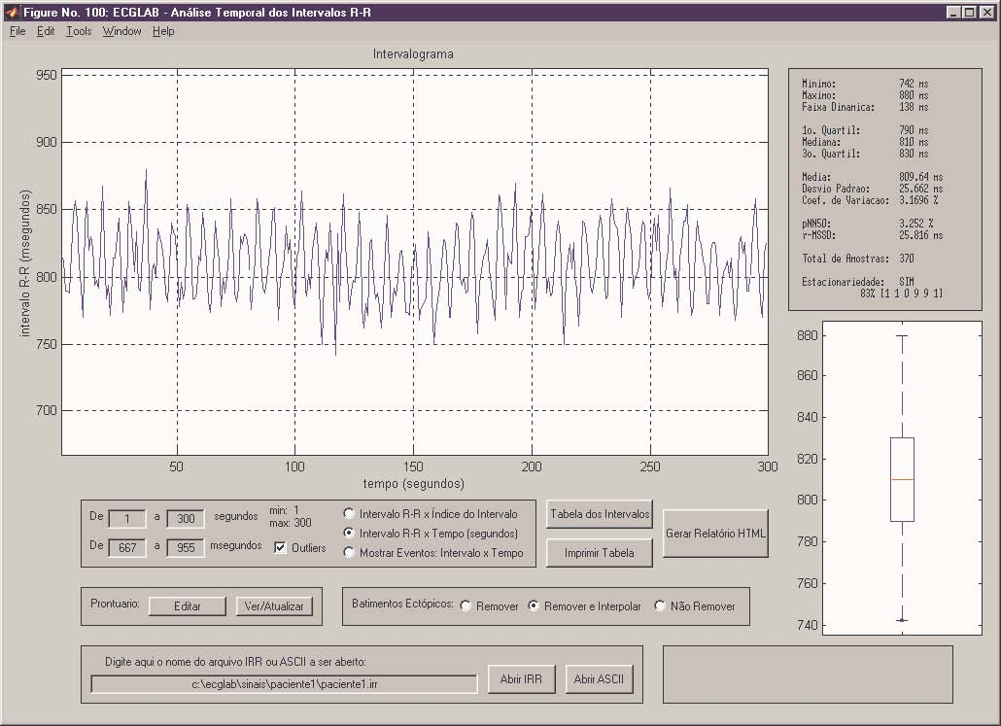

Note: The temporalRR records a file with extension ‘.trc’ that contains the RR wave analysis information in question. The ‘.trc’ file takes the following records:
The first 4 bytes correspond to a string of 4 characters determining the bases of the interval graph. It can be, time, beat, or event. The following byte is a character that determines which time unit is used. It can be ‘s’ (seconds), or ‘i’ (intervals). Next 4 32 bits, corresponding respectively to the variables eixox1, eixox2, minimum x, limit x that help in the scoring of the graph. With the same goal, 2 more 16 bits follow respectively eixoy1 and eixoy2.

- Espectral RR Module

To start this module, in the MATLAB command window, type:
cd c:\ecglab
espectralRR

To open the signal in the IRR format, type in the indicated area the name of the ‘IRR’ file that you desire to open and click on the button. If an error message appears, please check that you have chosen the correct directory, name of the file, and correct extension and try once more.

In this module you can also import an R-R wave series of intervals in the ASCII format, the procedure is the same as in chapter 5. Once again, it is reinforced that you do not import signals from the analysis modules. Instead of that, try to import in the OutliersRR module. Once you have analyzed and validated a series of intervals, save that scoring in the corresponding module, and in this module, use the option ‘abrir IRR’ (open IRR), once you have you have saved the scoring in the outliersRR module because it saves as well in the IRR format. In this way, one saves time, besides guaranteeing that the analyzed series does not contain ectopic movements.

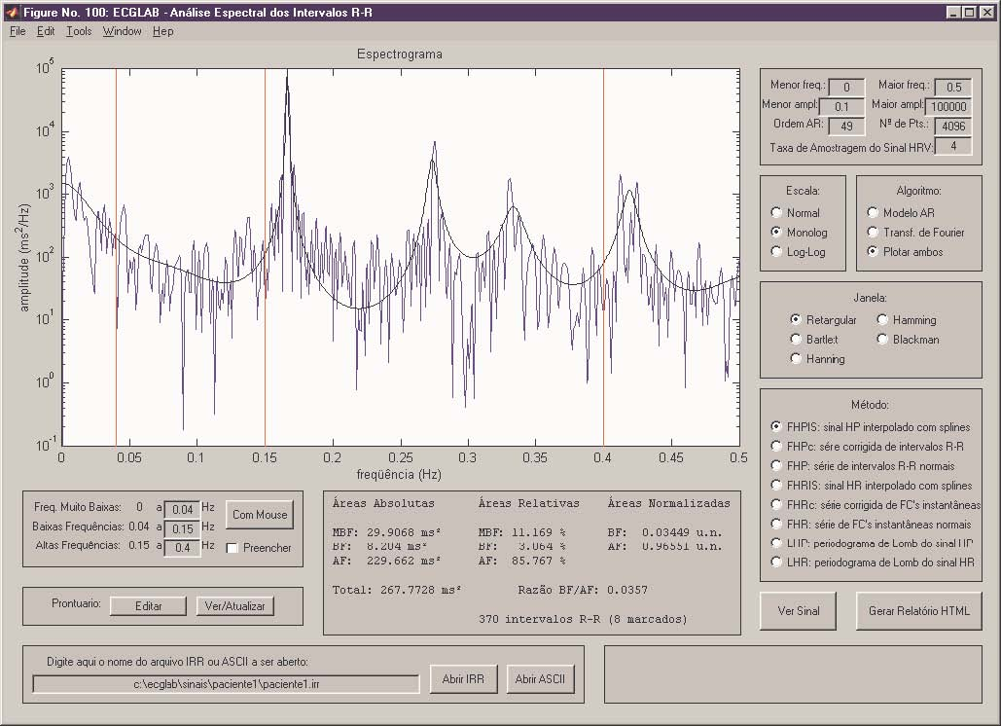

Once you have opened the signal, a graph of the expectogram(?) will appear. There is a series of controls that help better visualize the information. The first adjustment that one needs to do is limit the length of the frequencies, entering in the areas of ‘menor freq.’ and ‘maior freq.’ the frequency values in the start and end of the graph. This limitation, even with the limitation of the amplitudes does not influence at all the calculus of the areas of each band.

It is necessary here to give a little advice about regulating the amplitudes, especially when one is observing the algorithm of potency. Instead of entering a number like 0.0045, it can be entered as a number of scientific notation (4,5 . 10-), or one can use 1 or 2 as an example.

Continuing, it is possible to choose the number of points in the graph. A Fourier transformed is more sensible an option for such modifications in the graph. The higher the point number, the higher the resolution will be. On the other hand, the graph will be more irregular than originally. The values used are always in the 2 potential. When one is working with the auto regressive model, there is also the option ‘ordem AR’. The bigger this number is the closer the graph will look like the real potency is. The biggest number it will accept is 150, this parameter can easily be changed in the code ‘fonte da funcao’. When one works with R-R signals that are uniform through the interpolation, one can determine a new way to show the data. According to the criterion Nyquist, the potency expectrum can only be visualized until the half of the frequency showing in the program. A very low frequency can cause ‘aluasing’, or expectral super-positioning. Because of this, it is recommended that you work with values between 1 and 4 Hz.

The scare of the axis of the graph can easily be modified, choosing between a log-log, monolog, or normal graphing. None of the previous choices influences the band calculation; they simply offer alternatives to visualize the data. It can be useful to type the command ‘grid off’ in the command window when using a logarithmic scale.

The IRR expectral allows the visualization of the density of the strength in the R-R signal in 3 ways: through the autoregressive model; the ‘transforma rapida de Fourier’ or both graphs super-imposed on one another. The Lomb method is also available, but it will discussed further along. Choosing the algorithm is easy in the algorithm control, however, the choice of algorithm will interfere directly with the values of each band. Therefore note that when you want to visualize both graphs, the autoregressive model is used in the calculations of the bands. In this case it is necessary to choose an adequate order for the AR model so that the graph will approximate the real potency density.

The other option to calculate the expectogram is the type of window used. The potency density expectrum is calculated with infinite signals or periodical signals. Since the R-R signal is not periodic, and we do not have an infinite signal segment, it should be considered that we are working only with a section of the signal that in practice is infinite or the size of the life of the patient. When this happens, it is obvious that this is the reality of all systems that process digital signals, it is assumed that one is working with a window of infinite signals. This segmentation therefore distorts the potency of the density expectrum. For distortion to be absent, we would have to work with a rectangular window that is infinite. It is not possible since we only have a section of the signal, but with the variations the window format, the intensity and the distortion levels vary as well. A rectangular window is the basic window of most systems. With the rectangular window, the signal will be represented as if it was an infinite signal, corresponding to a section of the signal, that is infinite. The other windows give more weight to the elements of the section that are closer to the middle of the section. The elements in the extremities receive lesser weight, trying to minimize the effect of the signal trunking that happens. The form of the window determines how the weight is distributed. With the rectangular window all the elements receive a weight of 1. The value starts to decrease linearly as the signals approximate the extremities. With the Hanning, Hamming and Blackman windows, the reduction is not linear, but it does follow and equation that has a constant of decreasing value through a trig metric formula. The practical issue of choosing a window is that each window gives a different version of the expectrum potency. Experimenting with different windows, one can choose the most appropriate one for the signal in question.

There are other methods to treat the distortions in the determination of the potency expectrum. The distortions can be caused by the problems with the un-uniform show; characteristic in the variability signals of the cardiac frequency, like the presence of ectopic movements is the non-linear response of the heart to the stimuli from the nervous system.

The most utilized form to correct the problem of show is to interpolate the signal with splines and showing it again in a constant. It can also be assumed that the show was made with a constant signal and to use a proper series of intervals to calculate the expectrum, which will generate certain distortion. In relation to the ectopic movements, in this case they can be substituted by for more reasonable values or simply removed, which will cause even greater distortion in the expectrum.

Another solution that removes the need for interpolation is the ‘periodograma de Lomb’. The problem is that with this method the amplitude of the potency expectrum will be given in normalized values; besides the impossibility to use the AR model or the transform of Fourier with this method. The Lomb method is slower than other method that is why it is not recommended for use. It is of value to say that with the splines or with the Lomb method, the ectopic movements are removed without causing major distortions in the expectrum.

The other factor to consider is that the heart’s response to the nervous system stimuli isn’t linear. Since we are using the cardiac period to verify the nervous system function, the non-linear method generates further distortion. The distortion can be reduced using a 1/RR: a series of cardiac frequencies corresponding to each RR interval in function of time. In this case, the energy will be given in b.p.m.(squared) instead of the ms(squared).

All the above options are at your disposal in the area called ‘metodo’, and they are:
- FHPIS: a serie of RR intervals is interpolated with splines and re-showed with a uniform measure for the expectrum calculation using the auto regressive or transformada de Fourier.
- FHPc: there is no signal interpolation, but the scored RR intervals as ectopic movements are substituted with values that will cause lesser distortion.
- FHP: the ectopic movements are simply removed from the series, which creates distortion.
- FHRIS: it is the same as FHPIS, but it uses cardiac frequencies instead of cardiac periods
- FHRc: it is the same as theFHPc, but it uses cardiac frequencies instead of cardiac periods.
- FHR: same as the FHP, but it uses cardiac frequency instead of cardiac periods.
- LHP: uses the Lomb method to calculate the expectral signal. This is a slow method and it uses amplitudes that are not normalized.
- LHR: same as LHP, but it uses cardiac frequency instead of cardiac periods.

There are 2 ways to limit the frequency bands of the expectral analysis: Typing or clicking with your mouse. To enter the values manually, look for the areas that say ‘freq. muito baixas’ (ver low frequencies) and ‘baixas freq’ (low frequencies), and ‘altas freq’ (high frequencies) and enter the desired value in each. To enter the values with your mouse, click in the button ‘com mouse’, and click 3 times with the cursor over the graph. Each click will highlight a frequency band in the graph. Clicking the option ‘preencher’ each energy band will highlight in different colors.

As one alters each option in described in this chapter, one needs to keep in mind that the differences are not only present in the graph, but are also present in the expectral indexes presented. They are: absolute areas of each bang; the absolute total area as well as the 3 bands; relative areas of each band, in total percentage of the 3 bands; normalized areas of the low frequency (BF) and high frequency (AF), in total percentage of both bands; reason BF/AF; the total R-R wave intervals and the number of scored ectopic movements.

In this module it is possible to still do some more editing of the patients readings. To edit, click the button ‘editar’. A WordPad window will open, showing a formulary. Fill out the formulary, and when you are done, save the file. Next click in the button ‘ver/atualizar’ and confirm that the data you entered is correct. The data will be saved in the HTML file that will be generated with the data of this analysis. The same formulary will also be used in the following modules.

To generate the history formulary, click the ‘gerar relatorio HTML’. The document will have all the data entered, the expectogram and the indexes obtained in this module. The file needs to be opened immediately as soon as the Expectral RR finishes creating it (the process takes some time). We recommend that you use internet explorer as the attachment source. In windows 98 the ECGLab can open this file automatically. If the file does not open automatically, you can still open it manually. The file will be saved in the same directory where your RR interval files are. The graph will also be in the same directory, as a .bat file to open with internet explorer. The name of the file will be ‘xxxx_frr.html’, where xxxx is the name of the file with the intervals.

Also, this module has the option to see the R-R signal graph with the deleted ectopic movements with the option ‘ver sinal’.

Note: when an R-R signal file is open, the ExpectralRR saves the file with the extension ‘.frc’, containing information regarding the expectral analysis in question. The file ‘.frc’ follows this path:
The first 6 given are numbers of 16 bits without signal, corresponding to the frequencies of each band, the minimum and maximum frequencies plotted and the values of the R-R signal, respectively. Since the values are not complete, before they are saved, they are multiplied by 1000. The following 2 numbers are also 16 bits without signal, corresponding to the order of the auto regressive model and the number of points of the potency expectrum. Following 2 numbers in 32 floating bits correspond to the minimum and maximum length plotted. Following, 3 letters, corresponding to the algorithm: ‘mar’ (AR model), ‘fft’ (Fourier transformed), or ‘amb’ (both). The following 5 characters correspond to the method used, which will be described further ahead. The 3 next letters correspond to the window used: ‘ret’ (rectangular), ‘han’ (Hanning), ‘ham’ (Hamming), ‘bla’ (Blackman) or ‘bar’ (Bartlett). The last character corresponds to the scale used in the graph: ‘n’ (normal), ‘m’ (monolog), ‘l’ (log-log).

- Sequential RR Module
To start this module, in the MATLAB command window, type:

cd c:\ecglab
sequencialRR

To open the signal in the IRR format, type in the name of the file ‘.irr’ that you desire to open. Click the ‘abrir IRR’ button. If an error message appears, please verify that you’ve used the correct directory, name of file and extension, and try again.

Here one can also import a serie of R-R intervals in the ASCII format. The procedure is the same as described in module 5. We reinforce again that you should not import files directly from the analysis modules. Instead, import from the Outliers RR module. Once a series of intervals has been analyzed and validated, save the data in the corresponding module, and in this module, use the option ‘abrir IRR’. The IRR scoring is saved that module in the IRR format. This way, you can save time besides guaranteeing that you are analyzing a series without ectopic movements.

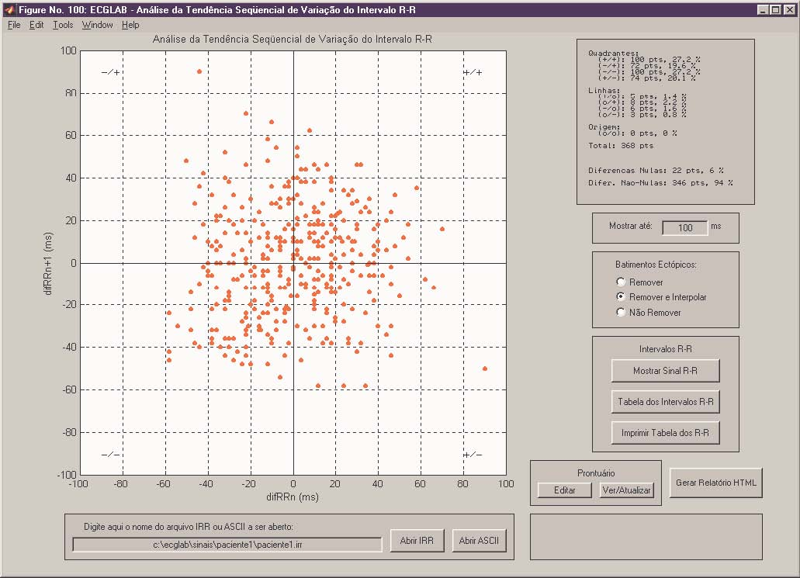

Once you have opened the signal, it’ll present itself in a graph type ΔRR_{n} x ΔRRn+1 (the ΔRRn is the difference between 2 RR interval sequences and ΔRRn+1 is the next difference, meaning each point in the graph will start from the differences between 3 consecutive RR intervals). To change the graph’s scale, just edit the area ‘mostrar ate X ms’.

The user can choose between 3 versions of the interval serie: the original serie, including all the scoring, even the ectopic movements; an original serie without the ectopic movements; a corrected serie substituting the ectopic movements for intervals with calculated values through interpolation. The latter can be done in the area ‘batimentos ectopicos’, choosing one of 3 options: ‘nao remover’ (don’t remove), ‘remover’ (remove), or ‘remover e interpolar’ (remove and interpolate).

The following indexes are obtained: the number of points in each quadrant and their percentages; the number of points in division line of the quadrants and percentages; the number of original points and their percentages; the total of differences that aren’t null and their percentages. The points classified as null differences are those that fall over the division lines of each quadrant or over the origin of the graph. What this is means is that points that have coordinates of zero indicate that there is no difference between intervals so they are null. The points that are classified as differences are those that are inside one of the 4 quadrants.

With the above indexes as a base, it is possible to determine which area of the nervous system is acting with more intensity, the points in the quadrant +/+ indicate diminutions of the cardiac rhythm (longer intervals) and points in the -/- quadrant indicate increased cardiac rhythm (shorter intervals), meaning the parasympathetic and sympathetic activity levels respectively.

In this module, you can edit area of the nervous system or visualize the client’s formulary. To edit, click the ‘editar’ button. A window in wordpad will open, showing the directory formulary format. Fill out the formulary, and when finished, save the file. Next, click the ‘ver/atualizar’ button and confirm that the data entered was correct. The data will be in the HMLT that automatically generates in this analysis. The same formulary will be used in the following analytic modules.

To create the formulary, just click the ‘gerar relatorio HTML’ button. The document will show the data entered, the graph and the indexes obtained in this module. The file should open automatically once the ‘SequencialRR’ program generates it (the process takes time). We recommend you use internet explorer as the attachment to the program. The program was tested in windows 98 and with this program it opens the file automatically. If this doesn’t happen for you, you can access the data manually. The file will be in the same directory in which the RR intervals are saved. The graph will also be in the same directory as a .BAT file. The name of the file HTML with the information will be ‘xxxxx_srr.htmml’, the xxxxx is the name of the file with the intervals.

This module can also show a graph of the R-R wave intervals, the options’s name is ‘mostrar sinal R-R’. The button ‘tabela dos intervalos RR’ shows a tabulation of the RR intervals in the RR serie (the values are presented in lines). With the button ‘imprimir tabela dos R-R’, or sequencialRR, opens WordPad, allowing you to print the results.

NOTE: When an R-R file is open, the RR sequential records a file with the ‘.src’ extension. The ‘.src’ file has information regarding the sequential tendency of variation of the RR interval. The file contains a whole 16 bits with a number corresponding to the scale of the graph you chose.

- Poincare RR module
To start the module, in the command MATLAB window, type:

cd c:\ecglab
poincareRR

To open the signal in the IRR format, type the name of the ‘irr’ file you desire to open. Click the ‘abrir IRR’ button. If an error message appears, please verify that you’ve used the correct directory, name of file and extension, and try again.

You can import a serie of R-R interval signals in the text (ASCII). The procedure is the same as in module 5. We reinforce again that you should not import files directly from the analysis modules. Instead, import from the Outliers RR module. Once a series of intervals has been analyzed and validated, save the data in the corresponding module, and in this module, use the option ‘abrir IRR’. The IRR scoring is saved that module in the IRR format. This way, you can save time besides guaranteeing that you are analyzing a series without ectopic movements.

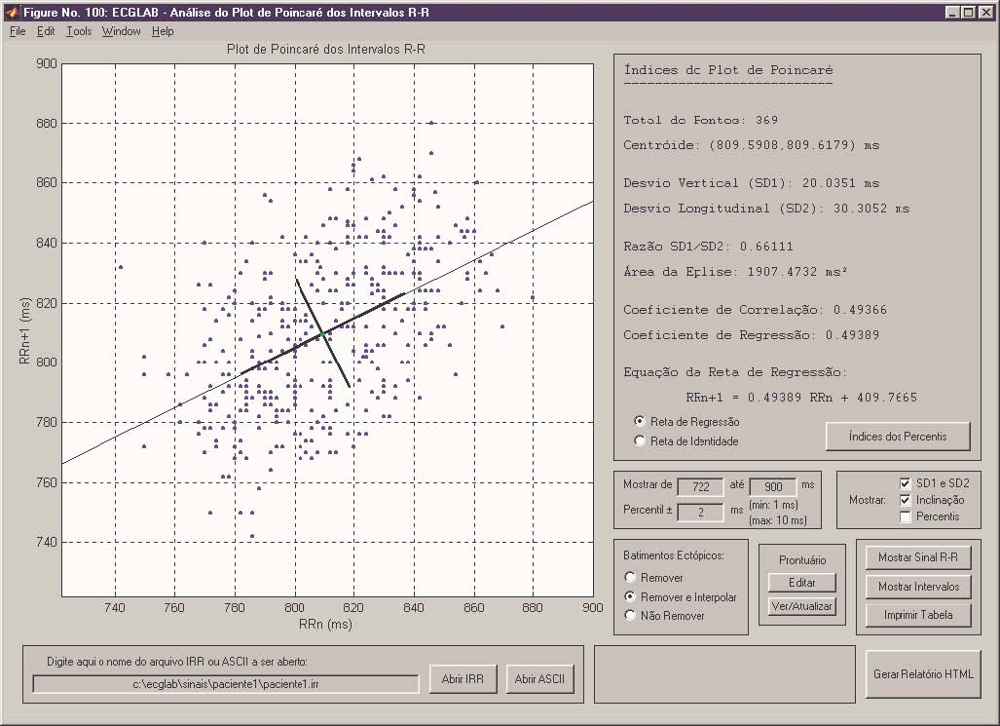
Once you open the signal, a plot graph appears, the graph type is RRn x RRn+1 (each RR interval for its own consecutive). To change the graph’s scale, change the area ‘monstrar de X ate X ms’. In the area ‘mostrar’ the user can choose between visualizing the data with the following deviations SD1 and SD2, inclination line chosen are the series of points in each percentile, with its respective deviations.

The choice between the regression line and the identifying line can be made in the indexes quadrant. The choice influences directly the indexes the user will obtain, once the SD2 and SD1 are calculated with their base in either the regression or identifying line and in its perpendicular, respectively.

The user needs to choose between 3 versions of the interval series: an original serie, with the ectopic movements included; a corrected serie, substituting the ectopic movements with intervals with calculated values through an interpolation. The latter can be done in the ‘batimentos etopicos’ area by choosing one of 3 options: ‘nao remover’ (don’t remove), ‘remover’ (remove), or ‘remover e interpolar’ (remove and interpolate).

The user will have the following indexes: total points in the graph, coordinates of the center point, vertical deviation (SD1) and longitudinal deviation (SD2), the ratio of SD1/SD2, the elliptical area formed by the SD1 and SD2 deviations, the correlational coefficient of the serie, the regression coefficient, and the equation of the regression line.

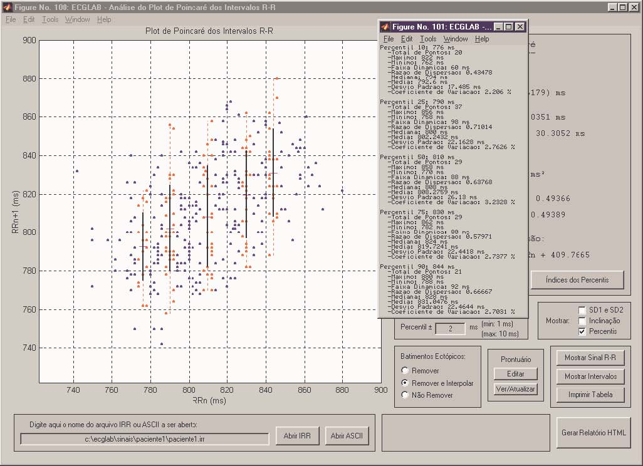

Clicking the button ‘indices dos pecentis’ presents a table with the statistics of the points in each percentile of the serie (the percentages are the following: 10, 25, 50, 75, and 90). For the serie in each percentile the following indexes are presented: the maximum and minimum values of each percentile; the dynamics of the serie, and the corresponding dispersion; the median, average, deviation and coefficient of variance. The dispersion and the dynamics of the points in each percentile total of the RR intervals in the serie.

It is possible to increase or decrease the number of points in each percentile changing the value in the area of ‘percentil +- X ms’. The value is the point of reference of the percentile and determines which values in the points will be considered as belonging to that percentile. For example, if the percentile is 800 mg, and the deviation is of 800 +- 2 ms, then the points with values 798 ms, 800 ms and 802 ms will be included in the serie percentile, giving you a more consistent statistical result.

In this module it is possible to edit or visualize the patient’s formulary. To edit the formulary, click the button ‘editar’. To edit, click the ‘editar’ button. A window in wordpad will open, showing the directory formulary format. Fill out the formulary, and when finished, save the file. Next, click the ‘ver/atualizar’ button and confirm that the data entered was correct. The data will be in the HMLT that automatically generates in this analysis. The same formulary will be used in the following analytic modules.

To generate the history formulary, click the ‘gerar relatorio HTML’. The document will have all the data entered, the graph and the indexes obtained in this module. The file needs to be opened immediately as soon as the Poincare RR finishes creating it (the process takes some time). We recommend that you use internet explorer as the attachment source. In windows 98 the ECGLab can open this file automatically. If the file does not open automatically, you can still open it manually. The file will be saved in the same directory where your RR interval files are. The graph will also be in the same directory, as a .bat file to open with internet explorer. The name of the file will be ‘xxxx_frr.html’, where xxxx is the name of the file with the intervals.

The user also has the option to see a graph of the R-R intervals that is being used in this analysis byt choosing the options ‘mostrar sinal R-R’, besides the button ‘mostrar intervalos’, that presents a table with the values of the R-R intervals in the serie (the values are shown in lines). With the ‘imprimir tabela’ button, Poincare RR opens WordPad, allowing printing.

NOTE: when an R-R signal file is open, Poincare Rr saves a file with ‘.prc’ extension, containg the information regarding the Poincare RR analysis plot. The file ‘.prc’ contains 2 complete 16 bits indicating the limits of the graph and a number in fluctuating 32 bits indicating the percentile differentials.

- EGCLabQT Module:

To start the module, in the command MATLAB window, type:

cd c:\ecglab
poincareRR

To open the signal in the IRR format, type the name of the ‘irr’ file you desire to open. Click the ‘abrir IRR’ button. If an error message appears, please verify that you’ve used the correct directory, name of file and extension, and try again. If a message saying ‘antes faca a marcacao dos intervalos R-R’, it means that the program found the file but that the R-R information or analysis was not save or are not there. The ECGLabQT uses the R-R information to locate each movement and correct the QT intervals observed. Because of that, it is necessary to open the ECGLabRR before using the ECGLabQT.

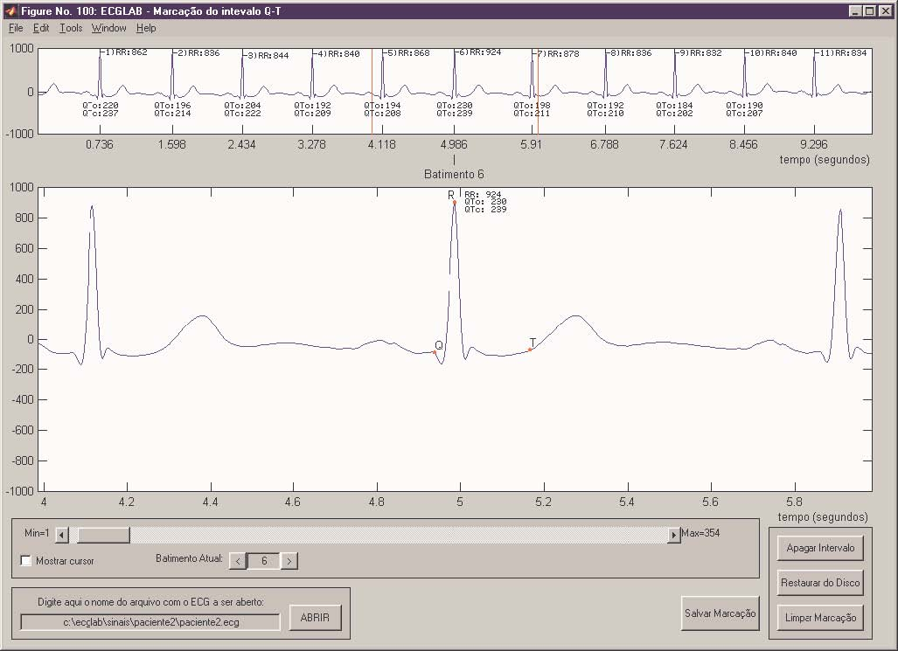

Once the ECG is open, you’ll see 2 windows or bands of information. The top band is a longer strech of the ECG and the numbers in the abscise indicate the instances of R waves. The value of each RR is also shown. The centratlized movement inside the red vertical bars is presented in an amplified form in the bigger graph bellow. The user can dislodge the movements using the sector ‘batimento atual; or using the rolling bar below the graphs. It is also possible to pull a specific movement directly by entering the number of the specific movement in the ‘batimento atual’ area.

Once the movement for which one wishes to measure the QT interval has been centralized, the user needs to do the following:
- Click in any place inside the bigger graph. That will make the cursor appear;
- Use the cursor to click the Q wave. A red strip will appear in the place indicating the base line.
- Use that as a reference to align the cursor and score the start and end of the T wave. This is not good to score the apix of the T wave.
- The user should now be able to see the 2 scored points indicating the Q and T waves. The interval value measured will be presented (QTo), as well as the corrected QTc with basis in the value of the R-R interval subsequent. The QTc is calculated with the following equation:

QTc _{o} _{c} = QTo/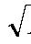RR

- If there was an error in the scoring, the user only has to re-start the process, clicking in the area ‘batimento atual’ and repeat the process.
- If the interval was correctly selected, the user must proceed to the next movement, repeating the same process
- Whenever desired, saave the scoring clicking the button ‘salvar marcacao’

To stop an interval, simply centralize in the interval that you desire to stop and click in the ‘apagar intervalo’ button. To stop all the intervals, the user can click in the ‘limpar marcacao’ button. To restore a saved scoring, click the ‘restaurar do disco’ button.

The classified ectopic movements during the scoring of the R wave appear in color red and with a black circle around the R wave. The QT values for these intervals can be removed or corrected in the analysis module.

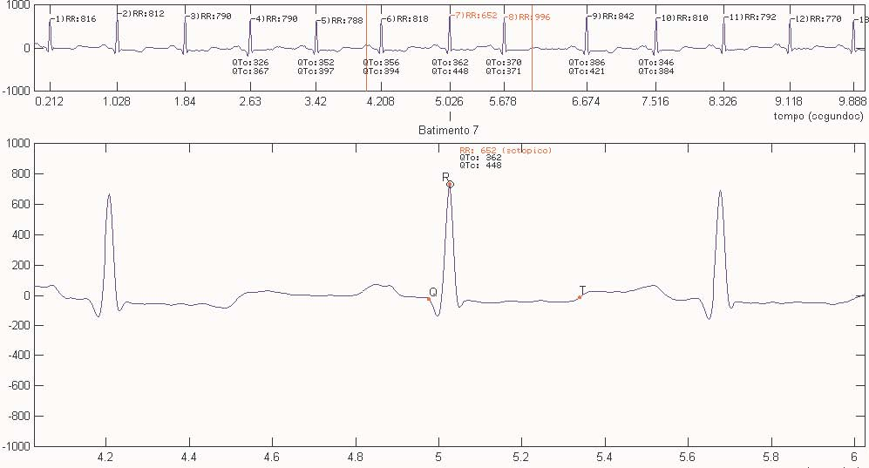

When the scoring is saved, the following information is generated:
- .QTC file: contains a serie of QTc intervals in fluctuating 32 bits points.
- .WRI file: in ACSII format, also contains a serie of QTc intervals, that can be visualized in any text editor.
- .IQT file: Contains an RRQT matrix saved in fluctuating 32 bits points. The matrix has 4 columns, and each contains respectively: the index of each R wave, the corresponding RR interval, the index of the Q wave and the index of the T wave. R waves with negative signals indicate ectopic movements. Q & T waves presented with -1 indicate that those waves were not scored.

Once finalized the Q & T wave scoring, the scoring should be saved, close the ECGLabQT, and follow to the next module.

