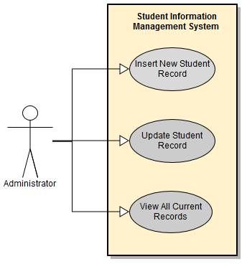

**Use Case: Insert New Student Record**

**Brief Description**

The Insert New Student Record use case enables the user (Administrator) to create a record containing all of the data relevant to a student record. This new record is then added to the database, and made available for updating and viewing. The Administrator will be required to include the student’s name and ID. Other information such as registered courses, exam scores and GPA can be added later, or not at all.

**Step-by-Step Description**

1. Administrator logs into the Student Information Management System.
2. Administrator selects the “Insert New Record” option
3. Administrator fills out student information: Name and ID, with additional optional information
4. Administrator selects the “Submit” option
5. System creates a new student record
6. System updates the database

**Use Case: Update Student Record**

**Brief Description**

The Update Student Record use case enables the user (Administrator) to access an existing student record. Once the Administrator has access, the Administrator is able to change some information that is included with a Student record. The Administrator can update registered courses, exam scores and GPAs. However, Student names and ID’s may not be changed.

**Step-by-Step Description**

1. Administrator logs into the Student Information Management System.
2. Administrator selects the “Update Record” option
3. Administrator types in the Student ID number
4. System retrieves the record and displays it
5. Administrator changes or adds information regarding Student registered courses, exam scores or GPA
6. Administrator selects the “Submit” option
7. System updates the database with any changes made

**Use Case: View All Current Records**

**Brief Description**

The View All Current Records use case enables the user (Administrator) to generate a report about the database that contains all of the Student records. The report will include entire student records (Name, ID, registered courses, exam scores and GPA). The report will also include the record’s creation date, as well as the date in which the record was last updated, and the name of the Administrator who made the changes.

**Step-by-Step Description**

1. Administrator logs into the Student Information Management System.
2. Administrator selects the “View All Records” option
3. System retrieves the entire database
4. System generates a report and displays it