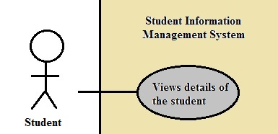

**Brief Description**

The Views Details of the Student use case enables the user (student) to view details of the student for that current semester including the student’s name, student’s ID, registered courses, each exam’s score in one course, and GPA calculation.

**Step-by-Step Description**

1. The student logs on the Student Information Management System.

2. The student is able to view details of their current semester.