Project Group Information: Expenditure Tracking Website,
Cael O’Connor coconnor10@students.stonehill.edu ,
Emilio Banchon Macias ebanchon@students.stonehill.edu,
Arthur C. De Sa Martins adesamartins@students.stonehill.edu.
Link: https://github.com/CaelOConnor/Expenditure-Tracking-Website
Project Description: This website project will be an expenditure tracking website. It will allow users to track their expenses and categorize them. The application will allow users to add things they spend money on, for example gas or rent. This project will be useful to those who want to see their expenditures to better track and find where they can save money.
Background and Motivation: We decided to work on this project because it has real world applications. People need to track their expenditures and having an application that makes that easier to do is helpful. Especially when people have many different cards and subscription services today, that makes it harder to track spending. With this application people will be able to see their spending and help them save money if they notice that they are spending too much money on things they deem unnecessary.
Wireframes and Prototyping:
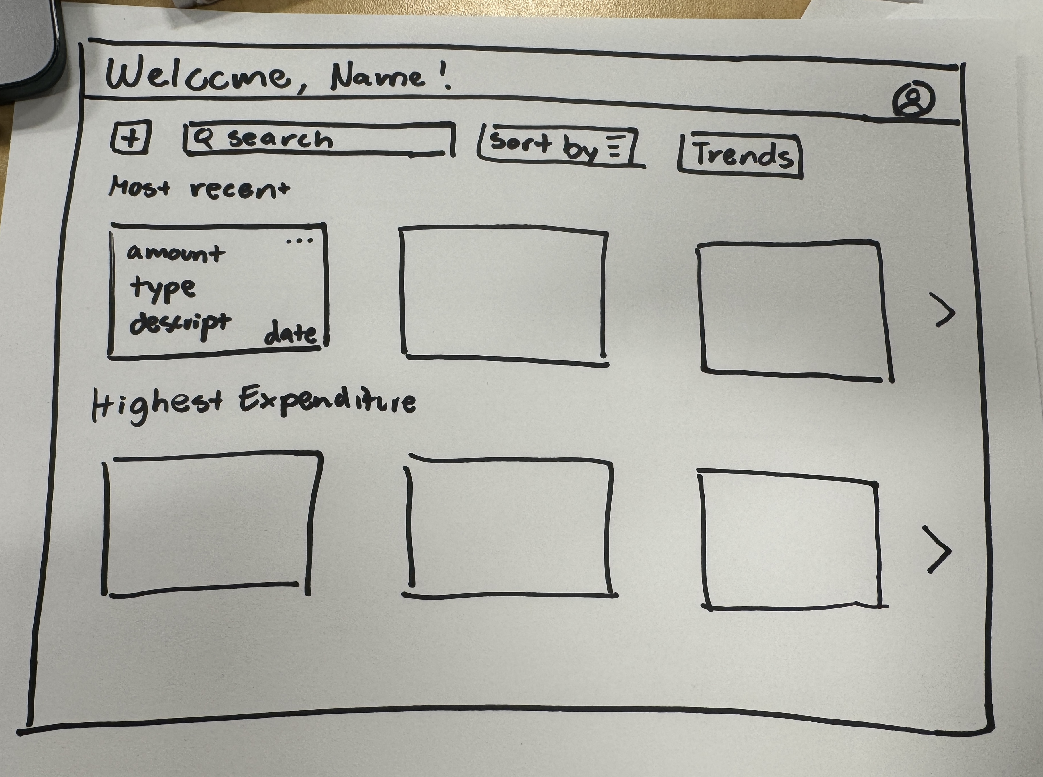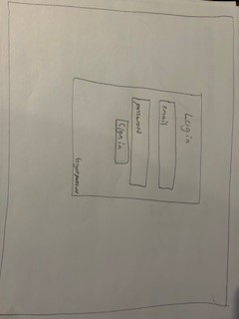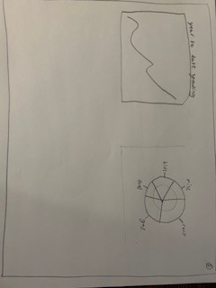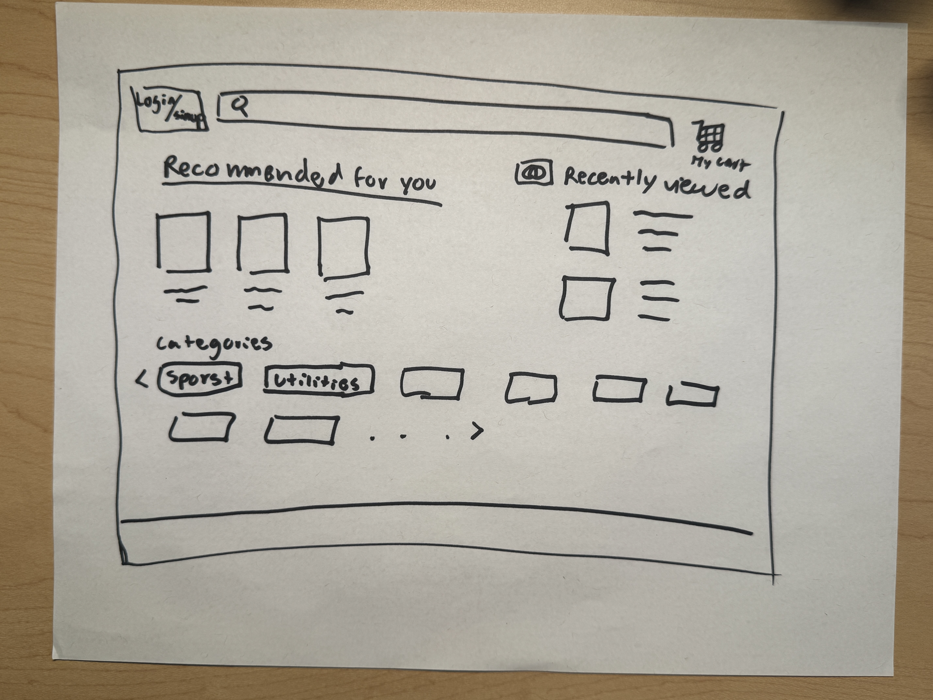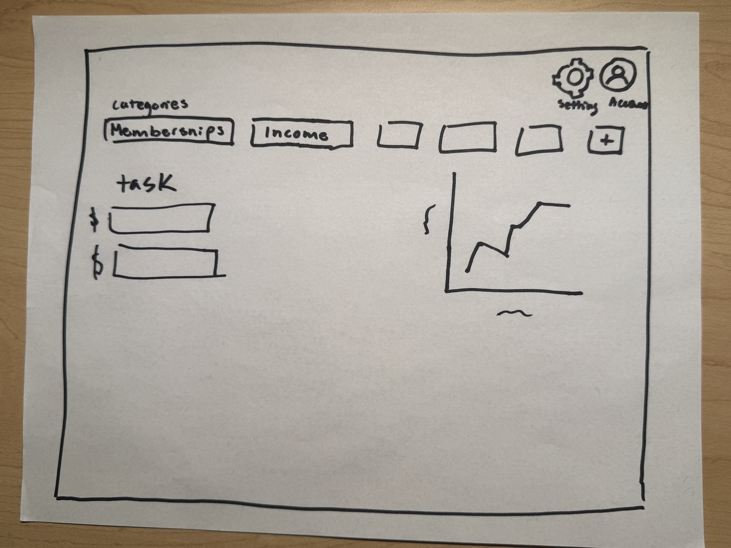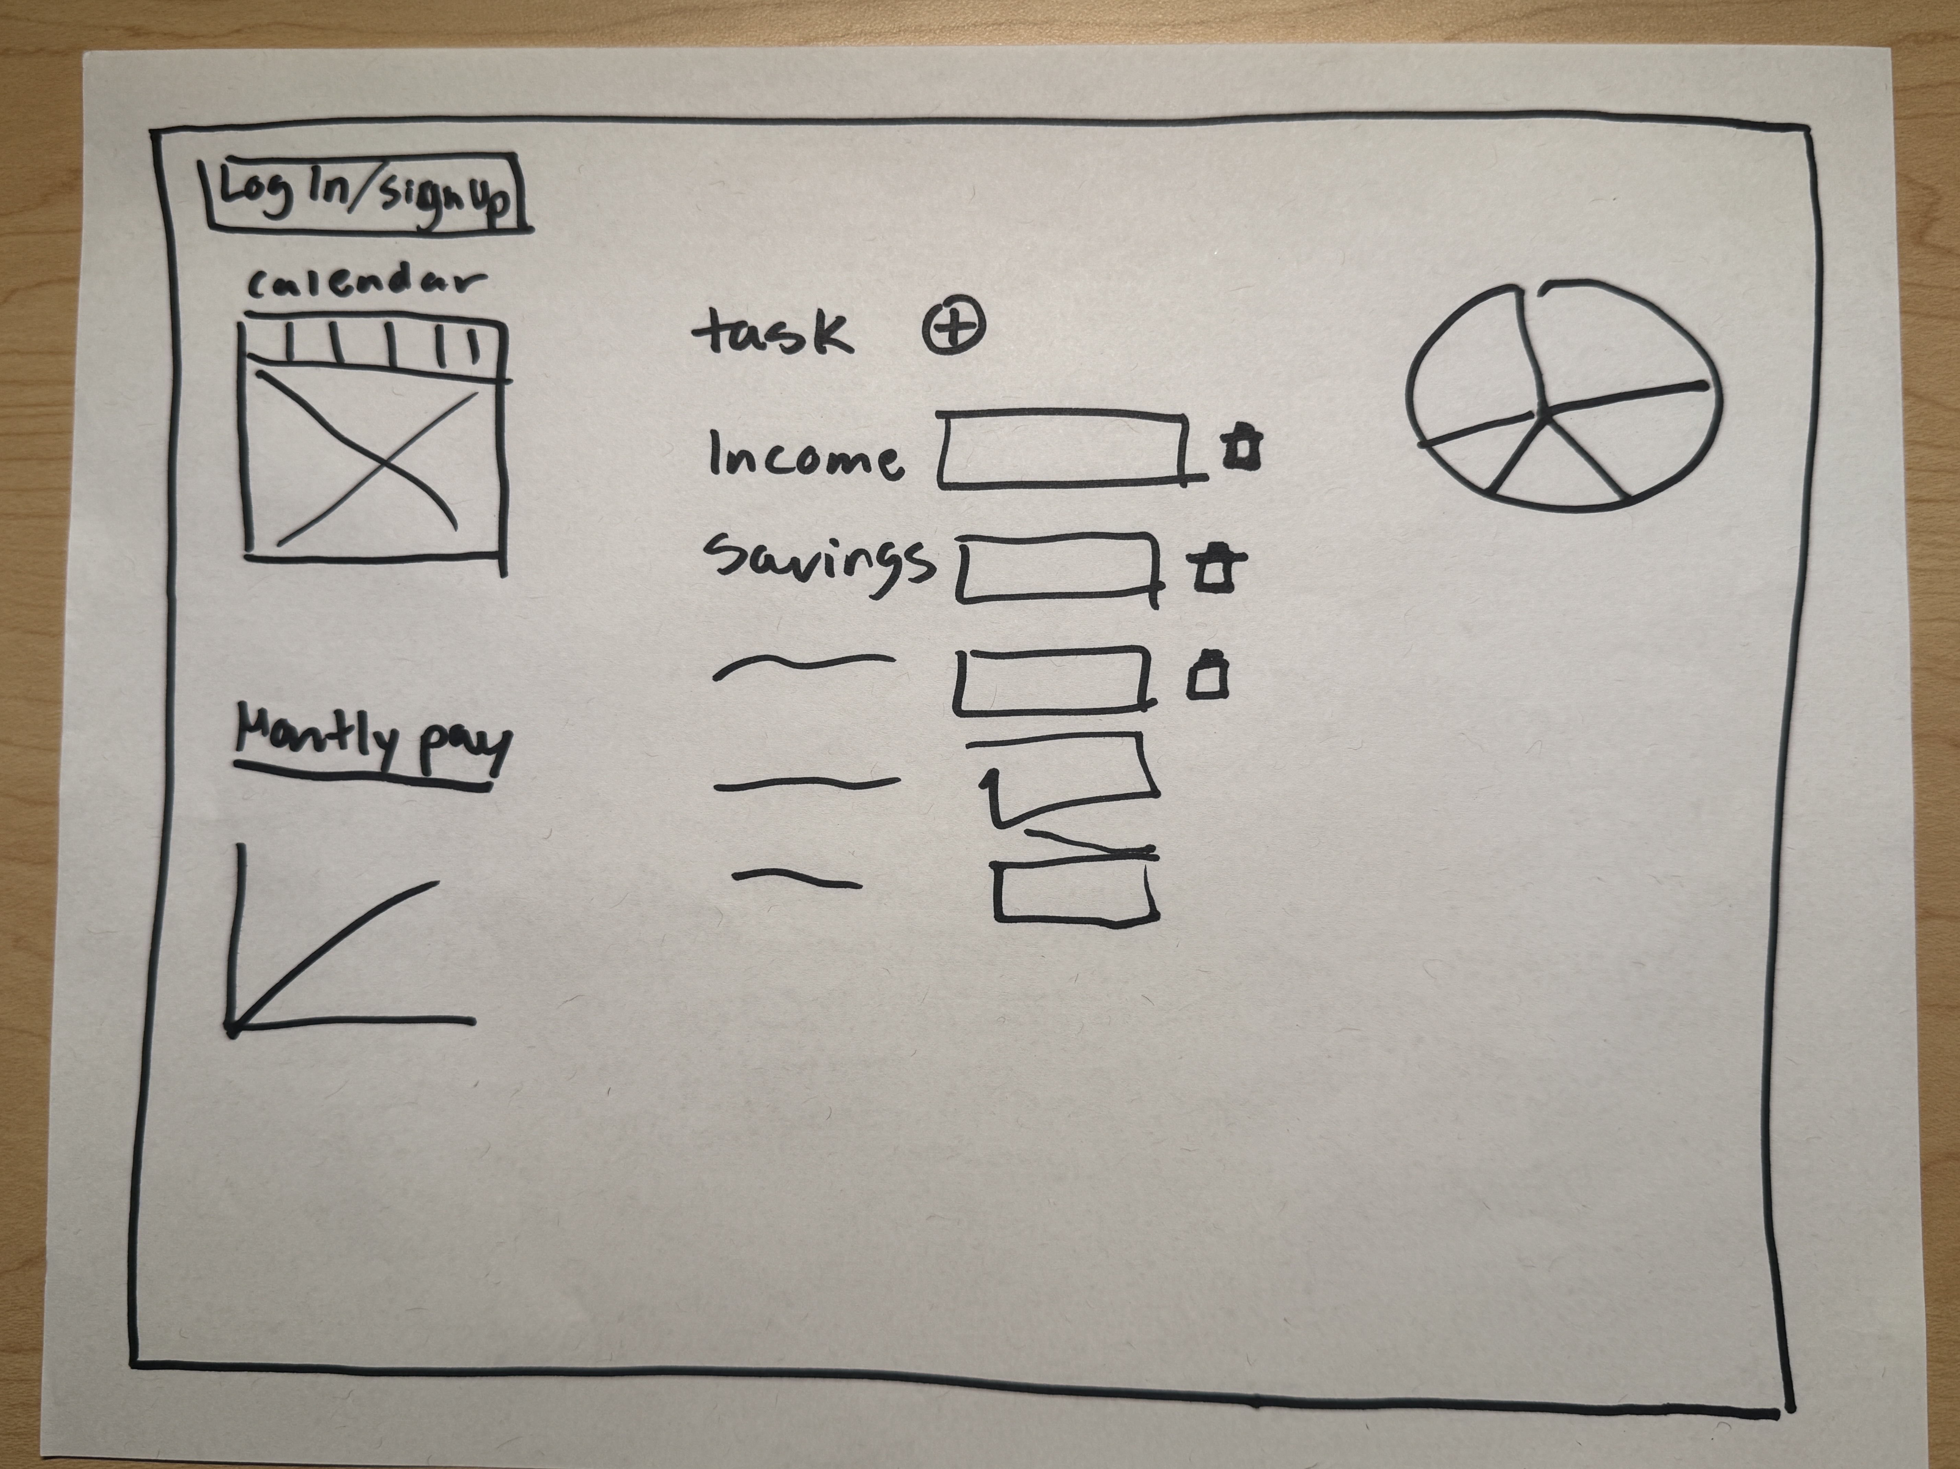
Description of Wireframes/Prototyping:
The home page will have an account button, add expense button, search button, sort by button, trends button. Each transaction will display information such as the amount, transaction type, description, date, and edit button. The login page will be basic and easy to use. It will have a text box for email and password and a sign-in button. It will also have a forgotten password button. The advanced details page will consist of graphs about the users' spending habits such as a year-to-date graph and a pie chart about categories of spending. The bottom three images are our drafts for the main and details pages.
Must-Have Features:
One must have feature is the ability to create a new event that holds data such as date, event type, and money spent. This is the main page of the website. On this page, users will be able to see all their transactions. We will need to store their transactions which contain the amount, type, description, and date. This information will also be able to be edited. On this page, users will be able to create new expenditures and edit their old ones, search through their expenditures, filter by price and date. They will also be able to access the trends page as well as their settings and logout. Another must have feature is the ability to log in. Since the site would be holding users' financial information, the site must have a login function. On this page, users will be able to fill out their information and login or register and account. Users' information such as email and password must be saved. Another feature is the ability to graph the data to track how users are spending money. These graphs would be accessed by clicking the trends button on the main page of the website. This button would bring users to another page with some visualizations of their graphs. This trends page is the advanced details page. Users will not make graphs but will be able to see much important information. The graphs users will see include a year-to-date spending line graph, a spending category pie chart to see where they are spending their money, and a bar chart to see the highest expenses a user spends on. Instead of an entire page dedicated to adding a new expense, a popup will appear asking for information about the expenditure on the main page. To register an account there will be a button in the login page that will change the login forms information. Another feature is to set limits for a user which would alert them when they are getting close or surpassing the limits. For this, we would need to store their limits. This feature would be accessed through the setting button.
Optional Features:
One optional feature would be the ability to customize the homepage layout for themselves. Another feature could be the ability to set goals which would be similar to limits but instead of a set limit it would be something you could work to achieve. For example, a user could set a goal of reducing spending in a category such as gas in or set a goal of reducing spending within a specified time frame.
Design Process:
The login page (Figure 1a) allows users to enter their email and password. This is checked with our data.json file to see if a corresponding user exits. If they do exist, they are brought to the main page, otherwise an error message appears (Figure 1b). The difference between the login page and our prototype is that we do not have a forgotten password button because we can't send emails to reset the password. We also added the register button because we forgot that in our prototype. This page now calls an end point on the server to check the information instead of accessing the data.json file directly.
Figure 1a: Login Page
Figure 1b: Login Page (incorrect username or password)

Our register account page (Figure 2b) allows the user to input an email and password. We did not create a prototype for this page, so we based it off the login page. We added the name field so that we could access a name to display in the top left corner of the home page. This now creates a new user object in the data.json file.
Figure 2a: Register Account Page Old
Figure 2b: Register Account Page New
We also added a base home page (Figure 3a) that is not based on a prototype. This is the page that would appear if you were to google our site if we had it on a server. This page allows users to be redirected to the login page while also explaining the purpose of the site.
Figure 3a: Base Page (index.hmtl)
The home page of our site (Figure 4a) is based on the prototype but currently looks slightly different. Instead of the expenditure's sections letting you scroll left to right, they just stack on top of each other. We decided to do this because we were having a hard time getting the page to behave correctly for scrolling left to right. So, we decided to keep the top-down scroll. This change is purely cosmetic and does not change any functionality of the site. Based on your feedback from class, we decided to get rid of the two sections with duplicate information and just made the home page one section (Figure 4b) that the user can sort in four different ways. We also changed the three dots button on each expense to two buttons and edit and delete button (Figure 4c). We did this because we were having a hard time with the drop-down menu in the expenses and reading the text. This is a cosmetic change because the functionality of the buttons remains the same. One the homepage there is an add button that creates a popup (Figure 4d) that allows the user to create a new expense (Figure 4e). This page has a search bar (Figure 4f) that filters expenses containing the text in the search bar. This page also has a button that allows the user to search based on four options most recent, oldest, highest expense, and lowest expense (Figure 4g). Then sort the expenses on screen to match the selected one. While working on the final touches, we struggled to figure out how to implement the edit expenditure feature. We decided to remove this feature and just have the delete button so that the user could delete an expense and remake it in place of editing. (Figure 4h (Final Home Screen)) This change is both cosmetic and changes the function of the site. As stated before, if a user does want to change an expense, they can delete it and re-create the expense with new information, it is just not as easy as an edit button.
Figure 4a: Home Page Old
Figure 4b Final Home Page
Figure 4c Home Page Change
Figure 4d Home Page Add Expense Popup
Figure 4e Home Page New Expense Created

4f Home Page Search Bar
4g Home Page Sorted
Figure 4h (Final Home Screen)
We also currently have a settings page. We did not create a prototype for the settings page. However, we did a basic interface so that users can edit their profile and want to set limits for themselves. Our design for this page has changed since the first milestone. We decided to profile, privacy, and notifications tabs and just leave the limit tab. We did this because we had the profile, privacy, and notifications as potential features and ran out of time. We placed them temporarily for the last milestone. Based on feedback from the last milestone, we made the settings page on the page where a user would set a spending limit for themselves. A user can set a spending limit for themselves and when they try to make a new expenditure (Figure 5c), if it goes over the limit an alert will appear saying they are going over their limit (Figure 5d).
Figure 5a Settings Page New

Figure 5b Settings Page Old
Figure 5c Setting A Limit
Figure 5d Limit Exceeded
Lastly, we also have a Trends page where users will be able to see visualizations based on their expenses. The purpose of this page is to give live to the expenditure data that the users input on the website. This makes it easier for them to have an idea of how much they are actually spending. The trends page (Figure 6b) has three graphs based on the user's data, a line chart that shows spending each month of the year. A pie chart that shows spending per category. Lastly, a bar chart shows the top ten expenses that a user has spent on. The purpose of these charts is to help visualize a user's spending. The reason these pages look so different is because the old one was taken very early in development when we were still trying to figure out how to make the graphs. This page looks different to our wireframes because we initially did not know how we wanted this page to be laid out. The changes compared to the prototype are purely cosmetic. We always knew the types of graphs we wanted. We just didn't know how we wanted to display them.
Figure 6a Trends Page New
Figure 6b Trends Page Old

Project Schedule:
First two weeks: html and CSS, Arthur: details page, Emilio: login page, Cael: main page
Second two weeks: JavaScript, Arthur: login, Emilio: main page, Cael: details page
Third two weeks: Database, Arthur and Emilio: spending information storage, Cael: login tables.
Fourth two weeks: Cleanup, all three of us will work on polishing all aspects of the project

