Tetromino Tussle

Welcome to Tetromino Tussle! This is a challenging, 2-player falling block game that is fun for all ages! Follow the instructions below to build Tetromino Tussle on your own computer.

# Installing The Game

## Clone the repository.

To clone this repository, simply enter the following in your terminal:

git clone https://github.com/clnmcdowell/TetrominoTussle.git

## Install Unity Hub

If you already have the Unity Hub and Unity Editor installed, you can skip this step. To download Unity, go to this link and download the latest version for your

operating system: <https://unity.com/download>. Make sure you have Unity Editor version 2021.3.15f1 installed for this game.

## Build and Run Tetromino Tussle

Once you have installed the Unity Hub and Editor, click on the arrow next to “Open” in the top right of Unity Hub and then click “Add project from disc”. Select the cloned src folder as your project folder. After Unity loads the project select File in the top left corner of the Editor, and then select “Build and Run”. This should take a few moments, and then you will see the Title Screen. Enjoy your game! If you have any trouble with the Unity Editor, check out the documentation here: <https://docs.unity.com/>.

# Playing Tetromino Tussle

## Start the game

1. Begin building your boards

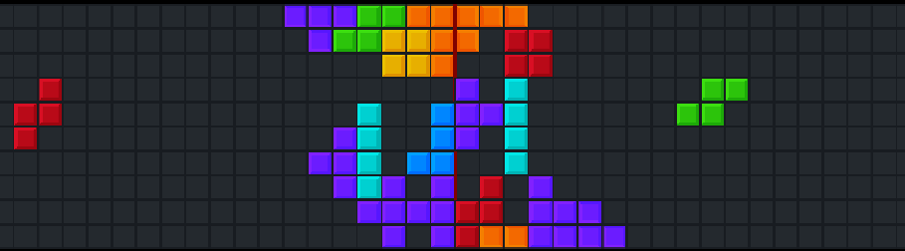

### PLAYER 1 Controls: W - Up

**S -** Down

**A -** Rotate

**D -** Fast Drop

### PLAYER 2 Controls:

**˄ -** Up

**˅ -** Down

**> -** Rotate

**< -** Fast Drop

**esc -** Pause

## First player to fill up their board loses!

## 4.Complete 3 or 4 columns at a time to move all the blocks towards your opponent!

Team Name: Team Tetris

Team Members: Colin McDowell, Jack Crowley, Caelan Wong

## **Final Game Test Cases and Expected Results**

1. **Press the control button:** Goes to the control screen
2. **Press escape leaving the control screen:** Goes to the main menu
3. **Press start game:** The game starts
4. **Press W, S, up arrow, and down arrow:** Tetrominoes move up and down
5. **Press A and the right arrow:** Tetrominoes rotate 90 degrees
6. **Wait for both tetrominoes to reach the center:** Tetrominoes will be placed and new tetrominoes will be spawned
7. **Press D and the left arrow key:**  Blocks will fast drop
8. **Spawn multiple tetrominoes:** Different random tetrominoes will be spawned
9. **Try to move a tetromino out of bounds:** Movement will be prevented
10. **Try to move a tetromino up or down into a set block:** Movement will be prevented
11. **Try to rotate a tetromino while at the edge or next to a set block:** Rotation that would move part of the tetromino out of bounds or into a set block will be prevented
12. **Complete a column:** That column clears and blocks to the side of cleared column move to fill the now empty column
13. **Complete 3 rows with 1 tetromino:** All set blocks move 1 space towards the opponent's side of the screen
14. **Complete 4 rows with 1 tetromino:** All set blocks move 2 spaces toward the opponent's side of the screen
15. **Place many tetrominoes:** The automatic drop will occur faster
16. **Stack blocks to one end of the screen:** Goes to victory screen for opponent’s side
17. **Press the main menu button on the victory screen:** Goes to the main
18. **Play the game again and stack blocks to the other end of the screen:** Goes to the other victory screen
19. **Play the game again and press escape:** The game pauses and a pause menu appears
20. **Press escape or click the resume button:** Game resumes
21. **Return to the pause menu and press the main menu button:** Goes to the main menu
22. **Press the quit game button:** The game window closes