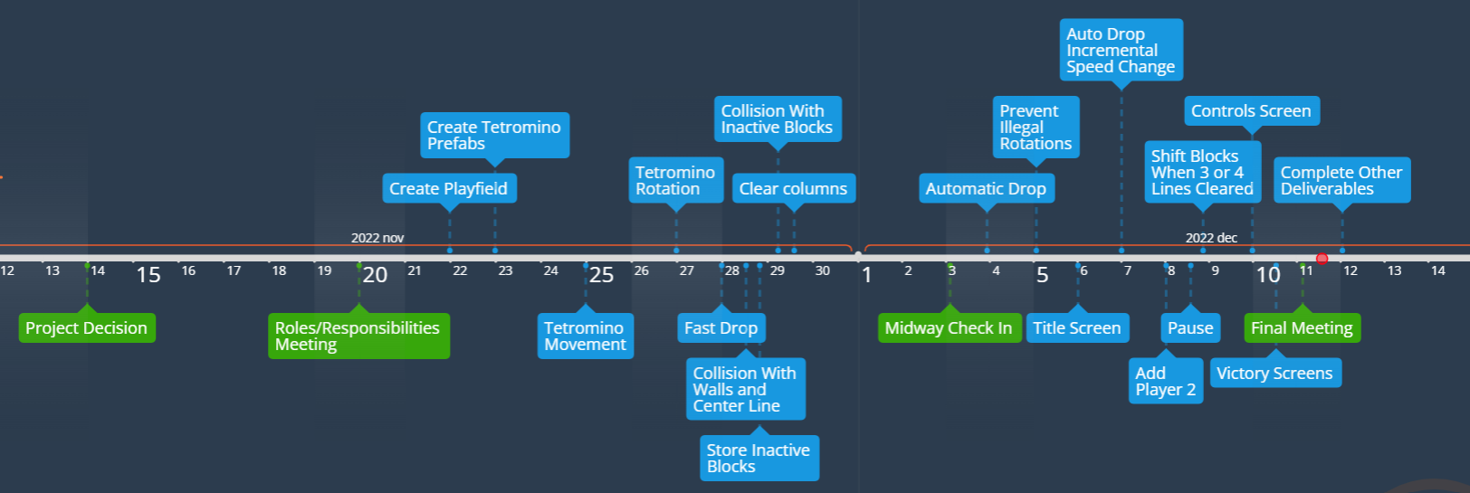

**Project Timeline:** Green = Meeting, Blue = Project Milestone

Discussion Points in Meetings

1. Project Decision
   1. Pros/Cons of each of our project ideas
   2. What development platform could be used for each project
   3. How realistic would it be for us to develop the skills necessary to complete each project
2. Roles/Responsibilities
   1. Who was going to take the lead in each of the five categories (technical, interface, specification, documentation, and project lead)
   2. Assign the first tasks for every to complete by the next meeting
3. Midway Check-in
   1. Review the current state of the game
   2. Determine the next tasks for everyone to complete in order to finish the game
4. Final meeting
   1. Test the game to ensure that everything is functional
   2. Divide the remaining deliverables for the project