Table S1. Selected hyperparameters for LSTM models trained on each hydroclimatic cluster. Units refer to the number of hidden units in the LSTM layer.
Cluster | Units | Dropout | Learning Rate | Batch Size
1 | 256 | 0.25 | 5 × 10⁻⁴ | 32
2 | 128 | 0.25 | 5 × 10⁻⁴ | 32
3 | 196 | 0.25 | 5 × 10⁻⁴ | 32
4 | 128 | 0.25 | 5 × 10⁻⁴ | 32
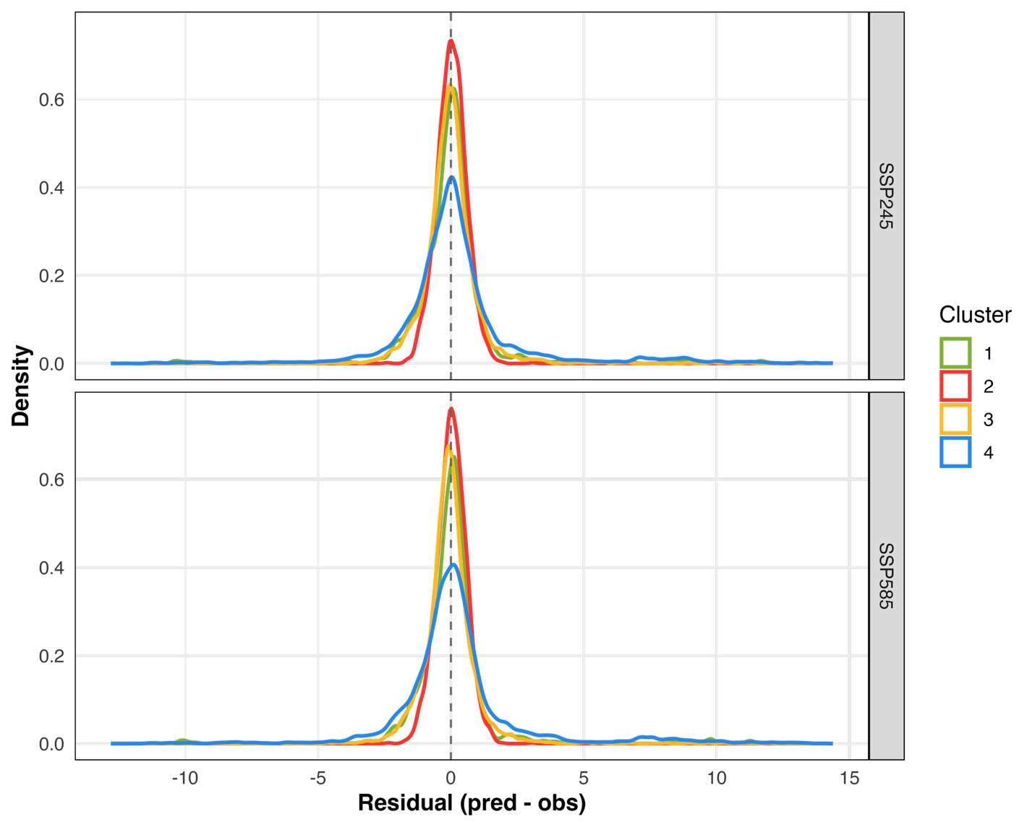
Figure S1. Distribution of standardized residuals from the LSTM models across all hydroclimatic clusters under SSP245 and SSP585 scenarios. Kernel density plots show residuals centered around zero, with generally symmetric spread and minimal bias across clusters, indicating consistent model performance.

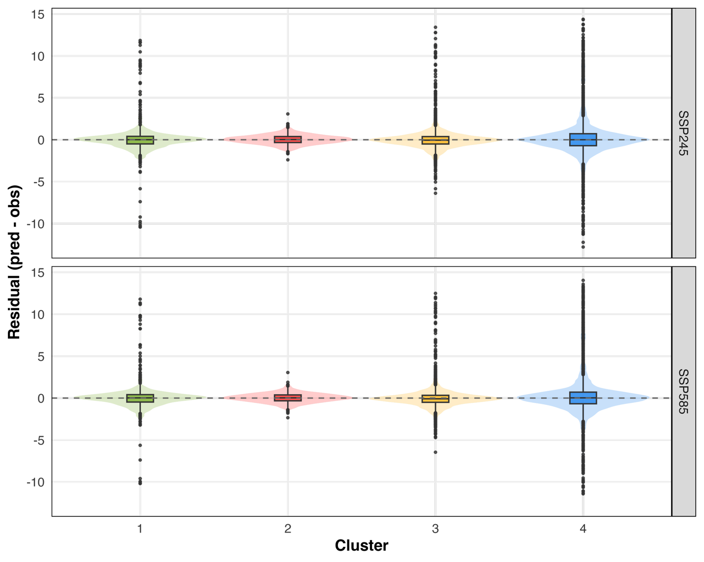
Figure S2. Distribution of residuals from LSTM base-flow validation by hydroclimatic cluster (1–4) and emissions scenario (SSP2-4.5 and SSP5-8.5). Violin plots show the density of residuals, with embedded boxplots indicating the interquartile range and median. Residuals are centered close to zero across clusters and scenarios, indicating minimal bias.

