iCerebro
Architecture Document

Written by: | Caerisse
Date: | 15/07/2020

Table of Contents
Contents
Background 3
Requirements 5
Functional Requirements [Expand] 5
Non-Functional Requirements ??? 5
Executive Summary 6
Overall Architecture 7
Settings 7
Actions 7
Crawl 7
Logger 7
Bot accounts database 7
Crawl database 7
Scheduling 7
ChatBot 7
Smart commenting 7
Settings Drill Down 8
Actions Drill Down 9
ChatBot Drill Down 9
Smart Commenting Drill Down 9
Logging 9
Role 9
Technology Stack 9
Architecture 10
Implementation Instructions 11
Receiver 11
Role 11
Technology Stack 12
Architecture 12
Implementation Instructions 14
Handler 14
Role 14
Technology Stack 14
Architecture 14
Implementation Instructions 16
Info 16
Role 16
Technology Stack 16
Architecture 17
Implementation Instructions 19

Background
iCerebro is an AI powered instagram bot, it will have an nlp chatbot for sending and answering messages, and an image recognition and analysis neural network for smart commenting.
Given a series of parameters it will like and comment images, follow and talk to other users, unfollow users that were only followed to get their attention, upload images at scheduled times and watch stories.
It also has the ability to crawl for data on relationships between users and posts.
This document describes the system architecture of iCerebro.
The architecture comprises of technology and modeling decisions, that will ensure the final product, assuming the architecture is followed, will be fast, reliable and easy to maintain.
The document outlines the thought process for every aspect of the architecture, and clearly explains why specific decisions were made.
It’s extremely important for the development team to closely follow the architecture depicted in this document. In any case of doubt please consult the Software Architect.

Requirements

Functional Requirements [Expand]
- Settings
- Actions
- Database account
- Database crawl
- Logger
- Ensured continuity (Handle all possible errors)
- NLP
- Smart comments
- Smart hashtags
- Smart similar accounts
- Smart scheduling (notice best time to make posts)

Non-Functional Requirements ???
The following non-functional requirements were defined after discussions with the customer, and are agreed upon by all the team members.
- Data Volume: 54GB Annually
- Load: 540 concurrent requests
- No. of users: 2,000,000
- Message loss: 1%
- SLA: ???

Executive Summary

This document describes the architecture of iCerebro.
Here is a high-level overview of the architecture: [Replace for one of ours???]
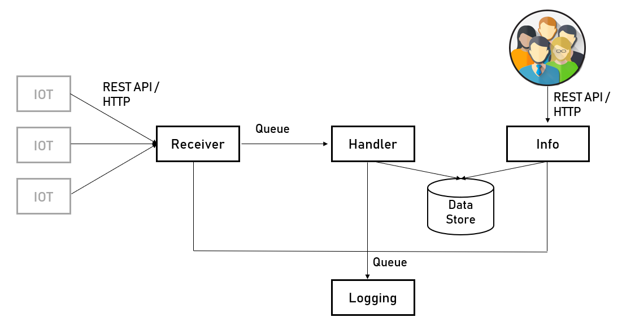
As can be seen in the diagram, ???.

Overall Architecture

Settings

Actions

Crawl

Logger

Bot accounts database

Crawl database

Scheduling

ChatBot

Smart commenting

Settings Drill Down

Liking

Commenting

Emoji Support

Following

Smart Hashtags

Smart Location Hashtags

Quota Supervisor

Restricting Likes

Ignoring Restrictions

Ignoring Users

Excluding friends

Mandatory Words

Mandatory Language

Don't unfollow active users

Blacklist Campaign

Simulation

Skipping user for private account, no profile picture, business account

Liking based on the number of existing likes a post has

Commenting based on the number of existing comments a post has

Commenting based on mandatory words in the caption

Interactions based on the number of followers/ing a user has

Interactions based on the number of posts a user has

Custom action delays

Smart comments

Chatbot

Scheduling

Running on a Headless Browser

Bypass Suspicious Login Attempt

Running internet connection checks

Use a proxy

Actions Drill Down

Like by Tags

Like by Feeds

Like by Locations

Comment by Locations

Follow by Tags

Follow by Locations

Following by a list

Follow someone else's followers

Follow users that someone else is following

Follow and interact someone else's followers/following

Follow the likers of photos of users

Follow the commenters of photos of users

Unfollowing

Interact on posts at given URLs

Interact with specific users

Interact with specific users' tagged posts

Interact with someone else's followers

Interact with users that someone else is following

Interact by Comments

Accept pending follow requests

Remove outgoing follow requests

Skip based on Profile Bio

ChatBot Drill Down

Smart Commenting Drill Down

