Reproducible Research Homework_01

Caesar Hermogeno

May 9, 2016

## R Markdown

This is an R Markdown document. Markdown is a simple formatting syntax for authoring HTML, PDF, and MS Word documents. For more details on using R Markdown see <http://rmarkdown.rstudio.com>.

When you click the **Knit** button a document will be generated that includes both content as well as the output of any embedded R code chunks within the document. You can embed an R code chunk like this:

# Loading and preprocessing the data

1. Load the data (i.e. read.csv())

activityData <- read.csv('activity.csv')  
dat = read.csv('activity.csv', header = T)  
names(dat)

## [1] "steps" "date" "interval"

str(dat)

## 'data.frame': 17568 obs. of 3 variables:  
## $ steps : int NA NA NA NA NA NA NA NA NA NA ...  
## $ date : Factor w/ 61 levels "2012-10-01","2012-10-02",..: 1 1 1 1 1 1 1 1 1 1 ...  
## $ interval: int 0 5 10 15 20 25 30 35 40 45 ...

head(dat)

## steps date interval  
## 1 NA 2012-10-01 0  
## 2 NA 2012-10-01 5  
## 3 NA 2012-10-01 10  
## 4 NA 2012-10-01 15  
## 5 NA 2012-10-01 20  
## 6 NA 2012-10-01 25

1. Histogram, Mean & Median

I will make a histogram of the total number of steps taken each day and I will summarize the data by day:

totalSteps <- tapply(dat$steps, dat$date, sum, na.rm = T)  
avgSteps <- tapply(dat$steps, dat$date, mean, na.rm = T)  
par(mfrow = c(2, 1))  
hist(totalSteps, breaks = 10, col = "red", main = "Distribution of the total Number of steps each day",   
 xlab = "Average Total Number of Steps")  
hist(as.vector(avgSteps), breaks = 10, col = "blue", main = "Distribution of the Average Number of steps each day",   
 xlab = "Average Number of Steps")

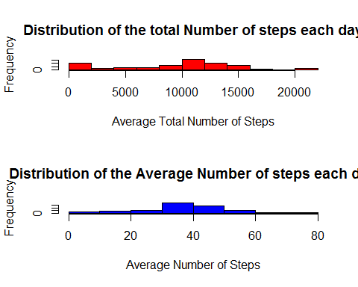

1. Average daily activity pattern

# Find the average number of steps grouped by intereval

Steps = tapply(dat$steps, dat$interval, mean, na.rm = T)

# Convert levels of intervals into numeric

Interval <- as.numeric(l)

# Create the dataframe df of the Interval and Steps columns

df <- data.frame(Steps, Interval)

library(ggplot2)

## Warning: package 'ggplot2' was built under R version 3.2.5

g <- ggplot(df, aes(Interval, Steps)) g + geom_line(colour = "blue") + ggtitle("Time Series Plot of the 5-minute Intervaland the Average Number of Steps,Taken across all Days") + ylab("Average Number of Steps")

Imputing missing values

# Missing data

missing <- is.na(dat)

# Number of missing values

(n.missing <- sum(missing))

## [1] 2304

## [1] 2304

# Impute data using the mice (multivariate imputation chains equation)

library(mice)

## Loading required package: Rcpp

## mice 2.21 2014-02-05

# Impute by replacing NA by the mean of steps

dat$steps[is.na(dat$steps)] <- tapply(dat$steps,   
 dat$interval, mean, na.rm = TRUE)

# Number of total steps each day

# Summary statistics before and after imputing

totStepsImp <- tapply(dat$steps, dat$date, sum)  
summary(totalSteps)

## Min. 1st Qu. Median Mean 3rd Qu. Max.   
## 0 6778 10400 9354 12810 21190

from my findings, there is seem to be not a significant difference in the average number of total steps each day before and after imputing data.

# Compare total number of steps each day before and after imputing

par(mfrow = c(2, 1))  
hist(totalSteps, col = "red", xlab = "Average Total Number of Steps Before Imputing",   
 main = "", breaks = 10)  
title("Distribution of the total Number of steps\n each day Before and After Imputing")  
hist(totStepsImp, col = "cyan", main = "", xlab = "Average Total Number of Steps After Imputing",   
 breaks = 10)

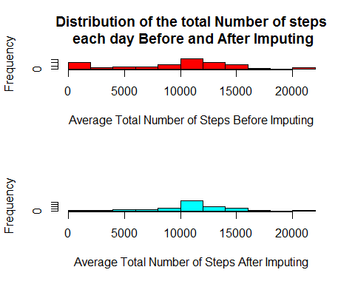

Are there differences in activity patterns between weekdays and weekends?

# Extract weekdays

dat$Days <- weekdays(as.Date(as.character(dat$date)))

# Create a logical vector d where Days are Saturday or Sunday

d <- dat$Days == "Saturday" | dat$Days == "Sunday"

# Call Saturday and Sunday Weekend

dat$Days[d] = "Weekend"

# Call weekdays (Monday through Friday) Weekdays

dat$Days[!d] = "Weekday"

# Weekdays

datWD <- dat[dat$Days == "Weekday", ]

# Weekend

datWE <- dat[dat$Days == "Weekend", ]

# Convert levels of interval into numeric for weekdays

IntervalWD <- as.numeric(levels(as.factor(datWD$interval)))

# Convert levels of interval into numeric for the weekend

IntervalWE <- as.numeric(levels(as.factor(datWE$interval)))

# Average number of steps during weekdays

avgWD <- tapply(datWD$steps, datWD$interval, mean)

# Average number of steps during the weekend

avgWE <- tapply(datWE$steps, datWE$interval, mean)

# Data frame combining average number of steps and interval during weekdays

dfWD <- data.frame(avgWD, IntervalWD)

# Data frame combining average number of steps and interval during the

# weekend

dfWE <- data.frame(avgWE, IntervalWE)

Convert Days into factor dat $Days<-as.factor(dat$ Days) dat $interval<-factor(dat$ interval)

plot(dfWD$IntervalWD, dfWD$avgWD, type = "l", main = "Comparison of the Average Number of Steps\n between Weekdays and the Weekend",   
 xlab = "Interval", ylab = "Number of Steps")  
lines(dfWE$IntervalWE, dfWE$avgWE, col = "red")  
legend("topright", c("Weekday", "Weekend"), col = c("black", "red"), lty = 1)

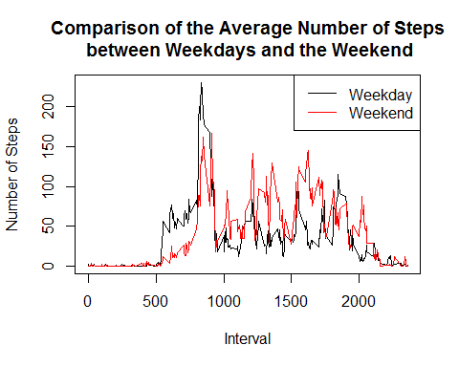

# Add a column to the data frames that include weekdays and weekend days

dfWD$wDays <- rep("Weekday", nrow(dfWD))  
dfWE$wDays <- rep("Weekend", nrow(dfWD))

# Rename column names to match

colnames(dfWD) <- c("Steps", "Interval", "wDays")  
colnames(dfWE) <- c("Steps", "Interval", "wDays")

# rbind the dataframes

df <- rbind(dfWD, dfWE)

# Convert wDays column into a factor

df$wDays <- factor(df$wDays)

library(lattice)

## Warning: package 'lattice' was built under R version 3.2.5

# Use lattice library to plot

xyplot(Steps ~ Interval | wDays, data = df, type = "l", layout = c(1, 2), ylab = "Average Number of Steps")

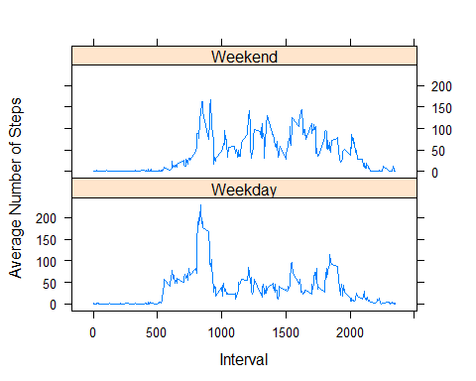

library(ggplot2)

# Using ggplot2 package

g <- ggplot(df, aes(Interval, Steps, fill = wDays, colour = wDays))  
g + geom_line() + labs(colour = "") + ggtitle("Comparison of the Average Number of Steps\n between Weekdays and Weekend") +   
 ylab("Average Number of Steps")

