**Euler’s Method of Approximation**

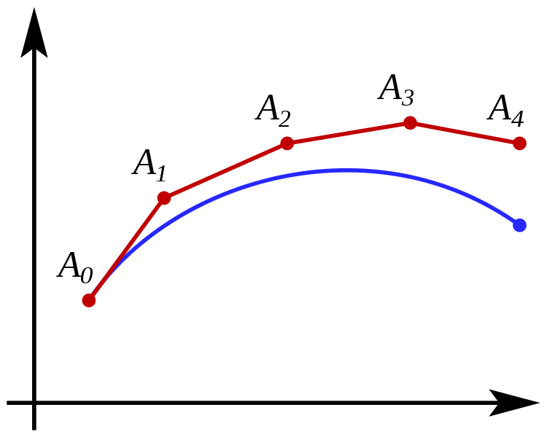

Euler’s method is a method for approximating the solution to a differential equation

**Formula:**

Given differential equation, the y’ (X0) = f (X0 , y (X0)) and the initial condition y (X0) = y0.

Now choose any value of h where $x_{n}= x_{0} + h*n$ (where n is any integer)

Now for one step from Xn to Xn+1, the approximation for yn+1 is $y_{n+1} = y_{n} + hf (x_{n}, y_{n}).$

**Example:**

$\frac{∂y}{∂x}$ = (XY + 1) and y (0) = 1; with a step size of h=1, approximate y(4).

X0 = 0 Y0 = 1

X1 = 1 Y1 =) = = 2

X2 = 2 Y2 =) =

X3 = 3 Y3 =) =

X4 = 4 Y4 = () = = 65

65 is Euler approximation of y (4) with initial condition y (0) = 1 and step size h = 1. This is the approximation for the differential equation using Euler’s Method.

**Tricks:**

* Remember, Euler’s method is basically point-slope form
* As the step size decreases, the accuracy of the approximation increases