|  |
| --- |
|  |
| “The Wizard of Menlo Park” |
| Rajat Bhageria |
|  |
| **National History Day: Senior Division** |
| **Historical Paper** |

Thomas Alva Edison (Figure 1)…One of the most prolific and legendary inventors history has ever seen. Indeed, “in the United States, where few questioned the values of the technological process, Edison, the ‘uncommon,’ common man, had become a revolutionary figure akin to the Founding Fathers. He did not just invent new and useful things but changed the way men and women” lived and continue to live today. [1] Almost every one of his inventions can be considered a turning point in history but the incandescent lamp, direct current, and the battery truly changed the face of history; the War or Currents was a turning point because it marked the first time that electricity began to be widely used commercially and residentially in the United States.

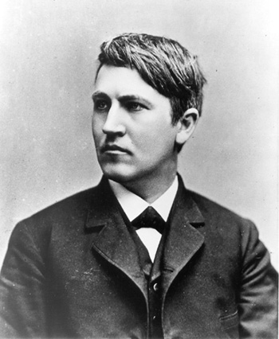

Figure 1: Thomas Edison at age 33

The first field Al (as Edison became known as) entered was telegraphy[2]. Before Al’s career, when trying to communicate via telegraph between faraway cities, currents leaked and as a result signals faded rapidly; in addition, the machine was very unreliable.[3] But Edison changed the face of the telegraphy by reinventing it to create an incredible communications device that would play a decisive role in history—mainly World War I and World War II. And indeed, most of Edison’s patents came not from the light bulb or phonograph—as is the modern misconception—but from the telegraph. To correct the problem of leaky currents, Al built relay instruments that would help correct this monumental issue.[4] Ultimately, might the Central Powers have won WWI or the Axis have won WWII without the improvements Edison made to the telegraph (Figure 2)? Might the Zimmerman telegraph never have been intercepted? Or might the telephone never have been invented because of the obvious failures of the pre-Edison telegraph? While we may never be able to justify a one-hundred percent sure “yes” or “no” answer, the questions certainly do advocate the idea that Edison’s improvements to the telegraph were a turning point in history.

But perhaps Edison’s best known contribution to the modern world was his invention of the incandescent lamp. 200 years ago, people lived in the dark, literally; the only sources for artificial light were kerosene lamps, illuminating gas, arc-lighting, and candles. There were no bulbs and efficiency of doing work at night was significantly low.[5] Edison’s visit to Sierra Nevada and the Rocky Mountains, where he saw the dark and desolate conditions that the men worked in, increased his enthusiasm to create electric light.[6]

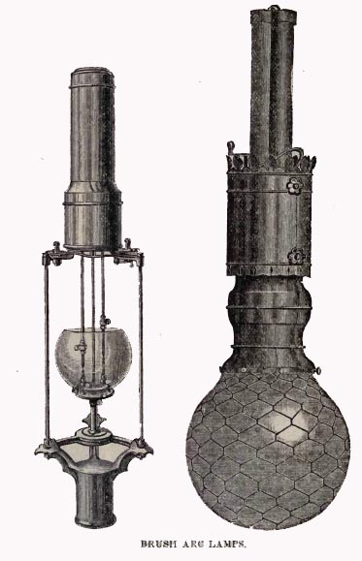

Figure 2: Arc-Lights

But Edison did not really *invent* the light bulb, he *reinvented* it. Before Edison’s lamp, arc-lighting (Figure 2) was frequently used. But the downfall of arc-lighting was that the bulbs only be used outdoors, they produced a deep hissing sound, they were un-adjustable, and they threw off embers.[7] Coupled with the fact that its price was sky-high and there was no powerful enough sustained electrical source,[8] there was truly no reason to purchase arc-lighting when candles or kerosene lamps were just as effective than the expensive bulbs. Imagine what life would be like today if Edison had not reinvented the light bulb and if candles and arc-lighting were still in effect. His reinvention of the bulb was a turning point because it inevitably was used to make enormous historical decisions.

Edison’s goal was to control output and efficiently power many bulbs from one power source. “With ten lights have been produced by a single electrical machine, it has been a triumph of scientific skill. With produce a thousand – aye ten thousand – from one machine. Indeed the number may be infinite.”[9] Indeed, scientists and researchers before Edison had created systems of electric lighting that were adequate, but no one had created a system in which all bulbs were lit by one source. And as trivial as this may sound, it was and is truly revolutionary to not have to pay a light bill for every light bulb one owns. Edison changed the course of history by instigating the idea that everything in a building should be powered from one source not multiple sources. This is still used today.

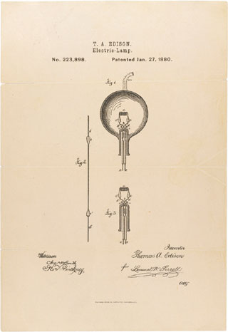

Figure 3: Edison's Light Bulb

He created a bulb (Figure 3) that glowed “like a yellow sun-set of an Italian autumn. [And] in a twinkling, the area bound by space, wall, and Nassau, and Pearl Street was in a glow.”[10] And the result was revolutionary as Menlo Park became an electric showplace and everyone in the town was rushing to be employed by the wizard that had reinvented *the world* with his lamp.[11] But in addition to Menlo Park, “two hundred sites across America—mills, factories, hotels, steamships, stores, and residences,” were alight with over 45,000 bulbs.[12] This is perhaps Edison’s most lasting invention without which life would truly be different; modern discoveries might not have been made without the light needed to make them, rate of crime would have significantly increased, and rate of fires might increase as result of greater usage of candles. Would we still be living in the dark without it?

And even though Edison is not as well known for his work in electricity, he made huge contributions that changed the face of history and life today. But most of his contributions arose in “the first and nastiest standards war [which] was fought between Alternating Current [masterminded by George Westinghouse and Nikola Tesla] and Direct Current [masterminded by Thomas Edison].”[13] Though this war occurred long before modern standards wars such as “VHS versus Betamax, Windows versus Macintosh, or Blu-Ray versus HD-DVD,”[14] its effects still play an integral part in determining today’s electricity. But this so called war was not fought with guns and armies and generals but with words and only with words.[15] Pragmatically, consumers favored a system that served a wide area, and could be distributed more economically and greater distances; AC did exactly that.[16] On the other hand, because of high costs, DC could only serve small districts (similar to Pearl Street). As a result, sales for Edison’s Light Company fell dramatically and hopes for the company fell. But Edison was not going to give up so he launched the war to regain the electric power. In his words, “there is no point in introduction of electricity so dangerous to people” and “the only remedy is to restrict electrical pressures,” something that DC did.[17] This war of words was a turning point in history because after it, electricity (both AC and DC) began to be widely used; before the war, scientists were just researching in the lab (under controlled conditions, with small voltages and small danger, and with small risk of failure), but after, electricity was introduced into the modern world. One must deeply contemplate its deep roots in today’s society and in the course of history to truly appreciate how integral electricity is to the lives of every creature and being on the planet. Would the second industrial revolution have been as successful as it was without it? Would we have as much electronic technology as we do today without it? Would individuals be able to go shopping at night without it? Either way, the war and Edison must be thanked.

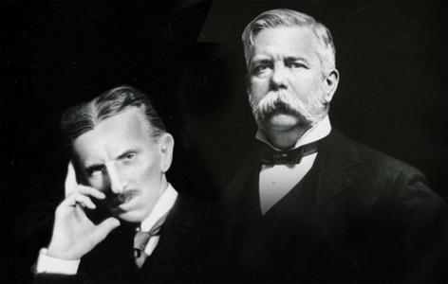

Figure 4: Tesla and Westinghouse

Edison miserably lost the war but he was once again steadfast; if DC was not going to be used to deliver electricity to homes and businesses, it could at least be used to power a storage battery—a box of direct current, right? The earlier storage battery was remarkably heavy and dangerously corrosive and so it was unsafe to use with an automobile. Edison knew that if he invented a superior storage battery, he would “open up new epoch in electricity” in which DC holds its rightful place *with* AC.[18]

“Out of Menlo Park came improved telegraph and telephone systems, dynamos, electric rail system, and photoelectric effect. The phonograph also sprang from Menlo Park.”[19] These inventions all clearly changed the face of history yesterday and continue to do so today and are therefore all turning points; but all of them have been upgraded, changed, or redesigned throughout time. Edison’s success with the battery similarly affected the course of history and continues to affect us; but it is different in that the battery today is very similar to the Edison battery of the 20th century. The fact that the battery’s ideas are still being applied truly demonstrates how much ahead of its time it was: it changed history. Nevertheless, without the battery (Figure 5), there would be no electric car, no airplane, no electric train, and no cell phone. Indeed, without the battery, Henry Ford may never have come up with design for the modern vehicle. And since it was an excellent conductor of electricity[20], Edison exclaimed that there would now be “a miniature dynamo in every home…an automobile for every family,” and said that the time has come “when every man may not only be able to light his own house, but charge machinery…work his food by electricity without depending on anyone for these services.”[21] Edison had succeeded and had changed the world yet another time. And according to the Detroit Electric Car Company, “next season an electric not thus equipped [with the Edison battery] will be as outdated as a single-cylinder gas engine.”[22] Indeed, the Edison battery changed the face of the world by enabling the world to be more portable: a turning point in history that eventually led to the mobile age today.

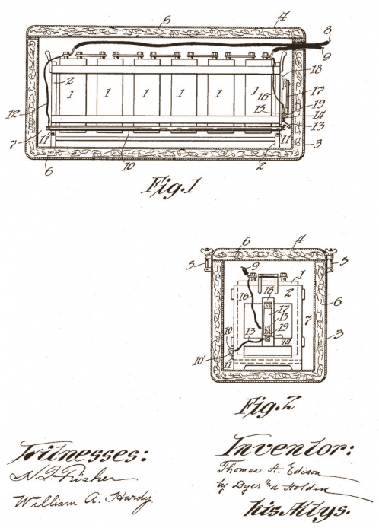

Figure 5: Edison's 1918 Storage Battery

The War or Currents was a turning point in history because marked the first time electricity began to be widely used outside the lab; but the invention of direct current (even though it and Edison lost the war) was also a turning point in history because it is still used in a variety of different ways today. AC was actually not perfect because it could not be used to connect out-of-step sections of the AC grid; therefore, DC was used.[23] Indeed, without Edison’s invention of DC, some sections of the c

ountry might not be getting electricity; even though it only assists AC, it was used and is used to ensure electricity in every corner of the country; although not as flagrant a turning point as the invention of AC, the invention of DC still changed the face of history by letting electricity access every notch of America.

Furthermore, the genius of Edison and Westinghouse in the War of Currents laid the foundations for electric power generator and mass transit rail electrification efforts such as New York Subway and Norfolk – West railroad.[24] Now, almost every major city across the world has a subway system and many homes have generators. The invention of these was a turning point because they revolutionized public transportation; people could now quickly travel from point A to B. Edison is once again the man to thank.

The invention of DC was a turning point in history because DC can also be used to send electricity underwater with a cable. AC cannot be used for this purpose because AC builds up high capacitance—stored electric charge—which has to be overcome; but DC is completely unaffected from being used underwater. Today, there is a 155 mile line from Sweden to Germany under the Baltic Sea that uses this technology. Without Edison discovering DC, these lines could not have been built and some sections of land near the areas mentioned above may not receive electricity; the invention of DC, even if it failed in the 19th century, was a true turning point in history.[25]

It took more than a century just for DC to *supplement* AC; but now every portable device from a laptop to a cell phone to a PDA to a MP3 Player runs on DC. And today, the world seems to be making a run towards a world that is connected 24/7. This calls for devices untethered from wall outlets and wires; so they have to be powered by batteries or fuel cells. Are we slowly moving from AC to DC? Alternating current may have dominated the industrial age but the computer age is bound to be dominated by direct current; the computer age is bound to be DC’s vengeance upon AC.[26] Again, without Edison’s discovery of DC, there may have never been a computer age. The innovation of direct current is irrefutably a turning point in history.

Today, Thomas Alva Edison’s legacy continues to amaze every being on earth. He became the founder of General Electric (GE), the leading supplier of equipment for producing stoves, dynamos, refrigerators, transformers, airplanes, transmission lines, engine boosters, and X-Ray machines. [27] Edison was truly a Renaissance man of his time, without whom we may not have any of the above items. GE would not have existed without Edison; he completely changed the course of history by leading the mass production of common household items for low prices (to some extent even before Henry Ford did with the automobile).

Something that defined Edison’s inventions was that they were all practical even though he was just utilizing them to gain money. In his own words, “A scientific man busies himself with theory. He is absolutely impractical. An inventor is essentially practical.” [28] All of his inventions were also topical and jumped into mainstreamed technology—like the telegraph, or developing technology such as the telephone, light, X-ray, or rubber. [29] Perhaps this is why his life was a turning point in history; because he invented items that the common person could use, items that were practical, and items that were topical.[30] Whatever reason one believes in, “The Wizard of Menlo Park”[31] was truly a wizard who changed the face of the earth.

‘

1. **Endnotes**

   Harold Green, “The Wizard of Menlo Park: How Thomas Edison Invented the

   Modern World.” International Social Science Review 84, no. ¾ (2009): 193. MasterFILE Premier, EBSCOhost, http://search.ebscohost.com/login.aspx?direct=true&AuthType=

   cookie,ip,cpid&custid=cincy&db=f5h&AN=47559849&site=ehost-live, Internet, Accessed December 18, 2012, n.p.
2. Jan Adkins, Thomas Edison (New York: DK Publishing, 2009), 10-29.
3. Ibid., 26-29.
4. Ibid.
5. John S. Anderson, John M. Saby, "The electric lamp: 100 years of applied

   physics." Physics Today 32, no. 10 (1979): 32. MasterFILE Premier, EBSCOhost,  http://search.ebscohost.com/login.aspx?direct=true&AuthType=cookie,ip,cpid&custid=cincy&db=f5h&AN=4957909&site=ehost-live, Internet, Accessed December 20, 2012, 33.
6. Neil Baldwin, Edison: Inventing the Century (New York: Hyperion, 1995), 102-103.
7. Ibid.
8. Anderson, Saby, "The electric lamp: 100,” 33.
9. Green, “The Wizard of Menlo Park: How,” 105.
10. Anderson, Saby, "The electric lamp: 100,” 111-114,139.
11. Baldwin, Edison: Inventing, 116-118.
12. Ibid., 139-142.
13. Tom McNichol, AC/DC: the Savage Tale of the First Standards War (San Francisco:

    Jossey-Bass, 2006), 0 (Blurb).
14. McNichol, AC/DC: the Savage, 0 (Blurb).
15. Baldwin, Edison: Inventing, 202-203.
16. Randall Stross, The Wizard of Menlo Park, (New York: Crown Publishers, 2007),

    171,175.
17. Thomas Edison, “The Dangers of Electrical Lighting,” The North American Review,

    November 1889, 625-634, http://www.unz.org/pub/NorthAmericanRe1889nov-06625, Internet, Accessed November 21, 2012, 628-633.
18. McNichol, AC/DC: the Savage, 156.
19. Varrasi, "The Age of Ingenuity," 45.
20. Devin Powell. "Edison's battery gets a makeover*." Science News* 182, no. 2 (July 28,

    2012): 12, *Academic Search Premier*, EBSCOhost, http://search.ebscohost.com/login.

    aspx?direct=true&AuthType=cookie,ip,cpid&custid=cincy&db=aph&AN=14428300&site=ehost-live, Internet, Accessed January 1, 2013, n.p.
21. McNichol, *AC/DC: the Savage*, 157-158.
22. Ibid., 159.
23. Ibid., 176.
24. Varrasi, "The Age of Ingenuity," 45.
25. McNichol, *AC/DC: the Savage*, 176.
26. Ibid., 177.
27. Adkins, Thomas Edison, 119.
28. Randall, The Wizard of Menlo, 17.
29. Conot, A Streak of Luck: the Life, 460.
30. Ibid.
31. Randall, The Wizard of Menlo, 0 (Title).

    **Bibliography**

    **Primary Sources:**

    Anderson, John M.Saby, John S. 1979. "The electric lamp: 100 years of applied

    physics." Physics Today 32, no. 10: 32. MasterFILE Premier, EBSCOhost

    http://search.ebscohost.com/login.aspx?direct=true&AuthType=cookie,ip,cpid&custid=cincy&db=f5h&AN=4957909&site=ehost-live, Internet, Accessed December 20, 2012 (accessed December 20, 2012).

    This source contains some information about arc-lighting and the kinds of artificial light that were used before Edison. It contains general information about arc-lighting as well as quotes.

    Edison, Thomas. “The Dangers of Electrical Lighting.” The North American Review, November

    1889, 625-634. http://www.unz.org/pub/NorthAmericanRe1889nov-06625 (accessed

    November 21, 2012).

    This primary source talks about why alternating current is dangerous and why it should be not be used anymore; it talks about the positives of DC over AC. It also talks of the imminent possibility of death if AC is continued to be used. Since, it is primary source, it provides great quotations about Edison’s beliefs.

    Green, Harold M. 2009. “The Wizard of Menlo Park: How Thomas Edison Invented the Modern

    World.” International Social Science Review 84, no.314: 193. MasterFILE Premier, EBSCOhost (accessed December 18, 2012).

    This journal has a great quote describing how Thomas Edison has become a revolutionary figure. It describes how Edison completely changed the way people live today.

    Powell, Devin. "Edison's battery gets a makeover*." Science News* 182, no. 2 (July 28,

    2012): 12. *Academic Search Premier*, EBSCOhost, http://search.ebscohost.com/login.

    aspx?direct=true&AuthType=cookie,ip,cpid&custid=cincy&db=aph&AN=14428300&site=ehost-live (accessed January 1, 2013).

    This source contains information about Edison’s storage battery and how it had been a century ahead of its time. It explains how it works and also explains that to some extent it

    is still being used today.

    Varrasi, John. "The Age of Ingenuity." Mechanical Engineering 127, no. 2 (2005):

    44. MasterFILE Premier, EBSCOhost, http://search.ebscohost.com/login.aspx?

    direct=true&AuthType=cookie,ip,cpid&custid=cincy&db=f5h&AN=15865025&site=ehost-live (accessed December 20, 2012).

    This source contains empirical information on the advantages and disadvantages of AC and DC. It also contains empirical information on how AC and DC affected the world today. However, it does not go into much depth.

    **Secondary Sources:**

    Adkins, Jan. Thomas Edison. New York: DK Publishing, 2009.

    This source presents Edison’s life chronologically but does not go into much detail or description. All events are superficially described and depth is not present. At the same time, it gives a holistic overview of Edison’s life. It has a lot of information about Edison’s childhood and how his passion for inventing developed.

    Baldwin, Neil. Edison: Inventing the Century. New York: Hyperion, 1995.

    This source contains a lot of information describing Edison’s invention of the incandescent lamp. It contains a plethora of details and has several chapters devoted solely to the light bulb. It also contains information about the Edison’s storage battery, DC, and the War of Current with Westinghouse.

    Conot, Robert. A Streak of Luck: the Life and Legend of Thomas Alva Edison. New York:

    Seaview Books, 1977.

    This source contains a holistic overview of all of Edison’s inventions. It briefly describes each of his prominent inventions and describes the affect it has on life today. The source also contains a breakdown of which area each of Edison’s 1093 patents came from i.e. lighting, electricity, battery, motion pictures.

    McNichol, Tom. AC/DC: The Savage Tale of the First Standards War. San Francisco:

    Jossey-Bass, 2006.

    This book is devoted to the War of Currents and therefore has tons of details about the war of words. However, it seems to be biased towards Edison and does not include a lot of information or opinions of opponents such as Westinghouse or Tesla. Nevertheless, in addition to discussing AC and DC, it also contains information about Edison’s other inventions and includes info about the effect of Edison’s inventions on the world today.

    Stross, Randall. The Wizard of Menlo Park. New York: Crown Publishers, 2007.

    This source provided a tremendous amount of information about the War of Currents. It has a plethora of quotes by all the major players including Edison and Westinghouse. It presents the conflict in an easy to understand chronological order. It presents the issue from multiple points of views and is a great source for information about the war of currents.

    **Images:**

    Barrett, Simon. "Westinghouse (The Minutes Of History)." Blogger News Network.

    http://www.bloggernews.net/124093 (accessed January 5, 2013).

    This is a picture of George Westinghouse and Nikola Tesla. They were partners advocating AC against Edison and DC.

    “History of Lighting 1888." Global Greenhouse Warming.

    http://www.global-greenhouse-warming.com/history-of-lighting.html.

    (accessed March 8, 2013).

    This is a picture of an arc-lighting bulb that was used before Edison invented the incandescent light bulb.

    "Lighting A Revolution: Thomas A. Edison." Home | National Museum of American

    History. http://americanhistory.si.edu/lighting/bios/edison.htm (accessed January 5, 2013).

    This is a picture of Thomas Alva Edison at age 33.

    "Thomas Edison's Patent Application for the Light Bulb." National Archives and Records

    Administration. http://www.archives.gov/historical-docs/document.html?doc=11&title.raw=Thomas%20Edison's%20Patent%20Application%20for%20the%20Light%20Bulb (accessed January 5, 2013).

    This is Edison’s 1880 patent for the light bulb.

    "Thomas Edison Storage Battery." Patent Room. http://patentroom.com/node/619

    (accessed January 5, 2013).

    This is Edison’s 1918 patent for his storage battery.