**Voyage to Greece**

**Part 1**

**Geography**

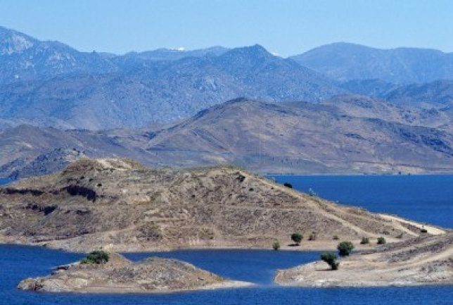22-30-8. I put in my locker combination. In the blink of an eye, I see a flash of REALLY bright light, then a big mass of green and blue, my head throbbing. As my eyes slowly focus, I look around. I then realize that I’m on the side of a hill. The air feels warm, and it smells like saltwater. Well, obviously, I’m near the sea… About a mile or so away from the bottom of the hill, I see a city. Basically, I have absolutely no idea whatsoever where I am. Mind = blown. What just happened? I start to panic. *AHHH what do I do I’m going to die NOOOOO…* After my… panic attack, I decide to go to the city I saw before, and figure out how to get back home. As I slowly stand up, I trip over something and collapse on the ground. I then realize what I’m wearing. A toga. Why the heck am I wearing a toga? I definitely did not wear this to school. Then, I notice a field of olive trees in the distance. I locate tons of jagged mountains. Wait a second. Slow down. *Mountains…sea…olives…toga…* I’m in *the Ancient Greek peninsula?* I look around again, this time taking note of the geography around me. East of me is probably the Aegean Sea. South’s got to be the Mediterranean. That leaves west to be the Ionian Sea. I noticed I was right on the west coast of the peninsula that goes into the Ionian Sea, but there are some islands ahead. How I know this? I have absolutely no idea. My mind finally puts together the puzzle and I realize that the city I noticed before is none other than Athens.

I finally and slowly get up and start walking to the city. In the distance, I see a giant cargo boat going with boxes and boxes of olives. Must be really easy to import and export around here. They must get flooded a lot, too. Though, now that I think about it, internally, it’d be hard to export because of the mountains. But those mountains would have the advantage of a barrier. So in the wars, the Greeks definitely had protection. Wow, did I really

**The Mountains of Greece**

just think about that? I guess all of the stuff I learn in social studies is getting to my head. As I walk, my hands go into my pockets, and I feel something squishy. I take it out, and realize it’s a piece of clay, but it’s inscribed with something. Για να επιστρέψετε στο χρόνο σας, θα πρέπει να μάθουν τις επιπτώσεις γεωγραφία, την κυβέρνηση και διαρκή την Ελλάδα. Μόλις αποκτήσουν αυτή τη γνώση, υπάρχουν τρία ερωτήματα που πρέπει να απαντήσει στο ναό των Δελφών. Αν απαντήσει σωστά, οι θεοί θα επιστρέψετε στην ώρα σας. Αν αποτύχει, θα παραμείνει για πάντα στην Αρχαία Ελλάδα. I can tell it’s Greek, but what does it say? Still in my train of thought, I look up, and realize that while thinking, I have reached Athens. As I walk through the city, trying to find a scribe, I am amazed. *I’m actually in Greece, my dream vacation…* I see a little wine shop, with a lady standing at the front giving samples, trying to promote their shop. . It’s so weird, because the citizens are all waving at me or ignoring me as if I’m supposed to be there. Wow, there are a lot of locals. I suppose the mountain barriers, the easy import and export, and the beautifulness of Athens must be the cause. I’m guessing the Greeks must need to do a lot of importing for their food, because they don’t have any farmland at all. It’s just mountains, mountains, and more mountains. Finally, I locate a scribe. I give him the tablet, and he translates aloud what it says. “In order to return to your time, you must learn the geography, government and enduring impacts of Greece.  Once you gain this knowledge, there are three questions you must answer at the Temple of Delphi.  If you answer correctly, the gods will return you to your time.  If you fail, you will remain forever in Ancient Greece.”

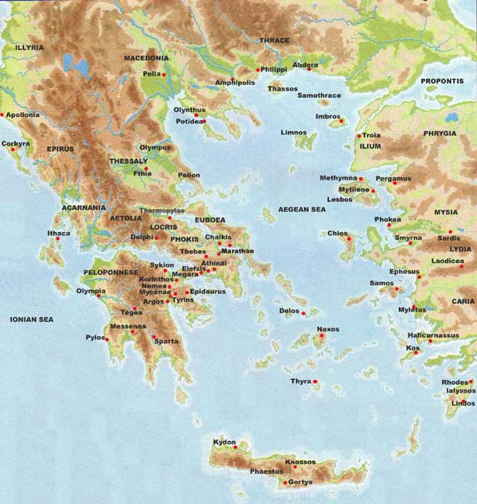  **Map of Ancient Greece**

Documentary on Ancient Greece: <http://www.youtube.com/watch?v=rETRu_w6zg>

**Part 2**

**Government**

*“In order to return to your time, you must learn the geography, government and enduring impacts of Greece.  Once you gain this knowledge, there are three questions you must answer at the Temple of Delphi.  If you answer correctly, the gods will return you to your time.  If you fail, you will remain forever in Ancient Greece.”*

Wow. Is this an attempt at a cliché social studies assignment? How the heck did Mr. Rodriguez get me

here? Well, there’s no use in thinking about it. I already know the geography, I’ve been learning it ever since I got here. Now, where to figure out the government? I have absolutely no idea what to do. Walk around and hope I’ll get lucky? Sure, that sounds like a starting point… Just when I look around to decide which direction to go in, I see a sign. It says “Meeting at the polis at the Parthenon concerning possible chance of allowing women to be citizens. Meeting for citizens (all men who own land) ONLY.” I decide to go there. See, sometimes you do get lucky. Well, that one piece of paper answered about a million of my questions. I know the Greek government; it’s a direct democracy, since the citizens are supposed to be deciding on all of the issues (different from those Spartans over there, with their stupid oligarchy, where only a little group of people get to decide. Here in Athens, everyone participates in making things like laws, but in oligarchies, a little group makes ideas, and their assembly reviews them. Really, an oligarchy isn’t a democracy – the people have no say. But I won’t go into that.). It also told me what you have to do to be a citizen – be a man who owns land. That’s so unfair. It also is unlike Sparta, where women can be citizens and have so much freedom. I mean, in either city-state, if you’re not a citizen, you’re basically a slave. It really sucks. But if you’re a citizen, you’re treated very fairly. Wow, Sparta and Athens are a lot alike. I personally like the idea of a direct democracy than an oligarchy. But, I prefer what we have here in the US. We could have a direct democracy, but it wouldn’t be a good idea in my opinion. The people we elect are probably smarter. In a direct democracy, it would be great that everyone had a say, since it may mean a better decision if everyone made it. But a direct democracy is also really bad, because it could lead to arguments or, taking it to the extreme, wars. It also might not be the greatest decision, because sometimes, people become selfish. They might not think about what’s good for themselves AND the neighboring countries. The sound of a horn interrupts my train of thought. I look up, and realize I’m here. How the heck do get to places without even realizing. I then realize that the horn was supposed to bring everyone to attention. I quickly take a seat and hope nobody will notice me.

“Σας ευχαριστώ που ήρθατε εδώ. Όπως γνωρίζετε, αυτή η συνάντηση σχετικά με τη δυνατότητα των γυναικών να γίνει πολίτες της Ελλάδα. Θα ήθελα να ξεκινήσω τη συζήτηση.” Says a man seated at the front, probably the guy who’s hosting it.

“Μιλούν αγγλικά, έχουμε κάποια τυχαία τουριστική μας παρακολουθούν.” Says some guy in the crowd, motioning to me. I have absolutely no idea what he just said, but I hope It wasn’t an order to kick me out. The guy at the front looks at me, nods, and says “Welcome, newcomer. I see that you are here to observe us deciding if we shall let women be citizens of our country. Feel free, but please do not participate, or you will be taken out.” I love how in Athens nor Sparta, it’s a group of people who rule – not just one person. It’s not a monarchy. From there, the debate begins in English, probably because of me. “I personally think this is an outrageous idea – women are in their rightful spot right now – houseworkers and slaves. They aren’t any help to us at all!”

“Yes, but they would be if they were allowed to! They too are humans!”

“This idea is absurd! I also support keeping them where they are!”

And on it continued, just like that. In the end, they held a simple vote by raise of hand, and the majority was saying no, so that’s what happened. After that, I thanked everyone for letting me stay and left. WOO HOO! I know the Greek government! It’s a direct democracy! Now, onto completing this ever so cliché assignment and finding the ENDURING IMPACTS! Yaaaay...

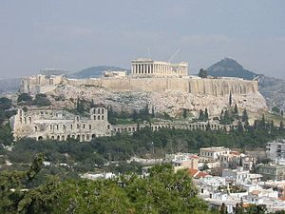**An example of a Greek polis (In this case, the acropolis)**

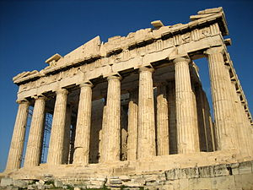**The Parthenon, a temple to the goddess Athena**

**Video on government of ancient Greece:** <http://www.youtube.com/watch?v=mLdk23DlNiY>

**Part 3**

**Enduring Impacts**

*WOO HOO! I know the Greek government! It’s a direct democracy! Now, onto completing this ever so cliché assignment and finding the ENDURING IMPACTS! Yaaaay...*

Well, I guess, for this one, I’ll just wing it like last time. That went well… I haven’t done any sightseeing here at all, and I’m guessing that a lot of buildings and stuff will make me think back to my time. Hmm, where should I go first that would probably have some kind of enduring impact? What place would show me how the ancient Greeks left their mark in the world? OF COURSE! THE PARTHENON! What better then the place that almost nobody hasn’t heard of in the present? Well, somehow, I ended up right next to a street map for tourists and its showing the Parthenon to be THREE MILES AWAY. UGGHHHHHH…. And I have to walk through a market. UUUUUUGGGGGGHHHHHHHHHHH… I start walking. Seriously, who even cares about the “enduring impacts”? It’s not like I really care that Homer, an ancient Greek poet, wrote some of my favorite and also worldwide famous texts, *The Iliad* and *The Odyssey*. I just know he wrote it, who cares that he is an enduring impact from Ancient Greece? Well, I kind of see why they matter. They matter because these people who left an enduring impact are the reason the world advanced. For example, the pieces of literature I mentioned above *inspired* others to write, to create a legacy like Homer did. That caused the world to advance in literature, and in knowledge of the Trojan War, and Ulysses’ adventures. Geez, my thoughts are getting pretty deep. Just then, I look around and realize I’m standing in the middle of a market.

I look around. At a hardware store, I see a huge tub of wooden screws. I see a man working with them, building a little catapult. To my right, I see a giant A- WOW IS THAT AN ARCHIMEDES SCREW I SEE? I DID MY GREECE PROJECT ON THAT! Those things are so cool! You just put the screw in a low lying body of water, turn it and water rises up! I’ve seen some of them back home, too, since they’re really helpful in bringing up water without using any resources like electricity. I see a little group of children sitting at a shop that sells schoolbooks, and learning about the Pythagorean Theorem, that an Ancient Greek guy, Pythagoras, invented. It’s a pretty big thing in math (and has helped me get A’s on some math tests). Wow, I’m starting to see how much influence the Greeks have on us. I see yet ANOTHER influence – a pottery shop, selling beautiful painted pots and plates. Well, who hasn’t seen clay dishes? Some people use them every day. OK, now this is just getting creepy. I could go on all day about all of the impacts I see, just standing in one place. I decide to just look at the ground and keep walking until I reach the Parthenon

I’m FINALLY here. At this absolutely beautiful piece of architecture. It’s breathtaking. Seriously, it’s awesome. I’ve seen tons of buildings that look like the Parthenon (if I find one more impact…), but none of them are as awesome as the actual thing. Everyone in modern culture is building things influenced by the Parthenon. Greeks are polytheistic, but they have done their part in showing Athena the love. HAHAHAHA MR.RODRIGUEZ SEE I DID FIND THE ENDURING IMPACTS! IN YOUR – wait a second. I found the geography. I found the government. I found the enduring impacts. That means… I CAN GO BACK HOME! WOO HOOOO! What had the tablet said again?

*“In order to return to your time, you must learn the geography, government and enduring impacts of Greece.  Once you gain this knowledge, there are three questions you must answer at the Temple of Delphi.  If you answer correctly, the gods will return you to your time.  If you fail, you will remain forever in Ancient Greece.”*

I have to go to the Temple of Delphi? Where the heck is that? GAHHH I’m too tired to go anywhere… I look around, and see a woman wearing a toga. I walk up to her and politely ask “Excuse me, where can I find the Temple of Delphi?” At first, she looks confused, probably because she doesn’t know how to speak English. Then, she points to my right. I thank her and yet again, start walking.

Guess what? I’m here. At this circle of columns. Yeah, that’s basically what the Temple of Delphi looks like. Well, let’s see what happens. “Hello?” I call into the empty space. No answer. And then, a bunch of green smoke begins to surround me. Sweet. I then hear a booming voice. *Definitely* not what I expected. “NAME THE THREE SEAS SURROUNDING GREECE!”

“Ummm the Ionian Sea, the Mediterranean, and the Aegean?”

“CORRECT. WHAT GOVERNMENT IS USED HERE IN GREECE?

“A direct democracy” I reply more confidently this time

“CORRECT AGAIN. NAME ONE ENDURING IMPACT OF ANCIENT GREECE.”

“Homer’s books, *The Iliad* and *The* *Odyssey*. They’re considered some of the best poems of all time, and people still study them.” I say like a robot.

Just then I see a really bright light, and I’m standing in front of my locker, my hand on the combination lock. I look around, and it looks just like when I left. Nobody looks surprised. What the heck? It was THAT easy? Seriously? I could’ve taken that test without walking all over Athens. GRRRR. There is no way I’m letting all that time go without showing off. I decide to make a little display, about the enduring impacts. That would be so cool, and people will be really surprised at all the impacts like I was. One of them, will be, of course, the famed books by Homer. Those wonderful poems are read and studied TONS. I think I’ll also use that Archimedes Screw I made. Those things are still used today, since they’re great to bring up water, and don’t use ANY electricity. Oh yeah, and the Parthenon. I’ll have to make a clay model of that one. That building’s design, with the columns, is used lots in buildings today. And of course, I can’t forget everyone’s favorite math formula! The Pythagorean Theorem! Good old Pythagoras made that one to add to helpful math. Hmmm what else? OH! THE CLAY POTS! Everyone uses clay to eat off of! Perfect! My museum must be completed NOW!

…

…

…

THE END

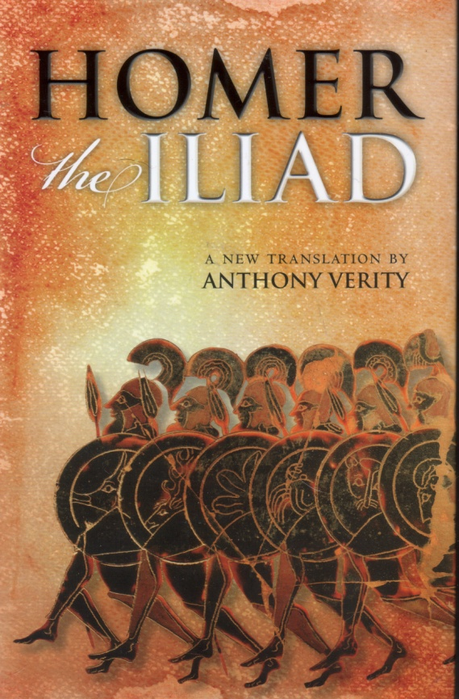The Iliad by Homer – a VERY famous poem

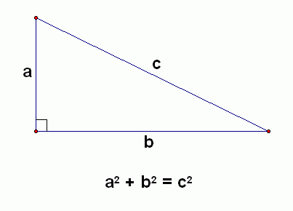The Pythagorean Theorem, made by Pythagoras

Video on the Parthenon: <http://www.youtube.com/watch?v=qC14v2XpX9Q>