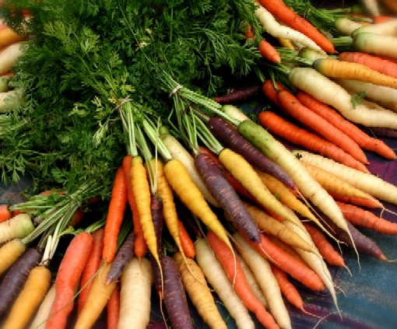Are you doing the right thing by paying the extra price for organic foods because the label says they are fresh and good for you?

**What are organic foods anyway?**

Organic foods are foods that under the circumstances have not been sprayed with pesticides, and fertilizers. Organic foods are conventionally grown foods that just haven’t been affected with fertilizers. Organic foods are well, organic, they grow on their own until a farmer picks them. Any food item can be organic, for example, animals can be organic, vegetables can be organic, and even tissue paper can be organic.

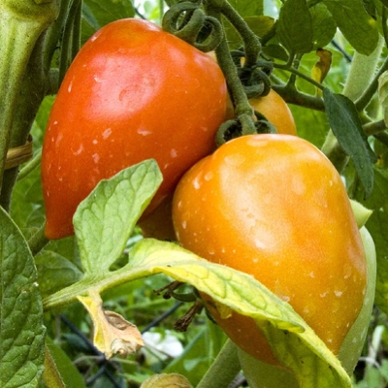**Where are organic foods grown?**

‘‘Crops are generally grown without synthetic pesticides, artificial fertilizers, irradiation or biotechnology. Animals on organic farms eat organically grown feed, and aren’t restricted 100 percent because they are sometimes they are raised on conventional farms without antibiotics or synthetic growth hormones.’’

**Where do you buy organic foods?**

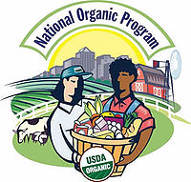One can buy organic foods anywhere. Supermarket, drug store, pharmacy, and even a electronic store. In some instances, non – living things can be organic. Examples are tissues, which are made from a organic plant. Organic foods are usually in another section of the store which can be found by asking a store employee. There one can find thousands of different organic foods. Most organic foods are marked with a sticker that says something along the lines of “Certified Organic.” In some non food related stores however, organic foods will be located at places people will see when they shop like along the checkout line or along the siding of the entrance.

**Should I buy Organic Foods?**

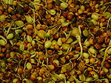“Some Organic foods have higher nutritional value than conventional food. This is because of the abundance of nourishments, plants boost their assembly of the vitamins and antioxidants that strengthen their resistance to bugs. Studies have connected pesticides in our food to everything from 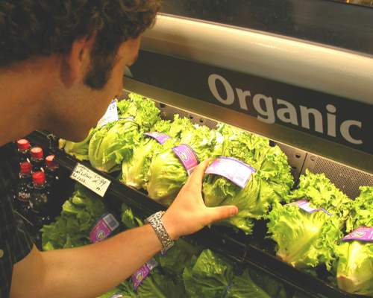headaches to cancer, but many experts say that it is safe to have conventional foods if the person taking them is already healthy. Low-level pesticide exposure can be significantly more toxic for fetuses and children due to their less-developed immune systems and for pregnant women. Rather than trying to beat nature, organic farmers work with the philosophy of plants and the natural surroundings. This is accomplished through crop rotation, allowing wildlife, and retaining wetlands and other natural areas. “Organic farmers often have to find superior solutions to usual production problems than the commercial farms. This means they often use their own money to research and develop new technologies to ensure the reduction of pesticides and other toxins.” The main point is to try to buy organic foods whenever possible as they will help you, but not to assume that eating conventionally grown food is going to kill you.”

**How do organic foods help the environment?**

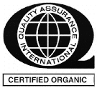“Organic farming reduces pollutants in the ground and creates richer soil which helps plants to grow and also reduces erosion in the area. It also decreases pesticides that can end up in your drinking glass and in some cities, to some extent, pesticide levels are so high they can make you ill for weeks. This is because chemicals used in conventional farming usually run off into watersheds and can seriously pollute the water. By refraining to use these chemicals, the water around organic farms remains pure. Conventional farming has allowed many species of plants to become lost. Organic farmers like to assemble and preserve seeds that have a chance of going extinct to grow over time for an overall miscellany of plants. “In a typical farming practice, soil is destroyed with chemicals and single crop farming. By building up the soil to grow plants, the farm is counter balancing the effects in a small.” Organic farming use 50% less energy than conventional farming methods and therefore buying and eating organic foods helps the environment because the farms use less energy and they are better for your health. WHY NOT BUY EM?”

**How much do organic foods cost?**

The price of organic foods differs with the product. For example a organic orange is going to cost less than a organic kiwi because oranges are a lot more abundant than Kiwis in the United States. In general, the price of organic foods will be higher because there are less organic farms than conventional farms making the products supply very little compared to the supply of conventional farms. Also when the products are shipped, environmental conditions have to be maintained for them to survive, conditions that conventional foods don’t need. After all things, however, the price gets some rest, because the cost of producing organic food is 50% less than producing conventional foods. All in all, the price of organic foods is actually 30% - 40% more than conventional foods.

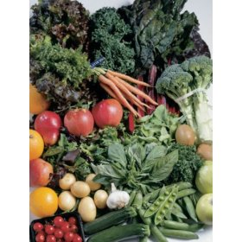

**Do you go into the clearance part of your store? Well LUCKY YOU!**

The prices of organic foods are higher than the prices of conventional foods. If you want organic foods but just don’t have enough money to buy them go to the clearance section of your grocery store. The clearance sections of the stores have items that people didn’t buy at their regular price resulting in reduction of the price by the store. The items in clearance part of the store cannot be too old or the store cannot sell them by law. There is certain remaining life a product has to have to go into a clearance section and also a limit on the amount of days it can stay there. The products they have are usually very fresh and have a lot of time until they will expire. The clearance section usually provides a fair amount of organic foods, anything from oranges to Australian chai or tea. If you buy conventional products at normal price, then go to the clearance section and get organic foods for the same price, they’re just a couple days old. It only makes sense to go ahead and buy those clearance items as they can be very good for your health.

**How do I know is something is organic?**

As mentioned before, organic foods are usually marked with a sticker that says something along the lines of “Certified Organic.” If a food has this sticker, then it is under the condition that it was grown with no fertilizers and has no artificial ingredients in it. Some of the sticker markings include, Certified USDA Organic, National Organic Program, and as mentioned before, Certified Organic. Some things that tell you that a food is organic is if it’s in the organic section, if it has a sticker, or if it actually says that there were no pesticides’ or fertilizers’ used. The product also has to have a special organic seed. To get this certification, foods have to be grown following strict procedures. “The certification shows that the ingredients and its manufacturer have been investigated.”

**What do organic foods taste like?**

To most people, organic foods taste like any other food. To some however organic foods are fresher, and taste better but to some other, it’s the opposite. Well balanced soil without the assistance of fertilizers synthesizes plants that taste great. The flavor is truly what nature wanted. Organic Fruits are sweeter and have more juice than conventional foods. Although this might be true, organic foods are proven to be better for health, and should be bought whenever possible.

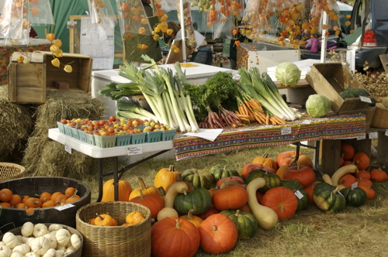

**WORKS CITED**

* **“10 Reasons to buy Organic foods.”*Organic Food Chart.*17 February 2010. <** [**http://www.organicfoodchart.com/**](http://www.organicfoodchart.com/)**>.**
* **“The Truth about Organic Foods.” *REDBOOK.* 17 February 2010. <** [**http://www.redbookmag.com/recipes- home/truth-about-organic-foods**](http://www.redbookmag.com/recipes-%20%20%20%20%20%20%20%20%20%20%20%20%20%20%20%20%20%20%20%20%20%20%20%20%20%20%20%20%20%20%20%20%20%20%20%20%20%20%20%20%20%20%20%20%20%20%20%20%20%20%20%20%20%20%20%20%20%20%20home/truth-about-organic-foods)**>.**
* **“Organic Foods.” *Wikipedia.* February 17 2010. <** [**http://en.wikipedia.org/wiki/Organic_food**](http://en.wikipedia.org/wiki/Organic_food)**>.**