**E - Commerce Application on IBM Cloud Foundry**

**Phase 3 – Development**

**Overview :**

Your Attire is not just another e-commerce website for clothing; it's a style revolution waiting to happen. We've reimagined the online shopping experience to create a platform that's unique, engaging, and, most importantly, all about you. Your Attire is more like a personal fashion hub. It focuses on promoting and showcasing the work of various brands around the world, offering features like product listings, user profiles, robust search and discovery tools, shopping cart and checkout functionality, customer reviews and ratings, customer support, marketing and promotions, community and social features, mobile-friendliness, secure transactions, analytics and reporting, and integration with shipping and logistics services. This application celebrates creativity while connecting fashion lovers with a broader customer base, making it easier for retailers to sell their unique products and for customers to find and purchase high-quality, durable goods.

**Website** **Layout :**

**Home** **section :**

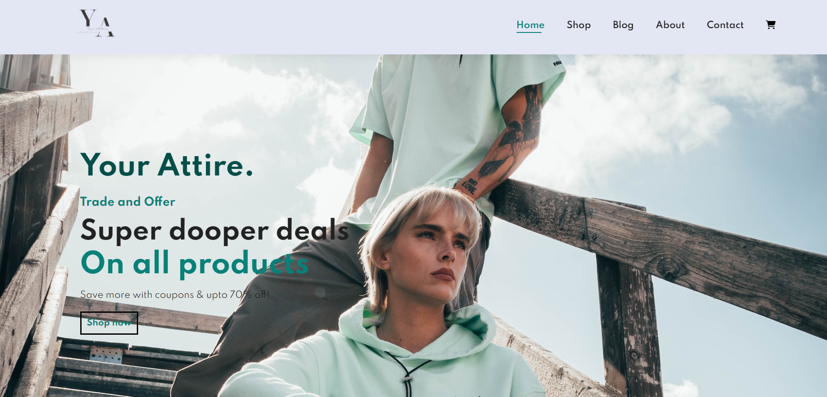

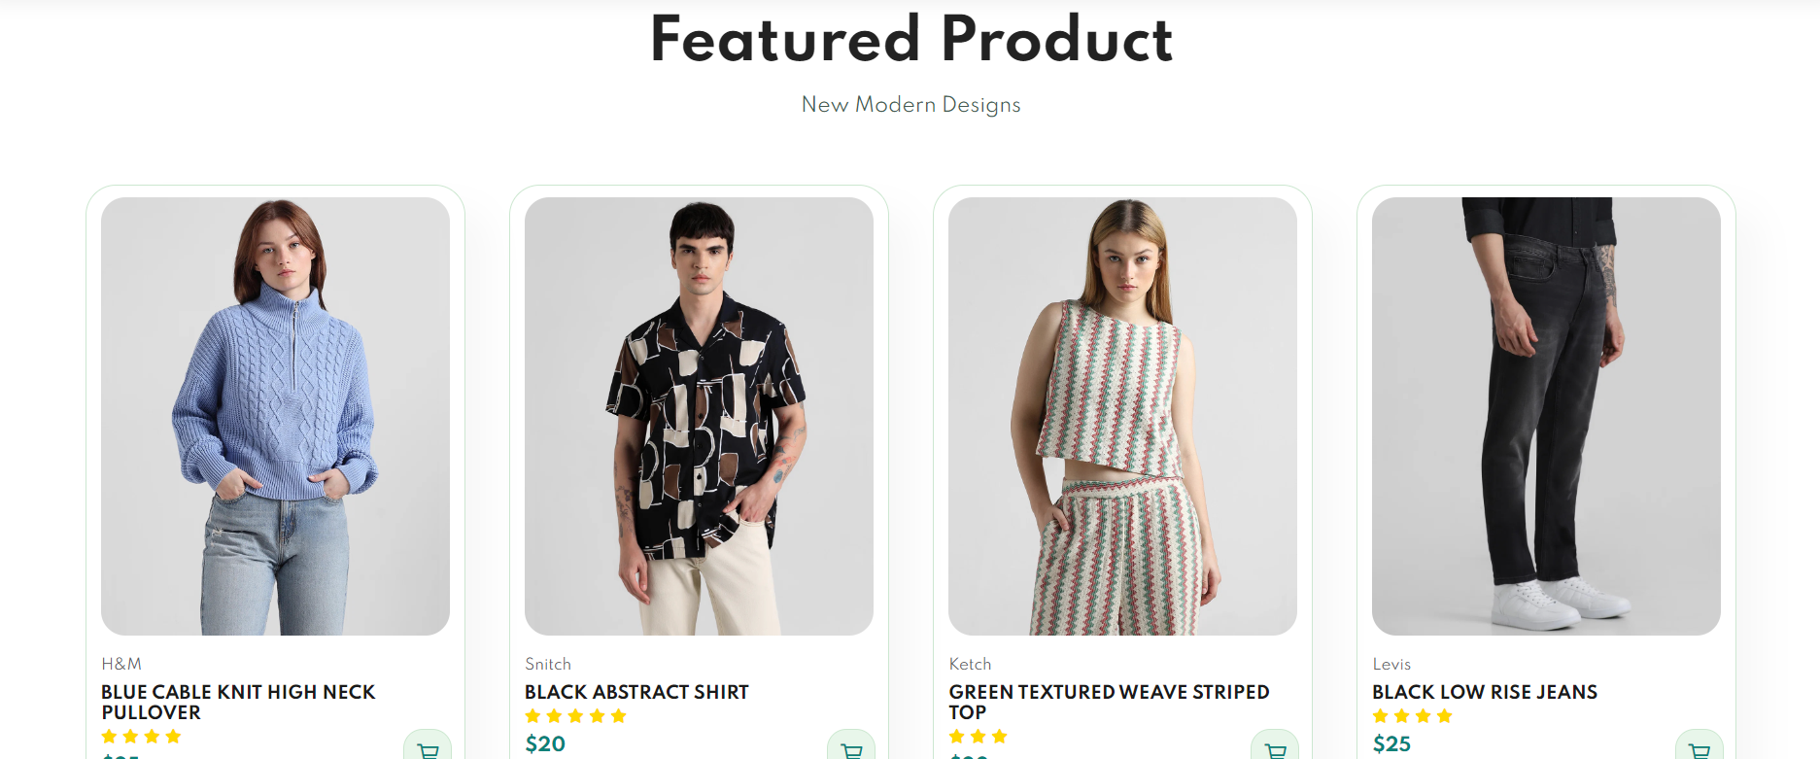

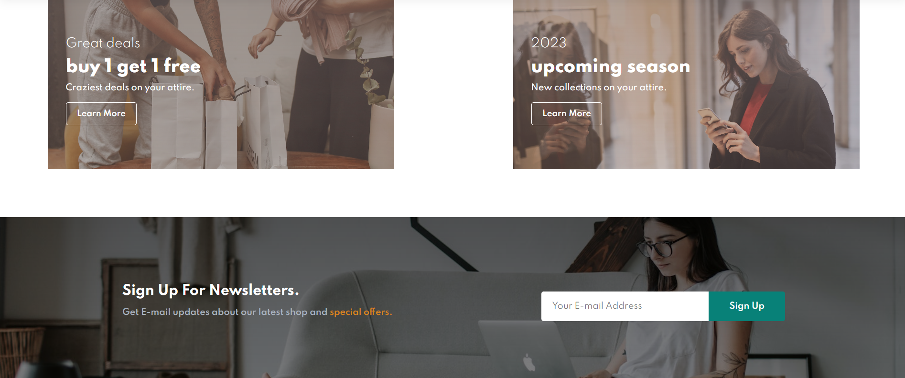

**Contact section:**

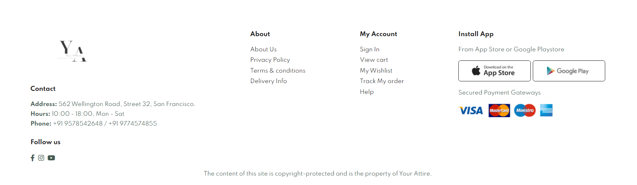

**Database Creation db****2 :**

The database connection at Your Attire with IBM Db2 is the backbone of our clothing website, ensuring efficient and secure data management. We've chosen Db2 for its robustness and advanced features, making it the ideal solution for storing and retrieving data vital to our fashion community.

Key aspects of our database connection:

* Security: We prioritize the security of your data, with strong encryption and authentication mechanisms in place.

* Efficiency: Our connection ensures quick and accurate data retrieval, whether it's product listings, artisan profiles, or blog posts.

* Scalability: As our artisan community grows, our database can scale to accommodate increasing volumes of information without compromising performance.

* Custom Solutions: We leverage Db2 to develop custom solutions that cater to the unique needs of our artisan brand.

* Data Analytics: Data insights help us improve your experience, with tailored product recommendations and content.

Our connection with IBM Db2 is the foundation that supports the seamless experience of exploring our handcrafted products, reading inspiring blog posts, and connecting with fellow customers.

