E-commerce Application on IBM Cloud Foundry

Phase 4: Development Part 2

Overview:

This project aims to facilitate the buying and selling of clothing and fashion dress products. It focuses on promoting and showcasing the work of multiple brands, offering features like product listings, user profiles, shopping cart and checkout functionality, customer reviews and ratings, and promotions, community and social features, mobile-friendliness, secure transactions, analytics and reporting, and integration with shipping and logistics services. This application celebrates creativity while connecting brands with a broader customer base, making it easier to sell their unique products and for customers to find and purchase high-quality, clothing goods.

Solution:

We Continue building the e-commerce platform by implementing user authentication, shopping cart, and checkout functionality and we have successfully Implemented user registration and authentication features using a backend server (e.g., Node.js, Python) and Implemented shopping cart functionality, calculate the total, and enable a smooth checkout process.

Sign up Page:

* The signup page at Your Attire is where you embark on your journey to becoming a valued member of our fashion community. As a new member, you'll unlock exclusive benefits and enjoy a personalized experience, complete with tailored product recommendations and special offers. We are assured that your data is secure and private. Our straightforward signup process is designed for efficiency, and our support team is here to assist if needed. We welcome both seasoned sellers and newcomers to our thriving community. Join us today and embrace the world of modern fashion.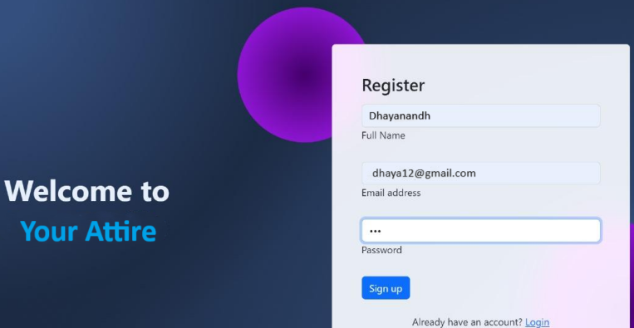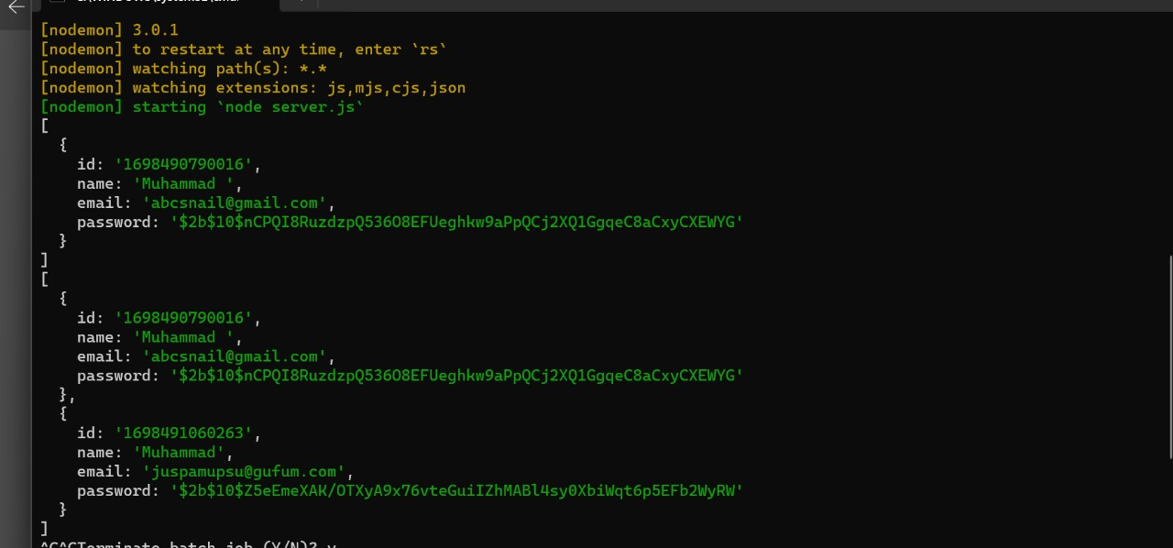

Code for signup:

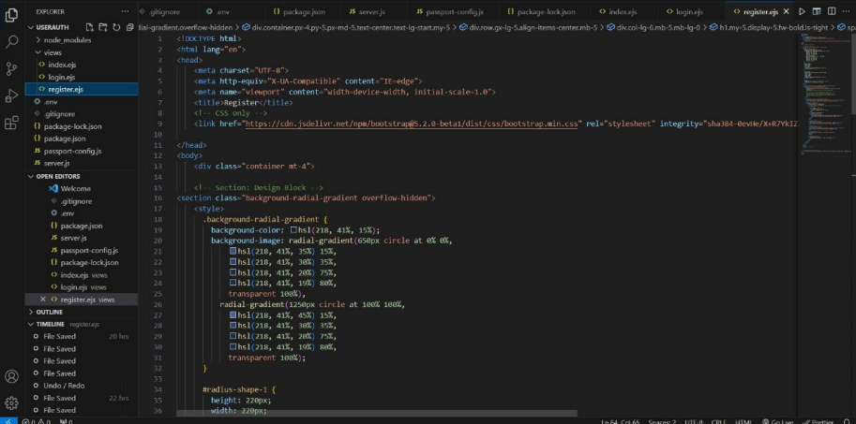

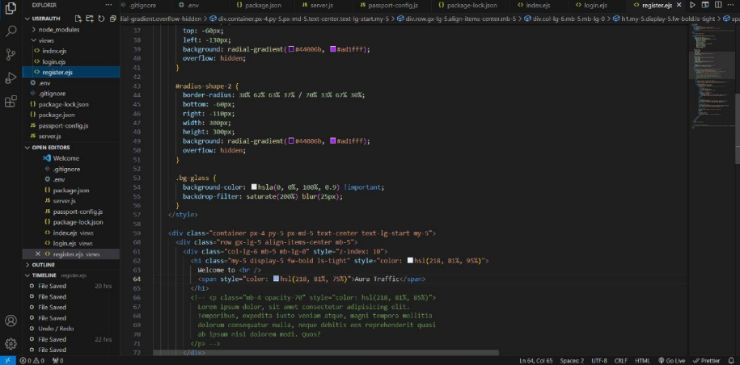

• If we logged in successfully then it will take to the Home page of the website.



Server Side code:

The server-side code for your attire website is the behind-the-scenes technology that powers the functionality, data handling, and interaction with visitors. It's the engine that ensures your website operates smoothly and securely. Here's a brief description: Empowering Your Artisan Website: Server-Side Code Welcome to the heart of Your Attire website Our server-side code forms the backbone of your website, working diligently behind the scenes to provide a seamless and secure experience for visitors like you.

• Data Management: Our code ensures efficient storage and retrieval of product listings, and blog posts, guaranteeing you quick access to the content you seek.

• User Authentication: It enables secure login and account management, safeguarding your personal data and privacy.

• Customization: The server-side code allows for personalized experiences, from tailored product recommendations to unique account settings.

• Smooth Checkout: It powers the smooth processing of your shopping cart, ensuring your products are processed securely and accurately.

• Security: We prioritize your safety and data privacy, employing advanced security measures and encryption protocols to protect your information. At Aura Traffic, we believe that the beauty of products should be matched by the efficiency and reliability of our website. Our server-side code is here to make that a reality.

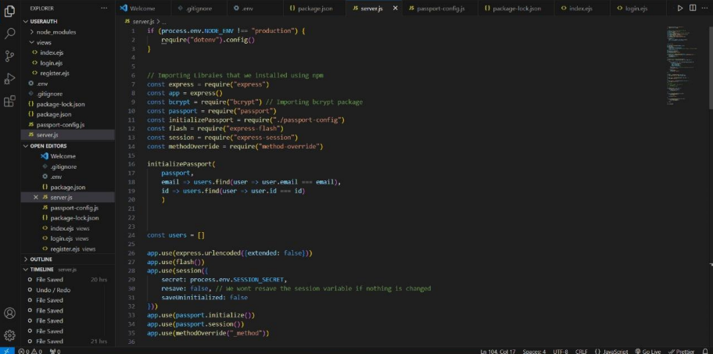

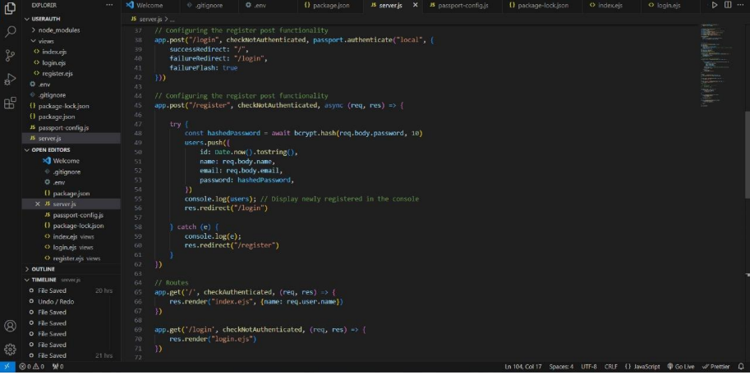

Shopping Cart Page:

• Your shopping cart at Your Attire is where your products come together. Review your selections, personalize your choices, calculate shipping, and explore special offers. Continue shopping or proceed to a secure checkout with ease. Should you need assistance, our support team is just an email away. Share your cart with friends and family for their input. Your shopping cart is the hub of creativity, where each product carries a unique story.

