Liver Fibrosis, MASH, and the Fibrotic Niche
A plain-language biology primer for target discovery discussions

The short version
Fibrosis means scar tissue. In the liver, scar forms when injury and repair keep repeating. At first, scar can be part of healing. Over time, too much scar stiffens the liver, changes blood flow, and disrupts normal metabolism. Cirrhosis is advanced scarring where the liver's structure is deeply remodeled.
MASH, formerly called NASH, is a common route into fibrosis. It begins with metabolic stress, fat buildup, and inflammation. The important point for target discovery is that fibrosis is made by a community of cells, not by one cell type acting alone.
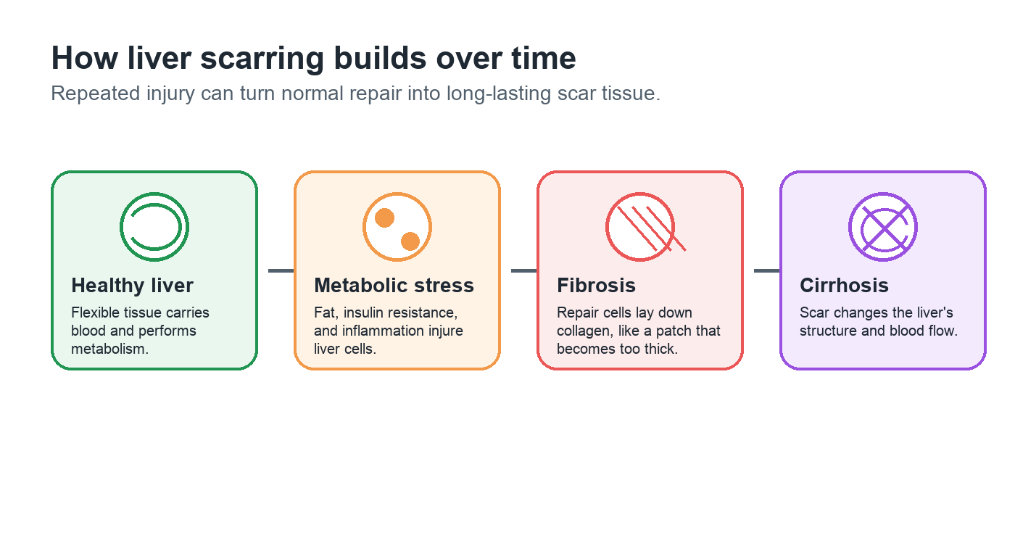
Figure 1. Repeated injury can shift repair from temporary patching to long-lasting scar.

The main cell players
A useful way to understand liver fibrosis is to picture a damaged neighborhood. Some cells send alarm signals, some cells try to clean up damage, some cells build scar, and blood-vessel cells change the local traffic pattern.
Cell type | Plain-language role | Why it matters in fibrosis
Hepatocyte | Main working cell of the liver. | Metabolic stress and injury start many inflammatory signals.
Hepatic stellate cell | Normally stores vitamin A; when activated, becomes a scar builder. | Central source of collagen and matrix remodeling.
Macrophage | Immune cell that cleans up damage and sends instructions. | Can support repair, but disease-associated states can push fibrosis.
Endothelial cell | Lines blood vessels and controls traffic between blood and tissue. | Changes in scarred liver affect immune entry, oxygen delivery, and niche signaling.
Cholangiocyte | Lines bile ducts. | Can expand or signal during chronic injury and ductular reaction.
In a healthy repair response, these jobs are coordinated and temporary. In chronic disease, the same repair machinery can become persistent and harmful.
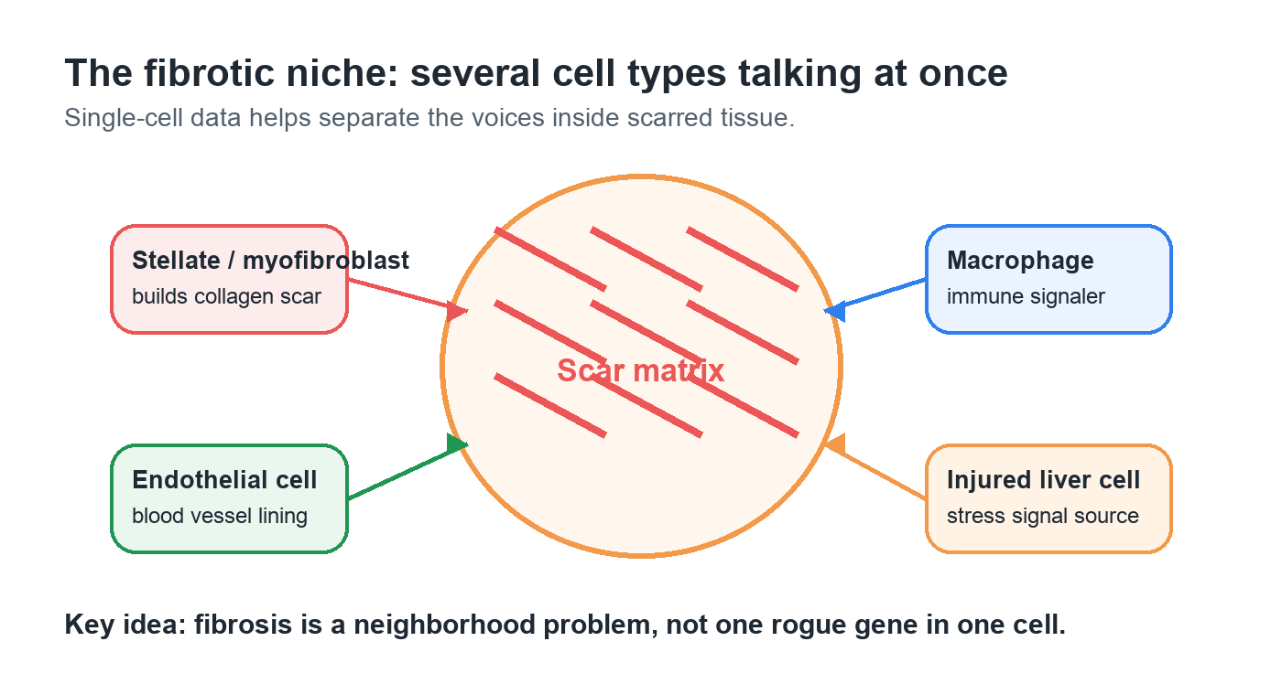
Figure 2. The fibrotic niche is the local scar environment where multiple cell types exchange signals.

Why single-cell data is useful
A liver sample contains many cell types mixed together. Bulk RNA-seq is like hearing the whole room at once. Single-cell RNA-seq puts a barcode on each cell and asks which genes are active in that cell. This helps separate a macrophage signal from a stellate-cell signal or an endothelial-cell signal.
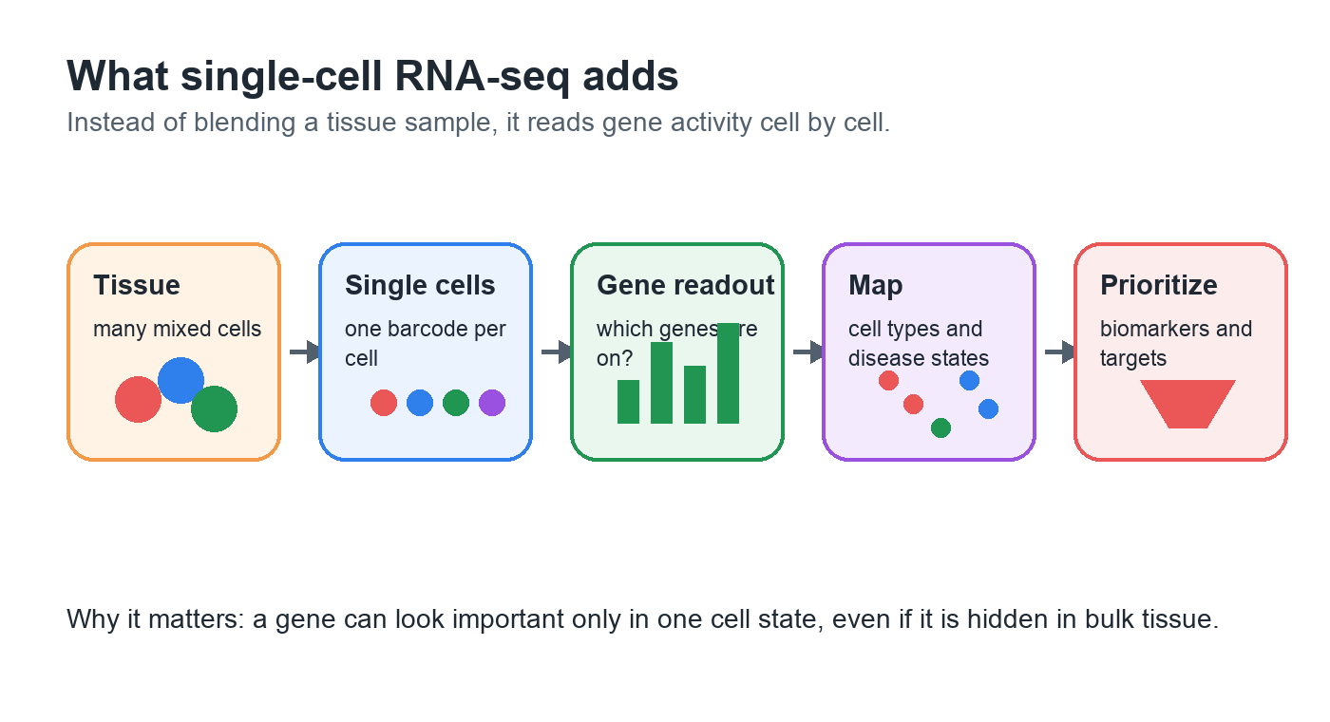
Figure 3. Single-cell RNA-seq separates mixed tissue into cell-type and cell-state signals.

What the Ramachandran cirrhosis dataset puts in focus
The Ramachandran et al. study mapped human cirrhotic liver at single-cell resolution. It highlighted disease-associated cell populations that sit within the scarred niche: TREM2+CD9+ scar-associated macrophages, ACKR1+ and PLVAP+ scar-associated endothelial cells, and PDGFRA+ collagen-producing mesenchymal cells.
For this project, those findings are not treated as trivia. They are anchors for quality control and interpretation. If an analysis cannot recover the expected macrophage, endothelial, and mesenchymal disease programs, the downstream target list should be treated with skepticism.

Biomarker is not the same as target
A biomarker is a measurable sign. A therapeutic target is something we might try to change with a drug. A smoke alarm is a good sign of fire, but it is not the fire itself. In the same way, a gene can be an excellent disease marker but a poor drug target.
- Good diagnostic biomarkers are measurable and track disease state.
- Good pharmacodynamic biomarkers change when a therapy affects the pathway.
- Good therapeutic targets are connected to disease biology, accessible to a drug, and tolerable to perturb.
- Good preclinical targets should have enough conservation in model systems to support animal studies.
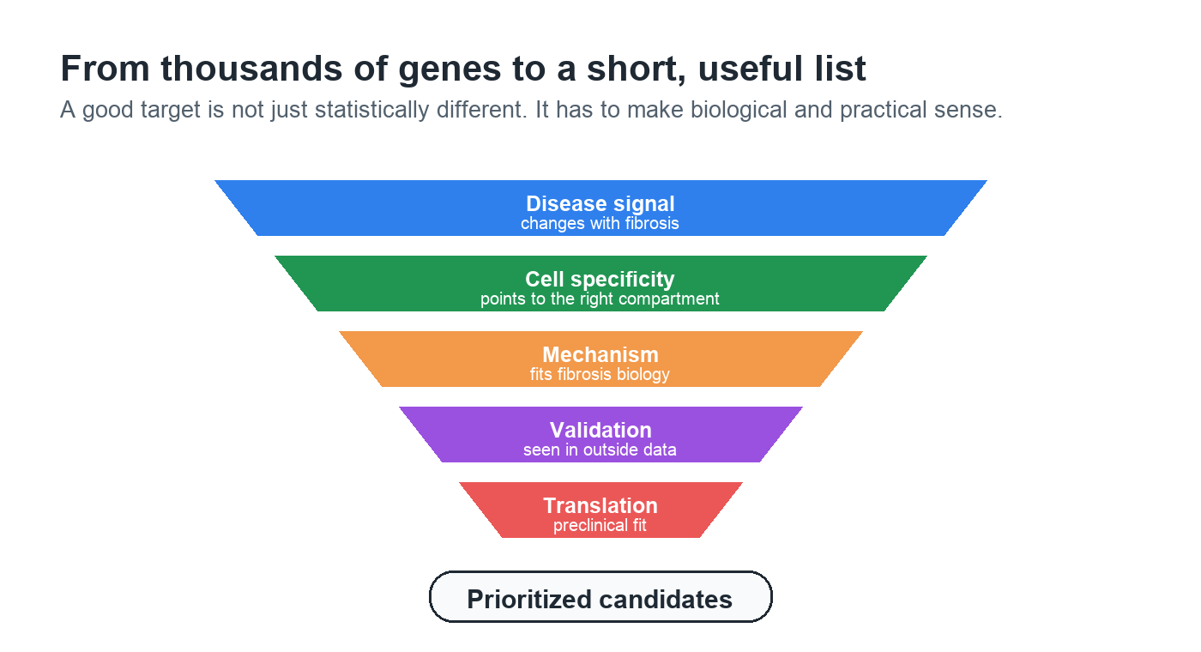
Figure 4. Target prioritization narrows genes through biology, validation, and translational filters.

How to read candidate evidence
A candidate becomes more convincing when independent lines of evidence point in the same direction. For example, a gene that is increased in cirrhotic mesenchymal cells, enriched in a fibrosis pathway, detected in an external MASH dataset, and encodes a surface or secreted protein is easier to prioritize than a gene supported by one statistical test alone.
The reverse is also true. A candidate should be downgraded if it is broadly expressed in many healthy tissues, lacks disease specificity, is not conserved enough for model testing, or appears only in a small number of cells from one donor.

Vocabulary
- Fibrosis: buildup of scar-like extracellular matrix after repeated injury.
- Cirrhosis: advanced fibrosis with major changes to liver structure and function.
- MASLD: metabolic dysfunction-associated steatotic liver disease, the updated term replacing much of the older NAFLD language.
- MASH: metabolic dysfunction-associated steatohepatitis, the updated term for NASH.
- Hepatic stellate cell: a liver cell that can become a major scar-producing myofibroblast.
- Macrophage: an immune cell that can clean up damage and send inflammatory or repair signals.
- Endothelial cell: a cell lining blood vessels that helps control vascular and immune traffic.
- Extracellular matrix: the structural material around cells; collagen is a major component of scar.
- Pseudobulk: an analysis strategy that aggregates cells by donor or sample before testing disease effects.

Selected sources
- Ramachandran P. et al. Resolving the fibrotic niche of human liver cirrhosis at single-cell level. Nature. 2019. https://www.nature.com/articles/s41586-019-1631-3
- Rinella M. E. et al. A multisociety Delphi consensus statement on new fatty liver disease nomenclature. Hepatology. 2023. https://pubmed.ncbi.nlm.nih.gov/37363821/
- FDA Drug Trials Snapshot: Rezdiffra (resmetirom), original approval March 14, 2024. https://www.fda.gov/drugs/drug-approvals-and-databases/drug-trials-snapshots-rezdiffra
- Nature Reviews Gastroenterology & Hepatology. Clues to cirrhosis: a focus on fibrosis. 2019. https://www.nature.com/articles/s41575-019-0232-9

