Lab 6: Morphological Image Processing
- Task1: Repair Broken Characters
- Problem:
Scanned text has broken strokes and disconnected letters, which can reduce OCR accuracy.
- Goal:
Restore continuity of characters so thay the text becomes readable and connected.
- Algorithm Summary:
  - Threshold image to get binary text.
  - Apply large Gaussian blur to connect broken parts.
  - Morphological closing with ellipse kernel to fill gaps.
  - Slight dilation to reinforce strokes.
  - Final thresholding to obtain clean binary image.
- Why it will work?
- It combine of blur and closing bridges broken letters.
- Elliptical kernel preserves natural character shapes.
- Final binary ensures text is readable and connected.
- Input image1.png


- Output result
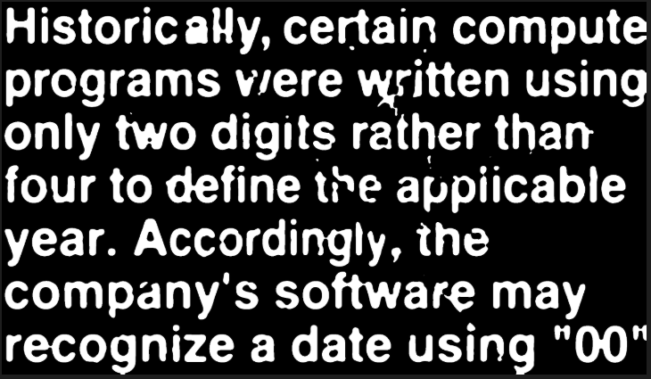

- Task2: Separate Merged Objects
- Problem:
Two objects in the image are merged due to thresholding errors, and one object may be broken.
- Goal:
- Split merged objects into distinct regions.
- Connect any broken parts of the same object.
- Over process flow that I have thought:
- Original image → grayscale → binary.
- Erosion removes thin bridges between merged objects.
- Dilation restores object sizes while keeping them separate.
- Result → objects separated and broken parts (if any) reconnected.
- Algorithm summary
- Convert image to binary using Otsu thresholding.
- Apply the larger randomly to make sure it able to remove thin connection between those two object or the middle one.
- Apply dilation back to restore original object size.
- Save and display the final separated objects.
- Why it will work?
  - Erosion will remove unwanted thin connections.
  - Dilation restores object structure without reconnecting separate objects.
  - The kernel size and iterations control the separation strength.
- Input image2.png
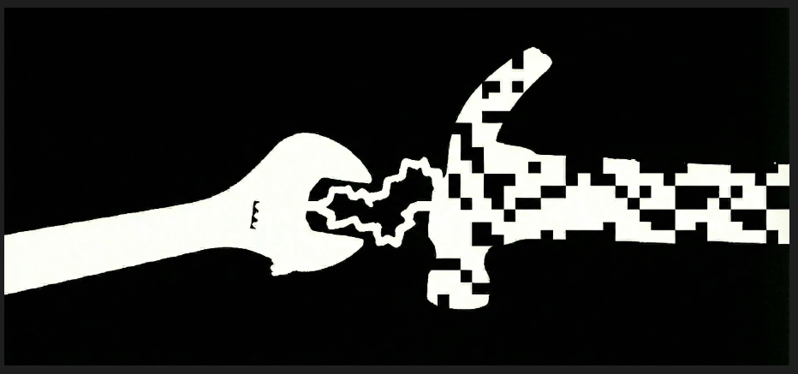

- Output result
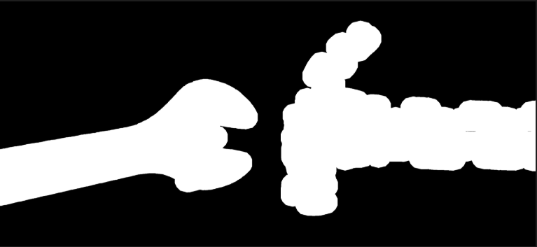

- Task3: Removing noise
- Problem:
Fingerprint images often contain small noise(isolated pixels) and holes in ridges due to scanning artifacts. These defects can reduce the accuracy of fingerprint analysis.

- Goal:
- Remove small noise pixels.
- Fill small holes in ridges.
- Smooth ridge pattern for clean representation.
- Algorithm summary
- Convert image to binary using Otsu thresholding.
- Apply the larger randomly to make sure it able to remove thin connection between those two object or the middle one.
- Apply dilation back to restore original object size.
- Apply the larger randomly to make sure it able to remove thin connection between those two object or the middle one.
- Save and display the final separated objects.
- Input image3.png
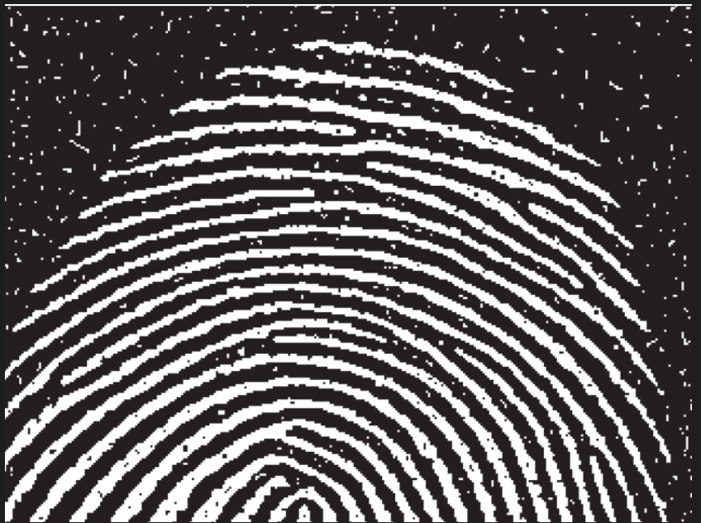

- Output result
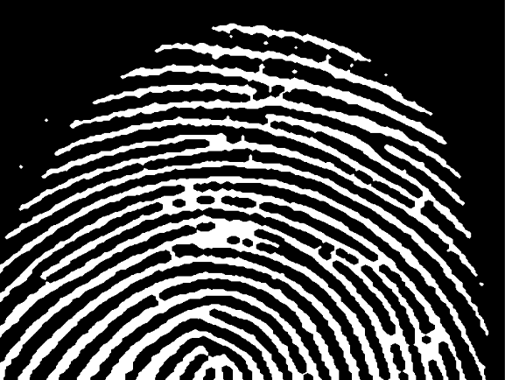

- Task4: Boundary Extraction
- Problem:
In this chosen image, I’ve selected the coins image and want to detect the boundaries of the objects in an image( each coin edge or shapes).
- Extract the object outline for analysis or shape recognition.
- Algorithm summary
1. Read the color image -> convert to grayscale -> threshold -> binary
2. Create a structuring element (3x3 rectangle).
3. Erode the binary object → removes outer layer.
4. Subtract eroded image from original → extract boundary.
5. Save and display boundary image.
- Input coin.png
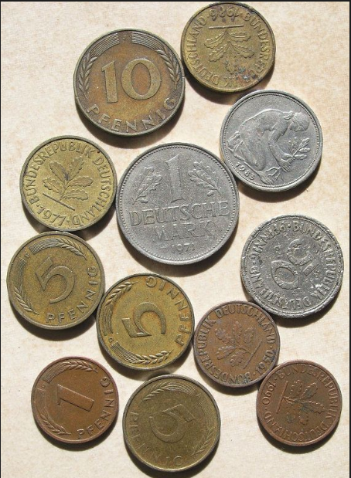
- Output result
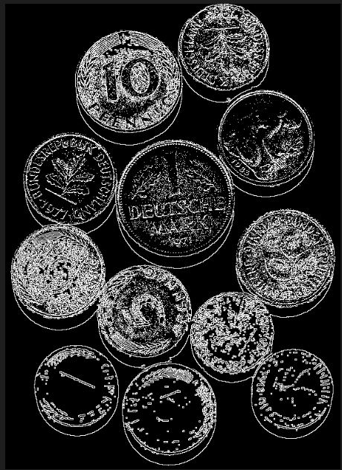

- Task5: Leaf Skeletonization
- Problem:
- Extract the vein structure from a leaf image. This problem also found by internet and it very useful technique and challenge as we have to obtain a clean, thin, connected skeleton of veins from binary image.
- Goal:
- Skeleton shows primary, secondary, and tertiary veins clearly.
- Minimal fragmentation and the topology of veins is preserved.
- Algorithm summary
- Convert image to grayscale and enhance contrast.
- Apply adaptive thresholding -> binary image.
- Morphological closing → fill gaps in veins.
- Morphological opening → remove noise.
- Light dilation → improve vein connectivity.
- Skeletonization → produce single-pixel-wide vein structure.
- Input leaf.png
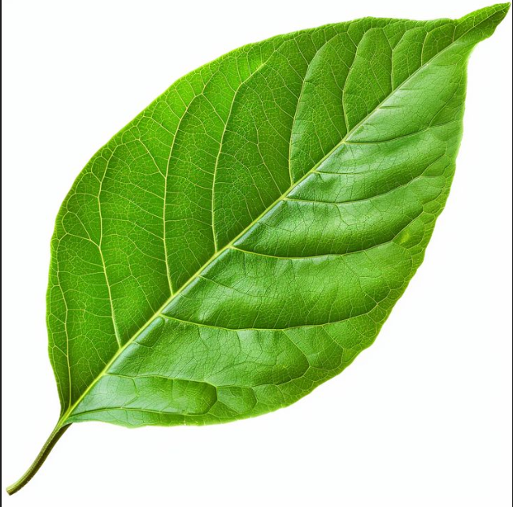

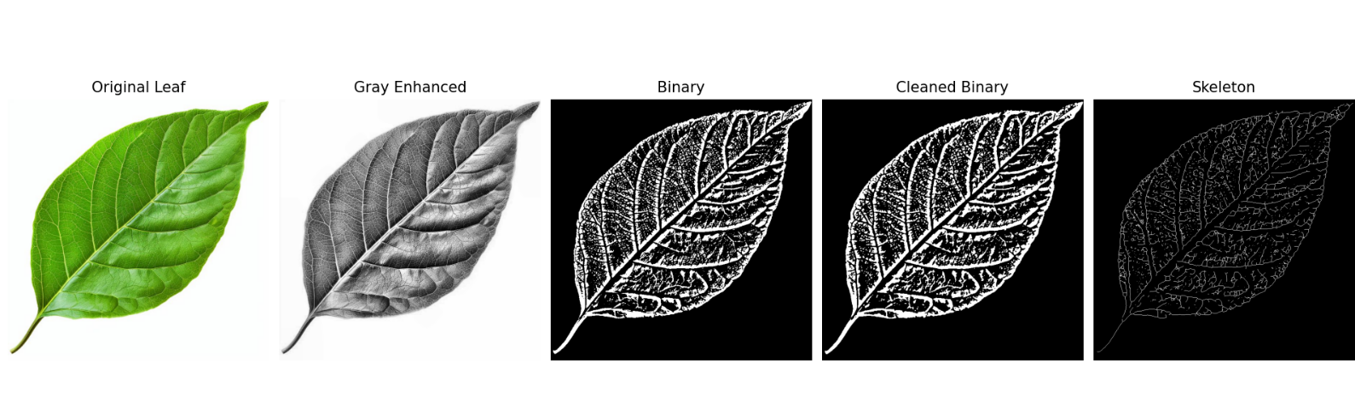
- Output results

