Journal of Physics: Conference Series

**PAPER • OPEN ACCESS**

IoT Based Smart Agriculture Monitoring, Automation and Intrusion Detection System

To cite this article: Ahmad Faisol Suhaimi *et al* 2021 *J. Phys.: Conf. Ser.* **1962** 012016

View the article online for updates and enhancements.

This content was downloaded from IP address 202.113.189.112 on 06/09/2021 at 14:24

The 1st International Conference on Engineering and Technology (ICoEngTech) 2021 IOP Publishing

Journal of Physics: Conference Series **1962** (2021) 012016 doi:10.1088/1742-6596/1962/1/012016

**IoT Based Smart Agriculture Monitoring, Automation and Intrusion Detection System**

**Ahmad Faisol Suhaimi2, Naimah Yaakob**1,2**, Sawsan Ali Saad**4**, Khairul Azami Sidek**3, **Mohamed Elobaid Elshaikh**1,2, **Alaa K. Y. Dafhalla**4, **Ong Bi Lynn1,2, Mahathir Almashor** 5

1. Advanced Computing, Centre of Excellence (CoE), Universiti malaysia Perlis (UniMAP), Perlis, Malaysia
2. Faculty of Electronic Engineering technology, Universiti Malaysia Perlis (UniMAP), Perlis,

Malaysia

1. Department of Electrical and Computer Engineering, Kulliyyah of Engineering, International

Islamic University Malaysia (IIUM), Selangor, Malaysia

1. Department of Computer Engineering, College of Computer Science and Engineering,

University of Ha’il, Kingdom of Saudi Arabia

1. Data61, Commonwealth Scientific and Industrial Research Organisation (CSIRO), Australia

1naimahyaakob@unimap.edu.my

**Abstract.** Manual irrigation is still widely used in agricultural field using traditional drip and can watering. However, traditional irrigation systems are inefficient and inexact, leading to either insufficient or excessive watering. Moreover, it is difficult for farmers to predict suitable quantities at the appropriate time. Manual monitoring of the crop field may also lead to human error and is potentially risky for rural areas. Farmers may also not be aware of intrusions if they are not on location. Therefore, this project is designed to develop a smart monitoring and automated irrigation system to provide not only efficient water consumption based on specific conditions, but also enables real-time monitoring of the environment. Furthermore, this system prevents damage to plants and reduces the likelihood of plant theft. This system uses NodeMCU ESP32 as a microcontroller that collects environmental data such as humidity, temperature, soil moisture levels from sensors. The NodeMCU is integrated with a relay and RTC module to

irrigate plants at specific times and is also equipped with a passive infrared sensor to detect

intruders near the crop-field. Upon detection, an ESP32 camera is used to automatically capture the current conditions and farmers will be subsequently notified. Warnings are also sent to farmers upon detection of unwanted circumstances such as extreme temperature, which could

prevent instances of open burning. The utility of the developed prototype is evident in the way

it automatically irrigates the crop field without human intervention. Farmers may monitor and manually control the irrigation process using an attached Android application. Additionally, they may manually activate a buzzer warn off any potential malicious actors.

1. **Introduction**

Agriculture leads the world’s water consumption, with farming and food production accounting up to

70% [1] and is also one of the major sectors that contributes to the economic growth. Apart from its importance in providing raw materials and major source of food, agriculture has also contributed to 8.2% of national gross income in 2017 [2], which is a vital part of a country’s income. With so much water consumption used in this sector, one would expect an over-abundance of water resources

Content from this work may be used under the terms of the Creative Commons Attribution 3.0 licence. Any further distribution of this work must maintain attribution to the author(s) and the title of the work, journal citation and DOI.

Published under licence by IOP Publishing Ltd

1

The 1st International Conference on Engineering and Technology (ICoEngTech) 2021 IOP Publishing

Journal of Physics: Conference Series **1962** (2021) 012016 doi:10.1088/1742-6596/1962/1/012016

dedicated to agriculture. However, one of the largest contributors to water wastage is no doubt caused by low irrigation efficiency. This is seen in many irrigation systems which still relies on traditional and widely used methods such as using watering cans as shown in Figure 1.

However, an important limitation is that farmers have difficulties in monitoring and irrigating

crop fields in remote locations. Inefficient use of water leads to excessive water consumption dedicated

to plants. Moreover, farmers sometimes cannot predict a suitable level of water consumption, which

affects the quality of the plants (too much or too little) and may lead to the water wastage. Furthermore, manual monitoring of the crop-field may lead to human error, and is also risky and potentially dangerous for certain types of rural areas, such as those bordering on wildlife areas.

**Figure 1**. Manual Irrigation System (Oder, 2019)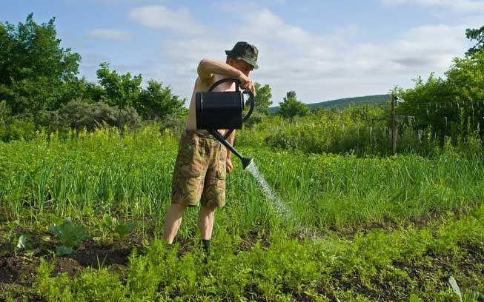

Manual monitoring is also time-consuming since most of the farmers spend a lot of time in the

crop field. Besides, in manual monitoring method, farmers will not be aware of any intruder (animals or

humans) in the crop that could damage or steal the plants. Hence, considering the crucial desire to

improve crop productivity, as well as ensure water consumption efficiency and ensuring quality of the

crops, an automated irrigation system that can help farmers automatically and efficiently water their

plants is developed in this project. The work herein aims to provide efficient water consumption based

on specific conditions using sensors to trigger watering of the crop field. In addition, this project also

focuses on the development of a mobile apps to monitor, display the real-time data from the environment

and notify users upon detection of intruders based on various sensors. This eases the farming activity and reduces the probability of damaged or stolen crops.

This project is developed with the help of latest technology of Internet of Things (IoT) which

can provide real-time measurement of temperatures and soil moisture levels using several on-site sensors. The developed system can also remotely monitor the irrigation system via the Internet. IoT is an emerging technology that is currently penetrating other automation systems such as smart home, smart farming, smart factory, and wearable smart bands. IoT technology can offer efficient way of implementing automatic irrigation system.

1. **Related Work**

Research on developing a smart agriculture system have attracted significant amount of attention from

researchers over the years. The following subsections discuss several smart agriculture and intrusion

detection available in the markets.

*2.1 Smart Crop Monitoring System*

Several related works have been found in literature. Ashifuddinmondal and Rehena [3] developed a system to monitor plants and control the water supply through a smartphone. The system integrates various sensors to measure the water content of soil and detect the temperature using soil moisture and temperature sensors respectively. This project makes used of Raspberry Pi to connect between the sensors and cloud server, and users can connect their smartphone to the raspberry pi using Bluetooth

2

The 1st International Conference on Engineering and Technology (ICoEngTech) 2021 IOP Publishing

Journal of Physics: Conference Series **1962** (2021) 012016 doi:10.1088/1742-6596/1962/1/012016

Module. A faster approach has been proposed by the authors in [4] using Wi-Fi to send sensors data tothe cloud using Arduino. This can also connect to multiple devices at once.

Next, an improvement has been done by Jindarat and Wuttidittachotti [5] which has introduced a system that can track ambient of weather conditions including humidity, temperature, atmosphere performance and fan power control in chicken farm. Using this design, farmers can easily monitor and

control their farm condition using their smart phone. A similar approach has been proposed in [6].Further enhancement has been done in this design which includes farm monitoring using smartphone and web application. This significantly makes the system easier to be used and can monitor farms from multiple devices.

Further improvement can be seen in [7] using Web Camera to monitor remote location of crop field by capturing time lapse images of the plant efficiently. A similar approach is also implemented in

[8] with more secure design. The system used an IoT platform such as System Under Analysis based on

Agro-Meteorology system for Viticulture Disease Warning. This system is used to monitor the vineyard using secure wireless or actuator sensor while server sub-system is used to transmit data to server. An enhanced method is proposed by authors in [9]. Two software are used to produce recommendation for solution needed by farmer which are PHP programing language and MATLAB to manage and synchronize IoT sensor for easy reading according to specific sensor range.

*2.2 Automated Irrigation System*

The article in [10] describes a system that is developed to manage water flow and power management

for an irrigation system. In this design, the optimal water supply was calculated using the approximate

information of an ambiguous expert method. A similar technique has been proposed by the authors in [11]. This later system assessed an event-based irrigation system by utilizing tomato plants. This method is used to reduce water consumption to improve the efficiency of the system. Apart from that, a system proposed by authors in [12] make used of renewable source such as solar power to implement automatic irrigation system. The main goal of this method is to develop a low cost and time-based irrigation system. A similar approach to irrigation system has been proposed by [13] which mainly centred on providing an active Modern Irrigation System (MIS) which depends on moisture control utilized by Arduino Nano with specific plantation modifications. This project can reduce water consumption and secure the crops from damage.

*2.3 Smart Crop Monitoring and Automated Irrigation System*

The article in [14] developed a system to monitor plants and control the water supply through a

smartphone by integrating various sensors to detects soil moisture and temperature of the crop. A similar

technique has been proposed by [15]. This system uses wireless transmission such as Wi-Fi to send data

to the cloud using Arduino and Ethernet connection. This improves the speed of data transmission and

can also connect to multiple devices at once. Another irrigation approach in [16] is more secure because the system focuses on security mechanism in its design. An infrared sensor is used to detect intruders (human or animal) at surrounding area. Upon detection, data will be sent to the cloud to alert farmers. The system in [17] used motion sensor to detect obstacles which is more reliable since motion sensor can detect and differentiate between the living object or non-living object around it. Apart from that, the maximum distance that motion sensor can detect is more longer compare to infrared sensor.

The work proposed in [18] has used water level sensor to monitor the water level inside a tank.

The system also uses two types of sprinkler: irrigation and overhead sprinkler. The overhead sprinkler will be activated if the surrounding temperature and water level of water is high. Otherwise, if the

temperature is high and water level is low, the irrigation sprinkler will be turned on. A method in [19]

implements Precision Agriculture with cloud computing that optimizes the usage of water fertilizer

while maximizing the crops yields and help in analyzing the weather conditions in the field. The

proposed system also reduces hardware complexity and improves the field of the crops and overall

production.

3

The 1st International Conference on Engineering and Technology (ICoEngTech) 2021 IOP Publishing

Journal of Physics: Conference Series **1962** (2021) 012016 doi:10.1088/1742-6596/1962/1/012016

1. **The Proposed System**

*3.1 System Overview*

This section explains the details of the proposed design and how it functions. The main idea of the

project will be elaborated and depicted with the flowchart and block diagrams. Figure 2 shows the

overall overview of the proposed system which make uses of ESP32 NodeMCU as the main hardware.The microcontroller serves as the brain of the system where the temperature and humidity, infrared and soil moisture sensor provide the digital information to and where it will process the information. The input from these sensors will be used to either turn on or off the motor pump based on the prescribe instructions. The soil moisture sensor is put inside the soil which is located near the crop to detect the moisture of the soil. The temperature and humidity sensor are positioned behind the crop to measure the temperature and humidity of surrounding air. All data that have been collected from all sensors will be displayed in the LCD located near the crop field for monitoring purposes. Collected information will be uploaded to the firebase cloud using microcontroller where all the data will be instructed by the server to be stored in the database. Moreover, the developed mobile app will display the data retrieved from the database. Users can have access and control to their automatic irrigation system and monitor the crop through their smartphones. Using this approach, users can monitor the crop efficiently and track the real time data condition of the soil, temperature and humidity of air surround crop.

**Figure 2.** Overall System Overview of the **Figure 3.** Overall Structure of Project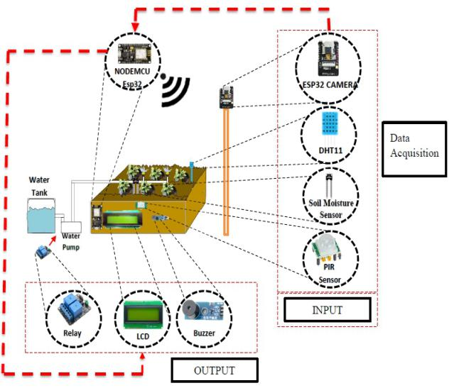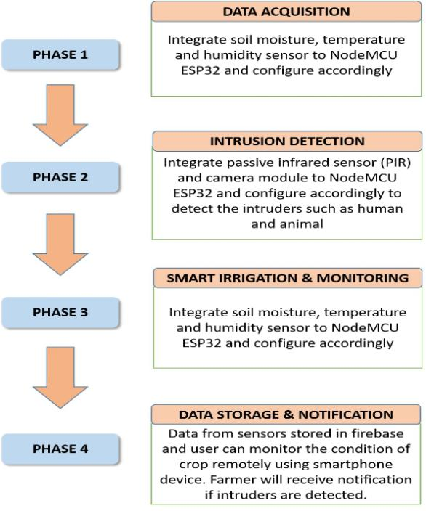

Data Acquisition and Irrigation System

Apart from that, this system can also serve as intrusion detection system which prevents visits

from unwanted animals that can damage the crops or the presence of any unauthorized human being.

This can be done with the help of the passive infrared (PIR) sensor. The PIR sensor is attached in front

of crop field to detect any kind of intrusion. If the PIR sensor detects the intrusion, the alarm will be

activated automatically The system is designed to send the sensed signals to the database everytime the

system is in the automatic or manual mode. These signals can be tracked from a personal computer

which serves as the database.

4

The 1st International Conference on Engineering and Technology (ICoEngTech) 2021 IOP Publishing

Journal of Physics: Conference Series **1962** (2021) 012016 doi:10.1088/1742-6596/1962/1/012016

*3.2 Overall Project Structure*

This section elaborates the proposed flow of the project from the start until completion. The project can

be divided into 4 phases as show in Figure 3 while Figure 4 shows the block diagram of the smart crop

monitoring and automated irrigation system. The microcontroller is connected with a power supply to

function which is then connected to the several input sensors and passive infrared sensor. The output

modules such as relay, LCD and buzzer are attached to the NodeMCU to be given an input so as to

activate the water irrigation, display the current data of the sensor and activate the alarm respectively. The microcontroller also has the capabilities to link the data online using the Wi-Fi technology. The following subsection give explanation of the block module used in the system such as data acquisition, output, intrusion detection, cloud storage module and monitoring and analysis module.

**Figure 4.** Top-level design for Smart Crop **Figure 5.** Data Acquisition Flowchart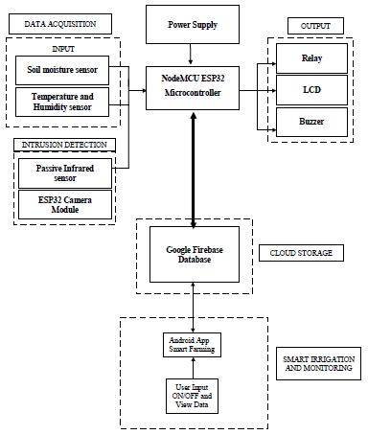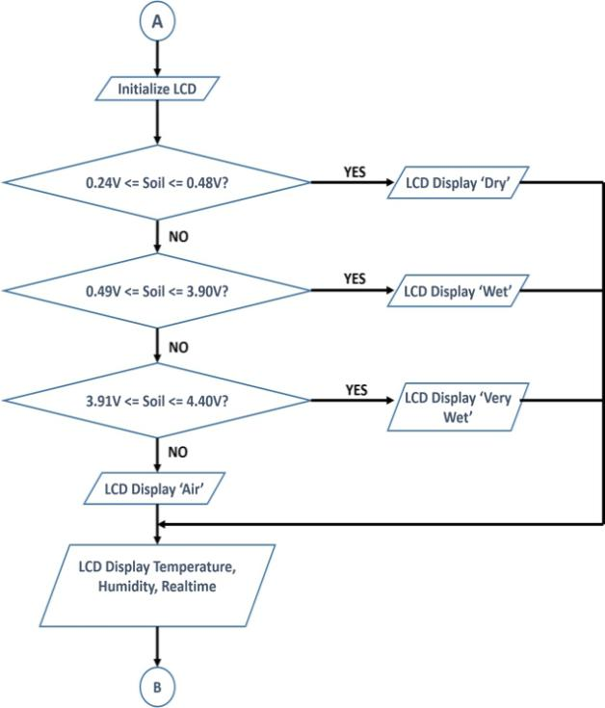

Monitoring and Automated Irrigation System

*3.2.1 Phase 1: Data acquisition.* Data acquisition process can be illustrated in Figure 5. This phase starts by initializing LCD and is the subsequent process after initializing all sensors and setting the RTC. Two sensors are used to measure the current data of crop condition. The first sensor use is soil moisture sensor. This sensor measures the condition of the soil based on the resistance receive by the soil

moisture. This sensor has two types of input which are analogue and digital. If the value is set to

analogue, the user can only see the current voltage receive by this sensor. However, if the user set the value to digital, the user can read the value in ASCII value which is from 0 to 1023. The lower value reflects that the soil moisture is more dry and vice versa.

The second sensor that is used in this project is temperature and humidity sensor (DHT11). This

sensor measures the current temperature and humidity surrounding the crop. Depending on amount of

water of natural surrounding such as rain, the humidity and temperature reading will be higher on rainy

days. However, if the condition is dry, the humidity and temperature will be lower. Furthermore, all the data that were measured by these sensors are collected and send to cloud using Wi-Fi connection. This phase will then continue to the next phase as indicated by ‘B’ which represents the intruder detection phase.

5

The 1st International Conference on Engineering and Technology (ICoEngTech) 2021 IOP Publishing

Journal of Physics: Conference Series **1962** (2021) 012016 doi:10.1088/1742-6596/1962/1/012016

*3.2.2 Phase 2: Intrusion Detection.* The flow of intrusion detection processes can be seen in Figure 6. This project is using passive infrared (PIR) sensor to detect if intrusion occurs at crop field. The PIR sensor can detect living obstacles such as human and animal. The sensor operates by detecting the

temperature and wavelength of objects. If an object or obstacle detected by the sensor meet the

requirement as the sensor detect human and animal presence, the sensor will send the data to the

NodeMCU microcontroller. Once detected, the microcontroller will activate the alarm by turning on the

buzzer and camera module. The camera will record the current situation and transmit the real time data of the captured image to the cloud.

Hence, the notification about the intruder will be sent to farmers via smartphone. Using this

method, farmers can always monitor their crops to check if there are any intruders that can steal, damage

or harm their plants. The PIR sensor detects the intrusion if there is obstacle that contain the wavelength

between the 1 µm to 13 µm respectively. The obstacle detected within this range is considered as intruder

since the PIR will detect infrared radiation emitted by the object/human and obstruct any empty spaces between the sensor and the crop field. Upon detection of any obstacle, the camera module located at NodeMCU microcontroller will be activated and will inform the user that intrusion is occurring at crop location.

**Figure 6.** Overall flowchart for Intrusion Detection Phase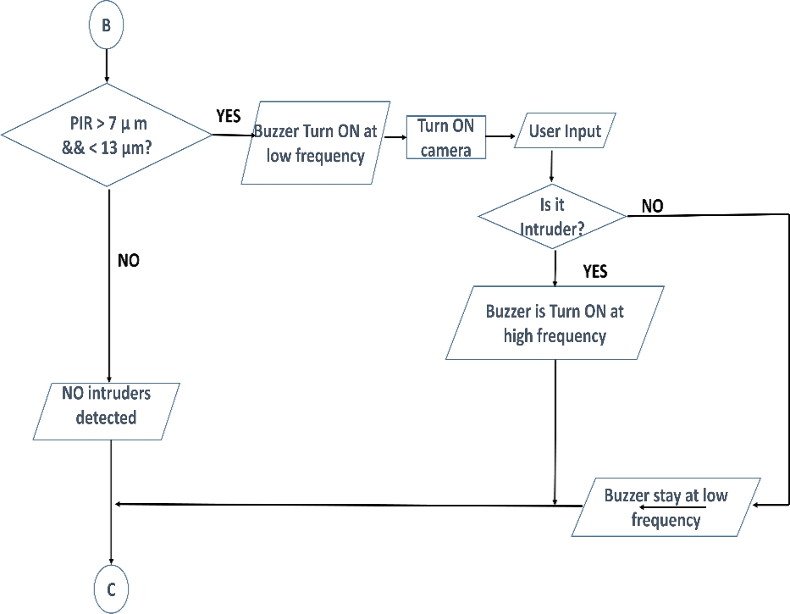

If the intrusion does not harm the crop, the farmer can stop the alarm by manually touch the

button in the smartphone. However, if intrusion really occurs, farmers can increase the volume of buzzer

to scare or warns the intruder by manually touch the button inside smartphone. The camera will record

the current situation and transmit the real time data of the captured image to the cloud. Hence, the notification about the intruder will be sent to farmer via smartphone. Using this method, farmers can always monitor their crops to check if there are any intruders that can steal, damage or harm their plants. Subsequently, this phase continues with the next phase (indicated by ‘C’ connector) which focuses on smart irrigation and monitoring system.

*3.2.3 Phase 3: Smart Irrigation and Monitoring System.* As shown in Fig. 6, there are various conditions for the automated irrigation to function properly in this system. The automated irrigation system must meet specific predefined requirements to perform its task. First, when the system entering into an automated mode, it will measure the current time by using RTC module.

6

The 1st International Conference on Engineering and Technology (ICoEngTech) 2021 IOP Publishing

Journal of Physics: Conference Series **1962** (2021) 012016 doi:10.1088/1742-6596/1962/1/012016

If the system detects that time is daylight, the system will measure the condition of the soil using

soil moisture sensor. It measures the condition of the soil during daylight every one hour. If the sensor

detect that soil is in dry condition, serial monitor will display message “*dry*” on LCD as can be seen in

Fig. 8. In this situation, the water pump will be turned on for 6 second automatically to irrigate the plant

using relay module. However, if the sensor detects that the condition of the soil is already wet, serial

monitor will display “*wet*” message on LCD screen and water pump will be turned on for only 3 seconds.

The decision to turning on the water pump soil wet condition is to ensure freshness and sustainability of the plant until the next watering. However, it is important to note that the amount of water in this condition might be slow enough and may just be a sprinkle. This is to avoid over watering of the already wet soil which could damage the plants. Then, if the sensor detects soil is very wet or sensor is placed at air surrounding, the water pump will not be activated. Moreover, if RTC module detects the time is at night or the temperature is greater than 38 Celsius, the water pump will not be activated too. The smart irrigation and monitoring system is then fed as an input to RTC module as indicated by ‘D’ connector in the figure. The output from this RTC is fed into the subsequent phase in ‘E’.

**Figure 7.** Overall flowchart for Automatic Irrigation System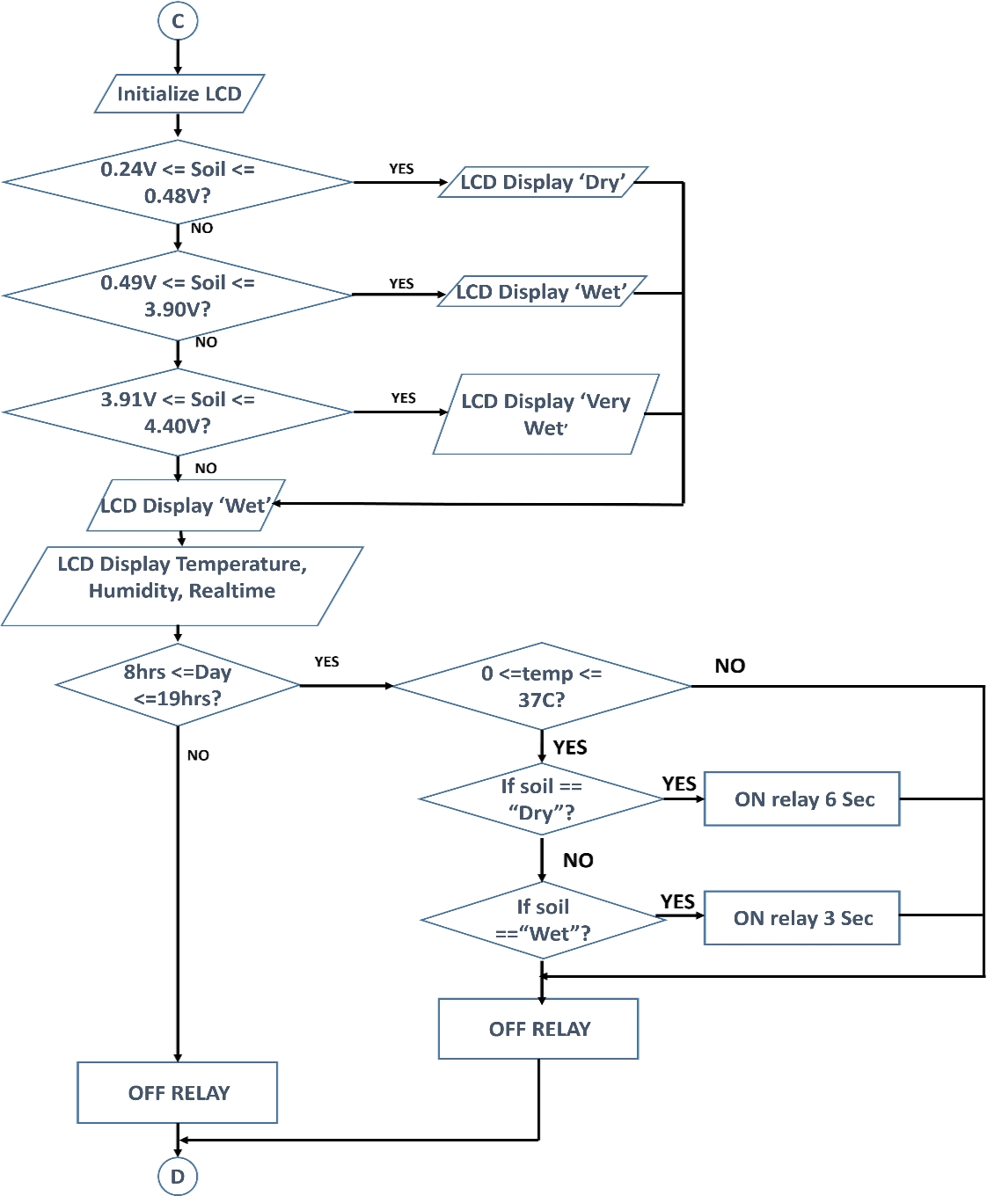

7

The 1st International Conference on Engineering and Technology (ICoEngTech) 2021 IOP Publishing

Journal of Physics: Conference Series **1962** (2021) 012016 doi:10.1088/1742-6596/1962/1/012016

*3.2.4 Phase 4: Data storage and notification.* The Figure 9 shows the overall flowchart for data storage and notification phase. The data storage is located at the cloud storage and IoT application such as Firebase Database platform. After the data is store at specific location, the data is sending back to the smartphone and other device to be monitor by the farmer. The farmer can receive the notification if the intruder is occurred and temperature of the crop field is too hot.

The data that been send by the Wi-Fi via NodeMCU will then transmit to the cloud server inside

the local. This cloud server is located inside the computer. The data that have been received by the cloud server will then be transmitted to the Firebase Database Platform which will store the data from the sensors. Apart from that, this platform can display the current data that have been transmitted from the microcontroller. This cloud database can be used to send the notification to the farmer if certain

threshold is reached.

**Figure 8.** Overall flowchart for Automatic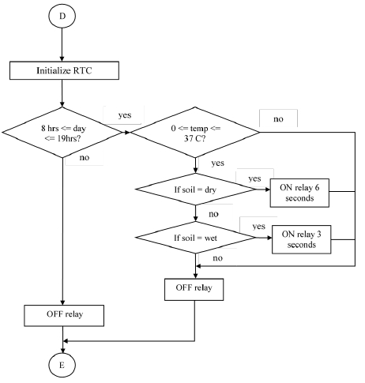

Irrigation System Phase

1. **Results and Discussion**

**Figure 9.** Overall flowchart for Data Storage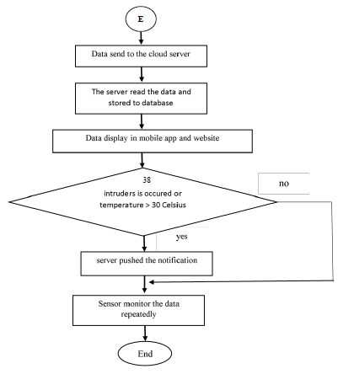

and Notification Phase

Figure 10 shows the prototype of the Smart Monitoring and Automated Irrigation. This project can

irrigate water in two modes: manually or automatically based on user’s input. Apart from that, it can also monitor the current data from temperature, humidity, soil moisture and motion sensor surrounding the crop-field.

This system has camera that captures the current images of the crop field to detect if intruder is

present or not. Results of the project implementation can be seen illustrated in Figure 11-12 while the

monitoring phases through smartphones can be seen as shown in Figure 13-14. The mobile apps has been developed to be user-friendly so that farmers can monitor the collected data in graphs forms and

8

The 1st International Conference on Engineering and Technology (ICoEngTech) 2021 IOP Publishing

Journal of Physics: Conference Series **1962** (2021) 012016 doi:10.1088/1742-6596/1962/1/012016

hence can figure the pattern of the plants conditions. According to the conditions provided at the instruction set, there are four condition of soil moisture sensor that are needed to detect the condition moisture of soil. The unit value of this soil moisture is measured in voltage which is between 0 and 5V. If the moisture sensor detects the reading is approximately 0V, it reflects that the moisture sensor is placed in air surrounding because it is not located inside the soil. However, if the value of soil is greater than 0.24V and less than 0.48V, the LCD will display that the moisture level of the soil is in too dry condition and water pump will be turned ON.

On the other hand, if the value of soil moisture is in between 0.49V and 3.90V, the moisture of

soil is categorized as dry and if the value of soil moisture is greater than 3.91V, the condition of the soil

moisture is detected as wet, thus water pump is OFF. The displayed messages on LCD is tabulated in

Figure 11.

(a)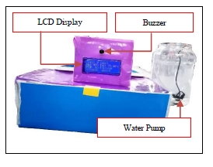

(b)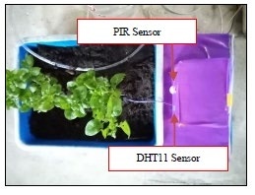

(c)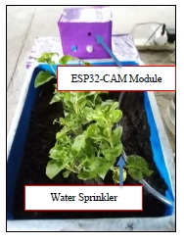

(d)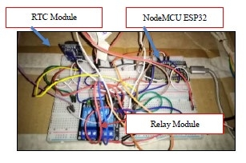

**Figure 10.** (a) Back View of Prototype (b) Top View of Prototype (c) Front

View of Prototype (d) Prototype Circuit Connection

Figure 12 shows the resulting displayed message on LCD screen based on the motion sensor in detection of the presence of intruders. If PIR sensor detects an intruder, the LCD will display message “*Intruder Detect*” and buzzer will be ON. However, if the sensor does not detect any intruder, LCD will keep displaying “No intruder” and during this time, buzzer will be OFF. The duration of the buzzer to turn ON is the same as the duration LCD display “*Intruder Detect*” which is about 6 seconds. Otherwise, the buzzer will be always OFF. For the security purposes, only registered users (farmers) are allowed to access the mobile application as shown in Figure 13. First, users need to login to the system using registered email. If the users have not yet register, they need to do so by clicking on ‘*register’* button and will be redirected to the *Registration Page* as shown in Figure 14. If the registration succeeds, user needs to login back inside the Login Page and page will display “*Registration succeed*”. If the registration failed during the process, error notification will popup below the android application and display “*Password too short or invalid username, Registration failed*”.

After fill-in the requirement of email and password of the user, they will be navigated back to

the Home Page of the SCMIS system as shown in the Figure 13 if the login is successful. Nevertheless,

9

The 1st International Conference on Engineering and Technology (ICoEngTech) 2021 IOP Publishing

Journal of Physics: Conference Series **1962** (2021) 012016 doi:10.1088/1742-6596/1962/1/012016

if the login failed, an error notification will popup below the android application and “*Invalid Username of password, Login failed*” will be displayed. ESP32 will transmit the sensed data to the firebase every one minute and trigger the timestamp once new data from the ESP microcontroller have been received.

**Figure 11.** System display of the detected **Figure 12.** Intrusion Detection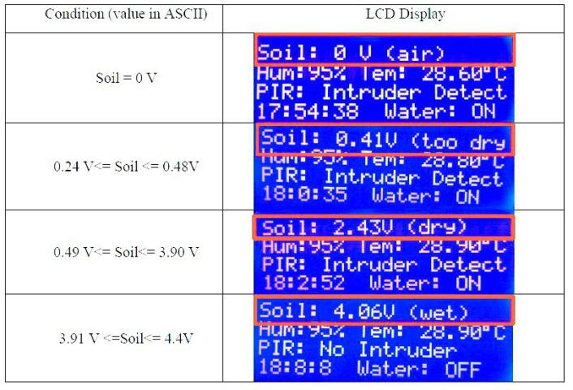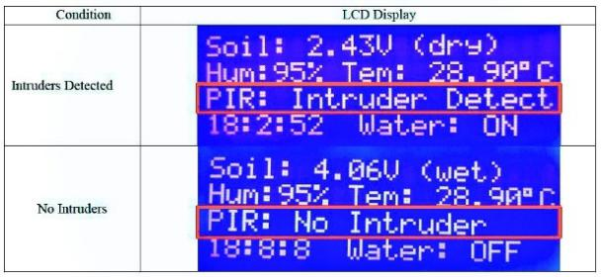

conditions

Timestamp can be used to detect current date and time the data is published. Apart from that,

Ionic application is used to monitor the data by using graph provided with *Plotly.js* plugin during the

programming development. Figure 16 shows the graph of temperature, humidity and soil moisture data

plot by the ionic. Moreover, farmers can also view images of intruders send by the camera. This can

help them identify and recognize if it is real intruder and perform appropriate actions as needed. Example of the image detected by the camera can be seen in Figure 18(b). This developed mobile application can also monitor the reading of temperature, humidity and soil surrounding the crop field on daily basis as

shown in Figure 17.

**Figure 13.** Mobile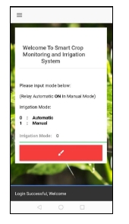

Application

**Figure 14.** Login Page **Figure 15. Authentication database**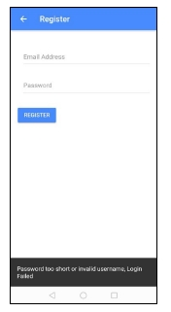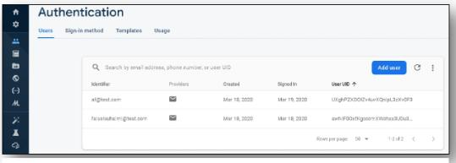

of Mobile Application

10

The 1st International Conference on Engineering and Technology (ICoEngTech) 2021 IOP Publishing

Journal of Physics: Conference Series **1962** (2021) 012016 doi:10.1088/1742-6596/1962/1/012016

All the data is permanently shown in the chart but users can edit and modify the content of data

using the android application. Apart from that, Figure 18(a) shows information of sensor values recorded

by firebase database. The x-axis represents days that have been collected for the 12 days. The system is

provided with view, add, delete and edit function if farmer wanted to changes any of the data inside

Firebase Database using the Android Application.

This system is also provided with an intruder detection system. The android application will

capture the current image of the crop field by using ESP32-Cam. Apart from that, ESP32-Cam needs an internet connection to send information to the database. The image will be captured and transmitted to Firebase Database every 4 seconds. The image will be stored in a firebase in base-64 format and will be retrieved and display later by the ionic application. Figure 18(b) shows the intruder detection image in the android application.

**Figure 16.** Monitoring of the crop field data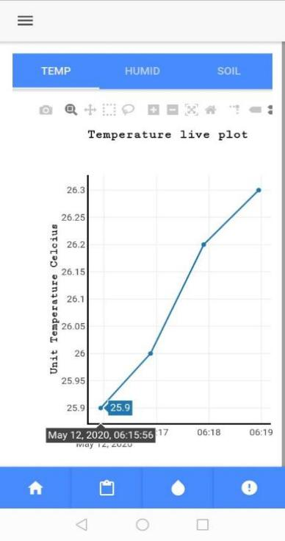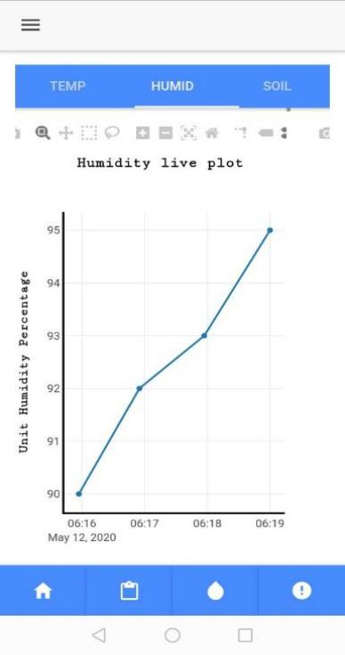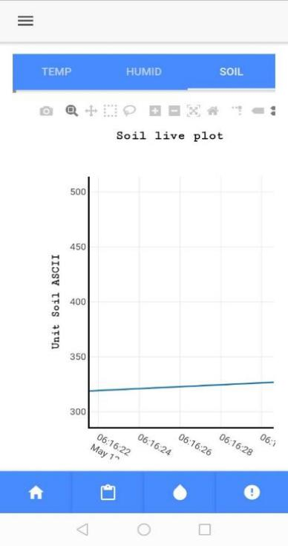

11

The 1st International Conference on Engineering and Technology (ICoEngTech) 2021 IOP Publishing

Journal of Physics: Conference Series **1962** (2021) 012016 doi:10.1088/1742-6596/1962/1/012016

**Figure 17.** History of collected data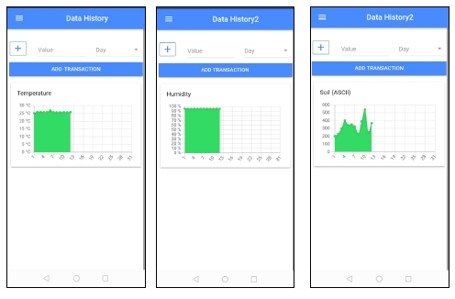

(a) (b)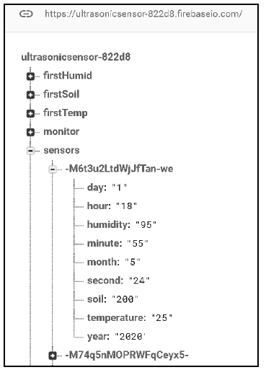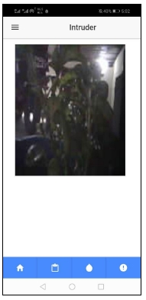

**Figure 18.** (a) Data insertion (b) Captured image

1. **Conclusion and Future Work**

This project has successfully addressed the stated problems and achieved the objectives in providing

efficient water consumption based on specific conditions. In establishing this objective, inefficient use

of water has been prevented as this method reduces the water usage to the plant based on inputs from

12

The 1st International Conference on Engineering and Technology (ICoEngTech) 2021 IOP Publishing

Journal of Physics: Conference Series **1962** (2021) 012016 doi:10.1088/1742-6596/1962/1/012016

sensors. The second objective is to develop a mobile app to monitor, display the real-time data from crop field environment and notify the user if intruders occur in the crop based on various sensors used to ease farmer activity and help to reduce the probability of plant might be damaged or stolen. This objective is also achieved as the system can be fully automated that can prevent the human error and more secure when implementing in rural area.

Nevertheless, the work herein represents a working prototype of a real system. For

commercialization, some enhancement need to be considered. First, the use of camera with machine learning can improve detection accuracy of intruder without the help of farmer. Moreover, the passive infrared sensor used can only observe between the living object and non- living object. It cannot differentiate between animal or human during detection. From the animal perspective, this sensor has some limitation, it cannot track whether the animal poses a threat to the plant or not.

**REFERENCES:**

[1] Rosegrant, M. W., Ringler, C., & Zhu, T. (2009). Water for Agriculture: Maintaining Food

Security under Growing Scarcity. Annual Review of Environment and Resources, 34(1), 205–

222.

[2[ Kei, H. M., Perhubungan, P., Bahagian, A., Strategik, K., Jabatan, A., & Malaysia, P. (2018).

Siaran Akhbar: Indikator Pertanian Terpilih. Retrieved from

https://www.dosm.gov.my/v1/index.php?r=column/pdfPrev&id=d3g5T2VOQUpEYzRLNi9ZZ GMzdm5TUT09

[3] Ashifuddinmondal, M., & Rehena, Z. (2018). IoT Based Intelligent Agriculture Field Monitoring

System. Proceedings of the 8th International Conference Confluence 2018 on Cloud Computing,

Data Science and Engineering, Confluence 2018, 625–629.

[4] Prathibha, S. R., Hongal, A., & Jyothi, M. P. (2017). IOT Based Monitoring System in Smart

Agriculture. Proceedings - 2017 International Conference on Recent Advances in Electronics and Communication Technology, ICRAECT 2017, 81–84.

[5] Jindarat, S., & Wuttidittachotti, P. (2015). Smart farm monitoring using Raspberry Pi and

Arduino. I4CT 2015 - 2015 2nd International Conference on Computer, Communications, and

Control Technology, Art Proceeding, (I4ct), 284–288.

[6] Siregar, B., Efendi, S., Pranoto, H., Ginting, R., Andayani, U., & Fahmi, F. (2017). Remote

monitoring system for hydroponic planting media. 2017 International Conference on ICT for

Smart Society, ICISS 2017, 2018-Janua, 1–6.

[7] Baranwal, T., Nitika, & Pateriya, P. K. (2016). Development of IoT based smart security and

monitoring devices for agriculture. Proceedings of the 2016 6th International Conference - Cloud System and Big Data Engineering, Confluence 2016, 597–602.

[8] Suciu, G., Istrate, C. I., & Ditu, M. C. (2019). Secure smart agriculture monitoring technique

through isolation. Global IoT Summit, GIoTS 2019 - Proceedings, 1–5.

[9] Kurniawan, F., Nurhayati, H., Arif, Y. M., Harini, S., Nugroho, S. M. S., & Hariadi, M. (2018).

Smart Monitoring Agriculture Based on Internet of Things. Proceedings - 2nd East Indonesia

Conference on Computer and Information Technology: Internet of Things for Industry, EIConCIT

2018, 363–366.

[10] Abidin, M. S. B. Z., Shibusawa, S., Buyamin, S., & Mohamed, Z. (2015). Intelligent control of

capillary irrigation system for water-saving cultivation. 2015 10th Asian Control Conference:

Emerging Control Techniques for a Sustainable World, ASCC 2015, 1–5.

[11] Pawlowski, A., Sánchez-Molina, J. A., Guzmán, J. L., Rodríguez, F., & Dormido, S. (2017).

Evaluation of event-based irrigation system control scheme for tomato crops in greenhouses.

Agricultural Water Management, 183, 16–25.

[12] Alex, G., & Janakiranimathi, M. (2016). Solar based plant irrigation system. Proceeding of IEEE

- 2nd International Conference on Advances in Electrical, Electronics.

13

The 1st International Conference on Engineering and Technology (ICoEngTech) 2021 IOP Publishing

Journal of Physics: Conference Series **1962** (2021) 012016 doi:10.1088/1742-6596/1962/1/012016

[13] Komal Kumar, N., Vigneswari, D., & Rogith, C. (2019). An Effective Moisture Control based Modern Irrigation System (MIS) with Arduino Nano. 2019 5th International Conference on

Advanced Computing and Communication Systems, ICACCS 2019, 70–72.

[14] Vaishali, S., Suraj, S., Vignesh, G., Dhivya, S., & Udhayakumar, S. (2017). Mobile integrated

smart irrigation management and monitoring system using IOT. Proceedings of the 2017 IEEE

International Conference on Communication and Signal Processing, ICCSP 2017, 2018-Janua,

2164–2167.

[15] Rajalakshmi, P., & Devi Mahalakshmi, S. (2016). IOT based crop-field monitoring and irrigation automation. Proceedings of the 10th International Conference on Intelligent Systems and Control,

ISCO 2016, 1–6.

[16] Shri Pradha, R., Suryaswetha, V. P., Senthil, K. M., Ajayan, J., Jayageetha, J., & Karhikeyan, A.

(2019). Agricultural Field Monitoring using IoT. 2019 5th International Conference.

[17] Sushanth, G., & Sujatha, S. (2018). IOT Based Smart Agriculture System. 2018 International Conference on Wireless Communications, Signal Processing and Networking, WiSPNET 2018,

1–4.

[18] Pandithurai, O., Aishwarya, S., Aparna, B., & Kavitha, K. (2017). Agro-tech: A digital model for

monitoring soil and crops using internet of things (IOT). ICONSTEM 2017 - Proceedings: 3rd

IEEE International Conference on Science Technology, Engineering and Management, 2018-

Janua, 342–346.

[19] Nageswara Rao, R., & Sridhar, B. (2018). IoT based smart crop-field monitoring and automation

irrigation system. Proceedings of the 2nd International Conference on Inventive Systems and

Control, ICISC 2018, (Icisc), 478–483.

14