COMP 306 – Mini Sahibinden
ER Diagram
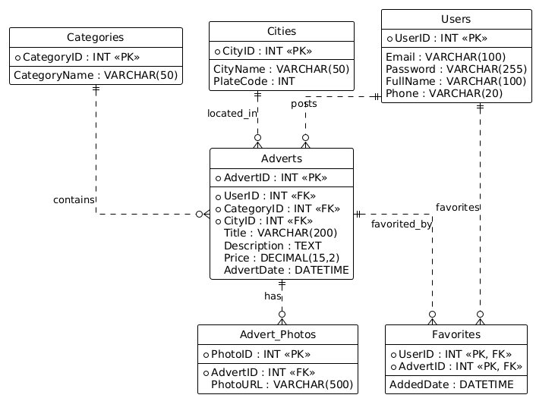

Relational Model
CREATE DATABASE IF NOT EXISTS MiniSahibinden;
USE MiniSahibinden;

CREATE TABLE Users (
UserID INT AUTO_INCREMENT PRIMARY KEY,
Email VARCHAR(100) NOT NULL UNIQUE,
Password VARCHAR(255) NOT NULL,
FullName VARCHAR(100) NOT NULL,
Phone VARCHAR(20),
RegistrationDate DATETIME DEFAULT CURRENT_TIMESTAMP
);

CREATE TABLE Categories (
CategoryID INT AUTO_INCREMENT PRIMARY KEY,
CategoryName VARCHAR(50) NOT NULL UNIQUE
);

CREATE TABLE Cities (
CityID INT AUTO_INCREMENT PRIMARY KEY,
CityName VARCHAR(50) NOT NULL,
PlateCode INT UNIQUE
);

CREATE TABLE Adverts (
AdvertID INT AUTO_INCREMENT PRIMARY KEY,
UserID INT NOT NULL,
CategoryID INT NOT NULL,
CityID INT NOT NULL,
Title VARCHAR(200) NOT NULL,
Description TEXT,
Price DECIMAL(15, 2) NOT NULL,
PublishDate DATETIME DEFAULT CURRENT_TIMESTAMP,
Status ENUM('Active', 'Sold', 'Inactive') DEFAULT 'Active',
FOREIGN KEY (UserID) REFERENCES Users(UserID) ON DELETE CASCADE,
FOREIGN KEY (CategoryID) REFERENCES Categories(CategoryID),
FOREIGN KEY (CityID) REFERENCES Cities(CityID)
);

CREATE TABLE Advert_Photos (
PhotoID INT AUTO_INCREMENT PRIMARY KEY,
AdvertID INT NOT NULL,
PhotoURL VARCHAR(500) NOT NULL,
FOREIGN KEY (AdvertID) REFERENCES Adverts(AdvertID) ON DELETE CASCADE
);

CREATE TABLE Favorites (
UserID INT NOT NULL,
AdvertID INT NOT NULL,
AddedDate DATETIME DEFAULT CURRENT_TIMESTAMP,
PRIMARY KEY (UserID, AdvertID),
FOREIGN KEY (UserID) REFERENCES Users(UserID) ON DELETE CASCADE,
FOREIGN KEY (AdvertID) REFERENCES Adverts(AdvertID) ON DELETE CASCADE
);

