**Client Documentation**

**I. Business Profile**

Provide a detailed overview of the business or chosen office.

1. **Business Name**:  
   TABING’S PATER HOUSE
2. **Industry/Field**:  
   FOOD SERVICE INDUSTRY
3. **Business Description**:  
   TABING PATER HOUSE is a renowned eatery specializing in providing a variety of delicious and authentic pater dishes, beverages, and complementary food items.

* **Mission**:

Mission is to offer an exceptional dining experience that combines traditional flavors with modern culinary techniques, ensuring that every guest leaves with a smile.

* **Vision:**

Vision is to become the leading pater house in the municipality of Tagoloan, known for our quality, hospitality, and dedication to customer satisfaction.

**Key Services/Products Offered:**

1. **Pater Dishes**: A selection of perfectly seasoned rice dishes with options of chicken or beef.
2. **Side Dishes**: A variety of Filipino dishes including homemade lumpia, fried chicken, boiled egg/sunny side-up, siomai, bola-bola, tuna chorizo, hot dog and rm soup.
3. **Refreshing Beverages**: Include classic soft drinks.
4. **Sweet Treats**: Variety of sweets like fresh milk and milk bar.
5. **Desserts**: Traditional and contemporary sweet dessert like mango float and tapioca.
6. **Organizational Structure**:

* **Owner**: Overall business management and strategic planning
* **Cook**: Food preparation and kitchen management
* **Cashier**: Handling customer transactions and financial records
* **Waiter**: Coordinates with the cook to serve the order. .

1. **Contact Information**:
   * Address: Zone 13 Arellano St. Poblacion Tagoloan Misamis Oriental
   * Phone Number: 09755726173
   * Email: fmabanta2017@gmail.com

**II. Flowchart of the Business/Chosen Office**

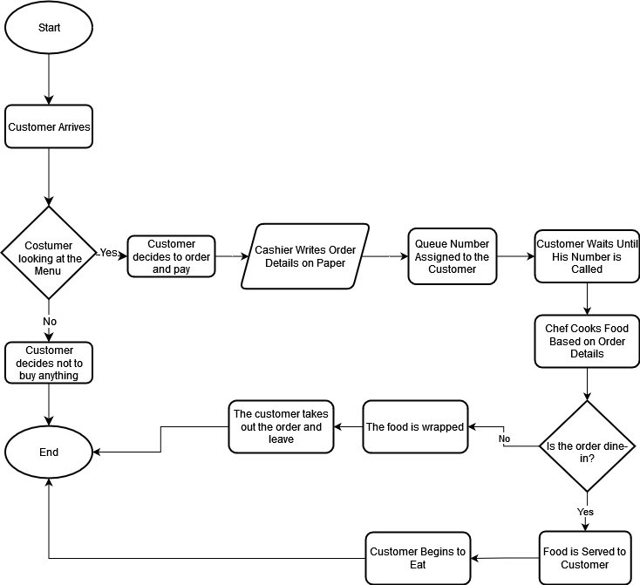

At TABING PATER HOUSE, the business process begins when customers arrive and look at the menu. After deciding what to order, customers place their orders with the cashier, then proceed to make the payment, which the cashier processes. The cashier then records the order details in the paper and proceeds to tell the cook about the order details. In the kitchen, the cook prepares the food according to the order specifications. Once the food is ready, it is placed on the serving counter. The customer picks up the food from the serving counter. Customers enjoy their meal at their table or happily takes out the wrapped meal.

**III. Logical Database Design**

1. **Entity-Relationship Diagram (ERD)**:

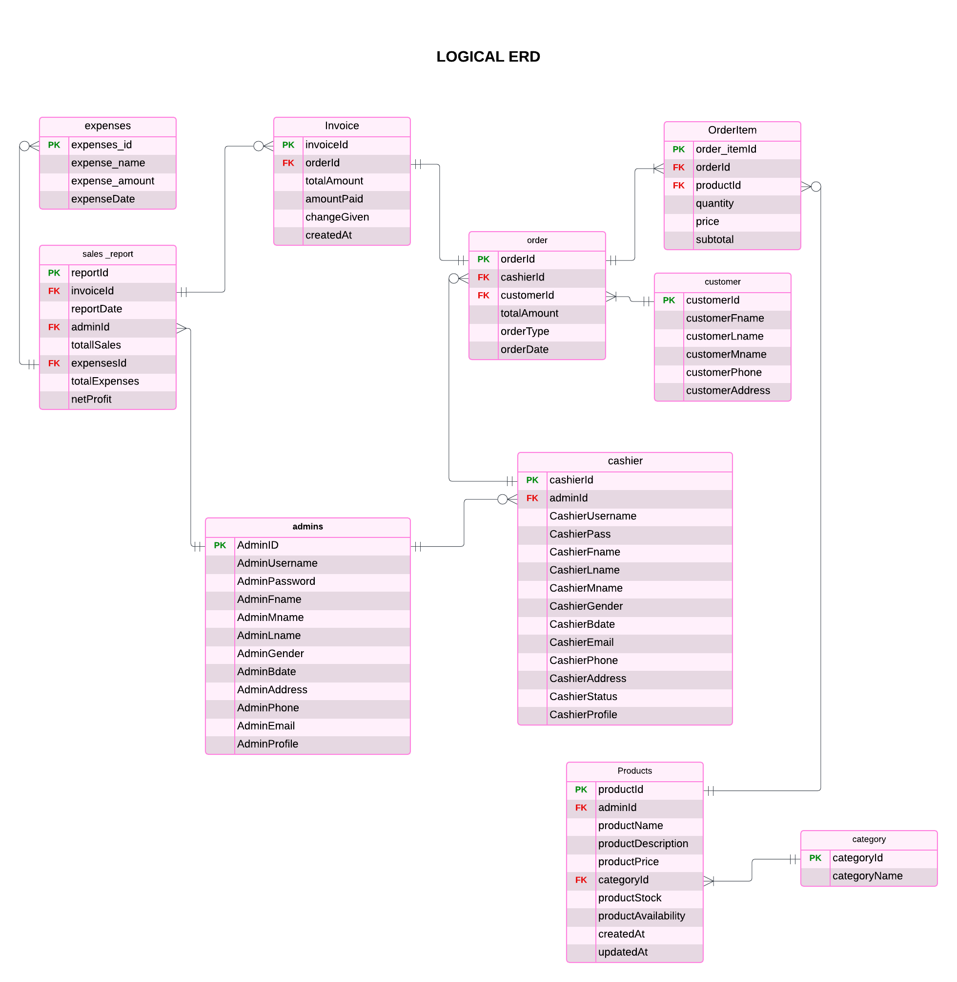

1. **Table Design**:

|  |  |  |  |  |
| --- | --- | --- | --- | --- |
| **Table Name** | **Attribute** | **Data Type** | **Constraints** | **Description** |
| admin | AdminID | INT(50) | PRIMARY KEY, AUTO INCREMENT | Unique identifier for each admin. |
| AdminUsername | VARCHAR(50) | NOT NULL | Username for admin login |
| AdminPassword | VARCHAR(100) | NOT NULL | Admin password |
| AdminFname | VARCHAR(100) | NOT NULL | Admin first name |
| AdminMname | VARCHAR(100) | NULL | Admin middle name |
| AdminLname | VARCHAR(100) | NOT NULL | Admin last name |
| AdminGender | VARCHAR(15) | NULL | Admin gender |
| adminBdate | DATE | NOT NULL | Admin birth date |
| AdminAddress | VARCHAR(100) | NOT NULL | Admin address |
| AdminPhone | INT(15) | NOT NULL | Admin phone number |
| AdminEmail | VARCHAR(100) | UNIQUE, NOT NULL | Admin email |
| AdminProfile | VARCHAR(100) | NULL | Admin picture |

|  |  |  |  |  |
| --- | --- | --- | --- | --- |
| **Table Name** | **Attribute** | **Data Type** | **Constraints** | **Description** |
| Cashier | cashierId | INT(50) | PRIMARY KEY, AUTO INCREMENT | Unique identifier for each cashier. |
| adminId | INT(50) | FOREIGN KEY(adminId) | Admin responsible for the cashier |
| cashierUsername | VARCHAR(100) | NOT NULL | Cashier's username |
| cashierPass | VARCHAR(100) | NOT NULL | Cashier's password |
| cashierFname | VARCHAR(100) | NOT NULL | Cashier's first name |
| cashierLname | VARCHAR(100) | NOT NULL | Cashier's last name |
| cashierMname | VARCHAR(100) | NULL | Cashier's middle name |
| CashierGender | ENUM | NULL | Cashier's gender |
| cashierBdate | DATE | NOT NULL | Cashier's birthdate |
| cashierEmail | VARCHAR(100) | UNIQUE, NOT NULL | Cashier's email |
| cashierPhone | INT(15) | NOT NULL | Cashier's phone number |
| cashierAddress | VARCHAR(100) | NOT NULL | Cashier's address |
| cashierStatus | VARCHAR(50) | NOT NULL | Status of the cashier (active/inactive) |
| cashierProfile | VARCHAR(100) | NULL | Cashier’s picture |

|  |  |  |  |  |
| --- | --- | --- | --- | --- |
| **Table Name** | **Attribute** | **Data Type** | **Constraints** | **Description** |
| customer | customerId | INT(50) | PRIMARY KEY, AUTO INCREMENT | Unique identifier for the customer. |
| customerFname | VARCHAR(100) | NULL | Customer’s first name |
| customerLname | VARCHAR(100) | NULL | Customer’s last name |
| customerMname | VARCHAR(100) | NULL | Customer’s middle name |
| customerPhone | VARCHAR(15) | NULL | Customer’s phone number |
| customerAddress | VARCHAR(100) | NULL | Customer’s address |

|  |  |  |  |  |
| --- | --- | --- | --- | --- |
| **Table Name** | **Attribute** | **Data Type** | **Constraints** | **Description** |
| order | orderId | INT(50) | PRIMARY KEY, AUTO INCREMENT | Unique identifier for the order. |
| cashierId | INT(50) | FOREIGN KEY(cashierId) | Cashier who processed the order. |
| customerId | INT(50) | FOREIGN KEY(customerId) | Customer placing the order. |
| totalAmount | DECIMAL(10, 2) | NOT NULL | Total amount of the order. |
| orderType | VARCHAR(100) | NOT NULL | Order type, if it is a dine in or take out. |
| orderDate | DATETIME | NOT NULL | Date and time when the order was placed. |

|  |  |  |  |  |
| --- | --- | --- | --- | --- |
| **Table Name** | **Attribute** | **Data Type** | **Constraints** | **Description** |
| Order  item | order_itemId | INT(50) | PRIMARY KEY, AUTO INCREMENT | Unique identifier for the order item. |
| orderId | INT(50) | FOREIGN KEY(orderId) | Related order id. |
| productId | INT(50) | FOREIGN KEY(productId) | Related product id. |
| quantity | INT(50) | NOT NULL | Quantity of the product in the order. |
| price | DECIMAL(10, 2) | NOT NULL | Price per product in the order. |
| subtotal | DECIMAL(10, 2) | NOT NULL | Subtotal price (quantity * price). |

|  |  |  |  |  |
| --- | --- | --- | --- | --- |
| **Table Name** | **Attribute** | **Data Type** | **Constraints** | **Description** |
| Product | productId | INT(50) | PRIMARY KEY, AUTO INCREMENT | Unique identifier for the product. |
| productName | VARCHAR(100) | NOT NULL | Name of the product |
| productDescription | TEXT | NULL | Description of the product |
| productPrice | INT(50) | NOT NULL | Price of the product |
| categoryId | INT(50) | FOREIGN KEY(categoryId) | Category id of the product |
| productStock | DECIMAL(10, 2) | NULL | Stock of the product. |
| productAvailability | BOOLEAN | NOT NULL | Indicates if the product is available or not. |
| createdAt | TIMESTAMP | NOT NULL | Timestamp when the product is added |
| updatedAt | TIMESTAMP |  | Timestamp if a product is updated. |

|  |  |  |  |  |
| --- | --- | --- | --- | --- |
| **Table Name** | **Attribute** | **Data Type** | **Constraints** | **Description** |
| category | categoryId | INT(50) | PRIMARY KEY, AUTO INCREMENT | Unique identifier for the category |
| catgeoryName | VARCHAR(100) | NOT NULL | Name of the product category |

|  |  |  |  |  |
| --- | --- | --- | --- | --- |
| **Table Name** | **Attribute** | **Data Type** | **Constraints** | **Description** |
| invoice | invoiceId | INT(50) | PRIMARY KEY, AUTO INCREMENT | Unique identifier for the invoice |
| orderId | INT(50) | FOREIGN KEY(orderId) | Related order id |
| totalAmount | DECIMAL(10, 2) | NOT NULL | Total amount paid for the order |
| amountPaid | DECIMAL(10, 2) | NOT NULL | Amount paid by the customer |
| changeGiven | DECIMAL(10, 2) | NULL | Change given to the customer |
| createdAt | TIMESTAMP | NOT NULL | Timestamp when the invoice was created |

|  |  |  |  |  |
| --- | --- | --- | --- | --- |
| **Table Name** | **Attribute** | **Data Type** | **Constraints** | **Description** |
| Sales report | reportId | INT(50) | PRIMARY KEY, AUTO INCREMENT | Unique identifier for the sales report |
| invoiceId | INT(50) | FOREIGN KEY(invoiceId) | Related invoice for the report |
| reportDate | DATE | NOT NULL | Date of the sales report |
| adminId | INT(50) | FOREIGN KEY(adminId) | Admin who generated the report |
| totalSales | DECIMAL(10, 2) | NOT NULL | Total sales for the report |
| expensesId | INT(50) | FOREIGN KEY(expensesId) | Related expenses for the report |
| totalExpenses | DECIMAL(10, 2) | NOT NULL | Total expenses for the report |
| netProfit | DECIMAL(10, 2) | NOT NULL | Net profit for the report (totalSales - totalExpenses) |

|  |  |  |  |  |
| --- | --- | --- | --- | --- |
| **Table Name** | **Attribute** | **Data Type** | **Constraints** | **Description** |
| expenses | expensesId | INT(50) | PRIMARY KEY, AUTO_INCREMENT | Unique identifier for the expense |
| expenseName | VARCHAR(100) | NOT NULL | Name of the expense |
| expenseAmount | DECIMAL(10, 2) | NOT NULL | Amount of the expense |
| expenseDate | DATE | NOT NULL | Date of the expense |

**IV. List of Prospect Reports to be Generated**

**Report Name:** Daily Sales Report

**Purpose:** To provide an overview of sales for a specific day including the total expenses and net profit.

**Fields Included:** Date of Report, Total Sales Amount, Total expenses, Net Profit.

**Sample Format:**

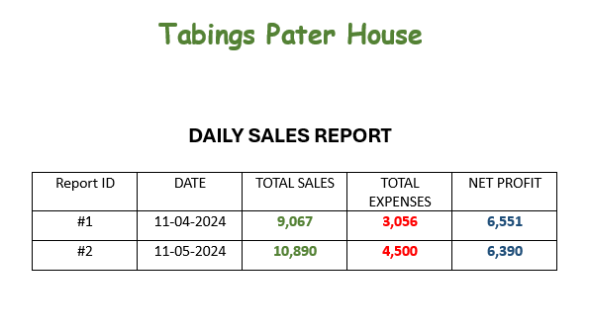

**Report Name:** Monthly Sales Report

**Purpose:** To provide an overview of sales for a specific month including the total expenses and net profit.

**Fields Included:** Date of Report, Total Sales Amount, Total expenses, Net Profit.

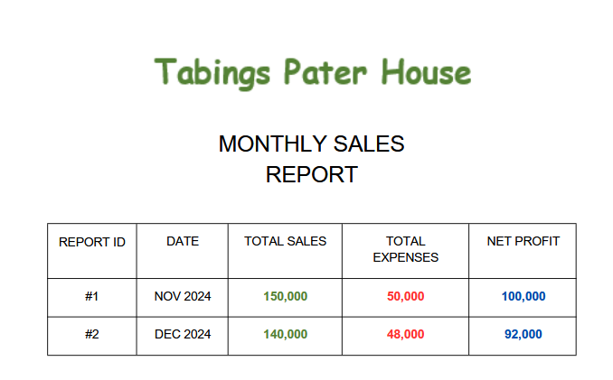**Sample Format:**

**Report Name:** Sales by product category

**Purpose**: To track the performance of each product category by analyzing the items ordered, their quantities, and sales trends.

**Fields Included:** Product Category, Product Name**,** Quantity Sold, Total sales of the product and Date.

**Sample Format:**

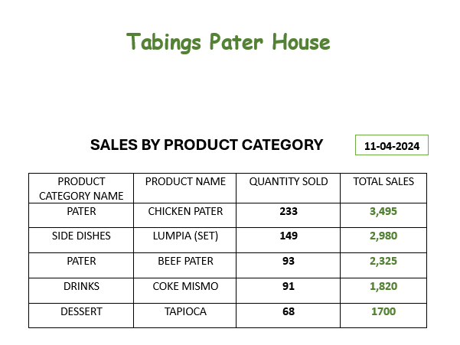

**V. Wireframes**

**Admin Login**

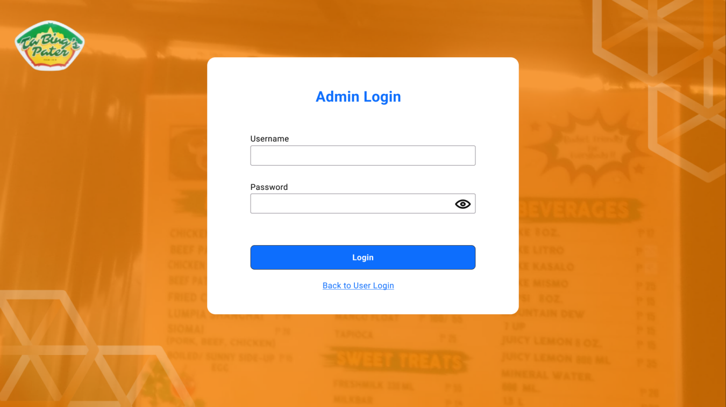

“**Username**” –Input admin username.

“**Password**” –Input admin password.

Button: “**Login**” –If you click this button, it will check if the credentials are correct then if it is, it will go to admin dashboard, if it’s not you need to enter a correct credentials.

Button: **“Back to User Login”** if you click this button it will go to cashier log in form.

**Cashier Login**

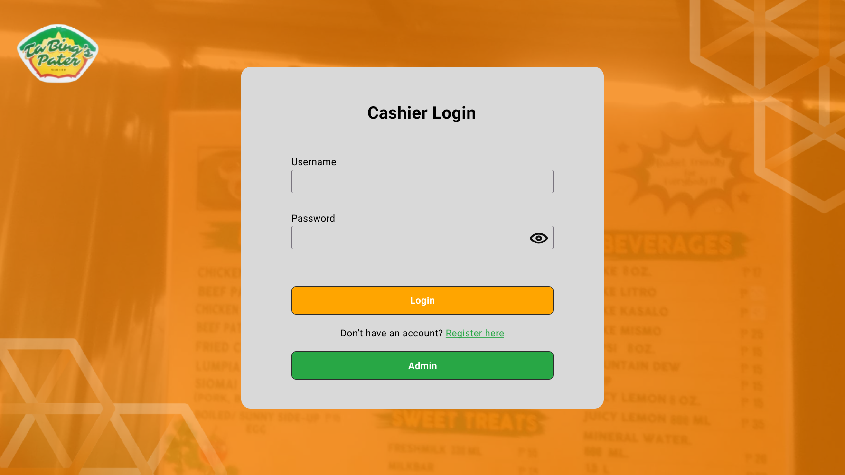

“**Username**” –Input cashier username.

“**Password**” –Input cashier password.

Button: “**Login**” –If you click this button, it will check if the credentials are correct then if it is, it will go to cashier’s pos, if it’s not you need to enter a correct credentials.

Button: **“Admin”** if you click this button it will go to admin login page.

Button: “**Register** **here**” – will redirect to cashier registration to create a new account.

**Cashier Registration**

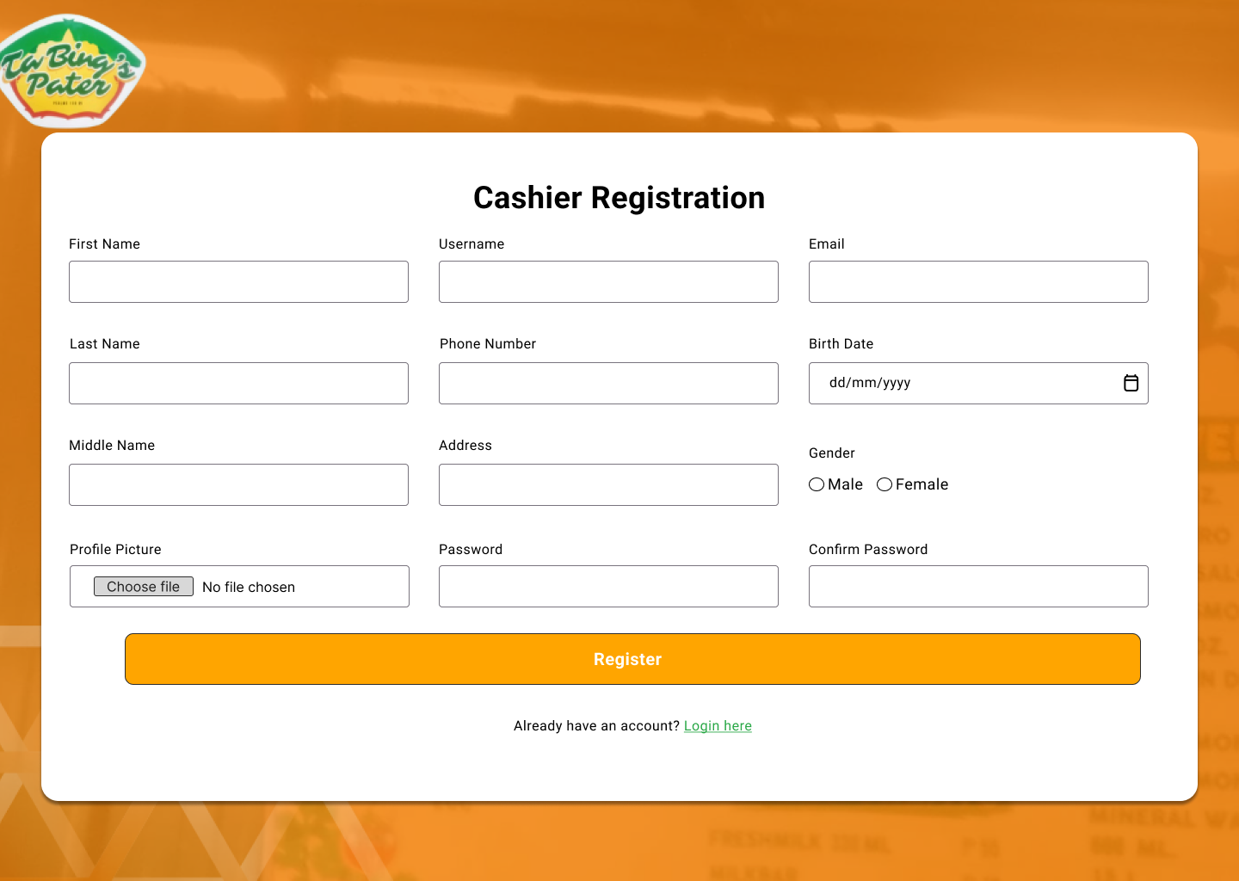

Button: “**Choose** **file**” - If you click this you can choose profile picture’s.

Fill out all information’s inside “**Register** **Form**”

Button: “ **Register**” - If you click this the data will be save to database.

Button: “Login here” - you will be redirected to the cashier login page.

**Admin Dashboard**

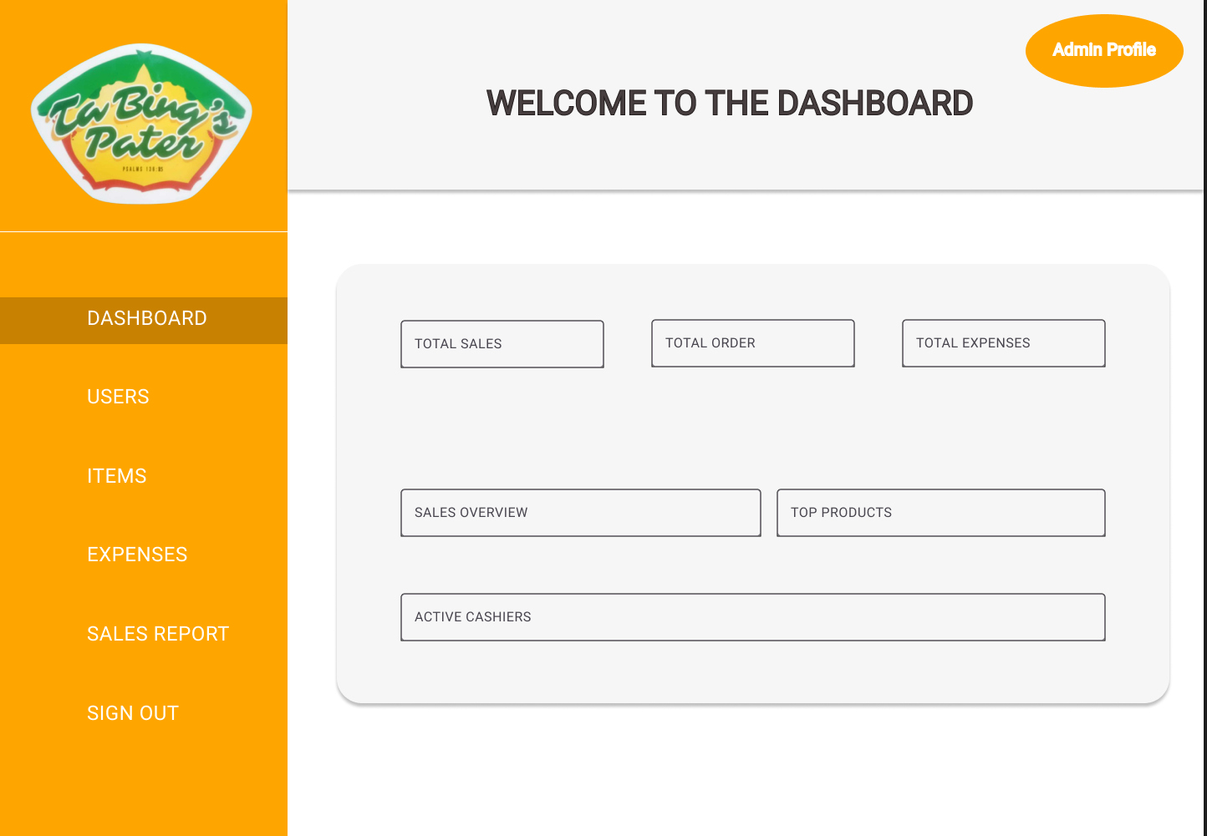

Button: “**Admin** **Profile**” – If you click this the admin profile will pop up.

Inside the “**Dashboard**,” you will see data on **Total Sales, Total Orders, Total Expenses, Sales Overview, Top Products**, and **Active Cashiers** from the database.

**Users**

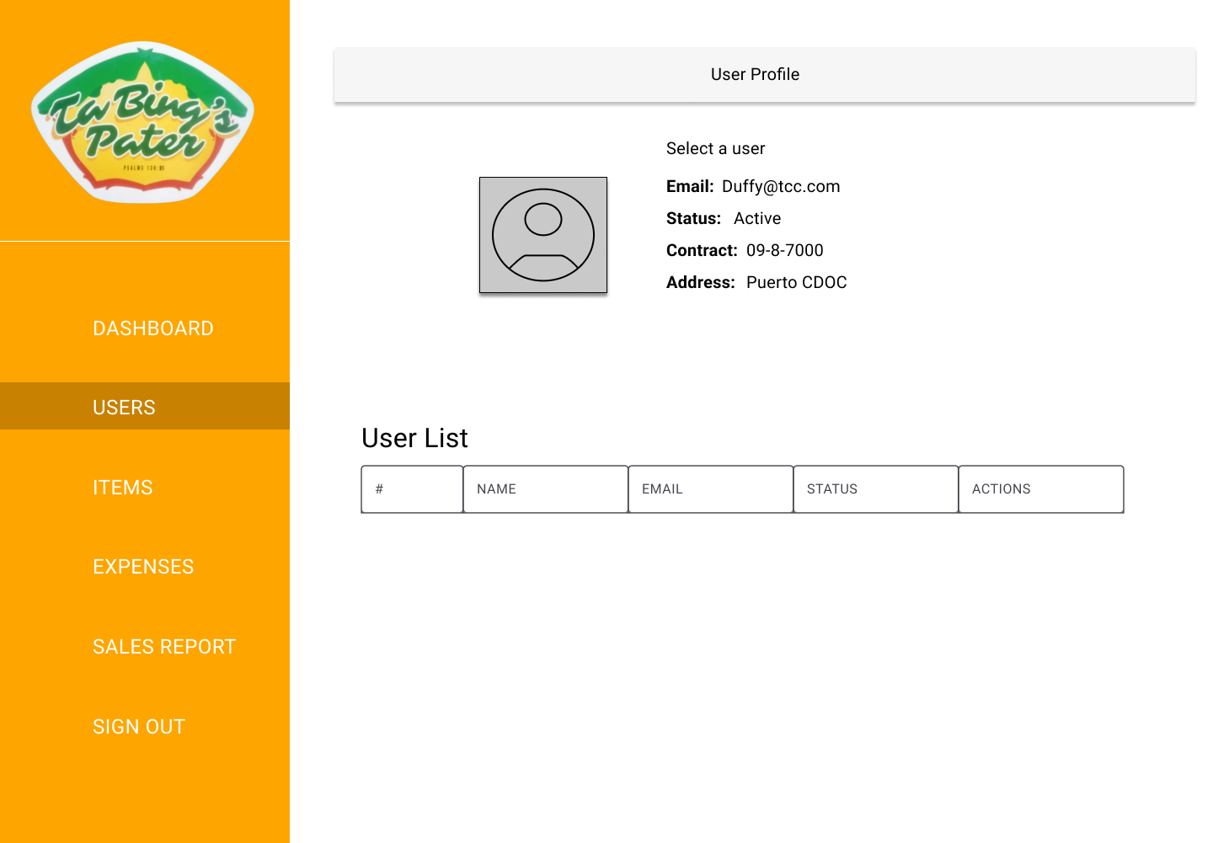

Inside User’s slide bar you will see the “**User’s** **Profile**” and also the “**User** **Lists**”

**Product**

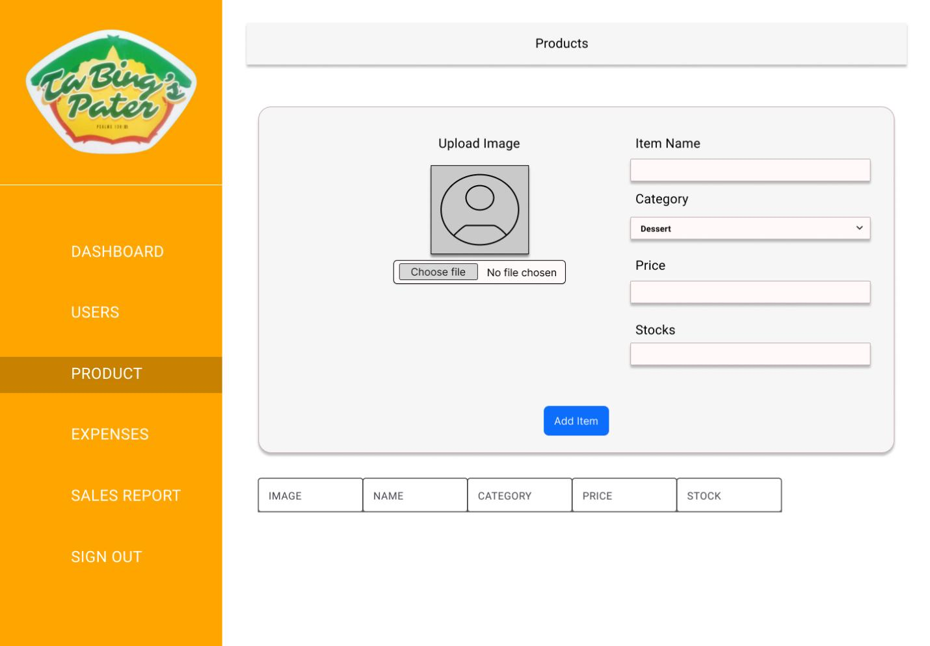

Button: “**Choose** **file**” –If you click this you can choose pictures.

Fill out all fields inside **“Product form”**

Button: “**Add** **Item**” – button use to save new product data to the database.

Table - use to display the existing products from the database.

**Point of Sale**

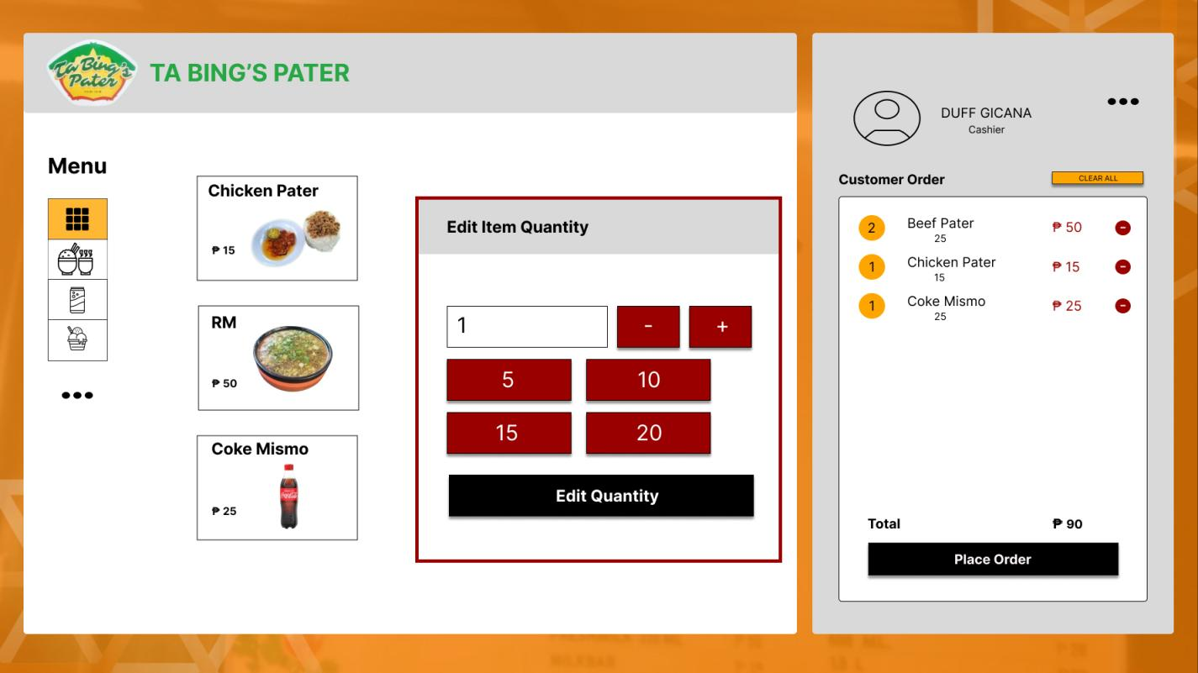

Menu images - shows the products that can be click to add in the order.

Button **“Edit quantity”** - to edit the quantity of the ordered product.

Button **“Clear all”** - use to clear all the ordered product, if the customer cancels.

Button **“Minus Sign icon”** - use to delete an existing order.

Button **“Place order”** - this button will redirect to payment form.

**Order confirmation and Payment**

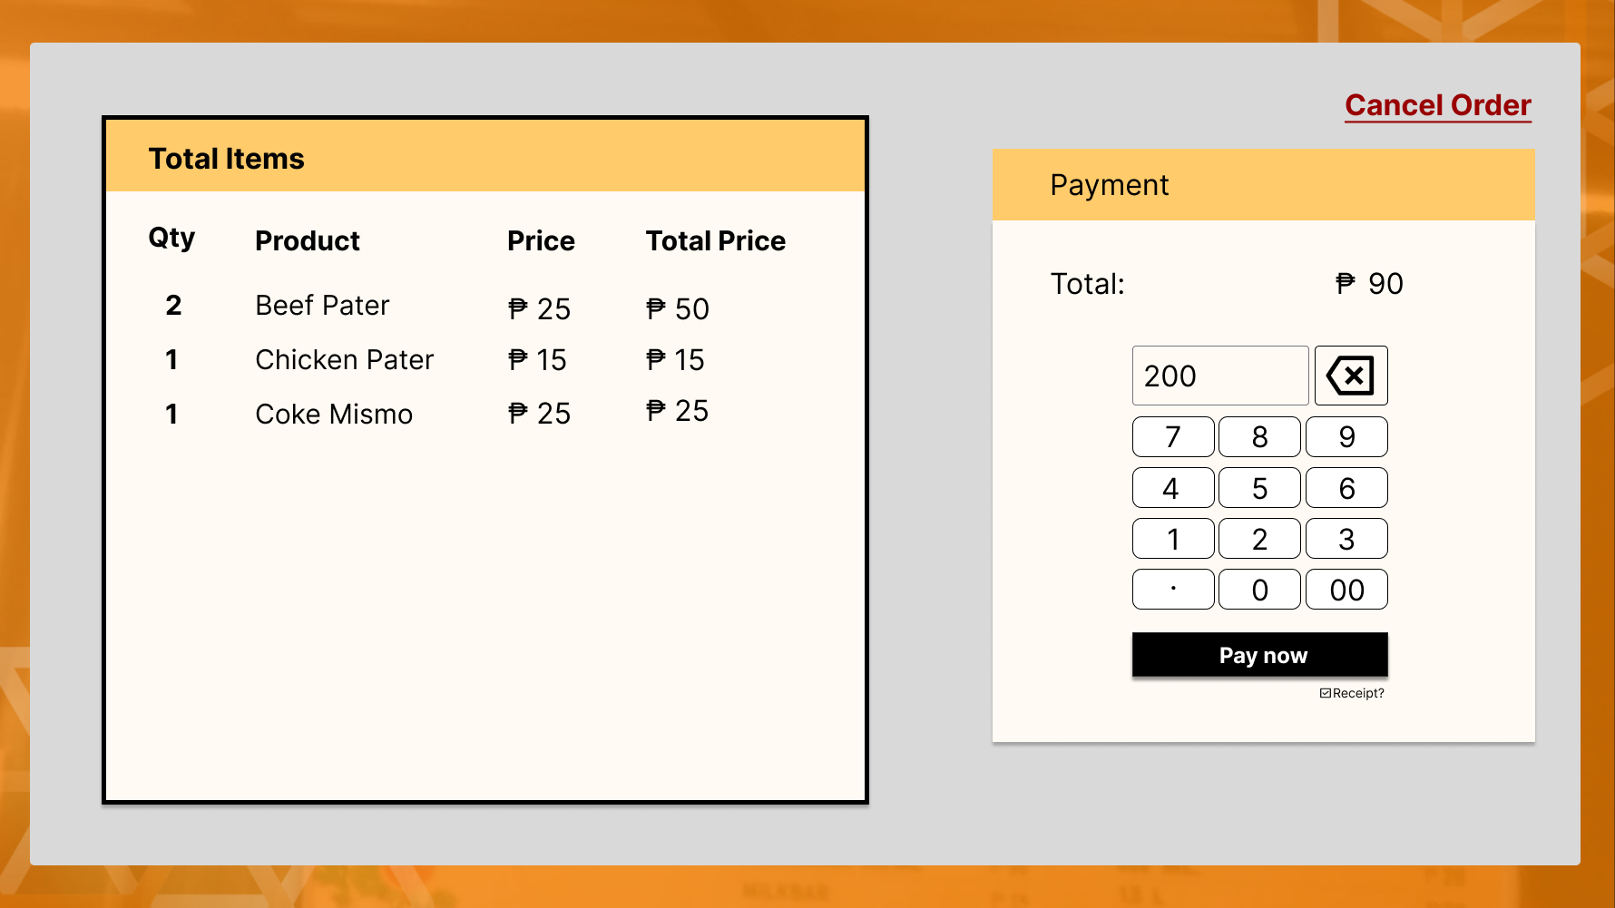

Button **“Pay now”** - will save the order details to database, print the invoice.

Button **“Cancel Order”** - use to cancel order.

**Expenses**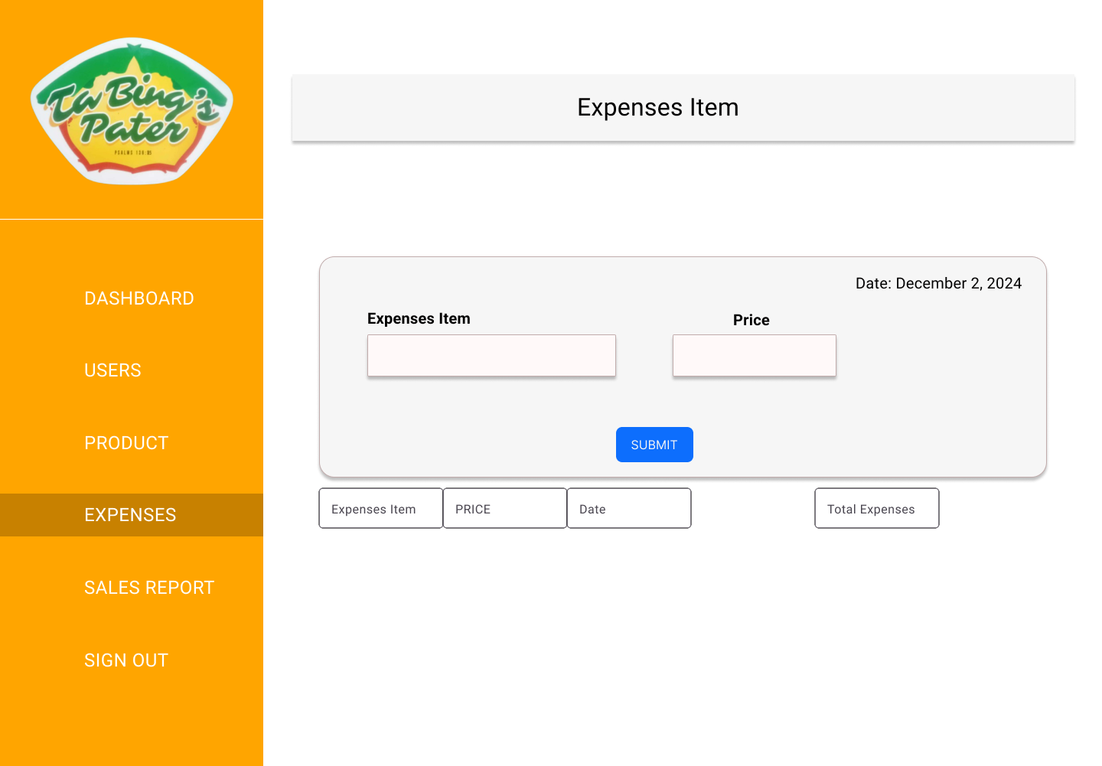

Fill out all information’s inside **“Expenses form”**

Button: “**Submit**” –Used to submit the expenses items and prices inputted into database.

Table - use to display the **Purchased** **Item**, **Price**, **Date**, and **Total** **Expenses** from the database.

**Sales Report**

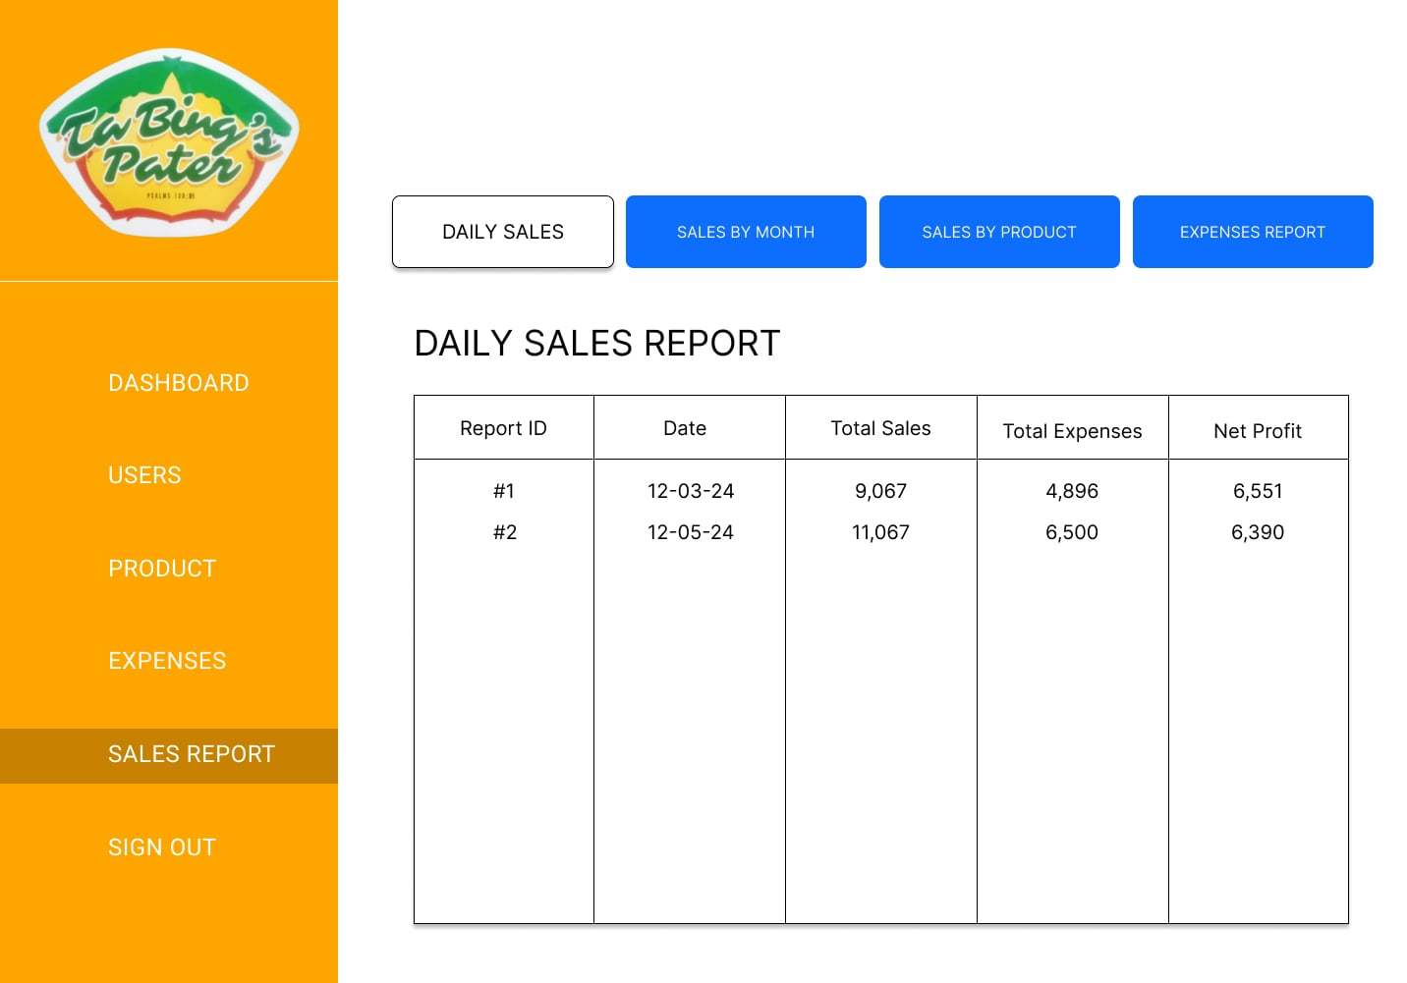

Button: **“Daily sales”** – Used to display sales each day.

Button: **“Sales by month”** – Used to display sales by month.

Button: **“Expenses report”** – Used to display the expenses report.

Button: **“Sales by product”** – Used to display sales by product.

Table - use to display sales related data from database.

**Invoice and kitchen order soft copy**

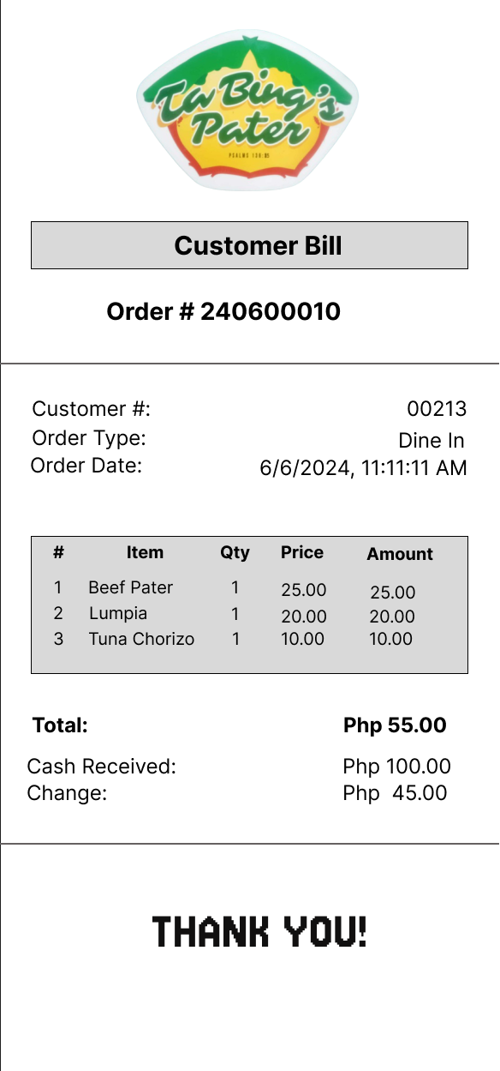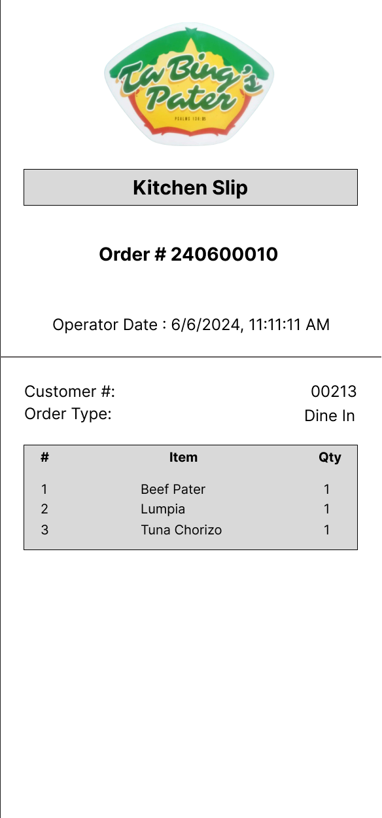

A copy for the customer invoice and kitchen order slip to ensure the correct order from both ends, making the transaction run smoothly.