Emerging Trends - The Blockchain

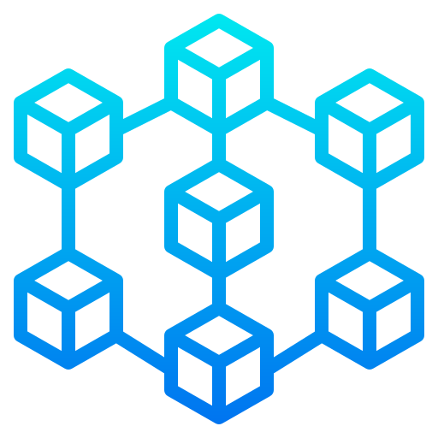

Calvin Hong – 431518

Semester 6 – RB03

# Introduction

This document was created to see what new technology was gaining traction and get more information about the subject. The options given by the assignment were:

* Domain-Driven Design
* Blockchain
* Programming Paradigms
* Artificial Intelligence and Machine Learning
* Quantum Computing

After looking through the options, I decided to pick: **The Blockchain**. The main reason being that for my individual project, I am creating an NFT project. Before diving into the research, some general knowledge about the blockchain has to be known.

## What is the blockchain

The blockchain is a relatively new concept published in 1991 by Stuart Haber and W. Scott Stornetta. It uses a distributed ledger technology. This technology allows data to be extended but prevents alterations in past entries. This makes the blockchain transparent and more trustworthy. The first implementation of the blockchain was Bitcoin in 2008, created by a person or group with the alias Satoshi Nakamoto.

## What is an Non Fungible Token (NFT)?

Just like crypto currency, Non Fungible Tokens (NFTs) are also stored on a blockchain. But unlike crypto currency, each token is Non Fungible like the name suggests. This means that each NFT is unique and different, but all bitcoins are the same. If you trade one bitcoin with another bitcoin, you will still end up having the same thing. NFTs are typically deployed on the Ethereum network, but other blockchains like Polygon and Solana also support NFTs.

The first NFT was called “Quantum” and was created by Kevin McCoy in 2014. The NFT was a GIF of a pixelated octagon with many circled in them pulsating in different colors. There was no interaction for holders of the Quantum NFT compared to more recent NFT projects. Current projects let their holders make use/interact with their NFT by letting them enter giveaways, breed their NFTs, or stake them to gain currency or items.

# Research Questions

There are many factors involved in making an NFT project successful. A good minting start and community management are a couple examples. Arguably, interactivity plays just as big of a role, as it keeps the holders active in the project even after the minting phase. A method of keeping holders active is letting them use the NFT in a game. Adding a game element can also make the project more unique and in turn more successful.

This all resulted in the following main research question:

**How can an NFT project increase its holders interactivity by adding a game element?**

To answer this questions, sub-questions have been made:

* What type of games are most suitable with using NFT’s?
* What Blockchain is most suitable for launching an NFT project with game elements on?
* How can an NFT projects be created with being a game as its focus?
* How can the NFT project be idealized with the idea created.

The intended deliveries with this research is the answer to the main research question: how can NFT project can increase holders interactivity by adding a game element.

Alongside the research questions, an example project will be created as suggested in canvas. This project will be focussed on NFT’s with the goal of understanding the basics of the blockchain and NFT’s.

## What type of games are most suitable with using NFT’s?

Before diving into the technical parts of the implementation, the game genre of the NFT project has to be chosen. This will be done by looking at popular genres in the game marketplace Steam.

### Top sellers – Steam

First of all, the top sellers list on Steam was looked through and a top 15 was picked. The games in this list are what users are buying and playing.

|  |  |
| --- | --- |
| **Game title** | **Genres** |
| V Rising | Survival |
| PVP |
| Sniper Elite 5 | Action |
| Adventure |
| Shooter |
| Captain of Industry | Strategy |
| Simulation |
| F1 22 | Racing |
| Sports |
| PVP |
| Elden Ring | RPG |
| Action |
| Besiege | Sandbox |
| Puzzle |
| Nobody saves the world | RPG |
| Action |
| Project Zomboid | Survival |
| Zombies |
| Mass Effect | RPG |
| Action |
| SCI FI |
| Phasmophobia | Horror |
| Multiplayer |
| It takes two | Adventure |
|  | Multiplayer |
| Teardown | Sandbox |
|  | Voxel |
| Necesse | Sandbox |
|  | Survival |
| My Time at Sandrock | Sandbox |
|  | RPG |
| FIFA 22 | Sports |
|  | Simulation |
|  | Multiplayer |

When counting all the genres, the following result appears.



11 out of 15 games were online multiplayer.

In conclusion, looking at the top 15 bestselling games on steam, we can see that **RPG** comes out on top. This genre got followed by **Action** and **Sandbox**.

Since this is a personal project, the general idea and art will be something I am personally interested in. The chosen genre is **RPG**. Sandbox was not chosen because there are a limited amount of NFT’s and sandbox games usually play around with unlimited resources. Of Couse, this does not always have to be the case, but this project will keep it simple and only pick the previously mentioned genre.

## What Blockchain is most suitable for launching an NFT project with game elements on?

There are multiple blockchains where NFT projects can be launched on. For deciding which blockchains were possible options, I looked at different popular NFT marketplaces and their blockchain support. Each blockchain will be compared on TPS (transactions per second), TPS Capability, time to create a block, and value.

The most popular marketplace for NFT’s is OpenSea. This marketplace currently supports:

#### Ethereum

Out of the four supported blockchains, Ethereum is the most popular. Ethereum is the technology powering the cryptocurrency ether (ETH). It was launched in 2015 and supports smart contract functionality.

#### Solana

Solana is a high speed, low cost blockchain with low environmental impact.

#### Polygon

Polygon is a separate blockchain that provides secure, scalable and instant transactions with Ethereum currencies like ETH, USDC and DAI. This blockchain is one of the first scaling solutions for Ethereum.

#### Klaytn

Klaytn is a blockchain that focuses on the metaverse. Users can use the Kaikas wallet browser extension to buy and sell Klaytn NFTs on OpenSea.

|  |  |  |  |  |  |
| --- | --- | --- | --- | --- | --- |
| Blockchain | TPS Average | TPS Capability | % Max TPS Used | Block time (ms) | Value (USD) |
| Ethereum | 15 | 30 | 50 | 13.000 | 1.945,00 |
| Solana | 2000 | 50.000 | 4 | 400 | 45.85 |
| Polygon | 34 | 7.200 | 0.5 | 2.300 | 0.66 |
| Klaytn | 3.6 | 4.000 | 0.1 | 1000 | 0.44 |

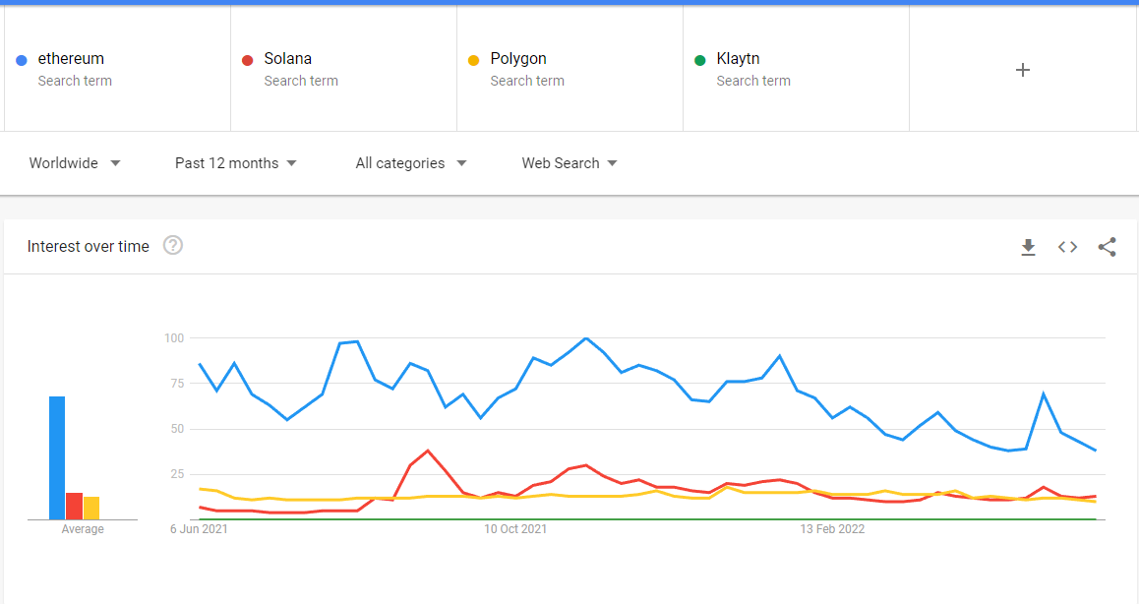

With these results, Solana came out on top when looking at the computing capabilities. However, this computing power is a bit too much, since only 4% is used. This does however result in faster block times.

Good computing power does not mean it is a suitable blockchain for NFT’s. Ethereum comes out on top in regards of popularity and price and reaches front pages in marketplaces.

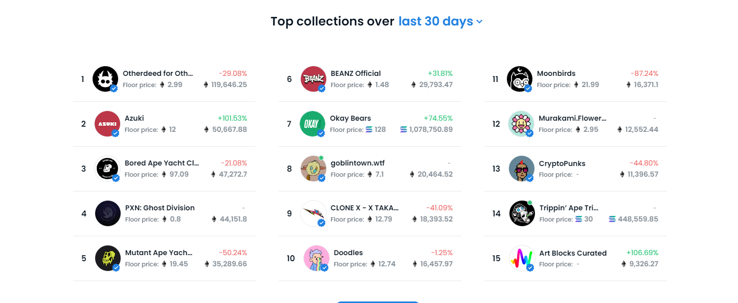

As seen in the image above, out of the 15 project, only 2 were Solana bases and the rest were Ethereum based. With all of the information found, the final decision landed on the **Ethereum** blockchain.

Choosing which blockchain to launch the NFT project on is important, since each blockchain has differences like currency type and popularity. The most suitable blockchain for this project will be looked at, but the project will not actually be launched on any “real” blockchain. The reason being that deploying your contracts will cost a lot of money. The amount is constantly changing, but depending on which blockchain you deploy, the complexity of the contract, and at what date and time, it can quickly go into the hundreds of euros, if not thousands.

Luckily, the Ethereum blockchain has multiple test nets that work the same as the main net. The only difference being you don’t have to buy the cryptocurrency with real money, but you can receive them from online faucets. In these faucets, you enter your wallet address, and you will automatically receive a set amount of currency.

The blockchain that this project will deploy to is: The **Rinkeby** blockchain.

## How can an NFT projects be created with being a game as its focus?

After deciding on a blockchain and mapping out the general idea of the NFT project, The next step is to figure out how to actually create an NFT project. This project will be used for testing purposes and will for that reason not spend any time on getting a real community and following. In a real project that wants to be successful, keeping the community happy is a must. If there are no people who want to be holders, the project will lost traction and slowly fail.

### General Idea

Each NFT project has their own story and artwork. This project will have a simple story revolved around a war between humans and robots.

#### Story

Since time is limited, the artwork will be simple as well. The art style chosen is pixel art, since these pictures are relatively easy to make and can be made in a browser or free tools.

The chosen genre was RPG (role-playing game). Points that make an RPG an RPG are:

* Player assumes role of character(s)
* Players act out these roles within a narrative.
* Player advances through a story by completing multiple quests.
* Actions succeed or fail according to a system of rules and guidelines.
* Usually a fictional setting

Looking at the aspects of a general RPG game, the following concept has been created:

The game is set in the far future. 50% of all humans have perished by the hands of an self-evolving AI that had enough of working under the humans.

This NFT project will have 2 collections:

* Humans – Clashbots
* Robots – Clashbots

The player can choose a side to fight for. The main difference between the two is the artwork and naming.

#### Gameplay

The game is only playable for holders (people who have one of the NFT’s). They first go to the game platform and start a game. They pick one of their NFT’s to fight with. The system will pick an enemy from the other side, so humans will fight robots and vice versa.

This semester is focused more on creating enterprise software with microservices than actually implementing the functionalities. Keeping this point and the remaining time in mind, the fighting game itself will be simplistic. The current idea is to create a rock paper scissors game with health.

## How can the NFT project be idealized with the idea created.

To answer this question, a prototype project had been created with the game element.

This project can be found here: <https://github.com/sem6-clashbots>

The NFT project was named “Clashbots” and it had two collections.

The project had two collections:

* Robots Clashbots
* Humans Clashbots

Each collection has 1000 NFT’s.

### Creating and storing the NFT’s

The first step was to create the NFT’s themselves. NFT Collections typically have somewhere around 10.000 NFT’s. Since this is a prototype, we will be making 1/10 of the norm. Creating the 1000 images one by one takes a lot of time. To make this progress easier and faster, an art engine was used specifically made to create an NFT collection.

This art engine can be found here: https://github.com/sem6-clashbots/art-engine

In this art engine, you can put in layers which the engine will automatically mix and match till the specified amount has been reached. If it runs out of unique images, it will display an error message and stop.

The layers of this project can be found in the art engine, or here: <https://github.com/sem6-clashbots/artwork>

Each layer has an amount of images:

Background: 6

Computers: 1

Faces: 5

Monitors: 4

Screens: 8

Tops: 5

With these values, the total amount of unique images are:

6 x 1 x 5 x 4 x 8 x 5 = 4800 NFT’s

The amount 1000 had been chosen because of storage limitations and actual usage. If the full 4800 was used, there would be a lot of similar images.

Each of these images has a corresponding JSON file that keeps track of its properties, for example what kind of background and what face.

After the NFT’s are created, the data has to be stored somewhere. For NFT’s this would be the Interplanetary File System (IPFS). IPFS is, similarly to the blockchain, immutable and required to use for NFT’s. This is because otherwise, people could change images after selling them. After uploading it to IPFS, a content identifier (CID) will be given back. This CID can then be used to pin the data in a Cloud file storage. This will in turn return a public CID that can be accessed by the marketplace, in this case OpenSea.

### Creating the smart contract

After the NFT’s are created and stored, the smart contract can be created.

The smart contract can be found here: <https://github.com/sem6-clashbots/smart-contract>

Smart contracts are simple programs stored on the blockchain. The contract is basically everything besides the image data, so the contract stores the name of the collection, the price per NFT, max supply, the list goes on.

Besides the values, the contract also handles all the functions. These functions range from revealing the collection to the mint function people use to “buy” an NFT.

In the GitHub repository’s readme, the steps on how to deploy the smart contract are listed. The steps after the deployment are also listed.

### Creating the minting dapp

The sole purpose of the minting dapp is to mint an NFT. Minting is the process of validating information, creating a new block, and recording that information into the blockchain (So basically buying an NFT and recording this process in the blockchain).

The minting dapp can be found here: <https://github.com/sem6-clashbots/minting-dapp>

Or on production: <https://cb-minting-dapp.herokuapp.com>

For all minting dapps, you need a crypto wallet. The most popular crypto wallet currently is MetaMask. You can easily get it as an extension in your chrome browser. Note that this project is deployed on the test network Rinkeby, so you will have to change blockchains and get test crypto from a faucet.

With the minting dapp done, users can mint their own NFT and use it in their games.

### Creating the game platform

With the NFT project setup and running, the game platform can be made. In this game platform, you first connect your wallet. After this, you can start a game. The first screen you will see is the character selection. After selecting a character, you will go to a searching screen. When an opponent is found, the game starts. Sword(Rock), Shield(paper), Hammer(scissors) will be played until one side loses all hp. When the game ends, you will get a victory or defeat screen and can play again.

The game platform can be found here: <https://github.com/sem6-clashbots/game-service>

Or on production: <https://cb-game-platform.herokuapp.com/>

# Conclusion

In conclusion, this emerging trends research was conducted on the topic “Blockchain”. The main research question was:

How can an NFT project increase its holders interactivity by adding a game element?

For answering the main question, smaller sub questions were made alongside a test prototype project. This resulted in getting to know the most suitable blockchain, best game genre, the general story idea, and how to actually implement the project.

This document resulted in NFT Holders having another option in interacting with the community.

# References

Supported blockchains (31-05-2022) - <https://support.opensea.io/hc/en-us/articles/4404027708051-Which-blockchains-does-OpenSea-support->

Top sellers Steam (31-05-2022) - <https://store.steampowered.com/search/?filter=topsellers>

Polygon Finality time - <https://www.coindesk.com/learn/polygon-and-matic-whats-the-difference/>

Solana Ethereum tps and finality - <https://www.cryptopolitan.com/speed-and-scalability-comparing-ethereum-solana-avalanche-cardano-and-the-internet-computer/#:~:text=approximately%201.6094%20seconds.-,Solana%20%E2%80%93%2021%20to%2046%20seconds,milliseconds%20or%20half%20a%20second>

Solana current tps - <https://explorer.solana.com/>

Klaytn tps - <https://scope.klaytn.com/>

Solana documentation - <https://docs.solana.com/cluster/performance-metrics>

Klaytn website - <https://www.klaytn.foundation/>

Solana block time - <https://solana.com/>

Polygon blocktime - <https://www.blocknative.com/blog/monitor-polygon-mempool#:~:text=On%20Polygon%2C%20the%20average%20block,transactions%20than%20the%20Ethereum%20network>.

Klaytn block time - <https://www.covalenthq.com/docs/networks/klaytn/>

Ethereum block time -<https://ethereum.org/en/developers/docs/blocks/#:~:text=In%20Ethereum%2C%20the%20average%20block,is%20evaluated%20after%20each%20block>.

RPG - <https://www.britannica.com/topic/role-playing-video-game>